Title 14 of the California Code of Regulations (14 CCR),
Division 1.5, Chapter 7
Subchapter 2, Articles 1-5
“DRAFT State Minimum Fire Safe Regulations, 2021”
If you are using an assistive reading device it is recommended to adjust your settings for strikeout and underline.
Subchapter 2. SRA/VHFHSZ State Minimum Fire Safe Regulations

Article 1. Administration

§ 1270.00. Title.
These regulations shall be known as the “SRA/VHFHSZ State Minimum Fire Safe Regulations,” and shall constitute the basic minimum wWildfire protection standards of the California Board of Forestry and Fire Protection.
Note: Authority cited: Section 4290, Public Resources Code. Reference: Sections 4102, 4126, 4127 and 4290, Public Resources Code.

§ 1270.01. Definitions Purpose
The following definitions are applicable to this Subchapter.
(a) Access: The Roads on a route from a Building to the nearest Collector Road or the Roads on a route from a Building to the nearest Road which is compliant with the standards provided in this Article, whichever is closer.
(b) Agriculture: Land used for agricultural purposes as defined in a Local Jurisdiction's zoning ordinances.
(c) Authority Having Jurisdiction (AHJ): the organization, office, or individual responsible for enforcing the applicable requirements of these standards, or for approving equipment, materials, an installation, or a procedure. This includes the local government and local fire authority in their respective roles of development approval process and regulatory enforcement.
(cd) Board: California Board of Forestry and Fire Protection.
(de) Building: Any Structure used or intended for supporting or sheltering any use or Occupancy, except those classified as Utility and Miscellaneous Group U.
(f) Building Construction: the construction, reconstruction, placement, or erection of any Building; a permit or approval for an increase in the density or intensity of use of land, including, but not limited to, subdivision pursuant to the Subdivision Map Act (commencing with Section 66410 of the Government Code), and any other division of land except where the land division is brought about in connection with the purchase of such land by a public agency for public recreational use.
(eg) CAL FIRE: California Department of Forestry and Fire Protection.
(fh) Clear Width: A horizontal area free of vegetation, debris, fences, or other materials that may impede traffic flow; this area may include flexible posts or barriers that bend upon vehicular impact and rebound to their original position.
(gi) Collector Road: Roads identified by the AHJ a Local Jurisdiction as a major collector, or minor collector, or general, collector road pursuant to Title 23, Code of Federal Regulations, § 470.105 and in conformance with the procedures in the US Federal Highway Administration “Highway Functional Classification Concepts, Criteria, and Procedures,” 2013 Edition, hereby incorporated by reference.
(hj) Dead-end Road: A Road that has only one point of vehicular ingress/egress, including cul-de-sacs and Roads that loop back on themselves looped Roads.
(ik) Defensible Space: As defined in California Code of Regulations, Title 14, § 1299.02(a).
(jl) Development: As defined in section 66418.1 of the California Government Code.
(km) Director: Director of the Department of Forestry and Fire Protection or their designee.
(ln) Driveway: A vehicular pathway that serves no more than four (4) Residential Units up to two (2) parcels with no more than two (2) Residential Units and any number of non-commercial or non-industrial Utility or Miscellaneous Group U Buildings on each parcel. A Driveway shall not serve commercial or industrial uses at any size or scale.
(mo) Exception: An alternative means or method to achieve a specified standard requested by the applicant subject to § 1270.06 (Exceptions to Standards).
(p) Existing: That which is legally established or legally in place at the time of the proposal for Building Construction.
(nq) Existing Road: A physical Road that is legally established or legally in place at the time of the proposal for Building Construction. constructed and used by vehicles prior to a Development proposal. An Existing Road is not one exempt under § 1270.03(d) if that Road is part of a Building Construction proposal where it is to be used for purposes other than those specified in § 1270.03(e). A Existing Driveway is not an Existing Road, if that Driveway is part of a Building Construction proposal where the Driveway will serve more than four (4) Residential Units.
(r) Finished Grade: The highest point of elevation of the finished surface of the ground, landscaping, vegetation, paving, curb or sidewalk within the area extending in a 5 foot diameter from the center of the fire hydrant.
(os) Fire Apparatus: A vehicle designed to be used under emergency conditions to transport personnel and equipment or to support emergency response, including but not limited to the suppression of fires.
(p) Fire Authority: A fire department, agency, division, district, or other governmental body responsible for regulating and/or enforcing minimum fire safety standards.
(qt) Fire Hydrant: A valved connection on a water supply or storage system for the purpose of providing water for fire protection and suppression operations.
(ru) Fuel Break: A strategically located area where the volume and arrangement of vegetation has been managed to limit fire intensity, fire severity, rate of spread, crown fire potential, and/or ember production.
(su) Greenbelts: Agricultural lands, open space, parks, wildlands, or a combination thereof, as designated by the AHJ Local Jurisdictions, which are in, surround, or near areas subject to these regulations that may function as Fuel Breaks or are adjacent to a city or urbanized area, and where Building Construction is restricted or prohibited Development.
(tv) Greenways: Linear open spaces or corridors that link parks and neighborhoods within a community through natural or manmade trails and paths.
(uw) Hammerhead/T: A road or Driveway that provides a “T” shaped, three-point Turnaround space for Fire Apparatus on a Road or Driveway, being no narrower than the Road or Driveway that serves it.
(vx) Hazardous Land Use: A land use that presents a significantly elevated potential for the ignition, prolonged duration, or increased intensity of a Wildfire due to the presence of flammable materials, liquids, or gasses, or other features that initiate or sustain combustion. Such uses are determined by the AHJ Local Jurisdiction and may include, but are not limited to, power-generation and distribution facilities; wood processing or storage sites; flammable gas or liquids processing or storage sites; or shooting ranges.
(w) Local Jurisdiction: Any county, city/county agency or department, or any locally authorized district that approves or has the authority to regulate Development.
(xz) Local Responsibility Area (LRA): Those areas of land not classified by the Board where the financial responsibility of preventing and suppressing Wildfires is that of local agencies the state or federal government, pursuant to Public Resources Code (PRC) section 4125.
(yaa) Local Road: Roads identified by the AHJ a Local Jurisdiction as a local road pursuant to Title 23, Code of Federal Regulations, § 470.105 and in conformance with the procedures in the US Federal Highway Administration “Highway Functional Classification Concepts, Criteria, and Procedures,” 2013 Edition, hereby incorporated by reference.
(zbb) Municipal-Type Water System: A system having water pipes servicing Fire Hydrants and designed to furnish, over and above domestic consumption, a minimum of 250 gpm (950 L/min) at 20 psi (138 kPa) residual pressure for a two (2) hour duration.
(aacc) New Road: That which is proposed as part of a Building Construction proposal that is the subject of consideration hereunder, and not legally established nor legally in place at the time of the proposal for Building Construction. A theoretical Road proposed in a Development application.
(bbdd) Occupancy: The purpose for which a Building, or part thereof, is used or intended to be used.
(ccee) One-way Road: A Road that provides a minimum of one Traffic Lane width designed for traffic flow in one direction only.
(ddff) Perimeter: The boundary of an individual parcel and/or the boundary of a tentative and final map or parcel map, pursuant to Government Code § 66411, within which lies any Building cConstruction.
(gg) Repair: The reconstruction, replacement or renewal of any part of an existing Structure for the purpose of its maintenance or to correct damage.
(eehh) Residential Unit: Any Building or portion thereof which contains living facilities, including which include provisions for sleeping, and can include provisions for eating, cooking and/or sanitation, for one or more persons. Manufactured homes, mobile homes, and factory-built housing are considered residential units. Buildings, unless being sited or installed as an accessory or junior accessory dwelling unit in accordance with § 1270.03(d) (Scope – Exemptions – ADUs) are not considered Residential Units.
(ffii) Ridgeline: The line of intersection of two opposing slope aspects running parallel to the long axis of the highest elevation of land; or an area of higher ground separating two adjacent streams or watersheds.
(ggjj) Road: A public or private vehicular pathway to more than two (2) parcels, more than four (4) Residential Units, or to any industrial or commercial Ooccupancy.
(hh) Road or Driveway Structures: Bridges, culverts, and other appurtenant structures which supplement the Traffic Lane or Shoulders.
(iikk) Shoulder: A vehicular pathway adjacent to the Traffic Lane.
(jjll) State Responsibility Area (SRA): As defined in Public Resources Code sections 4126-4127; and the California Code of Regulations, title 14, division 1.5, chapter 7, article 1, sections 1220-1220.5.
(kkmm) Structure: That which is built or constructed, a Building of any kind, or any piece of work artificially built up or composed of parts joined together in some definite manner.
(llnn) Substantial Compliance [or Substantially Complies]: Nearly complete satisfaction of each applicable all material requirements consistent with the purpose of the applicable State Minimum Fire Safe Regulations, including without limitation to concurrent Fire Apparatus ingress and civilian evacuation. Substantial Compliance may be found even though minor noncompliance exists. the formal requirements are not satisfied.
(mmoo) Substantial Evidence: Enough relevant information and reasonable inferences from this information that a fair argument can be made to support a conclusion, in light of the whole record of evidence, even though other conclusions might also be reached. Argument, speculation, unsubstantiated opinion or narrative, or evidence which is clearly erroneous or inaccurate does not constitute substantial evidence. Substantial evidence shall include facts, reasonable assumptions predicated upon facts, and expert opinion supported by facts.
(nnpp) Traffic Lane: The portion of a Road or Driveway that provides a single line of vehicle travel.
(ooqq) Turnaround: A portion of a Road or Driveway, unobstructed by parking, An area which allows for a safe opposite change of direction for Fire Apparatus at the end of a Road or Driveway. Design of such area may be a hammerhead/T or terminus bulb.
(pprr) Turnout: A widening in a Road or Driveway to allow vehicles to pass.
(qqss) Undeveloped Ridgeline: A Ridgeline with no Residential Units or commercial or industrial Buildings.
(rrtt) Utility and Miscellaneous Group U: A Structure of an accessory character or a miscellaneous Structure not classified in any specific Ooccupancy permitted, constructed, equipped, and maintained to conform to the requirements of Title 24, California Building Standards Code.
(ssuu) Vertical Clearance: The minimum specified height of a bridge, overhead projection, or vegetation clearance above the Road or Driveway.
(vv) Vertical Curve: A curve at a high or low point of a roadway that provides a gradual transition between two roadway grades or slopes.
(ttxx) Very High Fire Hazard Severity Zone (VHFHSZ): As defined in Government Code section 51177(i).
(uuyy) Wildfire: Has the same meaning as “forest fire” in Public Resources Code Section 4103. As defined in Public Resources Code Section 4103 and 4104.
(a) These regulations have been prepared and adopted for the purpose of establishing minimum wildfire protection standards in conjunction with building, construction and development in the State Responsibility Area (SRA) and, after July 1, 2021, the Very High Fire Hazard Severity Zones as defined in Government Code § 51177(i) (VHFHSZ).
(b) The future design and construction of structures, subdivisions and developments in the SRA and, after July 1, 2021, the VHFHSZ shall provide for basic emergency access and perimeter wildfire protection measures as specified in the following articles.
(c) These measures shall provide for emergency access; signing and building numbering; private water supply reserves for emergency fire use; and vegetation modification. The fire protection standards which follow shall specify the minimums for such measures.
Note: Authority cited: Section 4290, Public Resources Code. Reference: Sections 4290 and 4291, Public Resources Code.

§ 1270.02. Purpose. Scope
(a) These regulations have been prepared and adopted for the purpose of establishing state minimum Wildfire protection standards in conjunction with Building cConstruction and Development in the State Responsibility Area (SRA) and, after July 1, 2021, the Very High Fire Hazard Severity Zones, as defined in Government Code § 51177(i) (VHFHSZ).
(b) Building cConstruction in the SRA approved after January 1, 1991, and, after July 1, 2021, Building Construction in the VHFHSZ approved after July 1, 2021 shall provide for minimum Wildfire protection standards as specified in the following articles.
(c) These standards shall provide for emergency ingress and egress; signing and Building numbering; municipal-type, private, and public water supply reserves for emergency fire use; vegetation modification, Fuel Breaks, Greenbelts, and measures to preserve Undeveloped Ridgelines. The regulations which follow shall specify the minimums for such standards.
(d) By limiting Building construction in those areas where Prescribing these minimum Wildfire protection standards are not satisfied, this reduces the risk of Wildfires in these areas, which among other things protects the health, safety and welfare of residents, and protects natural resources and the environment.
(a) These regulations shall apply to:
(1) the perimeters and access to all residential, commercial, and industrial building construction within the SRA approved after January 1, 1991 , and those approved after July 1, 2021 within the VHFHSZ, except as set forth below in subsections (b) through (d), inclusive, and (f);
(2) the siting of newly installed commercial modulars, manufactured homes, mobilehomes, and factory-built housing, as defined in Health and Safety Code sections 18001.8, 18007, 18008, and 19971, except where being sited or installed as an accessory or junior accessory dwelling unit as set forth in subsection (d) below;
(3) all tentative and parcel maps or other developments approved after January 1, 1991; and
(4) applications for Building permits on a parcel approved in a pre-1991 parcel or tentative map to the extent that conditions relating to the perimeters and access to the Buildings were not imposed as part of the approval of the parcel or tentative map.
(b) These regulations do not apply where an application for a Building permit is filed after January 1, 1991 for Building construction on a parcel that was formed from a parcel map or tentative map (if the final map for the tentative map is approved within the time prescribed by the local ordinance) approved prior to January 1, 1991, to the extent that conditions relating to the perimeters and access to the Buildings were imposed by the parcel map or final tentative map approved prior to January 1, 1991.
(c) (1) At the discretion of the Local Jurisdiction, and subject to any requirements imposed by the Local Jurisdiction to ensure reasonable ingress, egress, and capacity for evacuation and emergency response during a Wildfire, these regulations shall not apply to the reconstruction or repair of legally constructed residential, commercial, or industrial Buildings due to a Wildfire, to the extent that the reconstruction or repair does not:
(A) increase the square footage of the residential, commercial, or industrial Building or Buildings that previously existed; or
(B) change the use of the Building or Buildings that had existed previously; or
(C) construct a new Building or Buildings that did not previously exist on the site.
(2) Nothing in this subsection shall be construed to alter the extent to which these regulations apply to the reconstruction or repair of a legally constructed residential, commercial, or industrial Building for reasons unrelated to a Wildfire.
(d) These regulations do not apply to the creation of accessory or junior accessory dwelling units that comply with Government Code sections 65852.2 or 65852.22, or any local ordinances enacted thereunder, as applicable, including any local ordinances requiring provisions for fire and life safety.
(e) Unless otherwise exempt pursuant to this Subchapter, affected activities include, but are not limited to:
(1) permitting or approval of new parcels, excluding lot line adjustments as specified in Government Code (GC) section 66412(d);
(2) application for a Building permit for new Building construction;
(3) application for a use permit; and
(4) road construction.
(f) EXEMPTION: Roads used solely for agricultural, mining, or the management and harvesting of wood products.
Note: Authority cited: Section 4290, Public Resources Code. Reference: Sections 4290 and 4291, Public Resources Code.

§ 1270.03. Scope. Provisions for Application of The Regulations
(a) These regulations shall apply to:
(1) the Perimeters and Access to all residential, commercial, and industrial Building cConstruction within the SRA approved after January 1, 1991, and those approved after July 1, 2021 within the VHFHSZ, except as set forth below in subsections (b), (c), (d), and (e) below.
(2) the siting or installation of newly installed commercial modulars, manufactured homes, mobilehomes, and factory-built housing, as defined in Health and Safety Code sections 18001.8, 18007, 18008, and 19971, except where being sited or installed as an accessory or junior accessory dwelling unit as set forth in subsection (d) below;
(3) all tentative and parcel maps or other Developments approved after January 1, 1991; and
(43) applications for Building permits on a parcel approved in a pre-1991 parcel or tentative map to the extent that conditions relating to the Perimeters and Access to the Buildings were not imposed as part of the approval of the parcel or tentative map.
(b) These regulations do not apply where an application for a Building permit in the SRA is filed after January 1, 1991 for Building cConstruction on a parcel that was formed from a parcel map or tentative map approved prior to January 1, 1991 (if the final map for the tentative map is approved within the time prescribed by the local ordinance). approved prior to January 1, 1991, to the extent that conditions relating to the Perimeters and Access to the Buildings were imposed by the parcel map or final tentative map approved prior to January 1, 1991.
(1) For tThis exemption shall apply only to the extent that to apply, the parcel map or tentative map that was approved prior to January 1, 1991, shall have imposed conditions relating to the Perimeters and Access to the Building cConstruction that is the subject of the Building permit application filed after January 1, 1991.
(2) These regulations shall apply to the Building construction to the extent that conditions relating to the Perimeters and Access to the Buildings were not imposed as part of the approval of the parcel map or tentative map.
(c) At the discretion of the Local Jurisdiction, and subject to any requirements imposed by the Local Jurisdiction to ensure reasonable ingress, egress, and capacity for evacuation and emergency response during a Wildfire, these regulations shall not apply to the reconstruction or repair of a Building due to a Wildfire, subject to the following:
(1) this exemption shall not apply if the reconstruction or repair encroaches on the minimum setback requirements in § 1276.01 Building and Parcel Siting and Setbacks;
(2) this exemption shall not apply if the reconstruction or repair changes the use of the Building or Buildings that had existed previously;
(3) nothing in this subsection shall be construed to alter the extent to which these regulations apply to the reconstruction or repair of a Building for reasons unrelated to a Wildfire; and
(4) nothing in this subsection shall be construed to alter the legal character of a Building reconstructed or repaired pursuant to this exemption.
(dc) These regulations do not apply to the creation of accessory or junior accessory dwelling units that comply with Government Code sections 65852.2 or 65852.22, or any local ordinances enacted thereunder, as applicable, including any local ordinances requiring provisions for fire and life safety.
(ed) These regulations The standards in these regulations applicable to Roads shall not apply to Roads used solely for Agriculture, mining;, or the management of timberland and harvesting of forest products; or the planting, growing, or harvesting of plants (including related activities such as processing, storage, and transportation) for the marketing of the resulting products.
(e) The applicable AHJ which approves or adopts construction development permits or maps shall provide the Director of the California Department of Forestry and Fire Protection (CAL FIRE) or their designee with notice of applications for Building permits, tentative parcel maps, tentative maps, and installation or use permits for construction or development within the SRA or the VHFHSZ.
(f) The Director or their designee may review and make fire protection recommendations on applicable construction or development permits or maps provided by the local jurisdiction.
(g) This Subchapter shall not apply retroactively. The requirements of this Subchapter shall apply when an approval or adoption is sought for Building permits, tentative parcel maps, tentative maps, and installation or use permits for construction or development within the scope of this Subchapter.
(h) The AHJ identified in subsection (e) shall not approve or adopt any applicable construction or development permit or map unless an inspection has been made in accordance with this Subchapter and it has been determined that the applicable sections of this Subchapter are satisfied.
(i) Activities within the scope of this Subchapter shall be subject to the regulations in effect at the time of the the activity’s approval.
This Subchapter shall be applied as follows:
(a) the Local Jurisdictions shall provide the Director of the California Department of Forestry and Fire Protection (CAL FIRE) or their designee with notice of applications for Building permits, tentative parcel maps, tentative maps, and installation or use permits for construction or development within the SRA.
(b) the Director or their designee may review and make fire protection recommendations on applicable construction or development permits or maps provided by the Local Jurisdiction.
(c) the Local Jurisdiction shall ensure that the applicable sections of this Subchapter become a condition of approval of any applicable construction or development permit or map.
Note: Authority cited: Section 4290, Public Resources Code. Reference: Sections 4290 and 4291, Public Resources Code.

§ 1270.04. Local Regulations Ordinances.
(a) These regulations shall serve as the minimum Wildfire protection standards applied in SRA and VHFHSZ. However, these regulations do not supersede local regulations which equal or exceed the standards of this Subchapter. Nothing contained in these regulations shall be considered as abrogating the provisions of any ordinance, rule or regulation of any state or Local Jurisdiction provided that such ordinance, rule, or regulation is equal to or exceeds these minimum standards.
(b) A local regulation equals or exceeds a minimum standard of this Subchapter only if, at a minimum, the local regulation also fully complies with the corresponding minimum standard in this Subchapter. Counties may submit their local ordinances for certification via email to the Board, and the Board may certify them as equaling or exceeding these regulations when they provide the same practical effect. If the Board determines that the local requirements do not equal or exceed these regulations, it shall not certify the local ordinance.
(c) A Local Jurisdiction shall not apply exemptions to these regulations that are not enumerated in this Subchapter. Exceptions requested and approved in conformance with § 1270.06 (Exceptions to Standards) may be granted on a case-by-case basis. When the Board grants certification, the local ordinances, in lieu of these regulations, shall be applied as described in 14 CCR § 1270.02 and used as the basis for inspections performed under 14 CCR § 1270.05.
(d) A Local Jurisdiction or Fire Authority may notify the Board upon commencement of any revisions to relevant local regulations. The Board may provide technical assistance to the agency during the revision drafting process. The Board's certification of local ordinances pursuant to this section is rendered invalid when previously certified ordinances are subsequently amended by Local Jurisdictions, or the regulations are amended by the Board, without Board re-certification of the amended ordinances. The Board's regulations supersede the amended local ordinance(s) when the amended local ordinance(s) are not re-certified by the Board. Amendments made by Local Jurisdictions to previously certified ordinances shall be submitted for re-certification.
(e) The Local Jurisdiction or Fire Authority may submit their draft regulation to the Board at least 90 days before the first meeting of the Local Jurisdiction or Fire Authority at which the proposed draft will be presented to the public.
(f) The Board may provide recommendations on the draft within 60 days.
(gd) Notwithstanding a local regulation that equals or exceeds the State Minimum Fire Safe Regulations, Building cConstruction shall comply with the State Minimum Fire Safe Regulations.
Note: Authority cited: Section 4290, Public Resources Code. Reference: Sections 4290 and 4291, Public Resources Code.

§ 1270.05. Inspections.
Inspections shall conform to the following requirements:
(a) Inspections in the SRA shall be made by the AHJ, which may be:
(1) the Director, or
(2) A local agency Local Jurisdictions that hasve assumed state fire protection responsibility on SRA lands, or
(3) A local agency Local Jurisdictions where the inspection duties have been formally delegated by CAL FIRE the Director to the local agency Local Jurisdiction, pursuant to subsection (b).
(b) The Director may delegate inspection authority to a local agency Local Jurisdiction subject to all of the following criteria:
(1) The agency Local Jurisdiction represents that they have appropriate resources to perform the delegated inspection authority.
(2) The agency Local Jurisdiction acknowledges that CAL FIRE’s authority under subsection (d) shall not be waived or restricted.
(3) The agency Local Jurisdiction consents to the delegation of inspection authority.
(4) The Director may revoke the delegation at any time.
(5) The delegation of inspection authority, and any subsequent revocation of the delegation, shall be documented in writing, and retained on file at the CAL FIRE Unit headquarters that administers SRA fire protection in the area. Local Jurisdiction.
Nothing in this section abrogates CAL FIRE's authority to inspect and enforce state forest and fire laws even when the inspection duties have been delegated pursuant to this section.
(c) Inspections in the VHFHSZ shall be made by the appropriate local AHJ Local Jurisdiction or Fire Authority.Reports of violations shall be provided to the CAL FIRE Unit headquarters that administers SRA fire protection in the Local Jurisdiction.
(d) Nothing in this section abrogates CAL FIRE's authority to inspect and enforce state forest and fire laws in the SRA even when the inspection duties have been delegated pursuant to this section. When inspections are conducted, they shall occur prior to: the issuance of the use permit or certificate of occupancy; the recordation of the parcel map or final map; the filing of a notice of completion; or the final inspection of any project or Building permit.
(e) Reports of violations within the SRA shall be provided to the CAL FIRE Unit headquarters that administers SRA fire protection in the Local Jurisdiction.
(f) Inspections conducted by the Director shall be limited to confirming compliance with the State Minimum Fire Safe Regulations. Inspections conducted by The local AHJ the Local Jurisdiction or Fire Authority shall confirm compliance with the State Minimum Fire Safe Regulations and may . A Local Jurisdiction may, in its discretion, conduct additional inspections with respect to a local regulation that equals or exceeds the State Minimum Fire Safe Regulations.
(g) The AHJ Local Jurisdiction shall ensure that any applicable Building Cconstruction complies with the applicable sections of this Subchapter.
Note: Authority cited: Section 4290, Public Resources Code. Reference: Sections 4102, 4119, 4125, 4290 and 4291, Public Resources Code.

§ 1270.06. Exceptions to Standards.
(a) The requirements in this section apply to requests for Exceptions from the standards in the State Minimum Fire Safe Regulations.
(ba) Upon request by the applicant, and at the discretion of the AHJ, an eExceptions to a standards within this sSubchapter or to Local Jurisdiction certified ordinances may be considered granted allowed by the AHJ inspection entity in accordance with listed in § 1270.05 (Inspections). where the exceptions provide the same practical effect as these regulations towards providing defensible space.
(1) Exceptions shall only be granted where the Exception provides for Substantial Compliance with the minimum standards provided in this Subchapter.
(2) Decisions on Exceptions considered granted by the AHJ inspection entity listed in 14 CCR § 1270.05 , whether granted or denied, shall be made on a case-by-case basis only, shall be in writing, and shall be supported by Substantial Evidence. Decisions Exceptions granted by the AHJ inspection entity listed in 14 CCR § 1270.05 and all relevant documentation shall be forwarded to the Board and the appropriate CAL FIRE unit headquarters Unit Office that administers SRA fire protection in that Local Jurisdiction, or the county in which the Local Jurisdiction is located county. Decisions and all relevant documentation Exceptions shall be retained on file at both offices for a period of no less than five (5) years. and shall be retained on file at the Unit Office.
(bc) Requests for an eException shall be made in writing to the AHJ inspection entity listed in 14 CCR § 1270.05 by the applicant or the applicant's authorized representative.
(1) At a minimum, the Exception requests shall state
(iA)the specific section(s) for which an eException is requested,;
(iiB) material facts supporting the necessity for an Exception contention of the applicant,;
(iiiC) material facts demonstrating the proposed alternative mean(s) Substantially Complies with the State Minimum Fire Safe Regulation for which the Exception is requested; the details of the exception proposed, and
(ivD) a map showing the proposed location and siting of the eException, including address or parcel number, as applicable; and .
(E) any other information deemed relevant by the applicant or applicant’s representative.
(2) AHJs Local Jurisdictions acting as inspection entities pursuant to listed in § 1270.05 (Inspections) may establish additional procedures or requirements for eException requests.
(cd) Where an exception is not granted by the inspection entity, the applicant may appeal such denial to the Local Jurisdiction. The decision by an AHJ not to consider an Exception request may not be appealed. Decisions on Exception requests considered by the AHJ, whether granted or denied, decisions may be appealed to the local governmental body with jurisdiction over the AHJ, which The Local Jurisdiction may establish or utilize an appeal process consistent with existing local Building or planning department appeal processes.
(1) In addition to local requirements, the governmental body hearing the appeal Local Jurisdiction shall consult with the inspector inspection entity prior to making a determination on an appeal.
(2) The inspector inspection entity shall provide documentation demonstrating how the requested Exception does or does not sSubstantially cComply with the standards in this Subchapter. Before the Local Jurisdiction makes a determination on an appeal, the inspection authority shall be consulted and shall provide to that Local Jurisdiction documentation outlining the effects of the requested exception on Wildfire protection.
(e) Where there is an appeal, If an appeal is granted, the AHJ Local Jurisdiction governmental body hearing the appeal shall make written findings of the Exception’s Substantial Compliance, as defined § 1270.01 (Definitions), with the minimum standards in this Subchapter, supported by Substantial Evidence. that the decision meets the intent of providing defensible space consistent with these regulations. Such findings shall include a written statement of reasons for reversing overriding the decision of the inspector inspection entity, if necessary applicable. A written copy of the written these findings shall be provided to the Board and the CAL FIRE Uunit headquarters that administers SRA fire protection in that area. Local Jurisdiction, or in the county in which the Local Jurisdiction is located.
Note: Authority cited: Section 4290, Public Resources Code. Reference: Sections 4290 and 4291, Public Resources Code.

§ 1270.07. Distance Measurements.
All specified or referenced distances are measured along the ground, unless otherwise stated.
Note: Authority cited: Section 4290, Public Resources Code. Reference: Sections 4290 and 4291, Public Resources Code.

§ 1270.08. Reconstruction and Repair After a Wildfire
(a) At the discretion of the AHJ, and subject to any requirements imposed by the AHJ to ensure reasonable ingress, egress, and capacity for evacuation and emergency response during a Wildfire, these regulations shall not apply to the reconstruction or Repair of a Building due to a Wildfire, subject to the following:
(1) the reconstruction or repair shall not encroach on the minimum setback requirements in § 1276.01 Building and Parcel Siting and Setbacks;
(2) the reconstruction or repair shall not change the use of the Building or Buildings that had existed previously;
(3) nothing in this subsection shall be construed to alter the extent to which these regulations apply to the reconstruction or repair of a Building for reasons unrelated to a Wildfire; and
(4) nothing in this subsection shall be construed to alter the legal character of a Building reconstructed or repaired pursuant to this exemption.
(b) Access to Buildings being reconstructed or Repaired after a Wildfire shall provide for at least one (1) fourteen (14) foot Traffic Lane for a distance of at least twenty-two (22) feet at an interval of at least every 400 feet; provided, however, where such Traffic Lanes are not possible due to physical site limitations such as localized topography, slope stability or soil conditions, Access shall provide for locations for vehicles to pass each other, or for one vehicle to pull off the Road so the another may pass, at reasonable intervals.
Note: Authority cited: Section 4290, Public Resources Code. Reference: Sections 4290 and 4291, Public Resources Code.

Article 2. Emergency Access Ingress and Egress

§ 1273.00. Purpose and Application Intent.
(a) Access to Building Construction shall provide for concurrent Fire Apparatus ingress and civilian evacuation, and shall provide unobstructed traffic circulation during a Wildfire, as set forth in this Article. New Roads, and dDriveways, and Road or Driveway Structures, whether public or private, unless exempted under § 1270.03(b)-(e) (Scope - Exemptions) 14 CCR 1270.02(c), shall provide for concurrent Fire Apparatus ingress and safe access for emergency wildfire equipment and civilian evacuation concurrently, and shall provide unobstructed traffic circulation during a Wwildfire emergency consistent with 14 CCR §§ 1273.00 through 1273.09, as set forth in this Article.
(b) The provisions of this Article and Article 3 (Signing and Building Numbering) shall apply to all New Roads, New Driveways, New elevated surface, or New appurtenant surfaces. New Roads, Driveways, or Road or Driveway Structures,
(c) the provisions of this Article and Article 3 (Signing and Building Numbering) shall further apply to all Existing Roads, Driveways, or Road or Driveway Structures within a Perimeter.
(c) The provisions of this Article and Article 3 (Signing and Building Numbering) shall further apply to any Existing Road, Existing Driveway, Existing elevated surface, or Existing appurtenant surfaces, as described in these regulations, Road or Driveway Structure that provides Access to the following types of Building cConstruction in the SRA high or very high fire hazard severity zones, as specified in 14 CCR § 1280.01, or VHFHSZ: which includes
(1) the permitting or approval of three (3) or more nNew parcels, excluding lot line adjustments as specified in Government Code (GC) section 66412(d); or
(2) an application for a change of zoning which proposes to increase zoning intensity or density; or
(3) an application for a change in use permit which proposes to increase use intensity or density.
(d) Notwithstanding any other provision in this Subchapter, Building construction is prohibited where Access is provided by a Road that does not meet the minimum requirements in § 1273.12 (Standards for Existing Roads).
Note: Authority cited: Section 4290, Public Resources Code. Reference: Sections 4290 and 4291, Public Resources Code.

§ 1273.01. Horizontal and Vertical Curves / Curb Radii at IntersectionsWidth.
(a) No Road or appurtenant surface Road Structure shall have a horizontal inside radius of curvature (measured from the centerline of the inside lane) of less than fifty (50) feet, except as provided for in subsections (b), (c), and (d).
(1) An additional four (4) feet of surface width shall be added to the required widths in § 1273.05 (Road and Driveway Traffic Lane Width and Clear Width) to curves of 50-100 feet radius.
(2) One (1) foot of additional Road width shall be added to curves of 100-200 feet, as illustrated on Figure 1 and Figure 2.
(3) Flexible posts may be placed within the required radius.
(b) Where the operating speed of a Road is 15 miles per hour (mph) or less, an alternative standard to subsection (a) based on modeling performed by a Professional Engineer, as described within the Professional Engineers Act (Chapter 7 of Division 3 of the Business and Professions Code), that demonstrates Fire Apparatus can negotiate the proposed horizontal inside radius satisfies the requirement of this section.
(c) At intersections where on-street parking and bike lanes may be present or where width allows, smaller curb radii or curb extensions to minimize pedestrian exposure and collision severity are present, the effective turning radius shall not be less than fifty (50) feet as illustrated in Figure 3 below.
(d) At intersections in areas without on-street parking and/or bike lanes where speeds approaching the intersection are less than 15 mph; and traffic volumes on the receiving road are less than 120 vehicles per hour during either an evacuation event or during the peak commute hour, whichever is a higher volume, curb radii of twenty (20) feet based on modeling performed by a Professional Engineer, as described within the Professional Engineers Act (Chapter 7 of Division 3 of the Business and Professions Code), that demonstrates Fire Apparatus can negotiate the proposed horizontal inside radius as illustrated in Figure 4, satisfies the requirement of this section.
(e) The length of vertical curves of rRoads, exclusive of gutters, ditches, and drainage structures designed to hold or divert water, shall be not less than one hundred (100) feet.
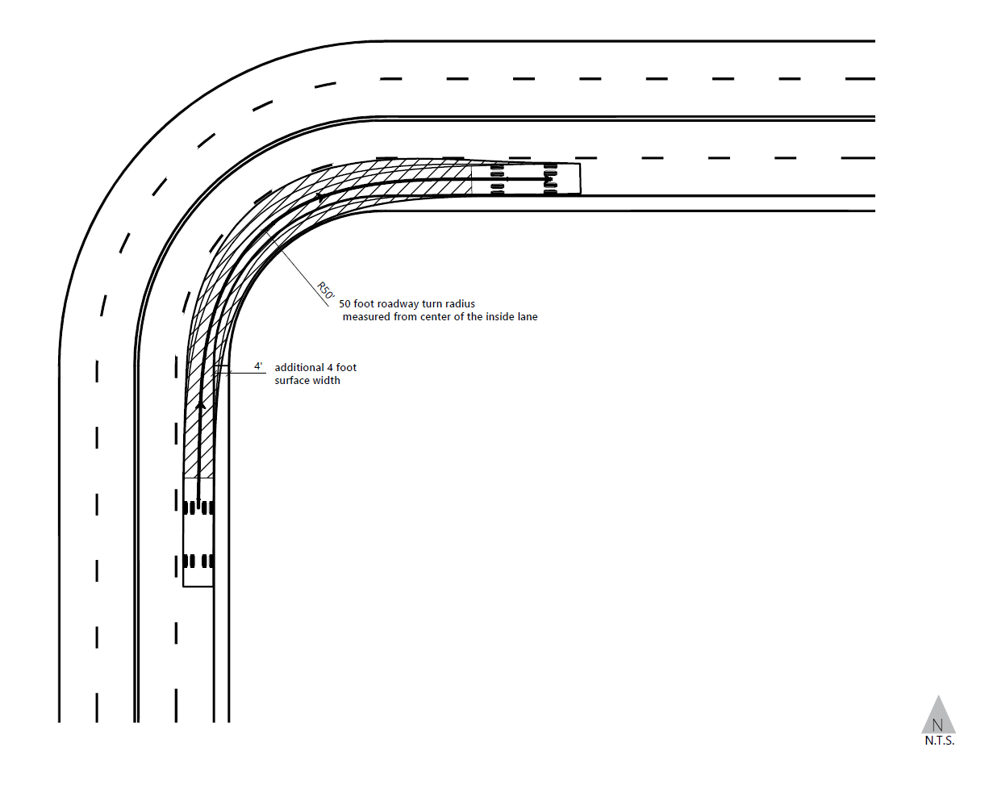

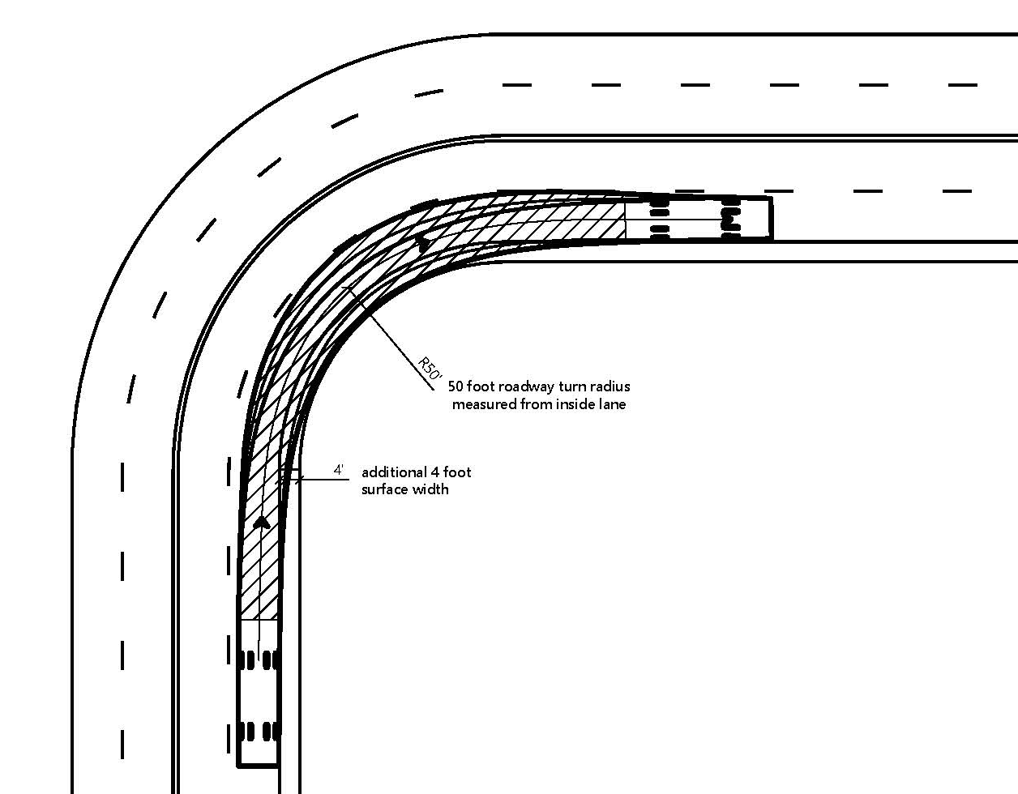

Figure 1
Effective Turning Radius for Horizontal Curvature with 50 Foot Radius

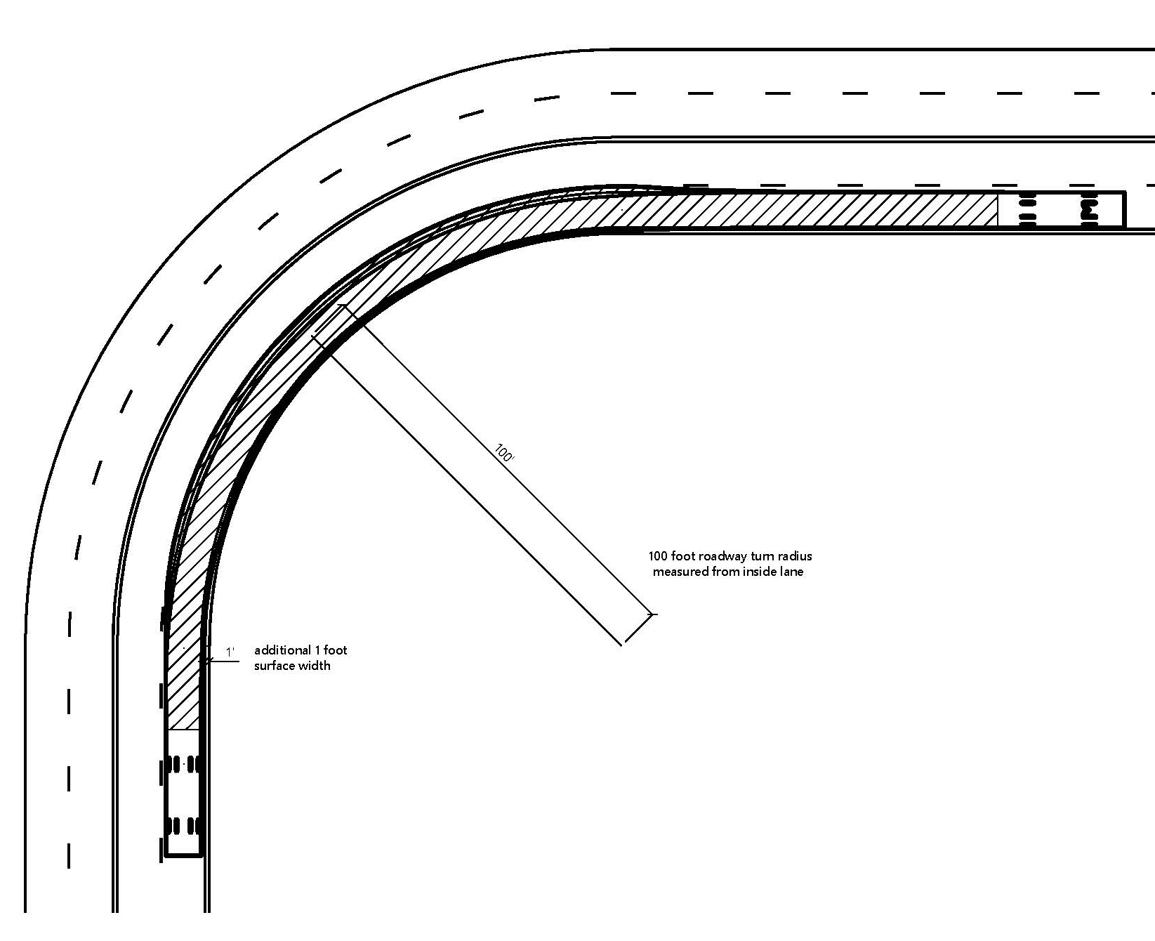
Figure 2
Effective Turning Radius for Horizontal Curvature with 100 Foot Radius

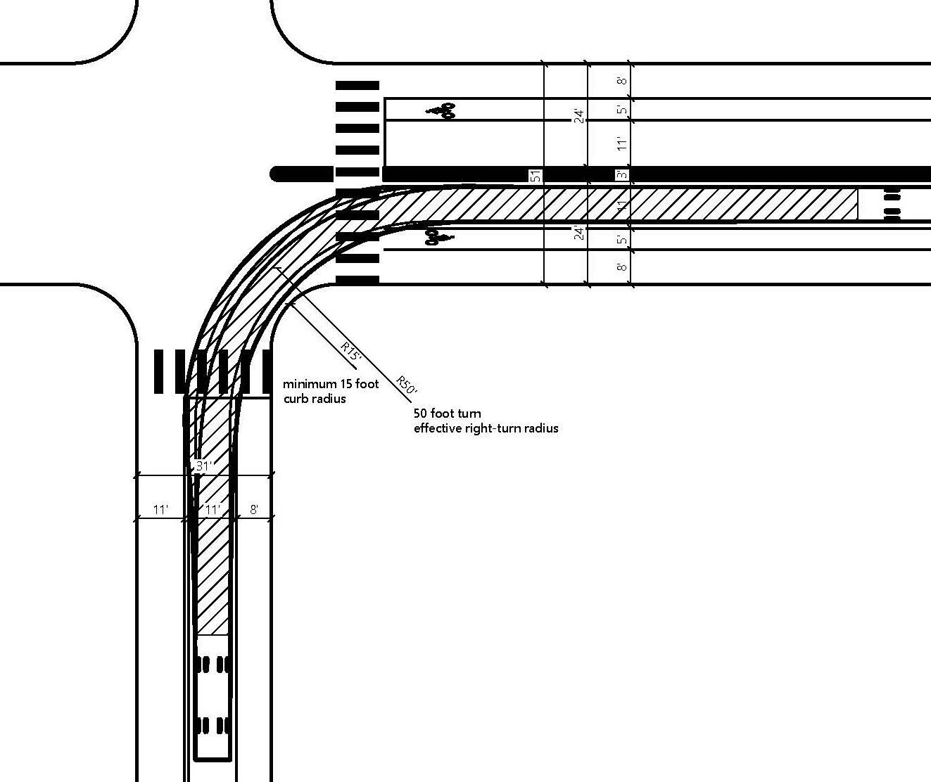
Figure 3
Effective Turning Radius for Intersections with Bike Lanes or Parking
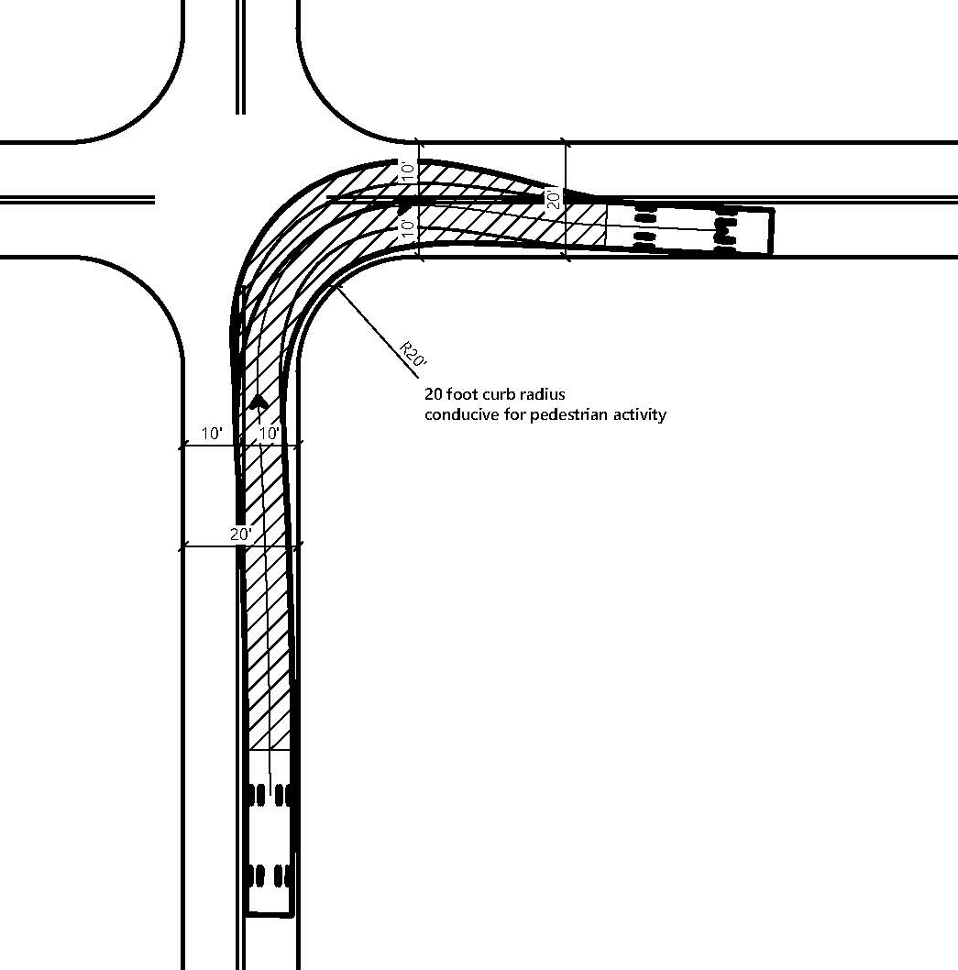
Figure 4
Effective Turning Radius for 20 Foot Wide Road Intersection

(a) All roads shall be constructed to provide a minimum of two ten (10) foot traffic lanes, not including shoulder and striping. These traffic lanes shall provide for two-way traffic flow to support emergency vehicle and civilian egress, unless other standards are provided in this article or additional requirements are mandated by Local Jurisdictions or local subdivision requirements. Vertical clearances shall conform to the requirements in California Vehicle Code section 35250.
(b) All one-way roads shall be constructed to provide a minimum of one twelve (12) foot traffic lane, not including shoulders. The Local Jurisdiction may approve one-way roads.
(1) All one-way roads shall, at both ends, connect to a road with two traffic lanes providing for travel in different directions, and shall provide access to an area currently zoned for no more than ten (10) residential units.
(2) In no case shall a one-way road exceed 2,640 feet in length. A turnout shall be placed and constructed at approximately the midpoint of each one-way road.
(c) All driveways shall be constructed to provide a minimum of one (1) ten (10) foot traffic lane, fourteen (14) feet unobstructed horizontal clearance, and unobstructed vertical clearance of thirteen feet, six inches (13' 6”).
Note: Authority cited: Section 4290, Public Resources Code. Reference: Sections 4290 and 4291, Public Resources Code.

§ 1273.02. Road and Driveway Surfaces.
(a) Roads and appurtenant driving surfaces that supplement the Traffic Lane shall be designed and maintained to support the imposed load of fFire aApparatus weighing at least 75,000 pounds., and provide an aggregate base. The surface material of the Road shall be non-erodible (including, but not limited to, a binding agent, gravel, lime slurry, or pavement) and designed to support the required weight at all times, including during saturated soil conditions.
(b) Driveways and and appurtenant driving surfaces that supplement the Driveway road and driveway structures shall be designed and maintained to support at least 36,0000 40,000 pounds.
(c) The Pproject proponent shall provide certified engineered engineering specifications to support the Road or Driveway design, if requested by the AHJ lLocal authority having jJurisdiction.
Note: Authority cited: Section 4290, Public Resources Code. Reference: Sections 4290 and 4291, Public Resources Code.

§ 1273.03. Bridges or Elevated Structures on Roads and Driveways. Grades.
(a) Signing in conformance with the requirements in Article 3 (Signing and Building Numbering), shall reflect the capability of each New bridge or elevated structure, including but not limited to weight or vertical clearance limitations, one-way road or single Traffic Lane conditions, or bridge weight rating limits.
(b) New Bridges and elevated structures shall be designed and constructed to accommodate a gross vehicle weight rating of 75,000 pounds. If an Existing Bridge or elevated structure provides Access to Building Construction, Vvehicle load limits shall be posted at both entrances to bridges when the weight rating is less than 75,000 pounds.
(1) Bridges or elevated structures may support a maximum weight of less than 75,000 pounds if the Fire Authority verifies that the Fire Apparatus most likely to be used will be under the maximum load weight of the bridge.
(2) If the bridge or elevated structure is designed for a lower weight, then it shall be identified through signing as required in Article 3 (Signing and Building Numbering). In no case shall the bridge or elevated structure be designed to support a weight below 36,000 pounds.
(c)(3) American Association of State Highway and Transportation Officials (AASHTO) Standard Specifications for Highway Bridges, 17th Edition, published 2002 (known as AASHTO HB-17), hereby incorporated by reference, may be used to confirm that a New bridge or elevated structure meets the weight rating of 75,000 pounds if the bridge or elevated structure is in lieu of total vehicle weight if bridges and elevated structures are designed and certified by a Professional Engineer, as described within the Professional Engineers Act (Chapter 7 of Division 3 of the Business and Professions Code).
(cd) Where elevated structures surfaces designed for Fire Apparatus use are adjacent to surfaces which are not designed for such use, barriers, signs, and/or other distinguishing features, as approved by the AHJ Local Jurisdiction, shall be installed and maintained.
(de) Notwithstanding the above requirements, a bridge or elevated structure with only one Traffic Lane satisfies the requirements of this section so long as it provides for unobstructed visibility from one end to the other and Turnouts at both ends. Bridges or elevated structures with only one Traffic Lane shall be consistent with requirements outlined in § 1273.05 (Road and Driveway Traffic Lane Width and Clear Width).
(ef) New Bridges and elevated structures shall be constructed of non-combustible materials.
(a) At no point shall the grade for all roads and driveways exceed 16 percent.
(b) The grade may exceed 16%, not to exceed 20%, with approval from the local authority having jurisdiction and with mitigations to provide for same practical effect.
Note: Authority cited: Section 4290, Public Resources Code. Reference: Sections 4290 and 4291, Public Resources Code.

§ 1273.04. Road and Driveway Grades. Radius.
(a) The grades for all New Roads and New Driveways shall not exceed sixteen (16) percent.
(b) Notwithstanding subsection (a), Road or Driveway grades of 16 to 20 percent satisfy the requirements of this section if the New Road or New Driveway has been treated to prevent slippage (including, but not limited to, aggregate treatments, binding agents, and/or paving) and scraping.
(c) Grade transitions on New Roads and New Driveways shall be constructed and designed to accommodate maximum approach and departure angles of twelve (12) degrees.
(a) No road or road structure shall have a horizontal inside radius of curvature of less than fifty (50) feet. An additional surface width of four (4) feet shall be added to curves of 50-100 feet radius; two (2) feet to those from 100-200 feet.
(b) The length of vertical curves in roadways, exclusive of gutters, ditches, and drainage structures designed to hold or divert water, shall be not less than one hundred (100) feet.
Note: Authority cited: Section 4290, Public Resources Code. Reference: Sections 4290 and 4291, Public Resources Code.

§ 1273.05. Road and Driveway Traffic Lane Width and Clear Width Turnarounds.
(a) All New bidirectional Roads shall provide a minimum of two ten (10) foot Traffic Lanes, not including Shoulders or striping. Where topographic or other limitations require the two Traffic Lanes to be constructed non-adjacently, each Traffic Lane shall provide a minimum of twelve (12) feet.
(b) New bidirectional Roads with a center median shall maintain a Clear Width of 20 feet on either side of the median. This Clear Width may include bike lanes, Shoulders, or flexible barriers used as traffic calming devices or to delineate a bicycle facility, or for other uses.
(c) All New One-way Roads shall provide a minimum of one twelve (12) foot Traffic Lane. New one-way Roads shall maintain a Clear Width of 20 feet. This Clear Width may include bike lanes, Shoulders, or flexible barriers used as traffic calming devices or to delineate a bicycle facility, or for other uses.
(c) One-way Roads shall maintain a Clear Width of 20 feet. Bidirectional Roads with a center median shall maintain a Clear Width of 20 feet on either side of the median. This Clear Width may include bike lanes, Shoulders, or flexible barriers used as traffic calming devices or to delineate a bicycle facility, or for other uses.
(d) All New Driveways shall be constructed to provide a minimum of one (1) ten (10) foot Traffic Lane, and fourteen (14) feet Clear Width, and unobstructed Vertical Clearance of thirteen feet, six inches (13' 6”).
(a) Turnarounds are required on driveways and dead-end roads.
(b) The minimum turning radius for a turnaround shall be forty (40) feet, not including parking, in accordance with the figures in 14 CCR §§ 1273.05(e) and 1273.05(f). If a hammerhead/T is used instead, the top of the “T” shall be a minimum of sixty (60) feet in length.
(c) Driveways exceeding 150 feet in length, but less than 800 feet in length, shall provide a turnout near the midpoint of the driveway. Where the driveway exceeds 800 feet, turnouts shall be provided no more than 400 feet apart.
(d) A turnaround shall be provided on driveways over 300 feet in length and shall be within fifty (50) feet of the Building.
(d) Each dead-end road shall have a turnaround constructed at its terminus. Where parcels are zoned five (5) acres or larger, turnarounds shall be provided at a maximum of 1,320 foot intervals.
(e) Figure A. Turnarounds on roads with two ten-foot traffic lanes.
Figure A/Image 1 is a visual representation of paragraph (b).
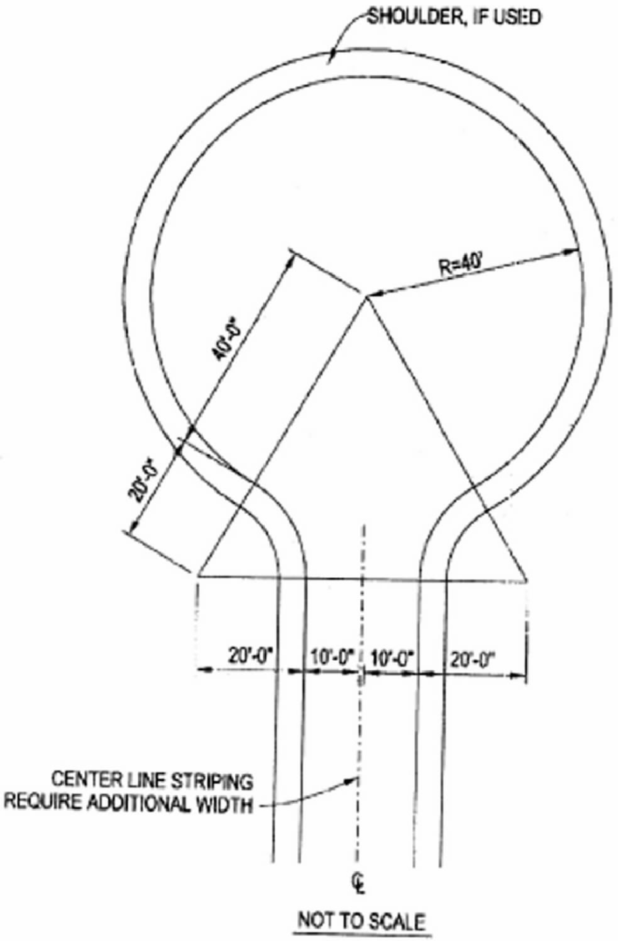

Note: Authority cited: Section 4290, Public Resources Code. Reference: Sections 4290 and 4291, Public Resources Code.

§ 1273.06 Road and Driveway Vertical Clearances Turnouts
Roads and Driveways shall provide for a minimum of thirteen feet and six inches (13’ 6”) of unobstructed Vertical Clearance.
Turnouts shall be a minimum of twelve (12) feet wide and thirty (30) feet long with a minimum twenty-five (25) foot taper on each end.
Note: Authority cited: Section 4290, Public Resources Code. Reference: Sections 4290 and 4291, Public Resources Code.

§ 1273.07 Maximum Lengths of New One-Way Roads Road and Driveway Structures
(a) In no case shall a New One-Way Road exceed 2,640 feet in length.
(a) Appropriate signing, including but not limited to weight or vertical clearance limitations, one-way road or single traffic lane conditions, shall reflect the capability of each bridge.
(b) Where a bridge or an elevated surface is part of a fire apparatus access road, the bridge shall be constructed and maintained in accordance with the American Association of State and Highway Transportation Officials Standard Specifications for Highway Bridges, 17th Edition, published 2002 (known as AASHTO HB-17), hereby incorporated by reference. Bridges and elevated surfaces shall be designed for a live load sufficient to carry the imposed loads of fire apparatus. Vehicle load limits shall be posted at both entrances to bridges when required by the local authority having jurisdiction.
(c) Where elevated surfaces designed for emergency vehicle use are adjacent to surfaces which are not designed for such use, barriers, or signs, or both, as approved by the local authority having jurisdiction, shall be installed and maintained.
(d) A bridge with only one traffic lane may be authorized by the local jurisdiction; however, it shall provide for unobstructed visibility from one end to the other and turnouts at both ends.
Note: Authority cited: Section 4290, Public Resources Code. Reference: Sections 4290 and 4291, Public Resources Code.

§ 1273.08 Maximum Lengths of New Dead-end Roads
(a) The maximum length of a New Ddead-end Rroad, including all dead-end roads accessed from that dead-end road, shall not exceed the following cumulative lengths, regardless of the number of parcels served:
(1) for New Roads with parcels zoned for less than not to exceed one (1) acre - 800 feet;
(2) for New Roads with parcels zoned for 1 acre up to 4.99 acres - 1,320 feet;
(3) for New Roads with parcels zoned for 5 acres to 19.99 or larger - 2,640 feet.
parcels zoned for 20 acres or larger - 5,280 feet
All lengths shall be measured from the edge of the road surface at the intersection that begins the road to the end of the road surface at its farthest point. Where a dead-end road crosses areas of differing zoned parcel sizes requiring different length limits, the shortest allowable length shall apply.
(b) All New Dead-end Roads shall meet the Turnaround requirements in § 1273.10 (Road and Driveway Turnarounds). See 14 CCR § 1273.05 for dead-end road turnaround requirements.
(c) All New Dead-end Roads shall meet the width requirements in § 1273.05 (Road and Driveway Traffic Lane Width and Clear Width).
(d) Each New Dead-end Road shall be connected either:
(1) directly to a through Road (a Road that is connected to other Roads at both ends); or
(2) an Existing Dead-end Road constructed prior to July 1, 2022.
(e) The length of New Dead-end Roads shall be measured from the center line of the through Road it connects to, to the terminus of the Dead-end Road at its farthest point.
(f) Where a New Dead-end Road provides access to differing zoned parcel sizes requiring different length limits, the shortest allowable length shall apply.
Note: Authority cited: Section 4290, Public Resources Code. Reference: Sections 4290 and 4291, Public Resources Code.

§ 1273.09 Road and Driveway Turnouts Gate Entrances
(a) Turnouts shall be a minimum of twelve (12) feet wide from the shoulder stripe, twenty-two (22) feet long with a minimum twenty-five (25) foot taper on each end and be facilitated outside of the Traffic Lane to accommodate one passenger vehicle as illustrated on Figure 5.
(b) On One-way Roads and Dead-end Roads over 400 feet in length, a Turnout shall be located at approximately the midpoint of the Road, in addition to any other Turnouts Required.
(c) Turnouts shall be provided no more than 400 feet apart on One-way Roads or on Roads that do not meet the width requirements.
(d) Driveways that are less than 20 feet wide and exceed 150 feet in length shall require a Turnout.
(e) Driveways greater than 150 feet in length and less than 800 feet in length shall provide a Turnout near the midpoint of the Driveway.
(f) Where the Driveway exceeds 800 feet, Turnouts shall be provided no more than 400 feet apart.
(g) No parking, obstructions, or storage of any material shall be allowed within Turnouts.

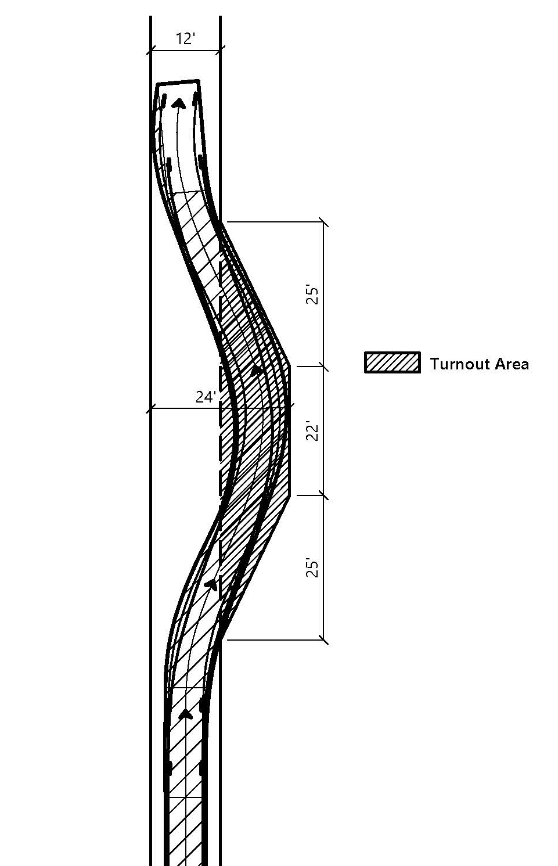

Figure 5
Turnout Dimensions

(a) Gate entrances shall be at least two (2) feet wider than the width of the traffic lane(s) serving that gate and a minimum width of fourteen (14) feet unobstructed horizontal clearance and unobstructed vertical clearance of thirteen feet, six inches (13' 6”).
(b) All gates providing access from a road to a driveway shall be located at least thirty (30) feet from the roadway and shall open to allow a vehicle to stop without obstructing traffic on that road.
(c) Where a one-way road with a single traffic lane provides access to a gated entrance, a forty (40) foot turning radius shall be used.
(d) Security gates shall not be installed without approval. Where security gates are installed, they shall have an approved means of emergency operation. Approval shall be by the local authority having jurisdiction. The security gates and the emergency operation shall be maintained operational at all times.
Note: Authority cited: Section 4290, Public Resources Code. Reference: Sections 4290 and 4291, Public Resources Code.

§ 1273.10 Road and Driveway Turnarounds
(a) Each Dead-end Road shall have a Turnaround constructed at its terminus. Where a Dead-end Road crosses parcels zoned for five (5) acres or larger, a Turnaround shall also be provided halfway along the Dead-end Road.
(b) A Turnaround shall be provided on Driveways over 300 feet in length and shall be within fifty (50) feet of the Building.
(c) A Turnaround shall meet one all of the following requirements in subsections (d), (e), and (f), and shall be in accordance with Figures 6.1, 6.2, or 6.3.
(d) Turnarounds with a radius smaller than 40 feet, shown in Figures 6.2 and 6.3 below, may be approved by the AHJ Local Jurisdiction when physical constraints prohibit the ability to install a 40-foot Turnaround.
(e) The center of the Turnaround shall remain clear of vegetation or decorative elements.
(f) If a hammerhead/T is used instead, the top of the “T” shall be a minimum of sixty (60) feet in length.

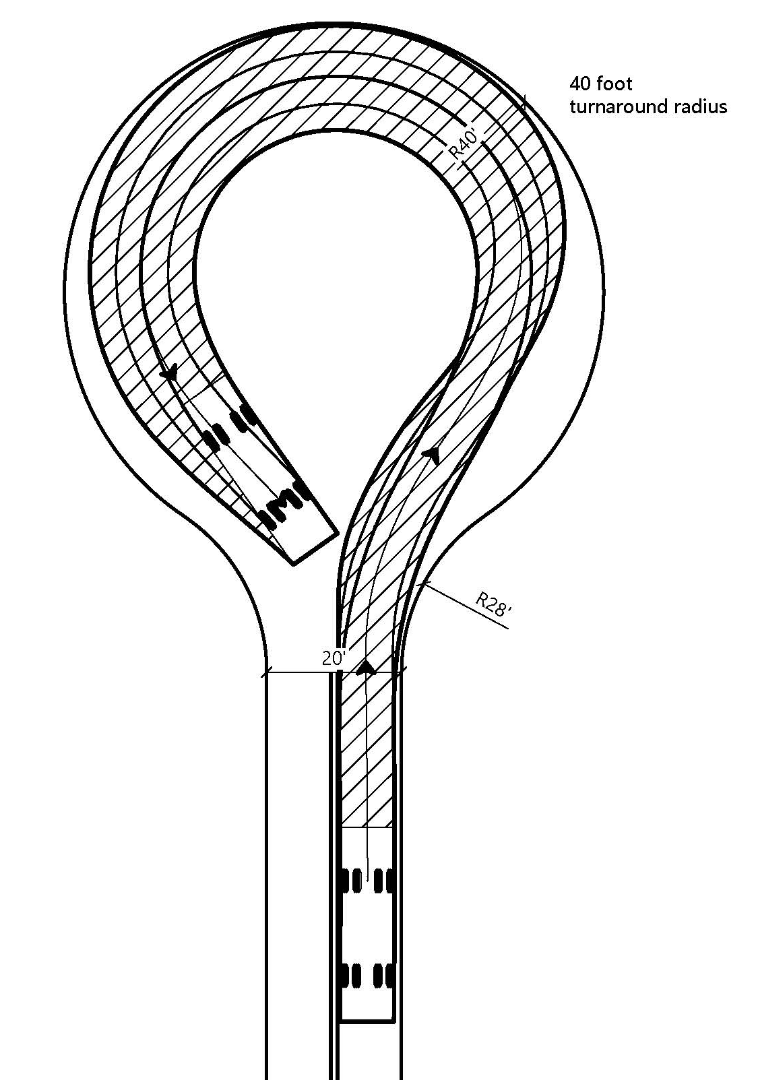
Figure 6.1
Turnarounds with 40-foot radius
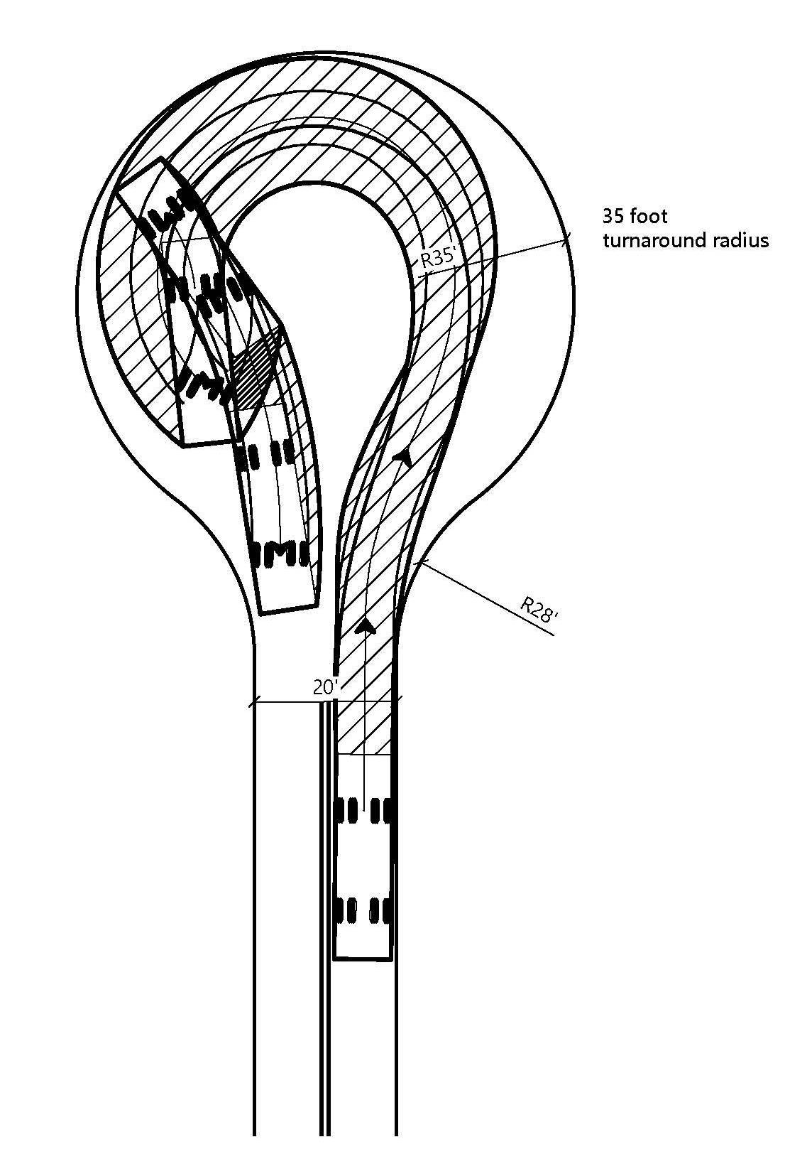

Figure 6.2
Turnarounds with 35-foot radius

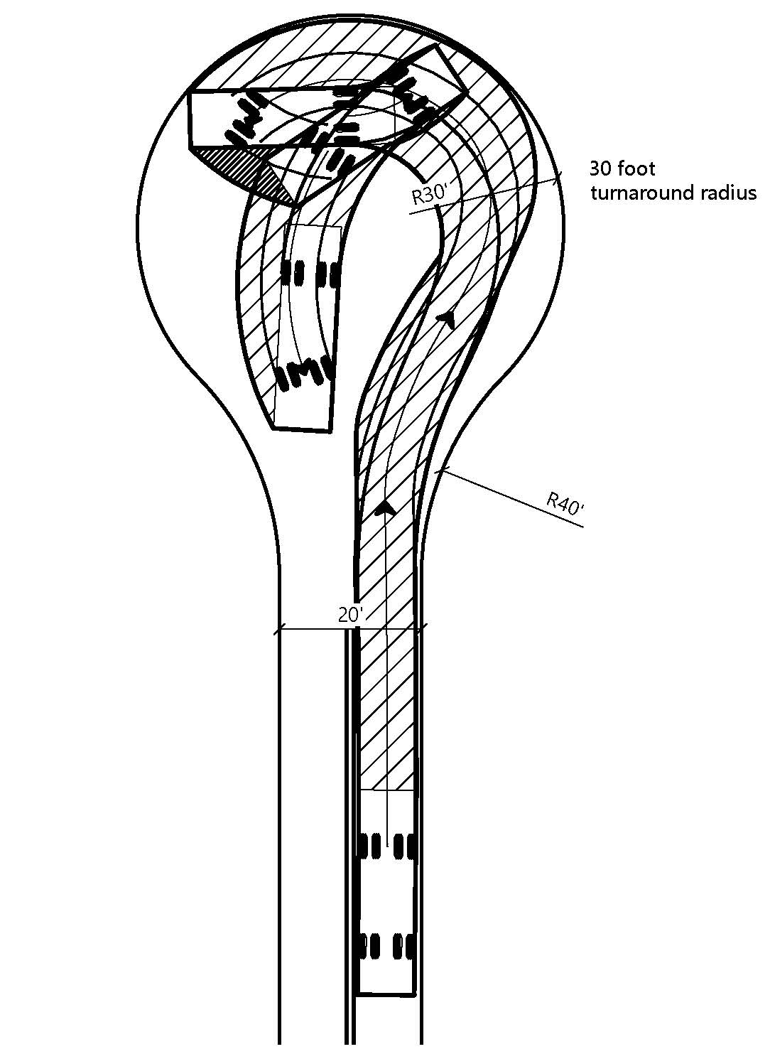
Figure 6.3
Turnarounds with 30-foot radius

Note: Authority cited: Section 4290, Public Resources Code. Reference: Sections 4290 and 4291, Public Resources Code.

§ 1273.11 Gates
(a) Gates shall have an approved means of emergency operation. Electronic gates shall have a manual method of opening in case of electronic failure. The manual method shall be maintained to be operational at all times.
(b) Gate entrances shall be at least two (2) feet wider than the width of the Road or Driveway, as shown in Figure 7 below. Where a gate is installed across an existing Road or Driveway, the gate shall be no less than ten (10) feet wide, with a minimum Clear Width of fourteen (14) feet and unobstructed Vertical Clearance of thirteen feet, six inches (13' 6”). Clearance shall be maintained at all times.
(c) Where a One-way Road with a single Traffic Lane leads to a gated entrance, a forty (40) foot turning radius shall be provided used as illustrated on Figure 7.
(d) All gates on a Driveway shall be located at least thirty (30) feet from the Road and shall either slide sideways or open to allow a vehicle to stop without stopping traffic on the Road, in direction of travel, in accordance with Figure 7.

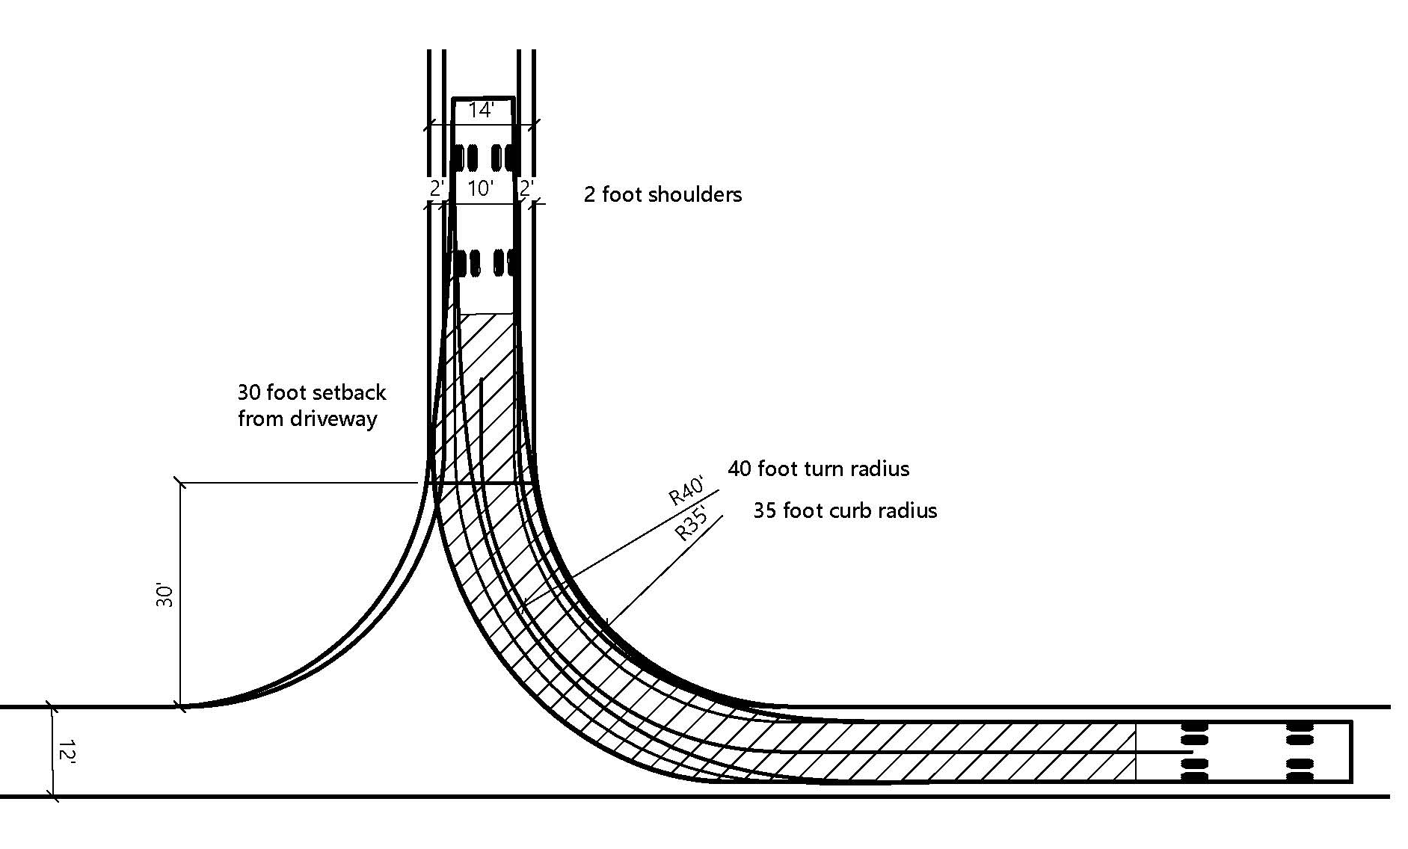
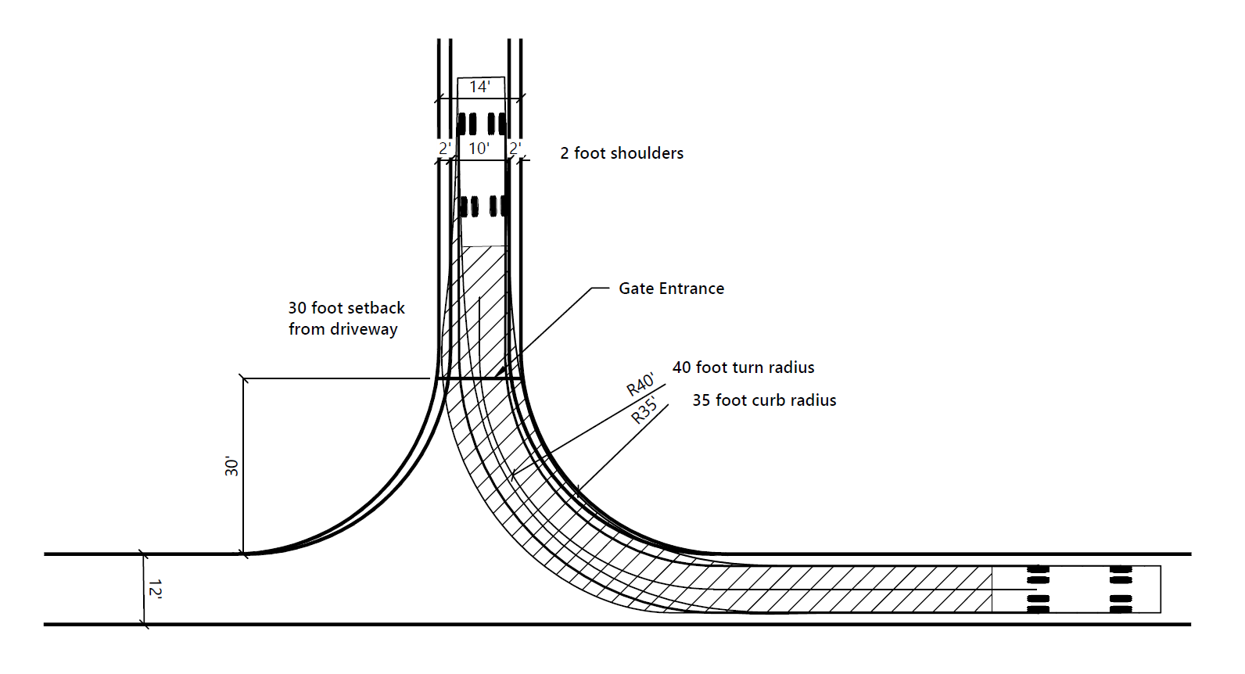
Figure 7
Effective Turn Radius for Gated Entrances/Driveways with Twelve Foot One-Way Main Road

Note: Authority cited: Section 4290, Public Resources Code. Reference: Sections 4290 and 4291, Public Resources Code.

§ 1273.12 Standards for Existing Roads
(a) Except as provided in subsections (b) and (d), Existing Roads that provide Access to New Building Construction along at least one route shall meet the following minimum requirements:
(1) One (1) fourteen (14) foot Traffic Lane;
(2) Surfacing which supports the imposed load of Fire Apparatus, subject to the standards set forth in § 1273.02. Native-surfacing for no more than 50% of the Road’s length; and
(3) Turnouts in compliance with § 1273.09 (Road and Driveway Turnouts), or maintains a twenty (20) foot Clear Width suitable to serve as a Traffic Lane for the length of the Road.
(b) Access to Buildings after a Wildfire shall provide for at least one (1) fourteen (14) foot Traffic Lane for a distance of at least twenty-two (22) feet at an interval of at least every 400 feet; provided, however, where such Traffic Lanes are not possible due to physical site limitations such as localized topography, slope stability or soil conditions, Access shall provide for locations for vehicles to pass each other at reasonable intervals.
(cb) Existing Roads providing Access to Buildings shall not exceed a grade of 25% over a distance of 500 linear feet.
(dc) An Existing Road with a secondary route in conformance with the conditions below § 1273.13 (Secondary Routes for Existing Roads) need not comply with subsections (a) or (b).
(1) Secondary routes shall meet the standards for New Roads in this Subchapter and shall provide for legal Access that serves as a typical travel way to and from the Building Construction. A secured secondary route shall meet the requirements in § 1273.11 (Gates).
(2)Secondary routes shall connect a user to an alternative route that would not be affected by a closure to the primary route, to the extent practicable.
Note: Authority cited: Section 4290, Public Resources Code. Reference: Sections 4290 and 4291, Public Resources Code, Section 51178 Government Code.

§ 1273.13 Secondary Routes for Existing Roads
(a) Secondary routes shall meet the standards for New Roads in this Subchapter and shall provide for legal and deeded Access that serves as a typical travel way to and from the Building construction. A secured secondary route shall meet the requirements in § 1273.11 (Gates).
(b) Secondary routes shall connect a user to an alternative route that would not be affected by a closure to the primary route, to the extent practicable.
Note: Authority cited: Section 4290, Public Resources Code. Reference: Sections 4290 and 4291, Public Resources Code.

Article 3. Signing and Building Numbering

§ 1274.00. Road Name Signs. Intent
(a) All Road signs shall conform to the requirements of the California Manual of Uniform Traffic Control Devices (CA MUTCD), hereby incorporated by reference.
(ba) New Roads shall be identified by a name or number through a consistent system that provides for sequenced or patterned numbering and non-duplicative naming within each Local Jurisdiction. This section does not require any entity to rename or renumber existing roads.
(cb) The size of letters, numbers, and symbols for road signs shall be a minimum four (4) inch letter height, half inch (.5) inch stroke, reflectorized, contrasting with the background color of the sign.
To facilitate locating a fire and to avoid delays in response, all newly constructed or approved roads and Buildings shall be designated by names or numbers posted on signs clearly visible and legible from the road. This section shall not restrict the size of letters or numbers appearing on road signs for other purposes.
Note: Authority cited: Section 4290, Public Resources Code. Reference: Sections 4290 and 4291, Public Resources Code.

§ 1274.01. Road Signs Installation, Location, and Visibility.
(a) All Road signs shall conform to the requirements of the California Manual of Uniform Traffic Control Devices (CA MUTCD), hereby incorporated by reference.
(b) Signs required by this article identifying intersecting roads shall be placed at the intersection of those roads.
(bc) A sign identifying traffic limitations, including but not limited to weight or Vertical Clearance limitations, Dead-end Roads, One-way Roads, or single lane Roads and bridges, shall be placed:
(1) at the intersection preceding the traffic limitation, and
(2) no more than one hundred (100) feet before such traffic limitation.
(cd) Road signs required by this article shall be posted at the beginning of construction and shall be maintained thereafter.
(de) Road signs shall meet the minimum sign retroreflectivity requirements in the CA MUTCD. Signs that are not required to meet the retroreflectivity requirements (e.g., blue or brown backgrounds) shall be retroreflective or illuminated to show the same shape and color by both day and night.
(a) Newly constructed or approved roads must be identified by a name or number through a consistent system that provides for sequenced or patterned numbering and/or non-duplicative naming within each local jurisdiction. This section does not require any entity to rename or renumber existing roads, nor shall a road providing access only to a single commercial or industrial occupancy require naming or numbering.
(b) The size of letters, numbers, and symbols for road signs shall be a minimum four (4) inch letter height, half inch (.5) inch stroke, reflectorized, contrasting with the background color of the sign.
Note: Authority cited: Section 4290, Public Resources Code. Reference: Sections 4290 and 4291, Public Resources Code.

§ 1274.02. Addresses for Buildings.
(a) All Buildings shall be issued an address by the AHJ Local Jurisdiction consistent with the standards in the California Fire Code, California Code of Regulations title 24, part 9.
(b) Addresses for residential Buildings shall be reflectorized.
(a) Road signs shall be visible and legible from both directions of vehicle travel for a distance of at least one hundred (100) feet.
(b) Signs required by this article identifying intersecting roads shall be placed at the intersection of those roads.
(c) A sign identifying traffic access or flow limitations, including but not limited to weight or vertical clearance limitations, dead-end roads, one-way roads, or single lane conditions, shall be placed:
(i) at the intersection preceding the traffic access limitation, and
(ii) no more than one hundred (100) feet before such traffic access limitation.
(d) Road signs required by this article shall be posted at the beginning of construction and shall be maintained thereafter.
Note: Authority cited: Section 4290, Public Resources Code. Reference: Sections 4290 and 4291, Public Resources Code.

§ 1274.03. Addresses for Buildings.
(a) All buildings shall be issued an address by the local jurisdiction which conforms to that jurisdiction's overall address system. Utility and miscellaneous Group U buildings are not required to have a separate address; however, each residential unit within a building shall be separately identified.
(b) The size of letters, numbers, and symbols for addresses shall conform to the standards in the California Fire Code, California Code of Regulations title 24, part 9.
(c) Addresses for residential buildings shall be reflectorized.
Note: Authority cited: Section 4290, Public Resources Code. Reference: Sections 4290 and 4291, Public Resources Code.

§ 1274.04. Address Installation, Location, and Visibility.
(a) All Buildings shall have a permanently posted address which shall be plainly legible and visible from the road fronting the property.
(b) Where access is by means of a private road and the address identification cannot be viewed from the public way, an unobstructed sign or other means shall be used so that the address is visible from the public way.
(c) Address signs along one-way roads shall be visible from both directions.
(d) Where multiple addresses are required at a single driveway, they shall be mounted on a single sign or post.
(e) Where a road provides access solely to a single commercial or industrial business, the address sign shall be placed at the nearest road intersection providing access to that site, or otherwise posted to provide for unobstructed visibility from that intersection.
(f) In all cases, the address shall be posted at the beginning of construction and shall be maintained thereafter.
Note: Authority cited: Section 4290, Public Resources Code. Reference: Sections 4290 and 4291, Public Resources Code.

Article 4. Water Supply. Emergency Water Standards

§ 1275.00. Application. Intent
(a) The provisions of this Article shall apply to Newly constructed water and wastewater facilities associated with New Building Construction. in the tentative and parcel map process when new parcels are approved by the Local Jurisdiction having authority, or when new Building construction is not already served by an existing water supply.
(b) The provisions of this Article These regulations shall not apply to eExisting water or wastewater facilities that are not newly constructed, or to the Repair of eExisting water or wastewater facilities that are repaired, reconstructed, or upgraded. For purposes of this subsection, "water and wastewater facilities" includes, but is not limited to, water storage tanks and reservoirs, pump stations, treatment facilities, regulator stations, Fire Hydrants, and similar water and wastewater system devices.
(c) Where a specific provision of code standard from the California Fire Code or of a National Fire Protection Association (NFPA) standard is referenced in this Article, the respective provisions of said code any sections of the California Fire Code or NFPA standards regarding alternative methods of compliance, equivalencies, or modifications to the specified provisions standards shall also apply.
Emergency water for Wildfire protection shall be available, accessible, and maintained in quantities and locations specified in the statute and these regulations in order to attack a Wildfire or defend property from a Wildfire.
Note: Authority cited: Section 4290, Public Resources Code. Reference: Sections 4290 and 4291, Public Resources Code.

§ 1275.01. Approved Water Supply. Application
(a) Water supply shall meet or exceed the California Fire Code, California Code of Regulations Title 24, Part 9.
(b) Where a Municipal-Type Water Supply is not available, the AHJ Local Jurisdiction shall utilize the National Fire Protection Association (NFPA) 1142, “Standard on Water Supplies for Suburban and Rural Fire Fighting,” 2022 2017 Edition, hereby incorporated by reference, as referenced in the California Fire Code, California Code of Regulations Title 24, Part 9, Appendix B and Appendix BB.
(c) All New Building Construction proposals Building construction shall include a water supply for structure defense. Such protection shall be serviceable prior to and during the time of construction, except when alternative methods of protection are provided and approved by the AHJ Local Jurisdiction.
(d) Nothing in this article prohibits the combined storage of Wildfire and structural firefighting water supplies unless so prohibited by local ordinance or specified by the AHJ Local Jurisdiction. Water supplies required under the California Fire Code, California Code of Regulations Title 24, Part 9, or other law or regulation may also be used to satisfy the requirements of this Article, so long as the full amount of water supply required by this article is provided.
(e) Where water systems are susceptible to freeze or crash, such protection measures shall be is required by the AHJ Local Jurisdiction., such protection measures shall be provided.
The provisions of this article shall apply in the tentative and parcel map process when new parcels are approved by the local jurisdiction having authority.
Note: Authority cited: Section 4290, Public Resources Code. Reference: Sections 4290 and 4291, Public Resources Code.

§ 1275.02. Identification of Water Sources. Water Supply.
(a) Fire Hydrants or water access located along a Driveway shall be identified by at least (1) reflectorized blue marker, with a minimum dimension of three (3) inches. This marker shall be mounted on a fire retardant sign post constructed of fire retardant material. The sign post shall be located and mounted as specified by the AHJ Fire Authority.
(b) Fire Hydrants or water access located along a Road shall be identified by one of the following marking standards, as specified by the AHJ:
(1) a reflectorized blue marker, with a minimum dimension of three (3) inches. This marker shall be mounted on a fire retardant sign post constructed of fire retardant material. The sign post shall be within three (3) feet of the Fire Hydrant or water access. The sign shall be no fewer than three (3) nor greater than five (5) feet above ground, in a horizontal position, and visible from the Road, or as specified by the AHJ Fire Authority.
(2) a reflectorized blue marker secured to the center of the road pavement, as specified by the AHJ.
(a) When a water supply for structure defense is required to be installed, such protection shall be installed and made serviceable prior to and during the time of construction except when alternative methods of protection are provided and approved by the local authority having jurisdiction.
(b) Water systems equaling or exceeding the California Fire Code, California Code of Regulations title 24, part 9, or, where a municipal-type water supply is unavailable, National Fire Protection Association (NFPA) 1142, “Standard on Water Supplies for Suburban and Rural Fire Fighting,” 2017 Edition, hereby incorporated by reference, shall be accepted as meeting the requirements of this article.
(c) Such emergency water may be provided in a fire agency mobile water tender, or naturally occurring or man made containment structure, as long as the specified quantity is immediately available.
(d) Nothing in this article prohibits the combined storage of emergency Wildfire and structural firefighting water supplies unless so prohibited by local ordinance or specified by the local fire agency.
(e) Where freeze or crash protection is required by Local Jurisdictions having authority, such protection measures shall be provided.
Note: Authority cited: Section 4290, Public Resources Code. Reference: Sections 4290 and 4291, Public Resources Code.

§ 1275.03. Secured Water Sources. Hydrants and Fire Valves.
Break away locks or similar systems shall be approved by the AHJ Local Jurisdiction and shall provide fire fighters with access to any water connections, valves, or controls that are normally secured by gates, doors, or other locking systems.
(a) The hydrant or fire valve shall be eighteen (18) inches above the finished surface. Its location in relation to the road or driveway and to the Building(s) or structure(s) it serves shall comply with California Fire Code, California Code of Regulations title 24, part 9, Chapter 5, and Appendix C.
(b) The hydrant head shall be a two and half (2 1/2) inch National Hose male thread with cap for pressure and gravity flow systems and four and a half (4 1/2) inch for draft systems.
(c) Hydrants shall be wet or dry barrel and have suitable freeze or crash protection as required by the Local Jurisdiction.
Note: Authority cited: Section 4290, Public Resources Code. Reference: Sections 4290 and 4291, Public Resources Code.

§ 1275.04. Municipal-Type Water System Hydrants. Signing of Water Sources
(a) The Municipal-Type Fire Hydrant valve stems and outlets shall be eighteen (18) inches above the Finished Gradefinished surface. Its location in relation to the Road or Driveway and to the Building(s) or structure(s) it serves shall comply with California Fire Code, California Code of Regulations Title 24, Part 9, Chapter 5, and Appendix C.
(b) The Municipal-Type Fire Hydrant shall be of sizes approved designated by the AHJ Local Jurisdiction, in consultation with the Fire Authority, and shall have male American National Fire Hose Screw Threads (NH).
(c) Where Municipal-Type water supply Fire Hydrant systems are not practical due to the absence of a Municipal-Type Water System, or other limiting factors, a performance-based water supply alternative approved by the AHJ Local Jurisdiction, in consultation with the Fire Authority, shall be designed and installed to meet the minimum fire flow water supply requirements of 250 gallons per minute (gpm) for two (2) hours.
(a) Each hydrant, fire valve, or access to water shall be identified as follows:
(1) if located along a driveway, a reflectorized blue marker, with a minimum dimension of three (3) inches shall be located on the driveway address sign and mounted on a fire retardant post, or
(2) if located along a road,
(i) a reflectorized blue marker, with a minimum dimension of three (3) inches, shall be mounted on a fire retardant post. The sign post shall be within three (3) feet of said hydrant or fire valve, with the sign no less than three (3) feet nor greater than five (5) feet above ground, in a horizontal position and visible from the driveway, or
(ii) as specified in the State Fire Marshal's Guidelines for Fire Hydrant Markings Along State Highways and Freeways, May 1988.
Note: Authority cited: Section 4290, Public Resources Code. Reference: Sections 4290 and 4291, Public Resources Code.

§ 1275.05. Dry Hydrants
When dry hydrants have been approved by the AHJ Local Jurisdiction, the requirements of NFPA 1142 (20222017) Chapter 8 (8.3, 8.4, 8.5, 8.6, 8.7 and 8.8), hereby incorporated by reference, shall be met.
Note: Authority cited: Section 4290, Public Resources Code. Reference: Sections 4290 and 4291, Public Resources Code.

§ 1275.06. Mobile Water Supply (Water Tenders)
(a) Fire flow water delivery systems that rely on mobile water supply (water tenders) shall only be permitted under either of the following conditions:
(1) During the construction phase of a new Building Construction Development, prior to the permanent fire water delivery system installation; or,
(2) After the construction phase of a new Building Construction, Wwhen the Local Jurisdiction determines that all other means of water supply is not practical.
(b) The mobile water supply shall, within five (5) minutes of the arrival of the first Fire Apparatus on-scene, be capable of providing the Fire Apparatus with a minimum of 250 gpm for a 2-hour duration.
(c) Mobile water supplies may use NFPA 1142 (20222017) Annex C, hereby incorporated by reference, to achieve minimum fire flow requirements.
Note: Authority cited: Section 4290, Public Resources Code. Reference: Sections 4290 and 4291, Public Resources Code.

§ 1275.07. Protection of Water Supply Infrastructure from Wildfire.
(a) All water supply infrastructure shall be protected from Wildfire radiant heat, convective heat, and embers by at least one of the following:
(1) underground burial; or
(2) construction of non-combustible materials, fittings and valves, such as concrete or metal; or
(3) maintenance of a 100-foot, slope-adjusted defensible space immediately surrounding the infrastructure; or
(4) placement within a Building constructed to the requirements of the California Building Code (California Code of Regulations Title 24, Part 2) Chapter 7A.
Note: Authority cited: Section 4290, Public Resources Code. Reference: Sections 4290 and 4291, Public Resources Code.

Article 5. Building Siting, Setbacks, and Fuel Modification Fuel Modification Standards

§ 1276.00. Applicability Intent
(a) All Building cConstruction shall comply with the following provisions of this Article:
(1) § 1276.01 (Building and Parcel Siting and Setbacks);
(2) § 1276.02(c) (Ridgelines); and
(3) § 1276.06 (Disposal of Flammable Vegetation and Fuels).
(b) The following provisions of this article shall further apply in the tentative and parcel map process for nNew parcels:
(1) § 1276.01 (Building and Parcel Siting and Setbacks);
(2) § 1276.02(c) (Ridgelines);
(3) § 1276.03 (Fuel Breaks);
(4) § 1276.04 (Greenbelts, Greenways, Open Spaces and Parks);
(5) § 1276.05 (Maintenance of Fuel Breaks); and
(6) § 1276.06 (Disposal of Flammable Vegetation and Fuels).
To reduce the intensity of a Wildfire by reducing the volume and density of flammable vegetation, the strategic siting of fuel modification and greenbelts shall provide for increased safety for emergency fire equipment and evacuating civilians by its utilization around structures and roads, including driveways, and a point of attack or defense from a Wildfire.
Note: Authority cited: Section 4290, Public Resources Code. Reference: Sections 4290 and 4291, Public Resources Code.

§ 1276.01. Building and Parcel Siting and Setbacks. Setback for Structure Defensible Space
(a) All parcels shall provide a minimum thirty (30) foot setback for all Bbuildings from all property lines and/or the center of a Rroad, except as provided for in subsection (b).
(b) A reduction in the minimum setback shall be based upon When a thirty (30) foot setback is not possible for practical reasons, which may include but are not limited to, parcel dimensions or size; topographic limitations; dDevelopment density requirements or other dDevelopment patterns that promote low-carbon emission outcomes; sensitive habitat; or other site constraints easements, and shall provide for an alternative method to reduce Structure-to-Structure ignition by incorporating features such as, but not limited to:
Same practical effect options may include, but are not limited to: (1) non-combustible block walls or fences; or
(2) five (5) feet of non-combustible material extending five (5) feet horizontally from the furthest extent of the Building; or
(3) installing hardscape landscaping or reducing a reduction of exposed windows on the side of the sStructure with a less than thirty (30) foot setback; or
(4) the most protective additional structure hardening that exceeds the requirements in the California Building Code, California Code of Regulations Title 24, Part 2, Chapter 7A, as requested by the AHJ.
Note: Authority cited: Section 4290, Public Resources Code. Reference: Sections 4290 and 4291, Public Resources Code.

§ 1276.02. Ridgelines. Maintenance of Defensible Space Measures.
(a) The AHJ Local Jurisdiction shall identify sStrategic Ridgelines, if any, in consultation with the Fire Authority. Strategic Ridgelines shall be identified through an assessment of the following factors:
(1) Topography;
(2) Vegetation;
(3) Proximity to any existing or proposed residential, commercial, or industrial land uses;
(4) Ability to support effective fire suppression; and
(5) Other factors, if any, deemed relevant by the AHJ Local Jurisdiction and Fire Authority.
(b) Preservation of Undeveloped Ridgelines identified as strategically important shall be required.
(c) New Buildings Residential Units on Undeveloped Ridgelines identified as strategically important are prohibited, as described in subsections (c)(1) and (c)(2).
(1) New Residential Units are prohibited within or at the top of drainages or other topographic features common to Ridgelines that act as chimneys to funnel convective heat from Wildfires.
(2) Nothing in this subsection shall be construed to alter the extent to which Structures, Buildings, or Development other than Residential Units Buildings, such as but not limited to Utility and Miscellaneous Group U Structures, may be constructed on Undeveloped Ridgelines.
(d) The AHJ Local Jurisdiction may implement further specific requirements to preserve Undeveloped Ridgelines.
To ensure continued maintenance of commonly owned properties in conformance with these standards and to assure continued availability, access, and utilization of the defensible space provided by these standards during a wildfire, provisions for annual maintenance shall be provided in emergency access covenants or similar binding agreements.
Note: Authority cited: Section 4290, Public Resources Code. Reference: Sections 4290 and 4291, Public Resources Code.

§ 1276.03. Fuel Breaks Disposal of Flammable Vegetation and Fuels.
(a) When Building cConstruction meets the following criteria, the AHJ Local Jurisdiction shall determine the need and location for Fuel Breaks in consultation with the Fire Authority:
(1) the permitting or approval of three (3) or more new parcels, excluding lot line adjustments as specified in Government Code (GC) section 66412(d); or
(2) an application for a change of zoning increasing zoning intensity or density; or
(3) an application for a change in use permit increasing use intensity or density.
(b) Fuel Breaks required by the AHJ Local Jurisdiction shall be located, designed, and maintained in a condition that reduces the potential of damaging radiant and convective heat or ember exposure to Access routes, Buildings, or infrastructure within the Development.
(c) Fuel Breaks shall have, at a minimum, one point of entry for fire fighters and any Fire Apparatus. The specific number of entry points and entry requirements shall be determined by the AHJ.
(d) Fuel Breaks may be required at locations such as, but not limited to:
(1) Directly adjacent to Defensible Space to reduce radiant and convective heat exposure, ember impacts, or support fire suppression tactics;
(2) Directly adjacent to Roads to manage radiant and convective heat exposure or ember impacts, increase evacuation safety, or support fire suppression tactics;
(3) Directly adjacent to a Hazardous Land Use to limit the spread of fire from such uses, reduce radiant and convective heat exposure, or support fire suppression tactics;
(4) Strategically located along Ridgelines, in Greenbelts, or other locations to reduce radiant and convective heat exposure, ember impacts, or support community level fire suppression tactics.
(de) Fuel Breaks shall be completed prior to the commencement of any permitted construction.
(ef) Fuel Breaks shall be constructed using the most ecologically and site appropriate treatment option, such as, but not limited to, prescribed burning, manual treatment, mechanical treatment, prescribed herbivory, and targeted ground application of herbicides.
(g) Where an AHJ requires Fuel Breaks, maintenance mechanisms shall be established to ensure the fire behavior objectives and thresholds are maintained over time.
(h) The mechanisms required shall be binding upon the property for which the Fuel Break is established, shall ensure adequate maintenance levels, and may include written legal agreements; permanent fees, taxes, or assessments; assessments through a homeowners’ association; or other funding mechanisms.
(f) Fuel Breaks shall have, at a minimum, one point of entry for fire fighters and any Fire Apparatus. The specific number of entry points and entry requirements shall be determined by the Local Jurisdiction in consultation with the Fire Authority.
Disposal, including chipping, burying, burning or removal to a site approved by the local jurisdiction, of flammable vegetation and fuels caused by site development and construction, road and driveway construction, and fuel modification shall be completed prior to completion of road construction or final inspection of a building permit.
Note: Authority cited: Section 4290, Public Resources Code. Reference: Sections 4290 and 4291, Public Resources Code.

§ 1276.04. Greenbelts, Greenways, Open Spaces and Parks Greenbelts
(a) Where a Greenbelt, Greenway, open space, park, landscaped or natural area, or portions thereof, is intended to serve as a Fuel Break as part of a New Building Construction proposal, the space or relevant portion thereof shall conform with the requirements in § 1276.03 (Fuel Breaks).
(b) An AHJ Local Jurisdictions may require Greenbelts or Greenways, or portions thereof, or other open areas for the purpose of providing potential areas of refuge for the public or firefighters or other values as a last resort, if safe evacuation is not practicable.
Subdivision and other developments, which propose greenbelts as a part of the development plan, shall locate said greenbelts strategically as a separation between wildland fuels and structures. The locations shall be approved by the local authority having jurisdiction and may be consistent with the CAL FIRE Unit Fire Management Plan or Contract County Fire Plan.
Note: Authority cited: Section 4290, Public Resources Code. Reference: Sections 4290 and 4291, Public Resources Code.

§ 1276.05. Maintenance of Fuel Breaks
(a) Where a Local Jurisdiction requires Fuel Breaks pursuant to § 1276.03 (Fuel Breaks), maintenance mechanisms shall be established to ensure the fire behavior objectives and thresholds are maintained over time.
(b) The mechanisms required shall be binding upon the property for which the Fuel Break is established, shall ensure adequate maintenance levels, and may include written legal agreements; permanent fees, taxes, or assessments; assessments through a homeowners’ association; or other funding mechanisms.
Note: Authority cited: Section 4290, Public Resources Code. Reference: Sections 4290 and 4291, Public Resources Code.

§ 1276.065 Disposal of Flammable Vegetation and Fuels
The disposal, including burning or removal to a site approved by the AHJ Local Jurisdiction, of flammable vegetation and fuels caused by site development and construction, road and driveway construction shall be in accordance with all applicable laws and regulations.
Note: Authority cited: Section 4290, Public Resources Code. Reference: Sections 4290 and 4291, Public Resources Code.

