Month, Date, Year

The Honorable [Tribal Contact Name, Title]
[Tribe]
[Address]
[City, CA Zip Code]

RE: Tribal Notification of Midpeninsula Regional Open Space Districts’ Vegetation Treatment Project at Bear Creek Redwoods Open Space Preserve

Dear [CONTACT NAME],

This is the Midpeninsula Regional Open Space Districts’ (Midpens’) formal consultation notice to [TRIBE], regarding the Bear Creek Redwoods Open Space Preserve Vegetation Treatment Project (project). The project is seeking California Environmental Quality Act (CEQA) compliance as later activities covered by the Program Environmental Impact Report (PEIR) for CAL FIRE’s California Vegetation Treatment Program (CalVTP), using its Project-Specific Analysis checklist; the CalVTP PEIR was certified in December 2019. Although consultation pursuant to Public Resources Code section 21080.3.1 was completed under the CalVTP PEIR, this notice serves to request additional information regarding potential impacts to tribal cultural resources from the proposed treatment actions, as required by CalVTP Standard Project Requirement CUL-2.
The project would implement vegetation treatments across 214.4 acres to improve habitat conditions and increase wildfire resiliency. The treatment types and treatment activities proposed under the current project are consistent with the certified CalVTP PEIR. The CalVTP treatment type that would be implemented in the project area is ecological restoration and treatment activities that would be used to implement the project include manual and mechanical treatments. Please see the enclosed map for the location of the proposed project.
Proposed CalVTP Treatment Type
Ecological Restoration. The proposed project would implement ecological restoration treatments for the dual purpose of wildfire risk reduction and enhancement of natural habitats. Consistent with the CalVTP ecological restoration treatment type, Midpen’s proposed ecological restoration treatments would seek to return the landscape closer to native conditions where natural fire processes can be reestablished and habitat quality can be improved, including controlling and eliminating non-native, invasive plants and excess buildup of fire fuel. Specific restoration objectives include: promoting forest health and resiliency by removing trees heavily impacted by sudden oak death (SOD), removing heavy brush and invasive species, and providing ecosystem and habitat improvements to increase fire resiliency and to support the success of a California rare plant species known to occur.
Proposed CalVTP Treatment Activities
Mechanical Vegetation Treatment. Mechanical treatments would occur on up to 205 of the 214.4 acres proposed for treatment and would primarily include skidding, mowing, and masticating target vegetation. Equipment would include tractors/skidders, slope mowers, and masticators. Generally, mechanical treatments would remove or masticate target brush and trees 8 inches diameter at breast height (dbh) or less; masticate downed woody debris less than 8 inches in diameter; maintain at least 35 percent relative final density of chaparral vegetation; and retain live oak trees, blue elderberry, California buckeye, big-leaf maple, and other desirable species as determined by Midpen (i.e., those associated with beneficial organisms and characteristic species for sensitive natural communities).
Manual Vegetation Treatment. Manual treatments would be implemented exclusively on 9.4 acres and could be used on up to 28.1 acres (i.e., where manual and mechanical treatments would be used in combination). To implement manual treatments, hand tools and hand-operated power tools including chainsaws, pull saws, and/or brushcutters would be used to cut, clear, or prune herbaceous and woody species. Activities would include tree thinning and removal; invasive plant removal, and heavy brush removal. The same general guidelines for tree and vegetation removal and retention would be followed as described above for mechanical treatments.
The proposed mechanical vegetation treatments described above would masticate (mulch) much of the vegetative debris and place it on the ground concurrently with vegetation removal. Additional biomass generated from the CalVTP treatments would primarily be disposed by chipping (95 percent of biomass). Chipped biomass would be spread over treatment areas and would not exceed 6 inches in thickness. The remaining biomass (approximately 5 percent) would be lopped and scattered within the Preserve.
Implementation of the proposed vegetation treatments would occur September through December in years 2021, 2022, and 2023. Treatment crews would consist of up to 20 personnel, but would typically range from 8 to 12 crew members, and up to three crews could be working simultaneously. Vehicles and equipment would access the treatment areas using existing Preserve seasonal roads and trails.
Midpen is the lead agency for the project. Please contact Midpen in writing at the email address or physical address below, within 30 days of your receipt of this notice, if your Tribe has any information or concerns related to the project that you would like to share. If standard mail is to be used, the letter must be postmarked with a date that is within 30 days of your receipt of this notice. Please be advised that the result of the Sacred Lands File query conducted through the Native American Heritage Commission on September 9, 2020, was negative.
Midpeninsula Regional Open Space District
Attn: Coty Sifuentes-Winter, Project Manager
c/o: Lily Bostrom, Ascent Environmental
455 Capitol Mall, Suite 300
Sacramento, CA 95814
Email: csifuentes@openspace.org

Sincerely,

Coty Sifuentes-Winter
Project Manager
Midpeninsula Regional Open Space District

Enclosed: Map of the Proposed Project

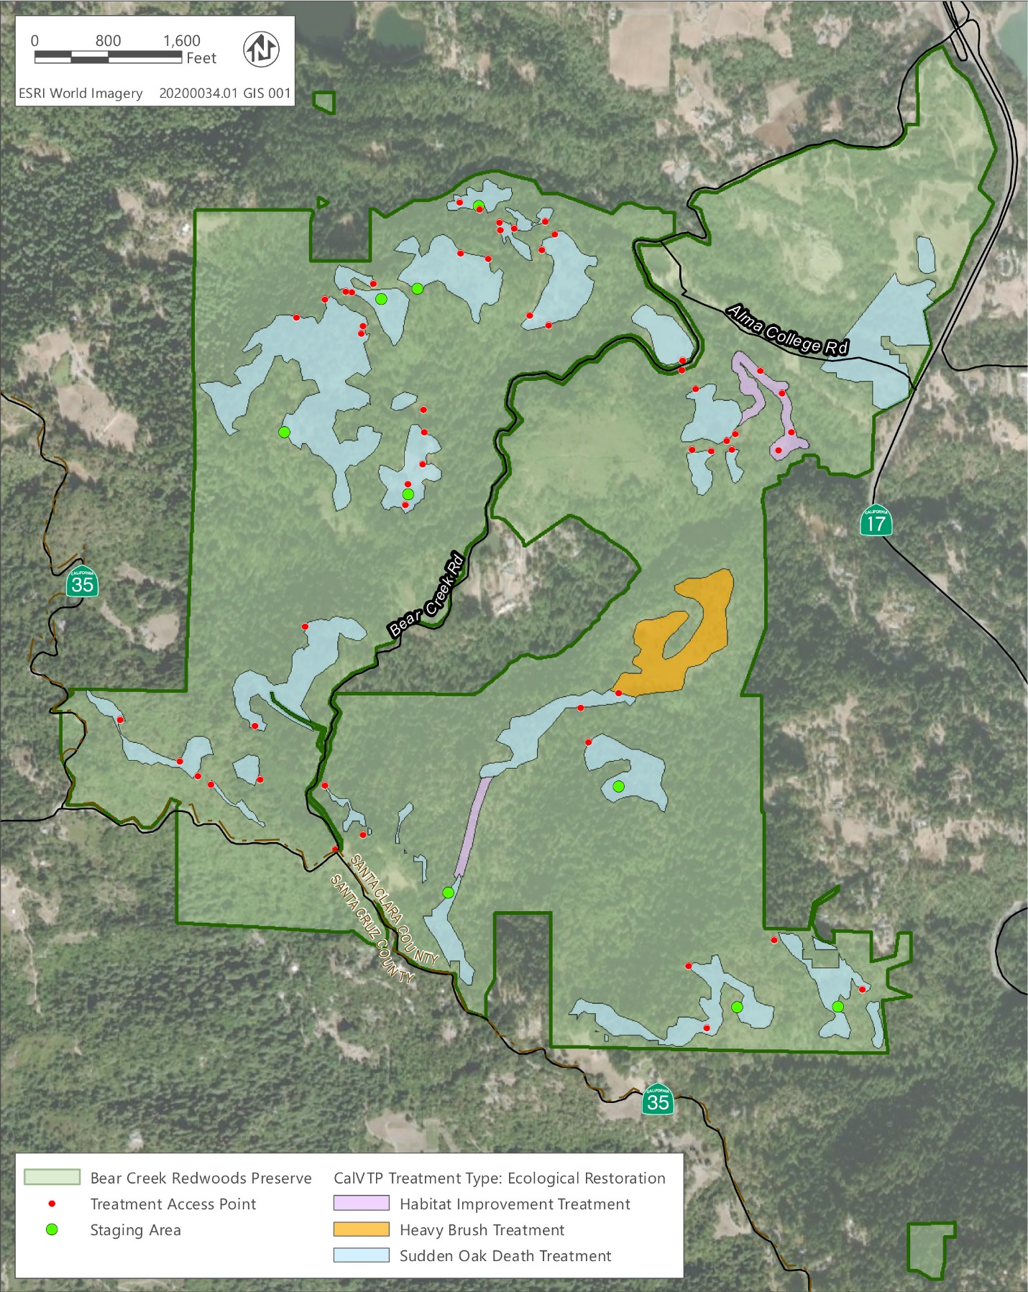

Bear Creek Redwoods Open Space Preserve Vegetation Treatment Project

