STATE OF CALIFORNIA NATURAL RESOURCES AGENCY Gavin Newsom, Governor

BOARD OF FORESTRY AND FIRE PROTECTION



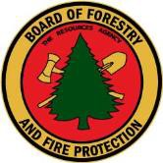

* 1. Box 944246 SACRAMENTO, CA 94244-2460 (916) 653-8007

Website: [www.bof.fire.ca.gov](http://www.bof.fire.ca.gov/)

Full 13 (a)(i)

January 22, 2025

The California Board of Forestry and Fire Protection (Board) has reviewed and certified the October 4, 2024 RPF and CRM Exam results. The following individuals are recommended for licensing as Registered Professional Foresters (RPF) by the PFEC

Applicant 7969 - Christopher Losi

Applicant 7972 - Richard Rappaport

Applicant 7978 - Elizabeth Sahara

Applicant 7980 - Jan Land

Applicant 7984 - Marie Antoine

Applicant 7987 – Mitchell McFarland

Applicant 7993 - Valarie Elder

Applicant 7994 - Wayne Davis

Applicant 7995 - Zach Rocha

Applicant 8009 - Alexander Herr

Applicant 8010 - Amanda Ma

Applicant 8011 - Andrew Mills

Applicant 8015 - Christopher Hale

Applicant 8016 - Jesse Gruenberg

Applicant 8018 - Kyle Dennis

Applicant 8021 - Parsa Arjomandinezhad

Applicant 8024 - Alexander Birkhofer

Applicant 8026 - Daniel Samaniego

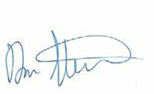Congratulations and good luck to you in your careers!

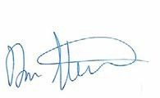

Dan Stapleton, RPF No. 2707

Executive Officer, Foresters Registration