EMC-2019-003 Fuel Treatments and Hydrologic Implications in the Sierra Nevada
Draft EMC Completed Research Assessment

Date: April 25th, 2025
Prepared by Givonne Law and Matt O’Connor

EMC-2019-003 Fuel Treatments and Hydrologic Implications in the Sierra Nevada
Peer-Reviewed Publications dated April 2023 and June 2024

Principal Investigators Terri Hogue- Colorado School of Mines, Golden, CO
Alicia Kinoshita- San Diego State University, San Diego, CA

Collaborators: The Nature Conservancy
USFS- Tahoe National Forest

Part 1. Does the study fulfill and address scientific questions posed in the proposed research?
- Does the study inform a rule, numeric target, performance target, or resource objective?
- Does the study inform the Forest Practice Rules?

The completed research answers the questions of how various forest treatments affect sedimentation, hydrological response and discharge in an upstream versus downstream comparison and on a sub-basin and basin scale. Secondarily, the research determined a method in which remote sensing could be utilized to quantify preliminary treatment effects of forest structure, as well as determine metrics to quantify habitat and hydrological changes. In summary, the study set out to determine if the minimal changes in forest structure achieved in treatment had implication for regional or state water resources, and how to measure that using pre-established data collection methods or technology.

The rules affected by the results of this study are 14 CCR 15355 (Cumulative Impacts) and 14 CCR 937 (Treatment of Snags and Logging Slash). The research provides data on hydrological impacts of singular and cumulative forest treatments defined in the forest practice rules using a replicable methodology. The study location and land-use history provided a unique opportunity to evaluate a range of potential hydrological changes in relation to compounding impacts from common forest treatments over a relatively short period of time. This evaluation used an in-situ observational network for data collection which could be used or replicated for the preparation of planning or permitting documents if such a need for hydrological evaluation is identified.

Part 2. Is the study scientifically sound?
The hydrological effects research methodology was based upon past studies and the metrics evaluated therein and was reasonably limited to the two primary datasets of field collected data (USGS stream data and Colorado School of Mines network of pressure transducers) alongside remote sensing data of vegetation. This was done for the purposes of developing a scientifically and statistically sound model which could be used in practice by decision makers when assessing or evaluating cumulative impacts of forest treatments of hydrological resources. The research used robust, distribution-free statistical methods to analyze trends in monitoring data, accounting for uncertainty and presenting results with 95% confidence. Data was cross checked with other data sets and field data where needed. The scale of the study area was large, but the use of multiple data sources led to sound conclusions.
Part 3. Is the study scalable?
This study yielded applicable data and results for use of FPRs in the Sierra Nevada watersheds and regions with similar hydroclimatic regimes, as designed. The data itself is specific to the Sagehen watershed and its associated forest practices at the time of the study, but the model used for data collection and analysis is more widely applicable. The data is limited in that it is an assessment of specific past and current management practices, watershed systems and the record of data collection. Kit is also temporarily specific, as it is constrained by the data quality. That being said, the data quality is notably greater than what a decision maker would usually find in many other parts of similar forest regions sense the study was based in an experimental forest, and this should be taken into account when considering scalability.

The study provided a scientifically based methodology for data collection and analysis for the purposes of assessing hydrological impacts in similar hydroclimatic regions where forest practices are taking place. In the PIs use of statistical analysis, the methodology is scalable.

The study found that the scope and scale of forest treatments with the study area and time frame were too small to measure notable change in hydrological functions on a sub-basin or basin scale. With few exceptions harvest treatments were conducted on a scale much smaller than the study units. This would imply that the methodology may not be applicable to assessments in which larger scales, cumulative or singular and over time or size of treatment(s), are being assessed. Furthermore, the scale of forest treatments in the study could not account for the hydrological function changes that were detected due to the methodology and outside-average variability in precipitation.

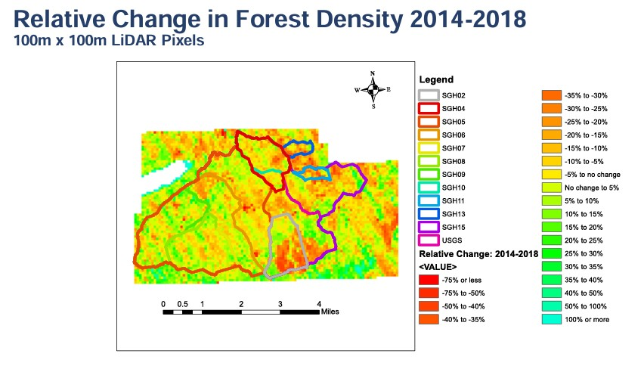
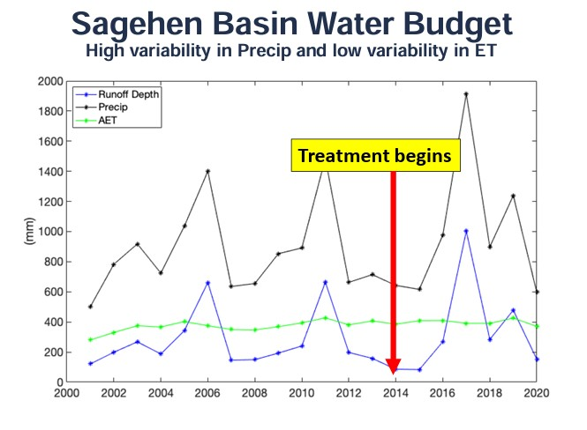

Synthesis of Key Findings
Question 1: (Within Sagehen Watershed) How do forest treatments impact annual runoff? At what spatial scale? Annual water budgets were assessed at basin and sub-basin scales. At the basin scale and sub-basin scale precipitation, while outside average annual amounts, accounted for greater or equal to than 85% of water yield variability. There was no measurable impact of forest treatments on water yield.

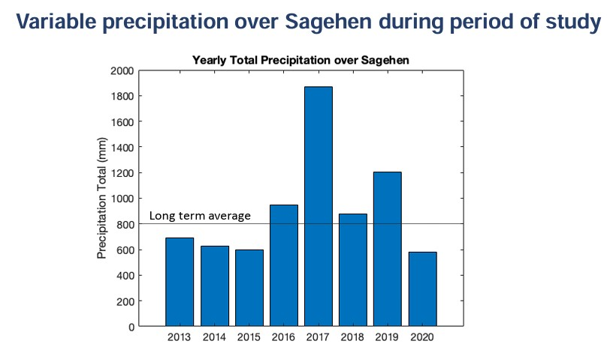

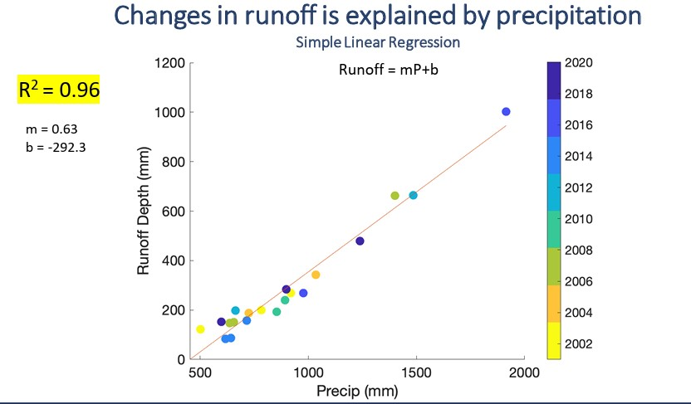

Question 2: (in Sagehen Watershed) What are the impacts of forest treatment on annual evapotranspiration (ET) at various spatial scales? At basin and sub-basin scales, ET was shown to be unaffected by forest treatments during the course of the study period. Despite high variability in precipitation, there was low variability in ET. At a smaller scale, referred to as “hot spots”, changes in forest density detected by the LiDAR data could be linked to changes in ET. This led the PIs to the conclusion that while forest treatments could have impacts on hydrological functions like ET, and those impacts could be assessed on a singular or cumulative scale utilizing this methodology, the forest treatments studies were too small in scope and scale to make a measurable change at larger spatial scales.

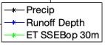 Sub-basin analysis of changes in precipitation and ET
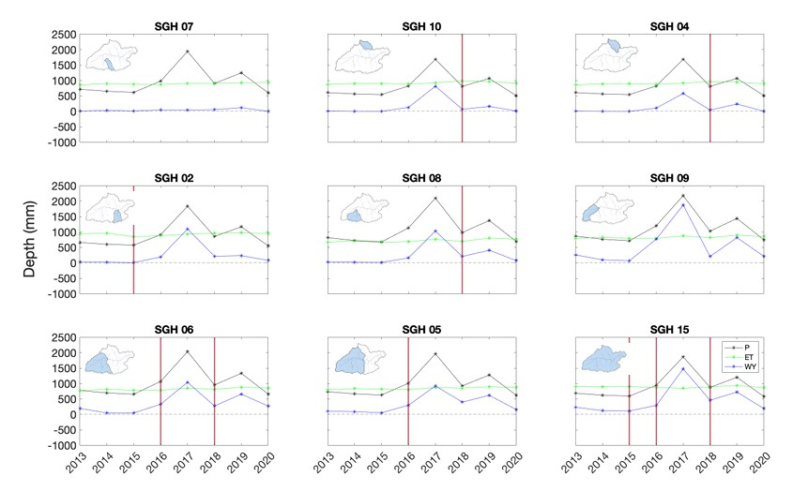

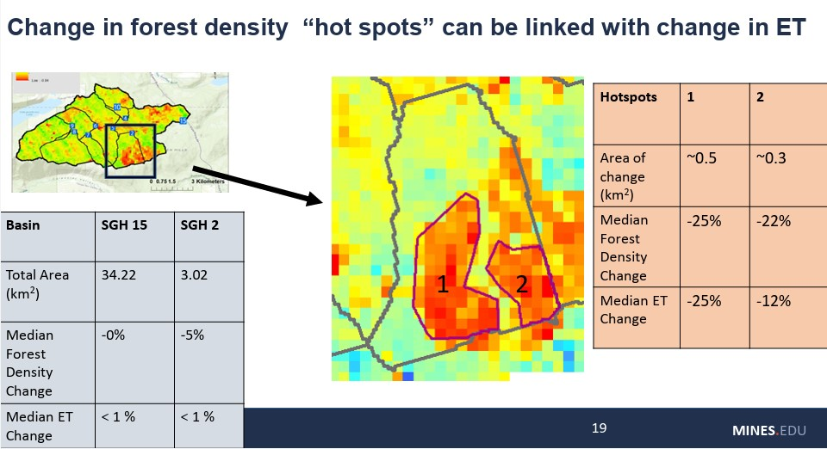

Part 4. More research needed?
- Literature Review Sufficient? The study methodology and statistical analysis were based off and referenced a variety of literature that was sufficient relative to the scope of this project. Publications on the finding of small-scale “hot spot” forest density changes correlating to change in ET appear to be missing in the literature review.
- Further Funding Needed? No. This study effectively accomplished what it set out to complete. Further study and associated funding could be put into replicating methodology with larger forest treatment scales, or in different regions or watersheds, or in the same region but during different time frames, but these would constitute entirely new studies and not a continuation of the research and study shared.
- What is the relationship between this study and any others that may be planned, underway or recently completed? This study is related to EMC 2018-006 and 2023-002 in terms of monitoring FPR effects on stream temperature, and completed EMC 2015-002 about filtering sediment from treatment roads before they reach the WPLZ, but otherwise no other ongoing projects about meadow restoration.
Part 5. Scientific Applications - What is the scientific basis that underlies the rule, numeric target, performance target, or resource objective that the study informs? How much of an incremental gain in understanding do the study results represent?
This study collected and analyzed data to assess hydrological function impacts from a variety of forest treatments in a watershed with a robust data collection network in situ and created a model to replicate this methodology and similarly analyze the data. These tools can be used by decision makers in planning and permitting forest treatments, specifically when accessing hydrological functions like yield and ET. From the 2025 FPR’s Addendum No.2: Cumulative Impacts, pursuant to 14 CCR § 15355, refers to two or more individual Effects which, when considered together, are considerable or which compound or increase other environmental Impacts. This assessment shall include evaluation of both on-site and off-site interactions of proposed project activities with the Impacts of Past Projects and Reasonably Foreseeable Probable Future Projects. In regard to the regulation, the study developed methodology that could assist.

The study specifically ran this methodology in a watershed with less typical monitoring equipment that collected an extensive amount of pre-treatment data. Despite this, it could not conclude that variability in yield could be caused by forest treatments and were more likely caused by precipitation. It found that ET was non-variable and concluded this could be due to the scale of forest treatments. Regarding these results, by itself the study was not robust enough to conclusively lead to a gain in understanding of cumulative impacts or the increased capability of the cumulative assessment process. With replication of the methodology as described by the PIs and above, this study could contribute to these efforts.

