|  |  |  |
| --- | --- | --- |
| STATE OF CALIFORNIA | **Board of Forestry and Fire Protection** | THE NATURAL RESOURCES AGENCY |
| Gavin Newsom *Governor* | **Terrence O'Brien, Chair** | Wade Crowfoot *Secretary* |

**BOARD OF FORESTRY AND FIRE PROTECTION**

P.O. Box 944246 SACRAMENTO, CA 94244-2460

(916) 653-8007

(916) 653-0989 FAX

Website: [www.](http://www/) bof.fire.ca.gov

Charter of the Effectiveness Monitoring Committee

2024

# Purpose

The Effectiveness Monitoring Committee (EMC), formed in 2014, was established to provide the Board of Forestry and Fire Protection (‘Board’) and the California Natural Resources Agency (CNRA) with a science-based committee whose charter is to better understand if the specific requirements of the California Forest Practice Rules (FPRs) and natural resource protection statutes and laws, codes, and regulations related to forest resources are effective in achieving resource objectives ([EMC Website](https://bof.fire.ca.gov/board-committees/effectiveness-monitoring-committee/)). Collectively, these are referred to as the ‘FPRs and associated regulations.’ Effectiveness monitoring is a key component of adaptive management and is an important part of developing a quantitative understanding of how management practices may impact resources, particularly as new regulations are developed and existing regulations are modified. With dedicated funding from the Timber Regulation and Forest Restoration Fund (TRFRF; see [AB 1492](http://leginfo.legislature.ca.gov/faces/billNavClient.xhtml?bill_id=201120120AB1492&search_keywords=) 2012), agency funding, and state grants, the EMC solicits robust scientific research that addresses specific forest practice rules and geographies to assess the effectiveness of regulations, regularly encouraging new and diverse studies covering a broad range of biophysical categories. Results may then be used to inform decision makers on options to incentivize or improve upon management to meet resource goals and objectives.

In response to the chaptering of AB 1492, the EMC and a statewide monitoring and assessment effort being led by CNRA were developed to assess the effectiveness of the CA FPRs and to evaluate “ecological performance measures” in California’s forests at the watershed scale, respectively ([CNRA Statewide Monitoring and Assessment Website](https://resources.ca.gov/Initiatives/Forest-Stewardship/epm)). The EMC may engage in collaboration with the statewide monitoring effort where research findings originating from either the EMC or the statewide forest ecosystem monitoring led by CNRA may mutually inform and direct further research on specific CA FPRs and associated regulations, all in support of adaptive management of the State’s natural resources (Figures 1 and 2).

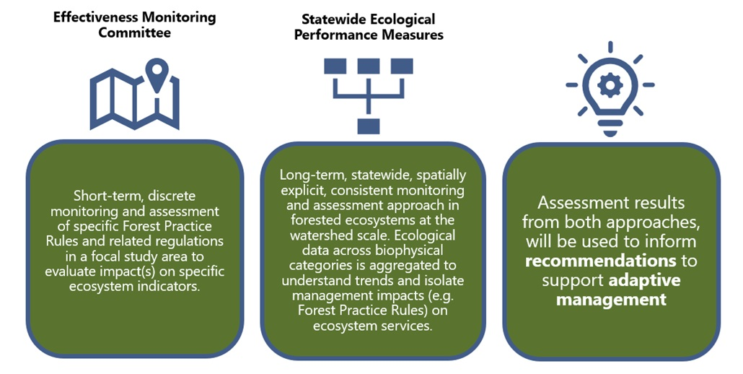

**Figure 1.** Comparison between EMC (and the Board) and EPM (California Natural Resources Agency Ecological Performance Measures) monitoring and assessment efforts under AB 1492.

**Figure 2.** Iterative cycle of policy development and implementation used in adaptive management, allowing monitoring data to inform management and regulation.

***Key:*** Board = Board of Forestry and Fire Protection; EMC = Effectiveness Monitoring Committee.

# Values

The EMC is guided by values that support long-term ecological, social, and economic sustainability:

* **Adaptive Management**

Ongoing inquiry informs management, and the EMC is built on an adaptive management framework that solicits new information via effectiveness monitoring research, translates research findings to on-the-ground applications for management, and incorporates updated information into the development or revision of science-based policies and regulations.

* **Sustainable Solutions**

Effectiveness monitoring research seeks to find economically, socially, and environmentally sustainable solutions to environmental management of timber harvesting activities. The FPRs should recommend sustainable, regenerative practices that build and maintain resilient communities.

* **Public Transparency**

A fully transparent, public process is built into the EMC’s activities. The EMC conducts business in an open fashion that encourages stakeholder input and participation.

# Goals and Objectives

The EMC acts as a technical advisory committee to, and receives oversight from, the Board to develop and implement an effectiveness monitoring program that can provide an active feedback loop to policymakers, managers, agencies, and the public. The EMC provides input to the Board to ensure a scientific-based monitoring effort is used to comply with the reporting requirements of AB 1492 and evaluates the effectiveness of the CA FPRs and other forestry-related laws and regulations related to water quality, aquatic habitat, and wildlife habitats. The EMC then takes this analysis and presents findings in a formal adaptive management format to inform the Board in its future policy development. The adaptive management process is described in detail in the EMC’s Strategic Plan ([EMC 2022](https://bof.fire.ca.gov/media/vaffvb42/2022-emc-strategic-plan-final.pdf)), which is updated on a bi-annual basis.

## Goals

The EMC aims to establish a collaborative, transparent, and science-based monitoring effort and process-based understanding of the effectiveness of the CA FPRs and other forestry-related laws and regulations on maintaining or enhancing water quality, aquatic habitat, and wildlife habitats. To that end, the EMC will:

1. Provide a framework and support to comply with the reporting requirements of AB 1492;
2. Support an adaptive management process by providing feedback to the Board regarding effectiveness of the CA FPRs and associated regulations;
3. Facilitate and recommend monitoring practices to evaluate how well current practices restore and maintain riparian, aquatic, and terrestrial habitat on private and state forestlands for state and federally listed species and Species of Special Concern (aquatic and terrestrial);
4. Ensure that the process is consistent with the goals of the Porter-Cologne Water Quality Act and the Clean Water Act for water quality on private and state forestlands;
5. Ensure that the process is consistent with the goals of the Federal and State Endangered Species Acts on private and state forestlands;
6. Ensure that appropriate scientific methods and statistical evaluation, when necessary, are used to evaluate effectiveness of CA FPRs and other forestry-related laws and regulations;
7. Encourage dissemination of information through general public and scientific outlets;
8. Support the Board in adjusting regulations for protection of aquatic and terrestrial resources, and promotion of forest management creating fire-resilient landscapes for wildfire hazard reduction, based on the most current and best available scientific knowledge and technical information; and,
9. Promote the use of the Demonstration State Forests for effectiveness monitoring of CA FPRs, water quality laws and regulations and Fish and Game codes, and other forestry-related laws and regulations.

## Objectives

1. Involve representatives of key stakeholders that have demonstrated previous collaboration in resource monitoring or scientific studies;
2. Develop an overall monitoring strategic plan or “road map” including:
   1. Catalog and review past and ongoing monitoring project results, encourage continuation of valuable projects/monitoring programs, guide development of new approaches, and avoid redundancy. The review should state in a hierarchical format the level of existing information for specific watershed and wildlife issues of concern.
   2. Seek, accept, and consider questions from stakeholders and the interested public (key areas of concern) about the effectiveness of specific aquatic or terrestrial-related forest practice rules (i.e., ecological performance).
3. Develop guidance for appropriate scientific methods and statistical analyses to be used to evaluate the effectiveness of the CA FPRs and other relevant regulations.
4. EMC members, in conjunction with the Board, should identify critical monitoring questions that address various EMC goals and objectives.
5. Increase understanding of the linkage between forest practices and the resource(s) of concern.
6. Provide guidance on the acceptable level of scientific uncertainty across the broad spectrum of monitoring efforts from small-scale short-term monitoring to long-term replicated studies.
7. Collaboratively develop methods to prioritize monitoring questions, and based on these methods, help select the highest priority projects to monitor.
8. Foster a collaborative scientific atmosphere to build partnerships and relationships. This may help defer or share the costs of monitoring and help build mutual trust and understanding of scientific results.
9. Promote collaborative fact-finding and understanding of scientific results at local, regional, and state levels.
10. Spread awareness of results to stakeholders, decision-makers, and the public through field tours, the internet, workshops and conferences, scientific journals, and other user-friendly formats.

# Membership and Committee Structure

## Appointment, Representation, and Compensation

The Board shall appoint EMC members and agency representatives[1] that: (1) have scientific and natural resource professional backgrounds, (2) have demonstrated previous collaboration in resource monitoring or scientific studies, and (3) are willing to serve on the EMC. Members participate in formal votes and agencies may provide no more than one individual to act as a committee member. Additional persons may serve as agency representatives which function as technical consultants or EMC staff and may not vote.

Members should be capable of working collaboratively and developing work products in a timely manner. Members shall be appointed by the Board, with appointees having expertise in hydrology, geology, fluvial geomorphology, aquatic ecology, fisheries, forestry, fire ecology, wildlife management, and/or resource monitoring and sampling. In addition, members shall also have a working knowledge of the CA FPRs and forest management operations on private and state forestlands.

A statement of qualifications shall be required to verify education and field/rule application experience. Members shall be appointed from academia, professional consulting firms, state and federal agencies, private and state forestland owners, and the public. Members should be applied scientists or natural resource professionals with demonstrated previous collaboration in resource monitoring that can also represent a stakeholder group.

There is no compensation for service on this advisory committee, but members shall be reimbursed for their expenses in attending meetings to the extent that the law allows.

### Duration

The EMC shall be a permanent Advisory Committee of the Board. The duration for original appointment to this committee is either two, three, or four years (i.e., mixed appointments). After the original term, all appointments convert to four year terms.

### Co-Chairs

The role of the Co-Chairs is to provide leadership and coordination for the EMC. The Board shall appoint two Co-Chairs to four-year terms. One Co-Chair shall be a representative of either CNRA (Executive or the Departments housed under CNRA) or Departments under the California Environmental Protection Agency.

## Meetings

EMC meetings shall be publicly noticed and will be open to all interested parties, following the Bagley-Keene Open Meeting Act requirements. Meetings are anticipated to occur quarterly in noticed locations and will incorporate the use of web-based conferencing where possible. Additional meetings may be scheduled as needed if agreed to by a quorum of the voting membership. The EMC Co-Chairs shall invite public comment at specified times during a meeting. The EMC Co-Chairs and Board/Department of Forestry & Fire Protection (CAL FIRE) staff shall be responsible for determining meeting times, format, location, and duration. CAL FIRE, the other agencies, and/or the Board shall provide staffing for the EMC. Meeting agendas and meeting notes shall be posted on the [EMC website](https://bof.fire.ca.gov/board-committees/effectiveness-monitoring-committee/).

EMC members shall be required to follow meeting “ground rules” to foster a collaborative scientific-based approach to achieving the stated goals and objectives of the EMC. These include a commitment to:

1. Attempt to reach consensus;
2. Attend all scheduled meetings;
3. Listen carefully and ask questions to better understand issues;
4. Allocate priority attention, staffing, and time to the EMC;
5. Clearly define the purposes and goals of their represented organizations; and,
6. Recognize the legitimacy of the goals and differing perspectives of other represented organizations.

## EMC Actions

The EMC aims to make all decisions and recommendations by consensus. Facilitation may be necessary. If failure to reach consensus occurs, the record (i.e., meeting notes) shall specify the key differences and the reasons consensus could not be reached. Members will self-attest to Conflicts of Interest and recuse themselves from any related discussions.

# Implementation of Effectiveness Monitoring

The EMC will aid in implementing effectiveness monitoring to inform the FPRs and associated regulations in several ways:

## Evaluation of Forest Practice Rules and Related Regulations

A key EMC activity is support of research targeted at understanding the effectiveness of the FPRs and associated regulations. Funding to support this research, led by the EMC, may come from a combination of sources, including:

* + AB 1492, requiring an evaluation of ecological performance [Sec. 4629.9 (a)(8)(F)], including monitoring the effectiveness of regulations promoting ecological benefits;
  + State agency and private sources; and,
  + Grants.

## Reports and Adaptive Management Process

The EMC may develop targeted literature reviews and other internal staff analyses, project summaries from funded proposals, and recommendations to the Board and/or its Standing Committees (i.e., Monitoring Committee, Forest Practice Committee, Resource Protection Committee).

Members of the EMC or principal investigators conducting effectiveness monitoring will synthesize the results into final reports for the EMC. The reports shall include descriptions of the purpose and necessity of the research, scientific methodology, technical analysis, results, evaluation of implications for resources and forest management operations (including consideration of alternative management approaches), and disclosure of any possible limitations of results and any scientific uncertainty. The reports may inform policy or regulatory recommendations, and potentially assist in further refinement of future study methods to address significant limitations and scientific uncertainty. The EMC shall encourage the publication of results in relevant scientific journals. All final reports will be made available to the public on the [EMC website](https://bof.fire.ca.gov/board-committees/effectiveness-monitoring-committee/).

All reports shall discuss the statistical, physical, and biological relevance of the monitoring and results. Due to relatively small sample sizes and lack of controls for both dependent and independent variables associated with “specific question” studies, statistically rigorous testing of water-quality, aquatic habitat, and wildlife resource questions are often difficult. However, well-developed resource monitoring questions can improve scientific monitoring designs to limit spurious results and enhance the range of inference. Both statistical and biological relevance of the monitoring and the resulting acceptable level of scientific uncertainty should be clearly stated in each monitoring proposal and final report.

Development of possible rule language options (i.e., adaptive management)[2] based on results and findings of EMC reports, if necessary, shall be brought before the Board’s Forest Practice Committee for review and comment prior to submittal to the full Board.

## Assistance and Oversight

The EMC Co-Chairs may seek technical advice from, including but not limited to, other state agencies or departments, federal agency representatives, and technical experts on developing effectiveness monitoring projects. The Board’s Executive Officer and/or Board staff will act as the liaison between the Board and the EMC.

1. Agency representatives include: California Natural Resources Agency, California Department of Fish and Wildlife, California Geological Survey, California Department of Forestry and Fire Protection, State and Regional Water Quality Control Boards, National Marine Fisheries Service, USDA Forest Service Pacific Southwest Research Station, and U.S. Fish and Wildlife Service. Agencies will assign a lead representative and a back-up representative. The Secretary for Natural Resources will be consulted regarding agency representation.
2. Gregory, R., D. Ohlson, and J. Arvai. 2006. Deconstructing adaptive management: criteria for applications to environmental management. Ecological Applications 16(6): 2411-2425.