Major land use and development decisions have important physical, economic, social, and environmental implications that must be considered by public officials during any planning process. This Element describes the Town’s role and responsibilities pertaining to the provision of Town services and assessing needs for resources. Through an effective Public Facilities, Services, and Infrastructure Element the Town will be better able to assist individuals and families in achieving and maintaining high levels of social well-being, ensuring that facilities, services, and infrastructure are planned for future changes in population and demand. A comprehensive approach to establishing resilient and adequate facilities, services, and infrastructure will lead to a more positive and satisfied community.
The goals, policies, and implementation programs in this Element support the provision and maintenance of public facilities, services, and infrastructure in Los Gatos and provide for their timely expansion, if required, to maintain adequate services. The goals and policies indicate where those facilities and services will be most beneficial to meet the needs of the community, residents, and businesses through 2040. This Element also includes policies in coordination with the Hazards and Safety Element, for the provision of facilities and services to ensure the safety and welfare of residents, businesses, and visitors and the protection of property. The Element also includes goals and policies that relate to the Environment and Sustainability Element for water supply and delivery.
The Town should be involved in meeting human needs but may not be responsible for directly delivering all services. The Town recognizes the value of public and private agencies working together to effectively deliver services. The Town can be a leader in bringing agencies together and encouraging long-range planning. For services not directly provided by the Town, the Town may assume any of the following five roles to assist in developing more effective delivery of services in Los Gatos: resource coordinator; educator; advocate; facilitator; or evaluator.

The Public Facilities, Services, and Infrastructure Element is divided into the following sections:

Contents
Section Title Page
Key Terms 6-2
6.1 Water 6-3
6.2 Wastewater 6-6
6.3 Storm Drainage and Flood Protection 6-8
6.4 Solid Waste Disposal and Recycling 6-9
6.5 Utilities and Alternative Energy 6-10
6.6 Public Facilities and Services 6-12
6.7 Law Enforcement 6-20
6.8 Fire Protection 6-21
6.9 Emergency and Medical Services 6-25
6.10 Schools and Lifelong Learning 6-28
6.11 Libraries 6-31
6.12 Town Arts 6-32
6.13 Healthy Community 6-33
6.14 Implementation Programs 6-34

Key Terms
Aquifer. A geological formation or structure that stores and/or transmits water, such as to wells and springs. Use of the term is usually restricted to those water-bearing formations capable of yielding water in sufficient quantity to constitute a usable supply for people’s uses.
Discharge. A rate of water flow, typically expressed as a unit volume of water per unit of time [e.g., cubic feet per second (cfs)].
Groundwater. Water that is found underground in the cracks and spaces in soil, sand, and rock.
Groundwater Basin. An area of permeable materials capable of furnishing a significant supply of groundwater to wells or storing a significant amount of water. A groundwater basin is three-dimensional and includes both the surface extent and all of the subsurface fresh water yielding material.
Groundwater Recharge. The natural or intentional percolation of surface water into a groundwater basin or aquifer.
Leadership in Energy and Environmental Design (LEED). LEED is a green building certification program. Developed by the non-profit US Green Building Council, it includes a set of rating systems for the design, construction, operation, and maintenance of buildings. Buildings are rated based on their impact on site/location, water and energy efficiency, materials, and indoor environmental air quality. This is a voluntary program meant to objectively measure a building’s sustainability.
Non-point Source Pollution. A pollution source that cannot be defined at a discrete location; a dispersed or spread-out source area.
Renewable Energy. Energy that comes from natural resources that are naturally replenished, such as solar, wind, rain, tides, geothermal, and biomass sources.
Riparian. Of, on, or pertaining to the bank of a natural course of water. For example, riparian vegetation is composed of plant species normally found near streams, rivers, lakes, reservoirs, and other freshwater bodies.
Riparian Corridor. A corridor of riparian vegetation adjacent to perennial and intermittent streams or other freshwater bodies.
Runoff. Precipitation (rain or snowmelt) that is not used by plants, evaporated, or infiltrated to soils, and is transported across land surfaces to streams or other surface water bodies.
Stormwater. Stormwater is precipitation that accumulates in natural and/or constructed storage and stormwater systems during and immediately following a storm event.
Wastewater. Wastewater is water (either treated or untreated) that has been affected by human use, including household, commercial, industrial, and agricultural activities. This water is conveyed through a wastewater system to a treatment plant, and may contain physical, chemical, and biological pollutants prior to treatment.
Water Quality. A term used to describe the chemical, physical, and biological characteristics of water, usually in respect to its suitability for a particular purpose.
Watershed. The land surface area from which water drains into a common downstream point.
Wildland. Land in an uncultivated natural state that is covered by trees, brush, weeds, or grass.
- Water
The San Jose Water Company (SJWC) has been the Town’s water service provider since 1870. The SJWC’s service area encompasses approximately 139 square miles including: most of the City of San Jose and the City of Cupertino; the entire area within the cities of Campbell, Monte Sereno, and Saratoga; the Town of Los Gatos; and parts of unincorporated Santa Clara County.

Water Supply
SJWC provides water from five major sources, as shown in Table 6-1.
- Water Supply in Acre Feet
Water Source | 2020 | 2025 | 2030 | 2035 | 2040
Imported Surface Water (Potable) | 76,670 | 79,383 | 82,256 | 85,377 | 88,651
Groundwater (Potable) | 54,160 | 56,078 | 58,106 | 60,307 | 62,621
Surface Water (Potable) | 9,606 | 9,606 | 9,606 | 9,606 | 9,606
Local Mountain Surface Water (Raw) | 172 | 178 | 184 | 190 | 196
Recycled Water | 4,072 | 6,853 | 8,350 | 8,369 | 8,369
Total | 144,680 | 152,098 | 158,502 | 163,849 | 169,443
Source: SJWC, Urban Water Management Plan, 2016, Los Gatos General Plan 2040 Background Report, 2019.
Numbers reflect water supply for the entire SJWC service area

Imported Surface Water
Imported surface water is purchased from Valley Water, which is the wholesale supplier to the SJWC. Surface water is imported from the Sacramento-San Joaquin Delta and accounts for approximately 53 percent of the water supply. A smaller portion is impounded in local reservoirs in Santa Clara County.

Groundwater
Groundwater is pumped from over 100 wells that draw water from the Santa Clara groundwater basin, which accounts for approximately 37 percent of the supply. The SJWC has rights to pump water from the aquifers in the service area when it is in compliance with Valley Water permitting requirements.

Local Mountain Surface Water
Local mountain surface water is also collected from the watershed in the Santa Cruz Mountains. SJWC has “pre-1914 surface water rights” to raw water in Los Gatos Creek and local watersheds in the Santa Cruz Mountains. Surface water accounts for approximately seven percent of the water supply in normal rainfall years.

Recycled Water
Recycled water has been used in Santa Clara County since the 1970s and currently comprises approximately three percent of the SJWC’s water supply. Recycled water is used for a variety of non-drinking purposes such as landscaping, agriculture, and industrial uses. All recycled water produced in the County meets or exceeds the water quality standards set by the State for the various uses for which recycled water is approved.

Water Treatment, Distribution, and Storage
SJWC provides water treatment and distribution for the Town of Los Gatos.

Water Treatment Plant
The Rinconada Treatment Plant in the Town of Los Gatos supplies drinking water to both residential and commercial users in the west Santa Clara Valley including the Cities of Santa Clara, Campbell, Sunnyvale, Cupertino, Mountain View, Los Altos, Los Altos Hills, and Los Gatos. The water treatment plant can treat and deliver up to 80 million gallons of water per day. The facility is currently under a five-phase renovation, expected for completion in 2027, to modernize the system and will result in an increase in capacity to 100 million gallons of water per day, improved water quality, and greater seismic stability.

Water Distribution Pipelines
SJWC has approximately 29 “stations” within the Town of Los Gatos. These stations include tanks, pump stations, and regulators that regulate the water pressure. Hillside planning in the Town poses unique challenges regarding water supply systems as it is difficult to provide water at higher elevations within the Town.

Water Storage
Los Gatos is located within the Guadalupe Watershed within the boundaries of the service area for Valley Water. Reservoirs located within the watershed provide water storage and are maintained by Valley Water, including James J. Lenihan Dam and Lexington Reservoir, Vasona Dam and Reservoir, Guadalupe Dam and Reservoir, Almaden Dam and Reservoir, and Calero Dam and Reservoir.

Water Reuse and Conservation

Water Reuse
SJWC is the wholesale retailer for the South Bay Water Recycling Program, which takes treated wastewater that would normally be discharged into the San Francisco Bay and pipes it back into the basin to be used for landscape irrigation. The Town of Los Gatos currently does not have the infrastructure in place to provide recycled water (purple pipe) to residents.

Water Conservation
Valley Water adopted an “Ensure Sustainability” strategy in its 2012 Water Master Plan. The strategy calls for securing baseline water supplies and infrastructure, optimizing the use of existing supplies and infrastructure, and increasing recycling and conservation. Through this plan, water conservation and recycled water usage is expected to increase to 8,369-acre feet per year (AF/yr) by 2040. Valley Water also operates a treated groundwater recharge/recycling injection program that promotes the reuse of treated groundwater from the clean-up of contaminated sites. The Ensure Sustainability strategy is currently (2020) being updated as part of Valley Water’s Water Supply Master Plan 2040.

Valley Water, the SJWC, and the Town of Los Gatos all have water conservation programs in place, including but not limited to the following:
- Los Gatos provides online tools and resources for homeowners and business owners on the Town website, including information on rebates through Valley Water;
- SJWC offers complimentary water check-ups, educational materials, and free low-flow devices; and
- Valley Water hosts a variety of informational resources at watersavings.org, including video tutorials and a calendar of classes and workshops.
The following goal and policies address the provision of water and water conservation efforts in Los Gatos.

Ensure an adequate water supply for the Town’s human, wildlife, and plant populations.

  - Water Conservation Requirements
Require that landscaping and hardscaping for all development is designed to minimize water usage and enhance water conservation.
  - Bay-Friendly Landscaping
Require the use of the Bay-Friendly Landscaping Guidelines in addition to the landscaping standards in the GreenPoint Rated Building Guidelines for all new home construction and remodeled homes.
  - Water-Saving Devices
Require the use of water-saving devices in new developments and plumbing-related remodels and develop incentives to encourage their installation in existing development.
  - Water-Efficient Irrigation Management Systems
Require all new development to install water-efficient irrigation management systems and devices, such as evapotranspiration or soil moisture-based irrigation controls.
  - Sustainable Water Use
Encourage the Encourage the use of recycled and reclaimed water.
  - Recycled Water
Ensure proper provisions and conditions are in place for the use of recycled water in areas when this water becomes available.
  - Water Supply for Fire Safety
Coordinate with local water providers to ensure and maintain the long-term sustainability of water supplies to meet current and anticipated future firefighting needs.

- Wastewater
The West Valley Sanitation District (WVSD) is a Joint Powers Authority (JPA) with board members representing the participating cities, the Town, and the County. WVSD provides wastewater collection and disposal services for the cities of Campbell, Monte Sereno, Town of Los Gatos, much of Saratoga, and some unincorporated areas of the County within the district boundary.

Collection System
The WVSD’s wastewater collection system consists of main and trunk sewers as well as sewer laterals, which are maintained and operated by the WVSD. The WVSD’s system within the Town of Los Gatos consists primarily of gravity mains with the collection system flowing north, exiting the Town limits through multiple trunk sewers. These systems continue through the City of San Jose trunk sewers and ultimately to the San Jose-Santa Clara Regional Wastewater Facility for wastewater treatment and disposal.

Wastewater Treatment
WVSD contracts with the San Jose-Santa Clara Regional Wastewater Facility for wastewater treatment and disposal. The San Jose-Santa Clara Regional Wastewater Facility is the largest advanced wastewater treatment facility in the United States. The facility serves 1.4 million residents and over 17,000 businesses in the Town of Los Gatos and the cities of San Jose, Santa Clara, Monte Sereno, Milpitas, Campbell, Cupertino, and Saratoga.
The facility has the capacity to treat 167 million gallons per day (MGD) utilizing an advanced, tertiary wastewater system. In 2017, average dry weather influent flow was 107.3 MGD, well below the plant’s 167 MGD capacity. In fiscal year 2016-2017, the WVSD collected and conveyed 9.6 MGD of wastewater to the treatment plant. The plant, located near Zanker Road in north San Jose, collects and treats wastewater from local municipalities and sanitation districts and discharges the treated wastewater into the San Francisco Bay. WVSD accounts for approximately 10 percent of the treatment flow at the plant.
The following goal and policies guide the provision of wastewater services in the Town.

Meet all wastewater treatment demands and Federal and State regulations.

  - West Valley Sanitation District
Support WVSD to maintain wastewater conveyance, treatment, and disposal infrastructure in good working condition, in order to supply municipal sewer service to the Town’s residents and businesses.
  - Development Beyond Public Water and Sewer Systems
For individual home site development where public water and sanitary sewer systems are not available, development shall be discouraged. Development may be allowed with private water systems and septic tank systems when such systems are shown to be adequate, with the condition that the property owner enters into an agreement to connect to the public water system and sanitary sewer system when they become available.
  - Septic Tank Inspection
Require that all septic tank systems be inspected to prevent surface flow of septic tank seepage.
  - New Septic Systems
Require that any new septic system is reviewed and approved by the Santa Clara County Department of Environmental Health prior to installation.
- Storm Drainage and Flood Protection
The Town is served by an extensive man-made storm drainage system including pipe networks, ditches, and culverts. These systems discharge into the natural creeks that traverse the Town.

Natural Drainage Systems
The Town of Los Gatos Planning Area is in the Guadalupe Watershed and the Santa Clara Valley Groundwater Sub-basin. The Sub-basin runs parallel to the northwest trending Coast Ranges and is approximately 22 miles long and 15 miles wide, with a surface area of 225 square miles. It is bounded by the Diablo Range on the east and the Santa Cruz Mountains on the west, extending from the northern border of Santa Clara County to the groundwater divide near the City of Morgan Hill. The Sub-basin receives approximately 15 inches of rainfall per year. January is the wettest month with an average rainfall of three inches.
The Town has several surface water channels within its limits. Los Gatos Creek, San Tomas Aquinas Creek, and Smith Creek flow south to north through the Town, and Ross Creek flows in a northeasterly direction. A large valley in Los Gatos is also drained northward to the San Francisco Bay by tributaries including the Guadalupe River and Los Gatos Creek. Other unnamed natural water courses are also located within the Town limits.

Man-Made Drainage Systems
The Town’s stormwater system is managed and maintained by the Town’s Parks and Public Works Department. The system includes a series of surface and underground drains to direct rainwater to the creeks and tributaries that eventually flow to the San Francisco Bay. Impermeable surfaces such as streets and parking lots are generally designed to channel water into this drainage system, serving as a part of the overall system by directing water to prevent flooding and standing water.
The following goal and policies guide stormwater management practices in Los Gatos.
Minimize the amount of stormwater runoff, as well as protect and improve the water quality of runoff.

  - Water Drainage Analysis in CEQA Review
Require CEQA review analysis for all development projects consisting of single and cumulative impacts on water drainage (runoff) and contamination (water quality) in all areas, but particularly in or adjacent to hillsides, riparian corridors, and important undeveloped watersheds.
  - Non-Point Source Pollution Control Programs
Provide non-point source pollution control programs to reduce and control the discharge of pollutants into the storm drain system.

- Solid Waste Disposal and Recycling
Garbage disposal and recycling are important and necessary for all residents and businesses of Los Gatos. The resources used to produce the items which end up in landfills are dwindling, and landfill space is limited. Los Gatos endeavors to work through the West Valley Solid Waste Management Authority (WVSWMA), a JPA with broad representation from the Town and the cities of Campbell, Monte Sereno, and Saratoga to proactively address issues of solid waste and recycling.
West Valley Collection and Recycling (WVCR) is the exclusive recycling, green waste, and garbage hauler for the municipalities in the WVSWMA. Garbage is picked up by WVCR and transported directly to the Guadalupe Landfill. The Guadalupe Landfill is a Class III solid waste landfill permitted to accept 3,650 tons of material daily. It is projected that the landfill will reach its capacity in 2048. Recycling and compostables are hauled to specific facilities to allow for reuse. To reduce the impact on the Guadalupe Landfill, the Town will need to proactively encourage limiting trash production, by continuing to actively promote recycling, and potentially introduce Townwide composting. If changes are not enacted before the horizon date of 2040 in this General Plan, the Town will have to collaborate with its hauler to locate a secondary landfill which has a wide range of fiscal implications.

Recycling
The Town of Los Gatos established a recycling program in February 1990 and instituted single-stream recycling (recyclables are all placed by customers in one bin instead of separating by type) in March 2007. WVCR collects paper products, oil, cans, containers, glass, plastic, yard trimmings, and scrap metal for recycling. Batteries and electronic waste can be dropped off at the WCVR facility headquarters in San Jose, or at local hardware and electronics retailers. Legislative changes have created increasing requirements for the recycling of compostables, including at the individual residence level. As a result of state legislative changes, the Town will need to plan and implement organics recycling programs to facilitate compliance with SB1383.

Household Hazardous Waste
The Santa Clara County Household Hazardous Waste Program provides household hazardous waste collection services for Santa Clara County, including Los Gatos. The Santa Clara County Household Hazardous Waste Program accepts household hazardous waste by appointment at several drop-off locations throughout the City of San Jose. A complete list of waste accepted can be found on the County’s Household Hazardous Waste website.
The following goals and policies address solid waste disposal and recycling in Los Gatos.

Promote recycling and reuse as well as reduction in demand.

  - Recycling of Reusable Materials
Require the use of and recycling of reusable materials from residential, commercial, and construction/renovation activities, when feasible.
  - Waste Reduction Education Programs
Collaborate with WVCR or any subsequent waste collection provider to develop waste reduction education programs.

Conserve landfill space.

  - Coordinated Recycling Plans
Cooperate with nearby jurisdictions and regional jurisdictions to design and implement coordinated recycling plans.
  - Expand Recycling Programs
Expand recycling programs through the local waste hauler.
  - West Valley Solid Waste Management Authority
Continue to work with other West Valley cities through the West Valley Solid Waste Management Authority to design and implement expanded recycling programs.
  - Recycling and Waste Reduction Commission of Santa Clara County
Continue to work with the Recycling and Waste Reduction Commission of Santa Clara County.

- Utilities and Alternative Energy

Energy Resources
Alternative energy production, energy conservation, and reduction of current energy consumption is of growing importance to individuals, agencies, and jurisdictions. As the State and Bay Area have learned, dependence on traditional energy resources (gas and electricity) can strain the energy grid and cause lasting and damaging fiscal repercussions. Traditional resources, while varied, are not limitless. Our community must direct its attention towards alternative energy applications that can meet future demands sustainably.
The Town of Los Gatos has several opportunities to promote energy conservation and reduce energy consumption, mainly through enforcing construction standards and through its own operations.

Silicon Valley Clean Energy
Silicon Valley Clean Energy (SVCE) was formed in 2016 as a locally controlled electricity provider (community choice aggregator, or CCA) in Santa Clara County that provides service to the Town of Los Gatos and 11 other jurisdictions as well as the unincorporated County areas. Participating jurisdictions are given the option of purchasing environmentally friendly power generated by renewable sources like solar, wind, and geothermal at competitive rates. Residents are automatically enrolled in the default GreenStart option, providing 50 percent renewably-sourced energy; or can upgrade to GreenPrime, providing 100 percent renewably-sourced energy, from carbon free sources, such as solar and wind energy. PG&E delivers the energy via its distribution system. The Town has subscribed at the GreenPrime level since SVCE started offering service.
SCVE began providing energy to customers in two phases in April and July 2017. In the first half of 2018, the program avoided 1.1 billion tons of carbon dioxide (CO2) emissions and collectively saved customers $20 million. There was an eligible participant enrollment rate of 97 percent.

The following goals and policies guide the preservation and conservation of energy resources.

Encourage development that reduces the use of non-renewable energy resources and expands the use of renewable resources and alternative fuels.

  - Energy Conservation in Development
Encourage the use of energy conservation techniques and technology in existing and proposed developments to improve energy conservation.
  - Renewable Energy Sources
Encourage the use of renewable energy sources and alternative fuels.
  - Energy Efficiency in Non-Residential Uses
Promote, incentivize, and recognize energy efficiency efforts of local non-residential uses.
  - Passive Solar Heating and Cooling
Require new subdivisions to examine the feasibility of incorporating site layouts that allow for passive solar heating and cooling.
  - Solar Orientation
Require new development to incorporate measures that reduce energy use through solar orientation by taking advantage of shade, prevailing winds, landscaping, and sun screens.

Promote green buildings that minimize consumption of energy and natural resources.

  - Sustainable Practices in Design and Construction
Require new construction and remodels to use energy- and resource-efficient and ecologically sound designs, technologies, and building materials, as well as recycled materials to promote sustainability.
  - Energy Efficiency Requirement
Require higher levels of energy efficiency as house size increases.

  - Reduce Use of Nonrenewable Resources
Encourage reductions in the use of nonrenewable resources in building construction, maintenance, and operations.
  - Green Roofs and Community Gardens
Encourage new multi-family construction to include green roofs and common space for community gardens.
  - Sustainability in New Town-Owned Facilities
New Town-owned facilities shall serve as examples of sustainable development by utilizing recycled and renewable resources, water conserving fixtures and landscaping, and energy efficient systems and appliances.
  - Weatherization
Continue to promote the weatherization of all homes by publicizing available utility energy audit and financing programs and investigate the possibility of contracting with PG&E to identify participants.
  - Public Education on Energy Efficiency and Green Building
Provide public education and publicity about energy efficiency and green building infromation, marketing, training, technical assistance to property owners, reduction programs, and incentives.
  - Coordinate Regionally
Coordinate with other local governments, special districts, nonprofits, and other public organizations to share resources, achieve economies of scale, and develop green building policies and programs that are optimized on a regional scale.
  - Incentivize Energy Efficiency
Consider providing incentives, such as giving priority in plan review, processing, and field inspection services, for energy efficient building projects.
  - LEED Certification and Alternative Methods
Encourage new construction, including municipal building construction, to achieve third‐party
green building certifications, such as the GreenPoint Rated program, LEED rating system,
Living Building Challenge, or an equivalent.
- Public Facilities and Services

Public Health
The Town of Los Gatos is committed to a healthy community through planning efforts that can directly enhance the wellness of the community.
Public health and planning professionals recognize that increasing individuals’ physical activity is paramount to healthy populations, and that the built environment greatly influences lifestyle choices that promote such activity. Los Gatos strives to be an active, inclusive, and responsive community, where healthy habits are encouraged by the environments we build. Goals, policies, and actions that promote active, healthy lifestyles are also found in the Land Use Element and Mobility Element.
Policies related to community health are also addressed in other sections of this General Plan, including:
- Emergency preparedness in the Hazards and Safety Element;
- Parks and recreational opportunities in the Open Space, Parks, and Recreation Element;
- Water and air quality in the Environment and Sustainability Element; and
- Law enforcement and fire protection services in Sections 6.7 and 6.8 of this Public Facilities, Services, and Infrastructure Element.

Measure A
In November 2016, Santa Clara County voters approved Measure A, a $950 million affordable housing bond. The housing bond provides the County with an opportunity to partner with jurisdictions, residents, and the affordable and supportive housing community to significantly address the housing needs of the community’s poorest and most vulnerable residents. The funds are intended to provide affordable housing for vulnerable populations including veterans, seniors, the disabled, low and moderate-income individuals or families, foster youth, victims of abuse, the homeless, and individuals suffering from mental health or substance abuse illnesses. The bond proceeds would contribute to the creation and/or preservation of approximately 4,800 affordable housing units, of which a portion will be in Los Gatos.

Youth Services
Having community activities and services catering to young persons 18 years of age or younger is important for families in Los Gatos. The Town of Los Gatos strives to be a youth-friendly community and recognizes that youth services must be identified and developed to foster a healthy and active environment for youth growing up in Los Gatos. Youth represent the future of Los Gatos and providing and maintaining services for youth continues to be an important issue to the Town.
Town of Los Gatos provides the following youth services.

Youth Commission
Formed in 2004, the Los Gatos Youth Commission includes 20 young persons who live in Los Gatos and go to schools throughout Santa Clara County. Youth on this Commission are in grades 8 through 12 and are formally appointed by the Town Council. The Youth Commission represents the youth community of Los Gatos and is supported by the Los Gatos-Monte Sereno Police Department. The purpose of the Youth Commission is to foster and encourage civic and neighborhood pride and a sense of identity through the knowledge, understanding, and increased involvement of the Town’s youth in the Town’s present and future municipal affairs. As part of their engagement, a Youth Commission representative is part of the Community Health and Senior Services Commission, Parks Commission, Los Gatos Library Board, and the Arts and Culture Commission.

Arts and Culture Commission
The Arts and Culture Commission is an advisory group to the Town Council and works to encourage the development of music, drama, art, and other cultural and creative activities. One of the seven members of the Arts and Culture Commission is a Youth Commissioner, appointed by the Youth Commission.

Community Health and Senior Services Commission
The Community Health and Senior Services Commission is an advisory group to the Town Council on health and human service needs of the community. One of the seven members of the Community Health and Senior Services Commission in Los Gatos is a Youth Commissioner, appointed by the Youth Commission. The Youth Commissioner helps provide support for intergenerational activities and other Commission initiatives. This Commission develops partnerships with public and private agencies that can help support various community programs.

Parks Commission
The Parks Commission advises the Town Council on issues related to public parks, off-street trails, open space, grounds, and street trees. One of the seven members of the Parks Commission is a Youth Commissioner, appointed by the Youth Commission.

Los Gatos Library Board
The Los Gatos Library Board provides collections and services specifically oriented toward children and teens. The library has expanded seating and study areas specifically for Los Gatos youth. The Library Board is a seven-member Commission that advises the Town Council on issues related to library service. One of seven members is a Youth Commissioner, appointed by the Youth Commission.

Community Unity
The Town’s volunteer recruitment and coordination service provides targeted opportunities for youth and family volunteer projects, internships, and other services in Town parks, trails, government offices, and other agencies and programs.

Childcare
Childcare is often defined as the care for and supervision of children from ages six weeks to age 13. Childcare is a fundamental component of child development. Childcare providers are children’s first teachers and can instill a variety of values including learning skills, social conventions, culture, and institutions. There are several private childcare centers within the Los Gatos Town limits.

Senior Services
Seniors, or persons age 65 and older, are a significant and growing population group in Los Gatos. In Santa Clara County, seniors are the fastest growing population segment, and the State of California Department of Aging estimates that the population 60 years or older in Santa Clara county will increase by more than 200 percent by 2060. The Town of Los Gatos strives to be an age-friendly community and recognizes that, as this population group continues to grow and age, services must be identified and developed to accommodate the needs of older adults.
The Town of Los Gatos contracts with Los Gatos-Saratoga Community Education and Recreation (LGS Recreation) for services, information, and activities for seniors living in Los Gatos. Many of these services are provided at the Los Gatos Adult Recreation Center at 208 E. Main Street in Los Gatos.
Los Gatos Adult Recreation Center. The Adult Recreation Center is a gathering place for seniors in Los Gatos and provides a multitude of senior recreation, wellness, and educational services. The Adult Recreation Center provides referral services to social service agencies and assistance in completing applications for social services. The location of the Adult Recreation Center is shown on Figure 6-1.
The Adult Recreation Center hosts a number of events for seniors in Los Gatos through the 55 Plus Program, including:
- A weekly walking group to promote exercise;
- A Live Oak Nutrition Lunch, followed by a free movie;
- A weekly board games and table games event;
- An annual Senior Thanksgiving luncheon with food from local restaurants; and
- An annual senior picnic.
LGS Recreation offers several classes geared toward seniors, ranging from dance and exercise to writing, language, and technology education. LGS Recreation organizes day and extended day trips for seniors. Information on such trips offered through other senior centers can also be obtained through the Los Gatos Adult Recreation Center.
Through the Adult Recreation Center, volunteer counselors and other partner organizations also provide assistance to seniors for tax preparation, legal matters, and health insurance counseling. The Adult Recreation Center holds drop-in hours for Los Gatos residents over 55 years of age. The 55 Plus Drop-In Office is open Monday through Friday from 9:00 a.m. to 12:00 p.m.

- Recreation Locations
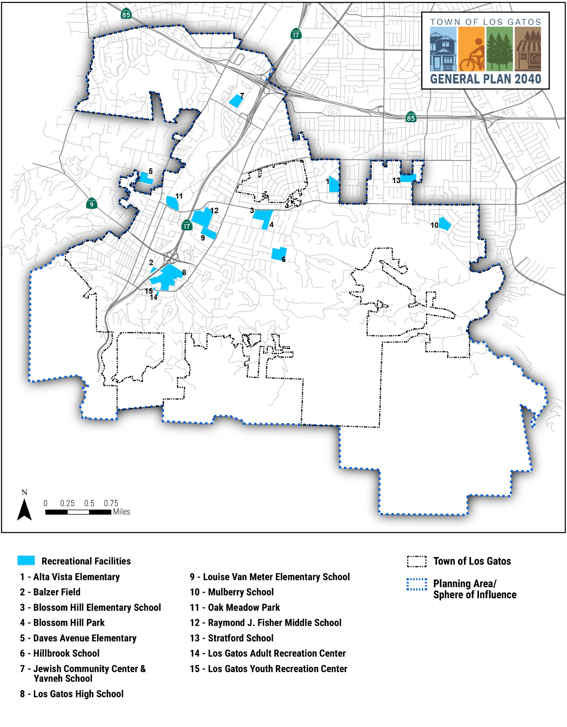

Healthcare and Social Services
Los Gatos provides a portion of its social service programming for seniors through the Los Gatos Adult Recreation Center. The Los Gatos/Monte Sereno Police Department also offers a daily senior check-in program called Operation C.A.R.E. In addition, the Town’s annual Community Grant Program provides financial resources to service providers focused on senior nutrition and other important community needs.

Housing
The Town of Los Gatos strives to provide a variety of housing alternatives to allow seniors to live independently and age in place as they so choose. These housing types include not only single-family homes, town homes, condominiums, and apartments, but also life care communities, affordable housing, shared housing, and below market rate properties.
Los Gatos has 150 subsidized units of senior housing in five developments. Villa Vasona at 626 West Parr Avenue and The Terraces of Los Gatos at 800 Blossom Hill Road contain most of these subsidized senior housing units. To ensure that Los Gatos seniors and those that are aging out of their current dwellings have accessible and affordable housing in the future, the Town needs to take a proactive approach to encouraging housing opportunities for this vulnerable population. Santa Clara County, including the residents of Los Gatos took a first step in 2016 to incentivize and provide affordable housing, with the approval of Measure A, described below.

Transportation
The Santa Clara Valley Transportation Authority (VTA) operates one public transit bus line that runs through the Town and several park-and-ride lots. The community relies primarily on non-profit organizations to provide transportation services and education for seniors in Los Gatos. The OUTREACH Senior Transportation Program, a non-profit serving Santa Clara County, provides public paratransit services as an alternative for seniors who are unable to access or use fixed route public transit. West Valley Community Services provides the RYDE (Reach Your Destination Easily) program which is a curb-to-curb transportation and local trip planning service for adults 65+ living in the west valley. The American Association of Retired People (AARP) hosts a quarterly senior driver safety course called the 55 Alive Driver Safety Program.

Recreational and Social Activities
The Los Gatos Public Library offers programs and services for both seniors and the general public on a regular basis. Examples include book clubs, arts workshops, technology tutoring, computer workshops, lectures, and author visits. The Library offers large print materials and adaptive technologies to assist community members with reading needs.
Several non-profit agencies also provide assistance and support for seniors in Los Gatos. Senior programs managed by non-profit agencies include:
- Live Oak Adult Senior Nutrition;
- Live Oak Adult Day Services; and
- West Valley Community Services.
The following goals and policies address public facilities and services in Los Gatos.

Public Health

Ensure resources and programs are available for the health needs of the entire community.

  - Retention of Hospitals
Encourage the retention of three nearby hospitals: El Camino Hospital Los Gatos; Good Samaritan Hospital; and Good Samaritan’s Mission Oaks Campus.
  - Promote Health Services
Promote health services provided by other agencies to local residents.
  - Encourage Health Care Professionals
Encourage a full array of heath care professionals to locate their practices in Los Gatos.

Foster all residents’ health and well-being.

  - Recreational Areas Throughout Town
Encourage safe and attractive places for recreational exercise within a one mile of every residence.
  - Retention of Farmers Market
Encourage the continuation of a farmer’s market in Town and community gardens in appropriate locations.
  - Pedestrian Network
Encourage pedestrian routes and sidewalks to be integrated into continuous networks.
  - Safe Disposal of Medical Related Items
Provide safe and convenient access to disposal sites for expired and unused pharmaceuticals, needles, and related items.

Youth Services

Offer a wide range of youth programs and services within the Town.

  - Youth Services
Require that the Town interact with applicable agencies and entities that provide youth services to ensure that the needs of children and teens are met.
  - Encourage Childcare Facilities
Require the Town to encourage a broad array of childcare facilities and services to meet the economic, geographic, and demographic diversity of Los Gatos.
  - Youth-Friendly Environments
Promote safe, youth-friendly environments within the Town.
  - Recreational Activities for Youth
Support organizations that offer recreational activities and events for youth.
  - Support Sports and Performing Arts Programs
Coordinate with public and private schools, local non-profits, service clubs, and other agencies to provide youth services and additional opportunities for youth to explore and enjoy sports, creative and performing arts, and future career paths.
  - Youth and Multi-Generational Volunteer Opportunities
Coordinate with local organizations to support and encourage youth and multi-generational volunteer opportunities.
  - Youth-Oriented Services
Promote learning environments where all students can receive social and economic support as well as mental health services.

Encourage civic involvement of all youth in the community.

  - Youth Commission Special Projects
Encourage the Youth Commission to explore youth concerns and opportunities, facilitate community forums, and undertake special projects.
  - Youth Commission Initiatives
Challenge the Youth Commission to develop new youth-oriented programs, events, and initiatives such as the Youth-Friendly Business Program.
  - Youth Participation in Town Activities
Encourage students from both middle school and high school and their families to participate in Town activities and to attend Council, Commission, and other public agency meetings.
  - Engage Youth in Civic Improvement Efforts
Ensure that youth are engaged in Town beautification and other civic improvement efforts.

Ensure that bicycling and walking are safe for youth throughout the Town.

  - Safe Routes to School
Promote the Safe Routes to School program, which supports safety improvements that encourage safe walking and bicycling to school.
  - Develop Youth Commute Programs
Coordinate with local businesses, organizations, and school districts to develop innovative programs, such as “Walking School Buses” and “Bicycle Trains” that encourage youth to commute to and from school in groups.

Senior Services

Ensure programs and facilities for social interaction for seniors.

  - Social Program Resource for Seniors
Require the Town to act as a resource for seniors by which seniors may locate agencies or programs that address their social problems.
  - Consult with Seniors
Consult with older adults and seniors on the services and programs they desire and need.
  - Provide a Wide Variety of Senior Services and Programs
Encourage, and facilitate to the extent possible, LGS Recreation and other service providers to provide a wide variety of senior services and programs, including daily opportunities for seniors to have physical activity, social interaction, and mental stimulation.
  - Senior and Youth Activities
Coordinate with local organizations to support intergenerational opportunities for seniors to safely interact with youth in Los Gatos.

Improve mobility and access to care and services for seniors.

  - Convenient Access to Social and Medical Services
Ensure that seniors have convenient and reasonable access to social and medical services, commercial areas, and transportation by coordinating with senior shuttle service providers.
  - Encourage Transportation Services from Senior Housing Developments
Encourage, and facilitate to the extent possible, all new senior housing developments to provide transportation services.
  - Encourage Senior Oriented Services
Encourage businesses and health care providers that serve seniors to locate in Town.

Encourage a wide variety of types of senior housing, including independent living, residential care facilities, and affordable housing within the Town.

  - Barrier-Free Design Principles
Encourage new development or substantial remodels to incorporate best practices in designing housing for seniors and people with limited abilities.
Ensure safe environments for Los Gatos seniors.

  - Public Safety Outreach to Seniors
Continue to provide daily public safety outreach and communications to seniors and their families requesting such support and track the nature and type of support requested.
 | For an expanded discussion on services and access to services for all community members, please refer to the Racial, Social, and Environmental Justice Element.
- Law Enforcement
Police protection for the Town of Los Gatos is provided by the Los Gatos-Monte Sereno Police Department (Police Department). The Town is characterized as a relatively safe community with limited crime.
The Police Department was established in 1926 to provide police protection services to the Town of Los Gatos. In 1995, the Town entered into a contract to provide police protection services to the City of Monte Sereno as well, resulting in the renaming of the department as the Los Gatos-Monte Sereno Police Department. This agreement allows for consideration of ongoing updates in law enforcement practices and more closely reflects the workload and modernized service delivery models for both the Town and the City of Monte Sereno.
The Police Department serves a combined population of approximately 34,000 residents, as well as the non-resident workforce and visitors to Los Gatos and Monte Sereno, and provides core services, including but not limited to, crime prevention and community outreach, communications and records services, response to both emergency and non-emergency calls, criminal investigations, and traffic and safety enforcement.

Facilities and Staffing
The Los Gatos-Monte Sereno Police Department has two primary locations in Los Gatos. The Police Operations building, located on Los Gatos Boulevard near Blossom Hill Road, houses the Police Operations Bureau, comprised of the Patrol Division and Investigations Division. The Operations Captain, Patrol Sergeants, Patrol Corporals, Patrol Officers, Detectives, Evidence Technician, and other support personnel are located at this site.
The Police Headquarters building is located in the Los Gatos Civic Center complex, located at 110 East Main Street in Los Gatos. This facility serves as the headquarters for Police Administration and the Support Services Bureau, which includes, the Records Division, Communications Division, Personnel and Community Services Division, and Traffic/Parking Division. The Police Department also has several specialty operational teams and collateral assignments including:
- Crime Analysis;  - School Resource Officer;  - Traffic and Motorcycle Unit;  - Canine Team;  - SWAT and Hostage Negotiation Teams; | - Bicycle Patrol Team;  - Evidence Team;  - Reserve Officer Program; and  - Homeless Encampment Resource Officer.

The Police Department, comprised of 39 sworn and 19 professional staff personnel and over 50 community volunteers, is responsible for all incorporated areas of Los Gatos and Monte Sereno. Patrol Teams consist of a Sergeant, a Corporal, and Officers. There are currently four patrol teams with shift rotations every six months. The Investigations Division consists of four Detectives, a School Resource Officer, a Sergeant, and two professional staff members.

Service Standards
The Police Department has a performance objective of “providing a safe environment through timely response and police assistance.” The Police Department categorizes calls as Priority 1, Priority 2, and Priority 3. Priority 1 calls involve either a serious emergency or public safety hazard. Priority 2 calls are those that require immediate response but are not considered an emergency. Priority 3 calls are other non-emergency calls. While most calls responded to by the Police Department relate to incidences of vandalism, domestic disputes, theft, and burglary, the Police Department does receive and respond to crimes of violence, including robbery, sexual assault, violent assault, and murder. During 2019/20, there were 9,557 calls to 911 and a total of 34,891 incidents addressed. The Town reports that response time for Priority 1 calls during FY 2019/20 averaged three minutes and 43 seconds.
The following goals and policies guide law enforcement efforts in Los Gatos.

Reduce the potential for injuries, damage to property, economic and social displacement, and loss of life resulting from crime.

  - Adequate Police Services
Support the Los Gatos-Monte Sereno Police Department to maintain adequate police staffing, performance levels, and facilities that serve the Town’s existing and future population.
  - Additional Crime Prevention Measures
Pursue community policing and other crime prevention measures for increased public safety.
Promote coordination between land use planning and law enforcement.

  - CPTED Site Planning for Crime Prevention
Emphasize the use CPTED principles in physical site planning as an effective means of preventing crime. Open spaces, landscaping, parking lots, parks, play areas, and other public spaces shall be designed with maximum possible visual and aural exposure to community residents.
  - Reduce Law Enforcement Hazards Through Project Review
Identify and mitigate law enforcement hazards during the project review and approval process.
- Fire Protection
The Town of Los Gatos is susceptible to threat from both urban and wildland fires. Fire protection services are provided to the Town by the Santa Clara County Fire Department (SCCFD). This section provides information, goals, policies, and programs related to the responsible agencies and fire protection measures currently (2020) in place. Urban and wildfire risks are discussed in the Safety Element, Section 8.4: Urban and Wildland Fire Hazards.

Santa Clara County Fire Department
The SCCFD provides ISO Class 2/2Y services for Santa Clara County and the communities of Campbell, Cupertino, Los Altos, Los Altos Hills, Los Gatos, Monte Sereno, and Saratoga, as well as the unincorporated areas adjacent to these communities. The Town of Los Gatos works with the SCCFD to protect Town residents and property from injury and damage resulting from fire hazards. SCCFD is a California Fire Protection District serving approximately 226,000 residents and 132 square miles of territory. The SCCFD provides the following services:
- Fire suppression;  - Emergency medical response;  - Rescue activities;  - Building plan review;  - Code enforcement;  - Hazardous materials regulation; | - Fire and life safety inspections for new construction, commercial businesses, multi-family residential buildings, and schools;  - Community-education and risk reduction activities;  - Emergency medical services; and  - Public education.
SCCFD includes 15 fire stations, an administrative headquarters, a maintenance facility, five other support facilities, 19 pieces of front-line apparatus, and three command vehicles. The SCCFD is budgeted to employ over 333 fire prevention, suppression, investigation, administration, and maintenance personnel, augmented with a trained volunteer staff. SCCFD maintains a 24-hour emergency response staff of 66 firefighters and officers. Figure 6-2 shows fire station locations within and adjacent to Los Gatos.
The Town of Los Gatos is home to the SCCFD Administrative Headquarters and the Winchester Fire Station, Shannon Fire Station, and Los Gatos Fire Station. The Redwood and Quito stations located adjacent to Los Gatos also provide fire protection services to the Town. Each of these five stations provides emergency medical service (EMS), Advanced Life Support (ALS), and responds to all types of fires (wildland, structure, vehicle, etc.).

Service Standards
The SCCFD has the following service standards:
Achieve a score of 95 percent or higher on citizen satisfaction survey;
Make contact with 20 percent or more of the population served and maintain Completion of Company level business inspections is greater than 85 percent;
EMS Calls: 90 percent of the time, a fire company with one paramedic arrives in under seven minutes (measured from time of dispatch to time of arrival);
Structure Fire Calls: 90 percent of the time, the first unit arrives in under seven minutes (measured from time of dispatch to time of arrival);
EMS urgent calls and structure fires: a fire company with one paramedic arrives in under five minutes (average) from time of dispatch to time of arrival;
Structure Fire Calls: Establish OSHA firefighter safety standard “2-in/2-out” on structural fires in less than nine minutes from dispatch of alarm at least 90 percent of the time;
Turnout times average for calls is under 80 seconds;
Obtain return of spontaneous circulation (ROSC) on cardiac arrest patients in the field at or better than the national average;
911 dispatchers screen for pre-arrival instructions in at least 65 percent of EMS calls and provide instructions as warranted;
Maintain annual employee injury rate below 20 percent for safety employees;
Maintain annual employee injury rate below 20 percent for all employees; and
Receive a “Clean” opinion on audited financial statements and comply with generally accepted accounting standards including any new pronouncements.

- SCCFD Facilities
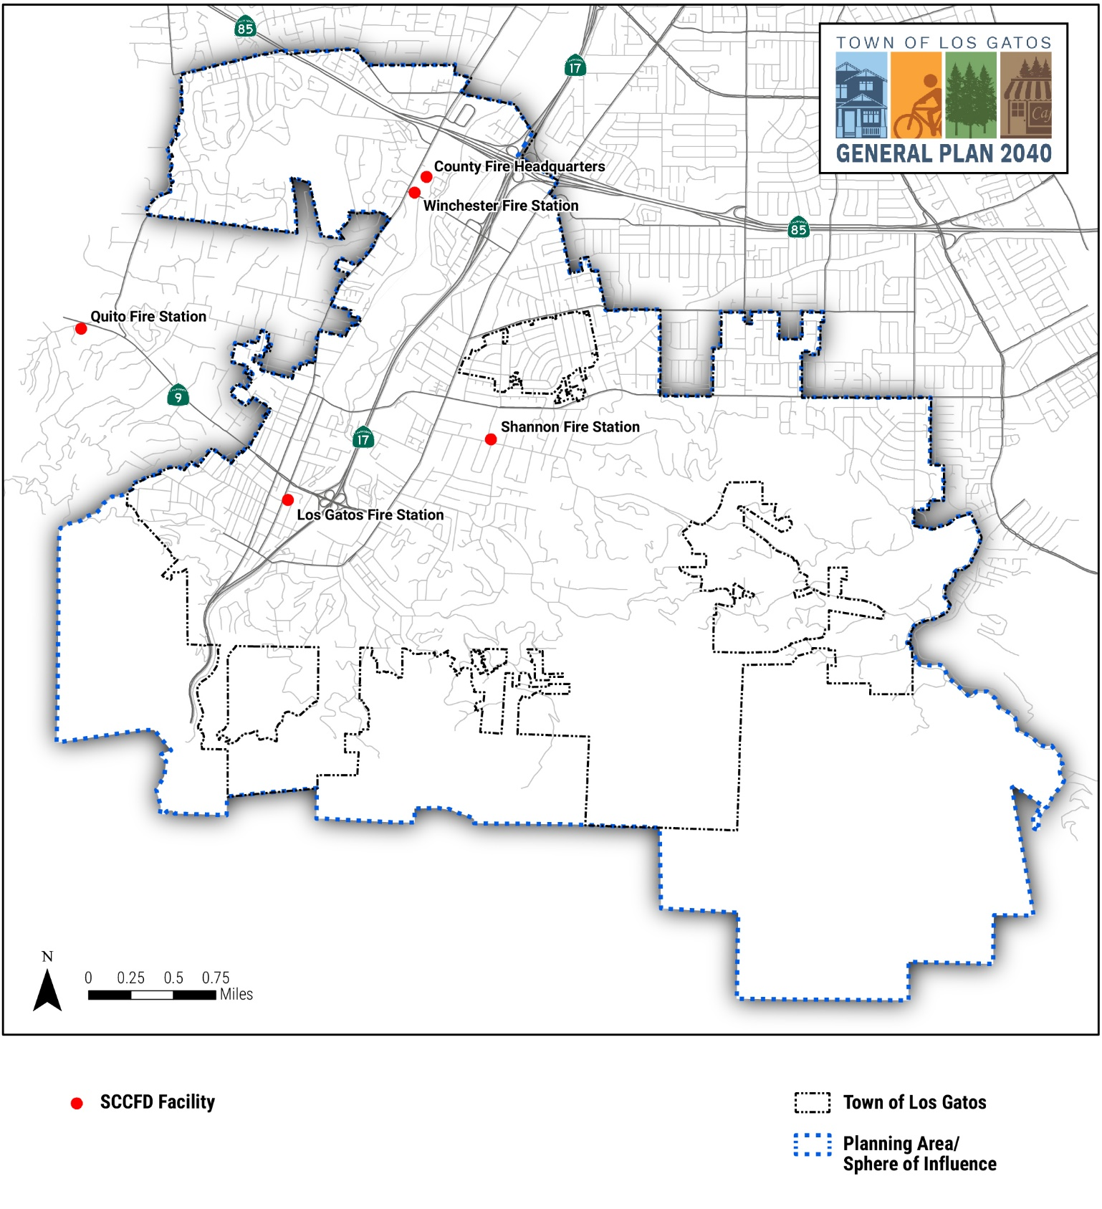
Note: The Redwood Fire Station is located south of Town beyond the area shown on map.

Community Wildfire Protection Plan
In 2016, Santa Clara County led the development of a countywide strategic plan, the Santa Clara County Community Wildfire Protection Plan (CWPP), to assist in protecting human life and reducing property loss due to wildfire. The CWPP outlines countywide issues and strategies and provides detailed information and specific projects for each of the 14 at risk communities within the county. For the Los Gatos hillside area, the Annex 9 of the CWPP provides community and parcel-level risk assessment, identifies critical infrastructure and community values at risk, creates mitigation projects, and prioritizes to proactively address wildfire risk. The CWPP is maintained by SCCFD.
 | Additional policies relating to wildfire risk, assessment, and mitigation are covered Section 9.2 (Urban and Wildland Fire Hazards) in the Hazards and Safety Element.

The following goals and policies guide fire protection efforts in Los Gatos.

Provide adequate fire protection and emergency medical response services to Town residents and businesses.

  - First Response Travel Time
Work with the SCCFD to ensure that first response travel time is maintained and enhanced where possible.
  - Emergency Response Facilities and Personnel
Work with the SCCFD to continue to increase the emergency response facilities and personnel necessary to meet residential and employment growth in the Town.
  - Fire Safety Requirements for New Developments
New development shall be required to incorporate and identify the location of the anticipated water supply, adequate emergency water flow, fire resistant design and materials, and evacuation routes.
  - Emergency Vehicle Accessibility
New development shall be accessible to emergency vehicles and shall not impede the ability of service providers to provide adequate emergency response.

Promote coordination between land use planning and fire protection.

  - Adequate Roadways for Fire-Fighting Apparatus
Require that new, existing, and non-conforming roadways, specifically those in SRA and VHFHSZ areas are constructed and updated to reflect contemporary fire safe standards in terms of width, radius, and grade in compliance with SCCFD requirements. At a minimum, new and improved roadways shall accommodate SCCFD fire-fighting apparatus, while maintaining Los Gatos’s neighborhoods and small-town character.
  - Fire Hazard Mitigation in Project Review
Identify and mitigate fire hazards during the project review and approval process.
  - Fire-Related Design Requirements
New development shall satisfy fire flow and hydrant requirements and other fire-related design requirements as established by the Town and recommended by the SCCFD.
  - Fire Suppressing Systems and Materials
Ensure compliance with California Fire and Building Code requirements for the installation of interior emergency sprinkler systems, fire-resistant building materials, early warning systems, and sufficient water supply systems for fire suppression in new development and remodels.
  - Secondary Emergency Access
Identify and secure secondary emergency access in new and, when feasible, existing development in locations that are identified as Very High Fire Hazard Areas on the Town’s Wildland Fire Severity Zone Map, as recommended by the SCCFD.
- Emergency and Medical Services

Emergency Services
The SCCFD provides emergency services to the Town of Los Gatos and the other communities and adjacent unincorporated lands in its service area, including the entire Los Gatos Planning Area. Emergency services provided by the SCCFD include technical rescue, hazardous materials response, emergency medical services, and emergency disaster management.

Emergency Operations Plan
The Town of Los Gatos adopted a comprehensive Emergency Operations Plan (EOP) in 2015, and it is currently being updated through its 5-year review. The EOP identifies the existing hazards within the Town, provides guidance and education on effective and skillful emergency response techniques, and ensures the most effective coordination of resources for protection of people and property in time of an emergency. In addition, annexes to the EOP will cover specific planning and response for the following topics:
- Aviation Disaster;  - Civil Disturbance;  - Dam Failure;  - Earthquake;  - Extreme Weather/Storm; | - Urban Fire;  - Floods;  - Landslides;  - Hazardous Materials Risks;  - Heat Wave; | - Public Health Emergency;  - Terrorism;  - Transportation-Highway Risks; and  - Wildland Fire.

Emergency Operations Center
The EOP identifies the Town’s Emergency Operations Center (EOC) as the location from which centralized emergency management would be performed during a major emergency or disaster, including receiving and disseminating information, maintaining contact with mutual aid partners and other EOCs, and providing instructions to the public. The EOC is located at the Police Department Operations Building on Los Gatos Boulevard.

Disaster Aid Response Team
Founded in 1982, The Disaster Aid Response Team (DART) is an organization of citizen volunteers trained to assist the Police Department in its emergency and service function. DART serves Los Gatos, Monte Sereno, and the surrounding communities. DART has members trained in:
- Technical rescue;  - Medical intervention;  - Swift water rescue;  - Scuba diving; | - Emergency radio communication;  - Traffic control; and  - A variety of other skills necessary for effective search/rescue and disaster assistance.

Community Emergency Response Team
Many neighborhoods in Los Gatos and Monte Sereno have organized for disaster preparedness. Sponsored by the Federal Emergency Management Agency (FEMA), the Community Emergency Response Team (CERT) is one of the most visible Town emergency preparedness organizations. In conjunction with the Town of Los Gatos, SCCFD offers a 20-hour course training in disaster preparation response and recovery skills. Sessions include:
- Disaster preparedness;  - Light search and rescue;  - Damage assessment;  - Disaster fire suppression;  - Disaster medical operations; | - Neighborhood preparedness;  - Terrorism/Hazmat;  - Disaster psychology; and  - CERT team organization.

During disasters, police and fire department personnel may be unavailable to respond to all emergency events. CERT members may be called upon to serve in their neighborhoods, as well as areas outside of their immediate neighborhoods.

Los Gatos Prepared
Los Gatos Prepared is an emergency response program empowering community self-sufficiency when disaster strikes. The program works toward a goal of every resident and business in Los Gatos having the awareness, skills, and resources necessary to be self-sufficient in the event of a disaster or other emergency.
Los Gatos Prepared holds informational community events, organizes and promotes CERT events and training, and provides informational resources on topics such as emergency preparedness for seniors, mental health in times of disaster, service interruptions, and evacuation planning.

Emergency Medical Facilities
The availability of primary care has a role in preserving good health and preventing morbidity and hospitalizations from chronic and communicable diseases. Figure 6-3 shows the location of health care facilities in Los Gatos.
 | Goals and policies pertaining to public health emergencies and associated response, action, and mitigation techniques are covered Section 9.1 (Emergency Preparedness, Response, and Recovery) in the Hazards and Safety Element.

El Camino Hospital
El Camino Hospital is a nonprofit organization with hospital campuses in the Town of Los Gatos and the City of Mountain View. The Los Gatos campus is a 143-bed acute care facility, that provides a full range of care, including emergency care, maternal child health services, general and outpatient surgery, and specialized programs, such as men’s health, urology, sleep disorders, and orthopedics. The Los Gatos campus also includes a clinic, a Breast Health Center, and a Sleep Center.

Good Samaritan Hospital
Good Samaritan Hospital is a 474-bed acute care hospital with two locations serving Santa Clara County. The main campus is located at 2425 Samaritan Drive in San Jose, just a few blocks from the Town of Los Gatos. The Mission Oaks campus is located at 15891 Almaden Road in Los Gatos.

- Health Care Facilities
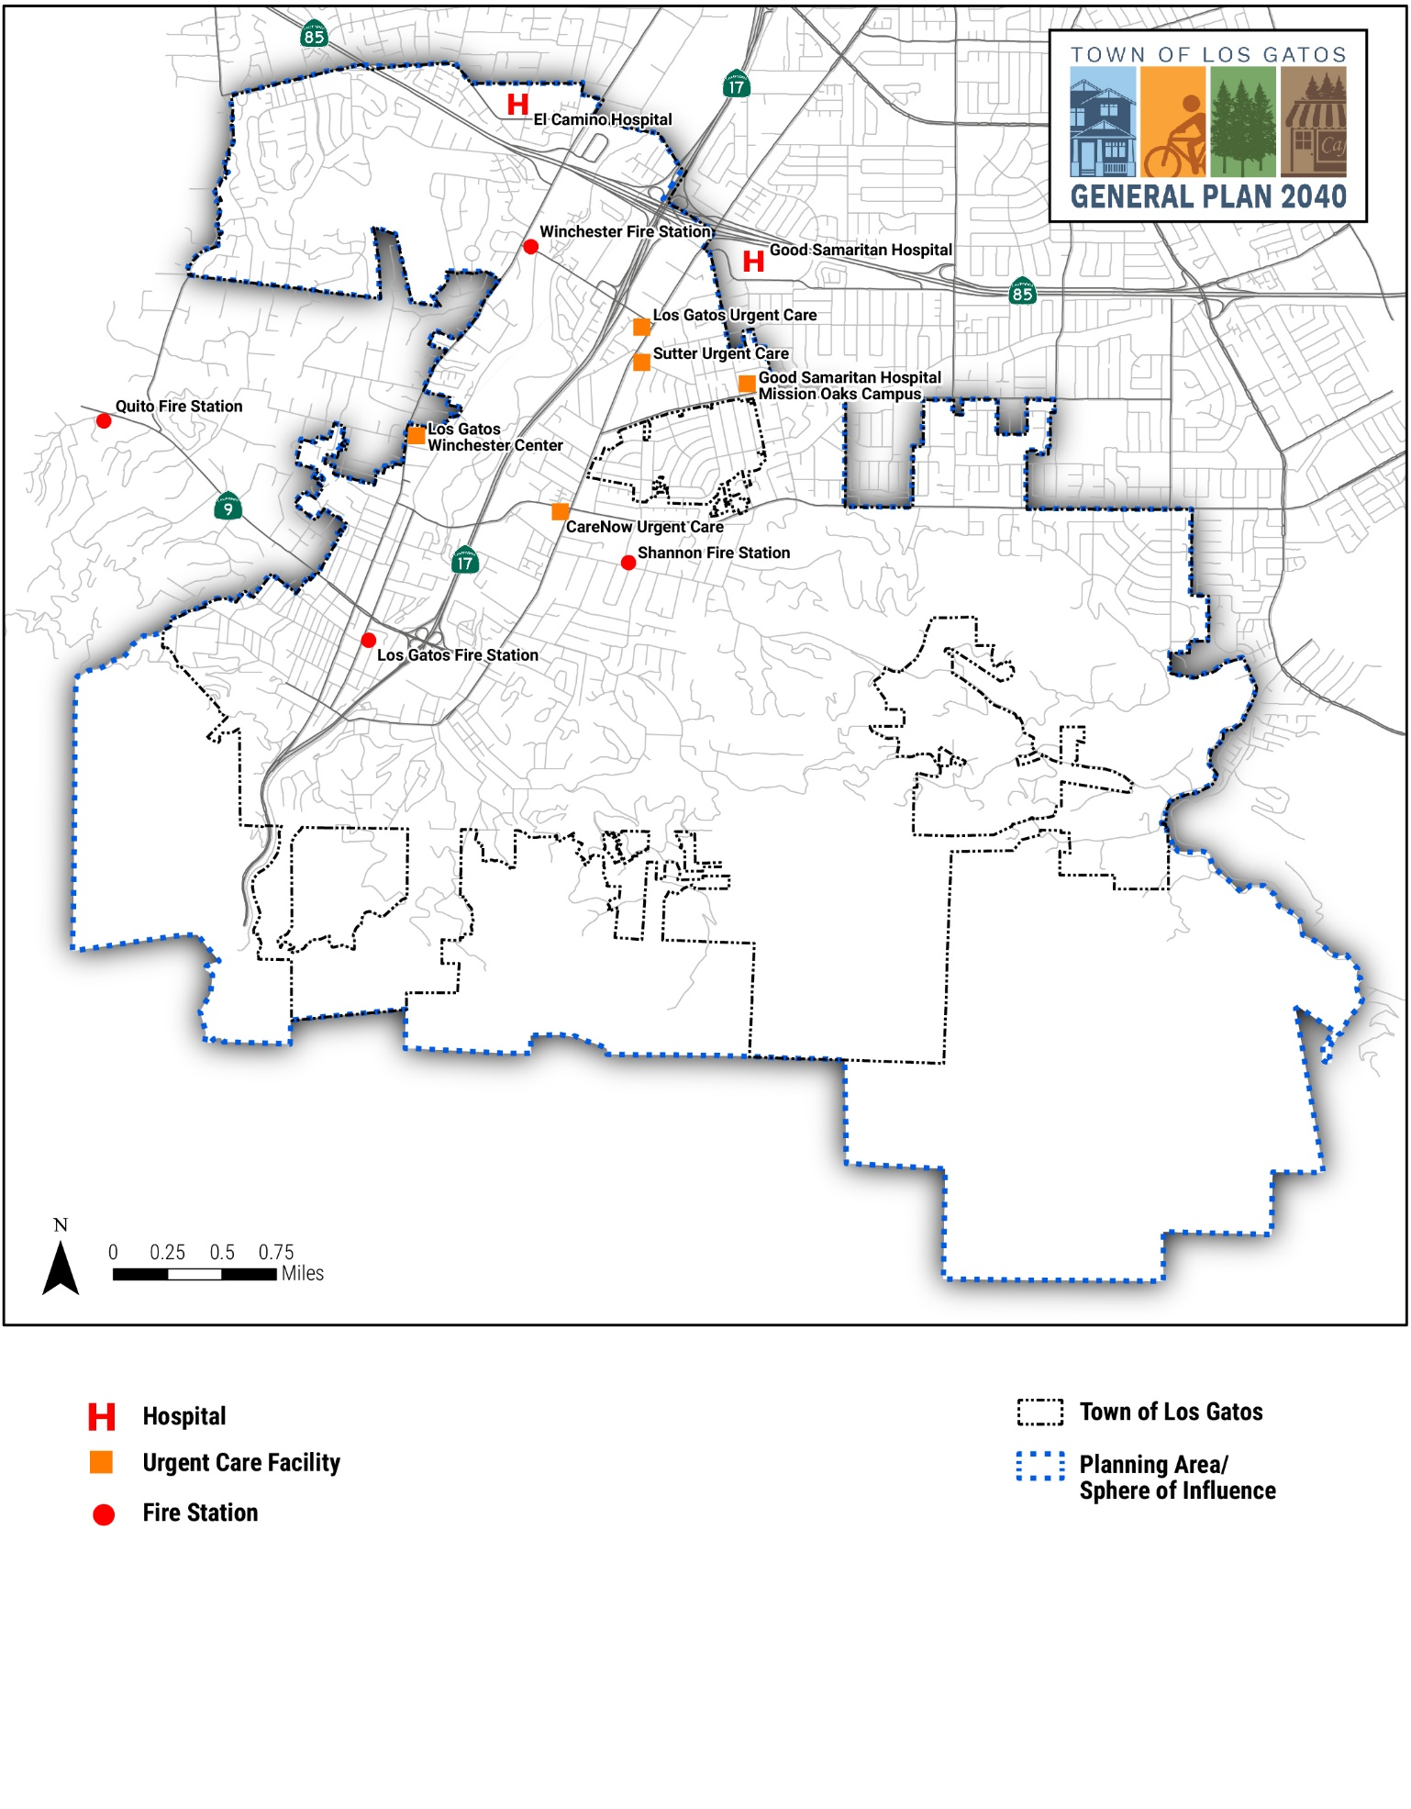
Hospital services include emergency care, anesthesia and pain management, cancer care, cardiology, children’s services, emergency care, general surgery, rehabilitation, robotic surgery, women’s services, and wound care. Hospital facilities also include a birthing center, breast care center, a comprehensive stroke center, heart rhythm center, and joint replacement center. Good Samaritan Hospital is a certified Comprehensive Stroke Center, STEMI Receiving Center, accredited Chest Pain Center, and a certified Afib Center.

Urgent Care Facilities
Los Gatos is also supported by urgent care facilities located throughout the Town, including CareNow which also provides occupational health services and x-ray services for minor injuries.
The following goal and policy address emergency and services in Los Gatos.

Reduce the potential for injuries, damage to property, economic and social displacement, and loss of life resulting from emergencies.

  - Emergency Response Planning
Maintain up-to-date preparedness and response plans for fire, flood, earthquake, hazardous materials, and other emergencies.
- Schools and Lifelong Learning
Quality education is important to the residents of the Town. However, while local land use and development decisions may impact school facilities, mitigation for school impacts required of developers may be limited by State legislation or other factors.

School Districts
Six different school districts serve the residents of the Town of Los Gatos. These are the Los Gatos Union School District, Los Gatos-Saratoga Joint Union High School District, Campbell Union School District, Campbell Union High School District, Cambrian Union Elementary District, and Union Elementary School District. In addition, nearby West Valley Community College, located in the City of Saratoga, offers academic and career programs. The location of schools in Los Gatos is shown on Figure 6-4.

Los Gatos Union School District
The Los Gatos Union School District has four elementary schools and one middle school providing educational services to the children of Los Gatos:
- Blossom Hill Elementary School (16400 Blossom Hill Road);
- Daves Avenue Elementary School (17770 Daves Avenue);
- Lexington Elementary School (19700 Old Santa Cruz Highway);
- Van Meter Elementary School (16445 Los Gatos Boulevard); and
- Raymond J. Fisher Middle School (19195 Fisher Avenue).
All the elementary schools serve kindergarten through grade 5. Raymond J. Fisher Middle School serves Los Gatos students in grades 6 through 8.

- Schools in Los Gatos
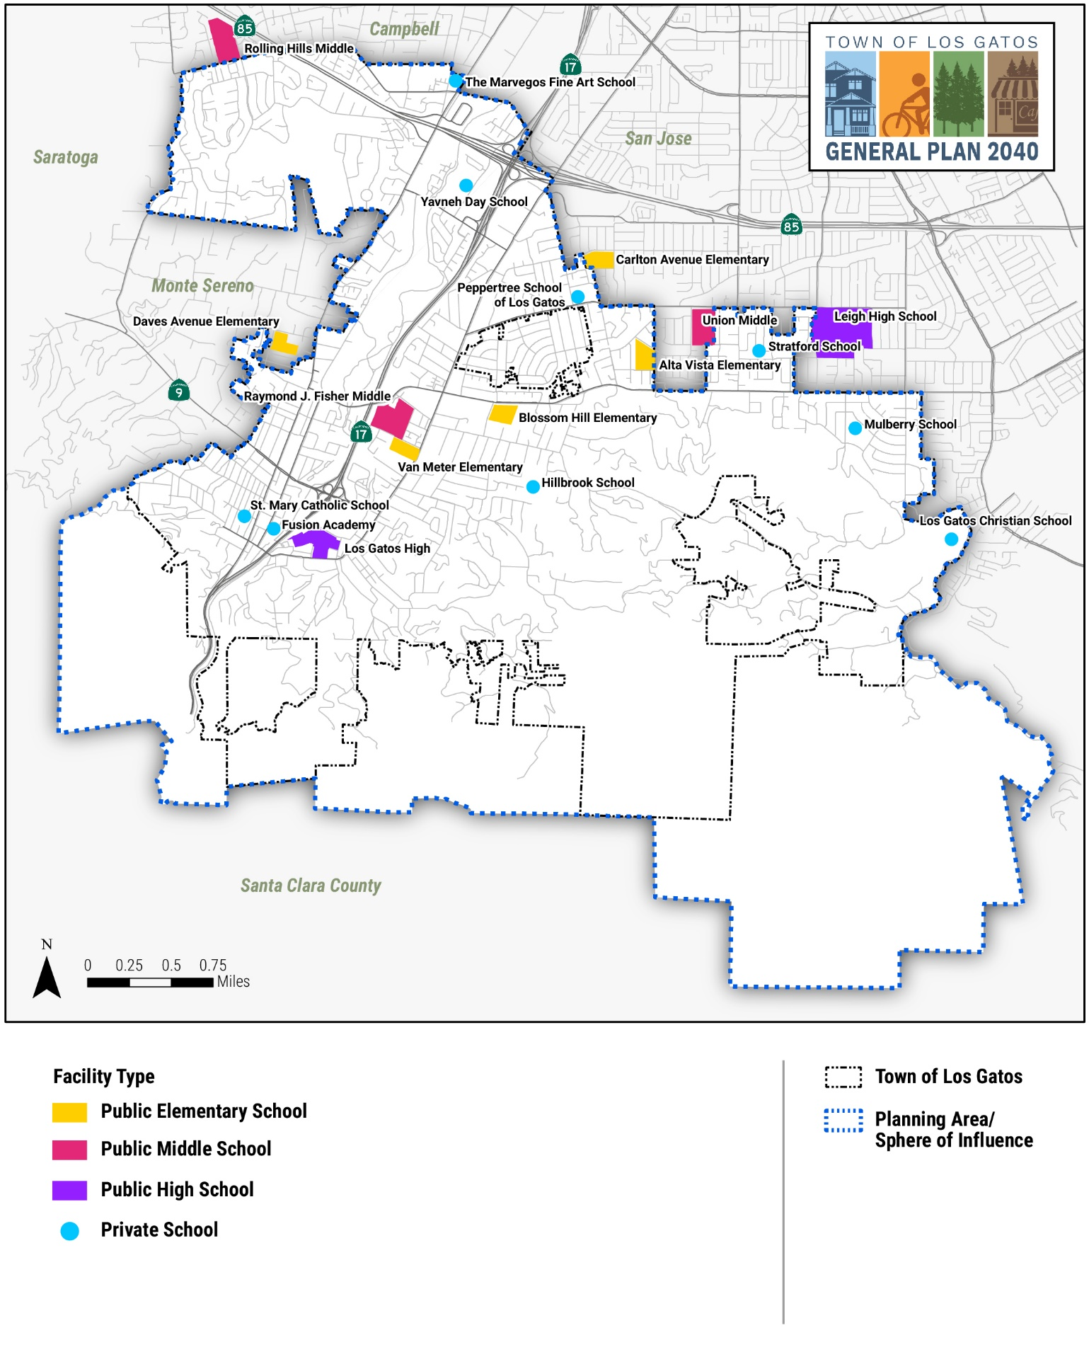

Los Gatos-Saratoga Joint Union High School District
The Los Gatos-Saratoga Union High School District has two high schools, Los Gatos High and Saratoga High, which serve over 3,400 students from unincorporated Santa Clara County as well as the communities of Los Gatos, Monte Sereno, and Saratoga. Each school offers grades 9 through 12.

Campbell Union School District
More than 7,500 students from the communities of Campbell, Los Gatos, Monte Sereno, San Jose, Santa Clara, and Saratoga attend the 12 schools within the Campbell Union School District. The four schools within the District that serve the Town of Los Gatos are Capri, Forest Hill, and Marshall Lane Elementary Schools (serving K-5 grades), Rolling Hills Middle School (serving 6-8 grades).

Campbell Union High School District
Campbell Union High School District serves 8,043 students at seven campuses, five of which are traditional public high schools: Branham; Del Mar; Leigh; Prospect; and Westmont High Schools. The District also has an alternative school, Boynton High School, which serves a variety of special needs in the community, an adults and continuing education school, Campbell Adult and Community Education, and a school that focuses on at-risk youth, Camden Community Day School. Both Prospect and Westmont High Schools serve the Town of Los Gatos.

Cambrian Union Elementary School District
Cambrian Union Elementary School District serves approximately 3,591 students enrolled in four elementary schools (serving K-5 grades) and one middle school (serving 6-8 grades). The Farnham Elementary School, located in San Jose at 15711 Woodard Road, is the only school in this district that serves Los Gatos students.

Union Elementary School District
Union Elementary School District serves approximately 4,400 students enrolled in six elementary schools (serving K-5 grades) and two middle schools (serving 6-8 grades). The Alta Vista Elementary School serves Los Gatos students.

West Valley Community College
Located within the City of Saratoga and serving Los Gatos residents, West Valley Community College offers career programs, professional certificates, and degree programs with preparation for transfer to four-year colleges and universities.
The following goals and policies address schools and education in Los Gatos.

Maintain a system of open communications between the Town, school districts, and the development community in order to coordinate the activities of each to achieve the highest quality of education for all students.

  - Evaluate Demographic Changes
Cooperate with school districts in identifying and evaluating population and demographic changes that may impact schools.
  - Alternative Uses of School Sites and Facilities
Encourage alternative uses of school sites and facilities, subject to conditions that will protect the surrounding neighborhood.

Lifelong Learning
Lifelong learning is an ongoing, voluntary, and self-motivated pursuit of knowledge, primarily for personal enjoyment and satisfaction. The term recognizes that learning is not confined to formal education and job training but takes place throughout life and in a range of situations.
The following goal and policies address childcare and lifelong learning in Los Gatos.
Enhance the educational and financial support system serving the Town to the benefit of all residents, from childcare through adult education within the community.

  - Enhancing Availability
Coordinate with local school districts, park districts, childcare providers, and pre-schools to identify opportunities to implement additional childcare and childhood development programs throughout the Town.
  - Employer Sponsored Childcare
Work with commercial development applicants for single users employing more than 100 persons to provide on-site childcare or offset the costs of off-site childcare for employees.
  - Grant Funding
Coordinate with the school district and community organizations to pursue grant funding for programs designed to improve schools and State standardized test scores.
  - Continuing Education
Encourage local colleges, vocational schools, and technical training institutes to maintain and improve continuing education courses and certificate programs, including opportunities for on-line learning.
- Libraries
The Town of Los Gatos is the primary service provider for library services. The Town has one public library located within the Town’s Civic Center complex. The 2-story, 30,000-square foot LEED Gold-certified library was opened in 2012, replacing the original 1964-built civic center library. In 2020, the Library had 32,000 active library card users, served 280,000 visitors, and circulated 419,000 items. The Library includes: a separate space for children’s story-telling programs; a separate teen room; reading and study areas for users of all ages; computer areas for research, internet access, and technology education; laptop areas; additional self-checkout machines; and space for the Town’s extensive history collection. The Library has open, airy seating areas filled with natural light, and added space for adult and youth book collections and multi-media collections. The current Library collection consists of books, ebooks, audiobooks, magazines and periodicals, newspapers, video and audio media, microfilm, and reference materials. The collection includes 155,000 physical items and 923,000 digital items. The Library also subscribes to computerized databases which provide access to thousands of archived newspapers, periodicals, primary source documents, reference works, streaming content, and media files. These databases are accessible on library computers and remotely using a library card number. Reference Librarians are available to assist in locating materials in the Library.
In addition to reference and checkout services, the Library offers: story-times; after-school programs; volunteer reading programs; book discussion groups; knitting groups; computer and internet access; wireless internet access; internet classes; summer reading programs; and Friends of the Library programs, featuring special speakers, artists, and performers. In 2020, the Library held 895 community programs serving 25,000 people, including adults, youth, teens, and community audiences. All programs are open to the public and are free of charge.
The following goal and policies address libraries in Los Gatos.

Provide a library facility that will accommodate library services to meet the educational and informational needs of the community.

  - Access to Library Services
Ensure that all residents have access to Library services, including electronic resources, technology resources, and a range of operating hours.
  - Maintain Relevance of Library
Maintain the Library as an important activity center within the community.
- Town Arts
The Town of Los Gatos has a rich history as a center of arts and literature and the home to both historical and contemporary artists of renown. And today, Los Gatos maintains a thriving arts community that is invaluable to people of all ages in the Town. The Town has committed to protecting and promoting its cultural resources, including theaters, museums, art galleries, and public art. The Town also strives to further attract and encourage performing arts in Los Gatos, including live theater, music, and dance, as well as the literary arts, including author events and poetry.
Los Gatos’s Arts and Culture Commission is actively involved in promoting cultural events and public art displays in the Town. The Arts and Culture Commission is an advisory group to the Town Council and works to encourage the development of music, drama, art, and other cultural and creative activities. One of the seven members of the Arts and Culture Commission is a Youth Commissioner, appointed by the Youth Commission.
The Town supports a wide variety of cultural experiences including the Music in the Park Summer Concert Series, the annual July Fourth musical celebration, and public art in the Council Chambers and throughout the community. Music in the Park is a free summer concert series held Sunday afternoons on the Civic Center Lawn which has been running since 1988. Arts in the Council Chambers displays exhibits throughout the year. The Forbes Mill Footbridge children’s murals span Highway 17 and link Forbes Mill to Old Town. The Banner Project incorporates public art in Downtown banners. The Utility Box program covers local utility boxes with artwork created by Town residents. Many of these efforts are supported or led by the Arts and Culture Commission.
Los Gatos has a museum – the New Museum of Los Gatos (NUMU). NUMU has been a key cultural element of the Town since its founding in 1965, contributing to the unique character of Los Gatos. The Museum’s stated mission is to engage the community at the intersection of art, history, and education through innovative, locally connected, and globally relevant exhibits, programs, and experiences. NUMU actively partners with many community organizations and Town departments and government leaders to make programs accessible and responsive to the community. The Museum is the custodian of an extensive art and history collection and works with the Los Gatos Library and other resources to enrich an understanding of our cultural heritage.
The following goal and policies address the arts in Los Gatos.

Enrich the Town by making visual arts, the performing arts, literary arts, and other cultural amenities more accessible to the Town’s residents.

  - Incorporation of Art-Related Uses
Encourage and maintain art-related uses (theaters, museums, and art galleries) in new and remodeled retail development.
  - Support and Maintain Arts Programs
Continue to support and maintain community-based, musical, and other arts programs in an effort to collect, archive, and share the stories and histories of Los Gatos residents through a variety of platforms and voices.
  - Performing Arts Facilities
Encourage new or expanded public and private facilities to host performing arts events.
  - Encourage Private and Public Funding for the Arts
Encourage private and public funding, development, and operation of cultural amenities, activities, and centers.
  - Facilitate Cross-Disciplinary Collaboration
Encourage all local arts groups and artists to collaborate and partner across disciplines, media, and venues for a richer and more diverse cultural experience.
  - Expand and Deepen Partnerships
Retain art-related uses, with the objective of retaining the museum and art organizations in Town.
  - NUMU and the Visual Arts
Continue to support the growth of NUMU, its visual arts program, local history and education programming, and the stewardship of its Art and History Collections for service to and benefit of, visitors and participants of all ages.
- Healthy Community
A healthy community promotes a positive physical, social, and economic environment that supports the overall well-being of its residents. While other parts of the General Plan also touch on aspects of health and quality of life, the purpose of section is to promote a healthy lifestyle and improve residents’ quality of life.
 | Outdoor activity is also part of a healthier community. Bicycle and pedestrian options are covered in Section 5.2 (Bicycle and Pedestrian Facilities) in the Mobility Element and in Section 6.2 (Parks and Recreation) in the Open Space, Parks, and Recreation Element.

The following goal and policies address health in Los Gatos.

Ensure all residents have access to healthy foods, including plant-based options.

  - Healthy Food Options
Encourage farmer’s markets and healthier food options within neighborhoods or near child-oriented uses (e.g., schools, day care, and parks).
  - Limit Concentrations of Alcohol and Tobacco
Establish zoning code requirements to guide locations and restrict concentrations of businesses selling alcohol and tobacco near sensitive land uses.
  - Healthier Diet Options
Support programs that guide healthier diet and plant-based eating options within the community.
  - Support Santa Clara County Efforts
Support Santa Clara County efforts and public health programs that improve access to healthy foods, address food inequities, and provide food education to help residents make healthier food choices.
  - Support Acceptance of Government-Issued Vouchers
Support the acceptance of Government-issued food vouchers (such as WIC and Cal FRESH) via an Electronic Benefit Transfer (EBT) card at food retailers and farmers markets.
  - Healthy Food at Government-sponsored Events
The Town shall provide healthy foods at Town-sponsored meetings and events when food is provided.
  - Nutritional Vending Machine Options
The Town shall encourage nutritional options for vending machines in Town-owned and leased locations.
- Implementation Programs
Programs |  | Implements Which Policy(ies) | Responsible  Supporting Department(s) | 2020 – 2025 | 2026 – 2040 | Annual | Ongoing
 | Water Efficient Landscape Ordinance  Review and update the Town’s Water Efficient Landscape Ordinance with improved large landscape conservation programs and agency incentives for non-residential customers. | PFS-1.1  PFS-1.2  PFS-1.3  PFS-1.4 | Community Development | ■
 | Water Audit Programs  In collaboration with efforts by local water purveyors, promote water audit programs that offer free water audits to single-family, multi-family, large landscape accounts, and commercial customers. Collaborate with purveyors to enact conservation programs for commercial, industrial, and institutional (CII) accounts and create programs to install ultra-low-flush toilets in facilities. | PFS-1.1  PFS-1.4  PFS-1.5  PFS-1.6 | Parks and Public Works  Community Development | ■
 | Artificial Turf  Determine the appropriate use of artificial turf. | PFS-1.1  PFS-1.2 | Parks and Public Works  Community Development |  | ■
 | Dual Plumbing Incentives  Develop incentives for dual plumbing in new development. | PFS-1.6 | Community Development | ■
 | Evaluate Development Impacts on Water Drainage  Development projects on riparian lands or undeveloped watershed areas that require environmental reviews shall include detailed evaluations of the individual and cumulative impacts on water drainage and contamination. | PFS-3  PFS-3.1 | Parks and Public Works  Community Development |  | ■
 | List of Priorities for Storm Drain System Improvements  Develop a list of priorities for improvements to the storm drain system based upon the Storm Drain Master Plan. | PFS-3  PFS-3.1 | Parks and Public Works | ■
 | Waste Education  Expand educational programs to inform residents about reuse, recycling, composting, waste to energy, and zero waste programs. | PFS-4.2 | Parks and Public Works |  |  |  | ■
 | Energy Saving Steps  Continue to adopt the following energy saving steps for Town facilities and operations:  - Conduct, with assistance from PG&E, a thorough energy audit of all Town facilities to identify cost-effective opportunities for conservation and use of solar energy systems;  - Establish realistic yearly goals for reductions in Town energy costs and keep Town personnel aware of program status; and  - Establish a fuel conservation program for the Town vehicle fleet and require Gas Cap driver training for all employees who use fleet vehicles. | PFS-6.1  PFS-6.2  PFS-6.3 | Parks and Public Works |  |  |  | ■
 | Improve Efficiency in Existing Buildings  Study possible measures to improve energy and water efficiency in existing buildings. | PFS-6.1  PFS-6.2  PFS-6.5 | Parks and Public Works | ■
 | Encourage Sustainable Purchasing Practices  Develop policies, incentives, and design guidelines that encourage the public and private purchase and use of durable and nondurable items, including building materials, made from recycled materials or renewable resources. | PFS-7.1  PFS-7.3 | Finance | ■
 | Energy Conservation Requirements  Amend the Town Code to establish regulations, in addition to Title 24 requirements, that promote and require the conservation of energy and the use of renewable energy sources. | PFS-7.1  PFS-7.2  PFS-7.4  PFS-7.5  PFS-7.9 | Community Development | ■
 | Outdoor Lighting Standards  Establish outdoor lighting standards in the Town Code to address energy efficiency. | PFS-7.1  PFS-7.9  PFS-7.10 | Community Development | ■
 | Green Building Requirements  Consider adopting the Santa Clara County Cities Association recommendations or regional standards/recommendations for green building requirements. | PFS-7.1  PFS-7.3  PFS-7.10 | Community Development |  | ■
 | Staff Training  Train all plan review and building inspection staff in green building and energy efficiency materials, techniques, and practices. | PFS-7.1  PFS-7.2  PFS-7.8 | Community Development | ■
 | Facilitate Green Building Practices  Identify and remove regulatory or procedural barriers to implementing green building practices in the Town, by updating codes and guidelines, and identifying incentives for LEED certification or similar. | PFS-7.1  PFS-7.2  PFS-7.3  PFS-7.4  PFS-7.5  PFS-7.9  PFS-7.10 | Community Development | ■
 | LEED Certification Feasibility Study  Study the feasibility of requiring LEED certification for all or certain new projects. | PFS-7.10 | Community Development |  | ■
 | LEED Exceptions Program  Establish a LEED Certification Exception Program and Checklist for small businesses who can prove it is financially infeasible to cover the costs for LEED Certification, but still want to reap the benefits, while implementing required sustainable building and construction practices. | PFS-7.10 | Community Development | ■
 | Annual Review of Health and Service Programs Program Review  Annually review health services programs the Town supports to assure they meet the health needs of target groups. | PFS-8.2  PFS-13 | Town Manager |  |  | ■
 | Identification of Missing Services  Identify health services that are not readily available in Los Gatos and add them to the Town’s economic vitality efforts. | PFS-8.2  PFS-8.3 | Town Manager | ■
 | Identify the Needs of Youth  Town staff shall meet with agencies as needed to identify the needs of youth in the community. | PFS-10.1 | Town Manager  Library |  |  |  | ■
 | Conduct Youth Needs Assessment  Coordinate with community partners to conduct a needs assessment for: youth facilities, activities, employment opportunities, and programs; prioritize results; and implement as feasible. | PFS-10.1  PFS-10.3  PFS-10.7 | Town Manager  Library |  | ■
 | Display of Youth Artwork  Encourage youth art by periodically displaying youth artwork in gallery space in the Town Council Chambers, Library, and the Civic Center. | PFS-10.5 | Town Manager  Library | ■
 | Develop Internet Safety Program  Work with the Library, Police Department, and LGS Recreation to create a program to educate youth about internet use safety. | PFS-11 | Town Manager  Library  Police Department | ■
 | Encourage Positive Behavioral Choices  Work with local schools and other community organizations to educate and encourage positive behavioral choices. | PFS-11 | Police Department |  |  |  | ■
 | Promote Youth and Senior Programs  Continue to utilize traditional communication tools and new media and technology to promote youth and senior programs as best suited to meet their needs. | PFS-11.1  PFS-11.2  PFS-11.3  PFS-12.3  PFS-13.3  PFS-14.3 | Town Manager  Library  Police Department |  |  |  | ■
 | Involve Youth Commission  Create additional opportunities to involve the Youth Commission with other Town Commissions. | PFS-11.1  PFS-11.2  PFS-11.4 | Town Manager |  |  |  | ■
 | Continuation of Community Unity Program  Continue the Community Unity program to encourage youth and adult volunteer opportunities and access to resources. | PFS-11.3  PFS-11.4 | Town Manager  Police Department |  |  |  | ■
 | Support Family Education  Support continuation of positive parenting and family relationship courses and programs provided by regional agencies and other resources. | PFS-13 | Library  Police Department |  |  |  | ■
 | Develop Bicycle and Pedestrian Safety Classes for Youth  Coordinate with local organizations and school districts to develop a program to offer bicycle and pedestrian safety and education classes for youth. | PFS-12.1  PFS-12.2 | Parks and Public Works  Police Department |  | ■
 | Identification of Safety Improvements  Identify safety improvements that will allow for safe walking and bicycling to schools. | PFS-12.1  PFS-12.2 | Parks and Public Works  Police Department | ■
 | Teen Driver Safety Program  Coordinate with schools and the Police Department to develop and implement a teen driver safety program. | PFS-11.2 | Town Manager  Police Department |  | ■
 | Collaboration with LGS Recreation  Collaborate with the LGS Recreation and other local organizations to develop a program to provide additional social, educational, recreational, and fitness programs for seniors. | PFS-13.3 | Town Manager | ■
 | Connect with Seniors  Connect seniors with existing resources in the community. | PFS-14.1  PFS-14.3 | Town Manager |  |  |  | ■
 | Set Funding Priorities  Annually set funding priorities which include funds for senior needs. | PFS-14.2  PFS-14.3 | Town Manager  Finance | ■
 | Coordination with VTA  Seek funding and coordinate with VTA to provide lower prices or subsidized public transit fares for seniors. | PFS-14.2  PFS-14.3 | Parks and Public Works  Town Manager | ■
 | Development of Senior Oriented Housing Options  Identify incentives for the development of a variety of types of senior housing, including independent living, and residential care facilities. | PFS-15 | Community Development |  | ■
 | Update Disaster Preparedness Tools  Update as needed, communication tools to encourage disaster preparedness for neighborhoods, and make it available to all residents. | PFS-21.1 | Town Manager  Police Department | ■
 | Update Emergency Management Plans  Regularly update the Town’s emergency management plans and make available to residents and businesses. | PFS-21.1 | Town Manager  Police Department  Fire Department  Parks and Public Works  Community Development |  | ■
 | Funding Opportunities for the Library  Investigate various funding mechanisms for ongoing operation and expansion of the library facility, services, and programs. | PFS-24.1  PFS-24.2 | Library Services  Town Manager |  |  | ■
 | Develop Design Guidelines for Art-Related Uses  Develop design guidelines to encourage incorporation of art and art-related uses in new and remodel developments. | PFS-25.1 | Community Development |  | ■
 | Performing Arts Center Feasibility Study  Study the feasibility of a performing arts center for the Town, including options for location and financing. | PFS-25.3  PFS-25.4 | Town Manager  Community Development |  | ■
 | Feasibility Study for an Art and History Museum  Study the feasibility of dedicating a permanent location for an art and history museum to support and enhance the innate character of the Town. | PFS-25.7 | Town Manager  Community Development |  | ■
 | Limit Alcohol and Tobacco Outlets  Explore establishing zoning code limitations on the density of alcohol and tobacco outlets near sensitive receptors such as schools, childcare facilities, senior housing, parks, etc., consistent with State law. | PFS-26.2 | Town Manager  Community Development | ■

