City of San Carlos
Safety Element Update Vulnerability Assessment
October 2021

Introduction
California Senate Bill (SB) 379, adopted in 2015, requires a jurisdiction’s General Plan Safety Element (Safety Element) address relevant climate adaptation and resiliency strategies. The Safety Element update must include a Vulnerability Assessment that identifies the specific risks that climate change poses to the local jurisdiction. The resulting Safety Element must respond to this assessment by including a set of goals, policies, and objectives that addresses identified risks.

This Vulnerability Assessment analyzes the risks that climate change poses to San Carlos consistent with SB 379. It includes an assessment of:

- The community’s exposure to past, current, and projected climate hazards, and
- Responsible agencies and their ability to respond and address climate change impacts.

The Safety Element will build upon this assessment with updated goals and policies that would comprehensively address climate change as required by state law.

Information available from federal, state, regional, local agencies, and consultants used in development of this assessment include:

- The Cal-Adapt tool.
- The most recent version of the California Adaptation Planning Guide.
- Local agencies on the types of assets, resources, and populations that will be sensitive to various climate change exposures.
- Historical data on natural events and hazards, including locally prepared maps of areas subject to previous risk, areas that are vulnerable, and sites that have been repeatedly damaged.
- Existing and planned development in identified at-risk areas, including structures, roads, utilities, and essential public facilities.
- Information and analysis from the 2021 Climate Change Mitigation and Action Plan (CMAP) Vulnerability Assessment Report, conducted by PlaceWorks.

In 2020, the City began the process of updating its 2009 Climate Action Plan with a new Climate Change Mitigation and Adaptation Plan (CMAP) with PlaceWorks (consultant). The CMAP identifies strategies the City will pursue to address climate change to 2050, focusing on threats of sea level rise, extreme heat, drought, flooding, and wildfire. This effort will be integrated into the Community Safety and Services Element. The CMAP was adopted by the City Council on September 27, 2021.

Vulnerability Assessment
The Vulnerability Assessment (VA) identifies the community’s risk to projected climate hazards. According to the CMAP and its VA, major potential consequences of climate change for the City include:

- Drought
- Extreme Heat
- Inland Flooding
- Human Health Hazards
- Landslides and Debris Flows
- Sea-Level Rise and Bayshore Flooding
- Severe Weather
- Wildfire

The specific climate change impacts included in this assessment are: precipitation and temperature fluctuations; drought; flooding; sea level rise; and wildfire. Other hazards with no association to climate change, such as earthquakes and liquefaction, were excluded.

Major Past Hazard Events
According to the 2016 San Mateo County Hazard Mitigation Plan, there have been two major past hazard events that impacted San Carlos since 1989 (Table 1).

Table 1: Major Historic Hazard Events in San Carlos (since 1989)
Major Historic Hazard Events in San Carlos
Event | Date | Locations
Loma Prieta Earthquake | October 17, 1989 | San Carlos
Flood | January 20, 2010 | Pescadero, San Carlos, San Carlos Airport
Source: 2016 San Mateo County Hazard Mitigation Plan, Volume I

Loma Prieta Earthquake (1989)
The 7.1 Magnitude Loma Prieta Earthquake occurred on the San Andreas fault, which is located approximately one mile west of San Carlos, in October 1989. It was the largest seismic event impacting San Carlos (and the greater Bay Area) in recent years.

Pulgas Creek Flooding Event (2010)
Periodic flooding associated with Pulgas, Cordilleras, and Brittan Creeks is known to occur along Industrial Road in San Carlos. Flooding has been caused by storm drain inlet blockages from leaves and debris, stormwater volumes greater than storm drain pipelines’ capacity, and backwater and overtopping from creeks.

On January 20, 2010, heavy rain induced Pulgas Creek to overflow its banks and flood some classrooms at Central Middle School in San Carlos. Also, several streets were blocked off in low-lying areas just west of US Highway 101, including Taylor Avenue in San Carlos and parts of Rolison Road in Redwood City.

Climate Change Projections
As noted in the CMAP VA, climate change is defined as a long-term change in the average meteorological conditions in an area. Currently, the global climate is changing due to an increase in greenhouse gas (GHG) emissions that trap heat near the Earth’s surface. This can create intensified or new hazards that increase the risk of damage to critical infrastructure, injury to sensitive populations, and disruption of essential services.
To have a better understanding of how a changing climate may harm San Carlos, and which aspects of the community – including people, buildings and infrastructure, services, and economic drivers – are most vulnerable to its effects, City staff prepared a vulnerability assessment as part the CMAP preparation. This report summarizes the vulnerability assessment methods and results, which used Cal-Adapt as the main data source used for projected climate impacts discussed here.
Emissions Scenarios
Cal-Adapt uses two greenhouse gas and climate scenarios in California’s 4th Climate Assessment, known as Representative Concentration Pathways (RCPs):
- RCP 4.5. A “medium” emissions scenario that models a future where greenhouse gas emissions peak around 2040 and then decline to lower than 1990 levels by the end of the century. This moderate scenario assumes that society will make significant strides in reduction of greenhouse gas emissions.
- RCP 8.5. A “business as usual” scenario where emissions continue to rise strongly though 2050 and plateau around 2100.
This assessment uses data modeled data for both the RCP 4.5 and RCP 8.5 scenarios. While best available data is used in these models, climate change projections involve inherent uncertainty. The most accurate data for California-specific projections is available for the RCP 4.5 and RCP 8.5 scenarios. In addition to Cal-Adapt, the following reports and tools that were used in the VA:

- California 4th Climate Change Assessments (statewide and regional reports)
- California Adaptation Clearinghouse
- California Adaptation Planning Guide
- California Building Resilience Against Climate Effects
- Planning and Investing for a Resilient California
- Safeguarding California

Precipitation
Although extended drought conditions are expected to become more frequent, increased storminess (more intense storms) will also occur as a result of climate change. With a warming climate, all models predict more volatile storms with greater amounts of rainfall and increased flood potential. The warming climate also influences large-scale circulation patterns, influencing the intensity of storm events around the world.

The historical average (1961-1990) rainfall in San Carlos is 19.9 inches. The average rainfall in San Carlos is expected to increase above this baseline by 4.2 inches in the medium emissions scenario and 6.2 inches in the high emissions scenario by 2070. This is a 21% increase in precipitation over the historical average.

Temperature
The historical average (1961-1990) temperature in San Carlos is 70.2ºF. The average temperature in the San Carlos is expected to increase above this baseline by 4.3ºF in the medium emissions scenario and 7.1ºF in the high emissions scenario by 2070.

An extreme heat day in San Carlos occurs when temperatures are recorded above 94.7ºF. Table 2 below shows that the number of extreme heat days in San Carlos is projected to increase from 4 days per year, to an average of 11 extreme heat days per year by mid-century. This trend also projects an average of 22 extreme heat days per year by the end of the century.

Table 2: Extreme Heat Days
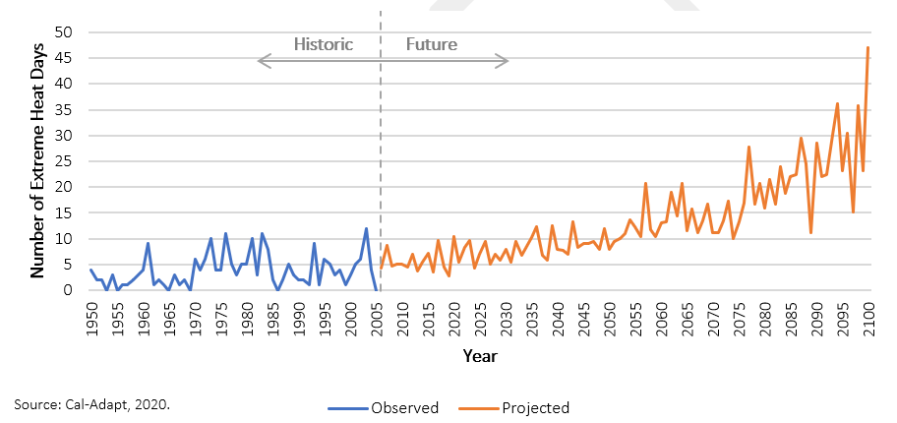
Note: Cal-Adapt’s Local Climate Change Snapshot dashboard visualizes modeled historical data, not observed climate data. This provides an apples to apples comparison to future modeled projections. The climate models make predictions for the period of 2006 to 2100 and recreate historical climate for the period of 1950 to 2005.

Extreme heat can cause illnesses, such as heat cramps, heat exhaustion, and heat stroke, as well as worsening respiratory and cardiovascular health conditions. The most vulnerable populations are those that spend high amounts of time outside such as children, outdoor workers, and persons experiencing homelessness.

Energy delivery services and associated infrastructure are also highly vulnerable to extreme heat. High temperatures can stress and overload the grid, causing power outages and damage to transmission lines. Additional vulnerable assets include outdoor recreation, as people may be deterred from recreating outdoors in high temperatures, and aquatic and wetland habitats, which can lead to decreases in water quality as temperatures increase.

Extended Drought
According to Cal-Adapt, recent research suggests that extended drought occurrence (“mega-drought”) could become more pervasive in future decades. The data for the future (2051 to 2070) has been projected based on a warmer/drier climate model and “business as usual” greenhouse gas emissions. Under extended drought conditions, models predict an increase of 5.9°F in maximum temperature and a 2.9-inch decrease in precipitation in San Carlos.

California Water Service (Cal Water) and other water providers in San Carlos purchase water from the City and County of San Francisco, derived from the Hetch Hetchy Regional Water System in the Sierra Nevada Mountains along the Tuolumne River. During droughts, water stored in the Hetch Hetchy system’s primary reservoir decreases due to lack of rainfall and reduction in snowpack. This causes water shortages and/or price hikes that could increase economic instability of low-income residents. It is estimated that the watershed feeding Hetch Hetchy Reservoir could experience a reduction in base flow of 2.7 inches, or 24 percent, during an extended drought. The amount of water stored in the snowpack, is projected to decrease by an average of 1,230 inches, or 45 percent, during an early-century drought (2023 to 2042) and an average of 1,710 inches, or 62 percent, during a late-century drought (2051 to 2070).

Local aquatic and riparian habitat reliant on water from the Pulgas, Brittan, Belmont, and Cordilleras Creeks are most vulnerable to drought impacts. In both early- and late-century drought scenarios, San Carlos could experience a drop in average precipitation from 19.9 inches to 17.4 inches per year, which would subsequently lower base flows in streams from an average of 5.6 inches per day to 4.1 inches per day. This could lower water quality and raise water temperatures, causing lower dissolved oxygen levels and algae growth that could harm a variety of fish species and their ecosystem. Wetlands and riparian habitats may also experience increased soil erosion, degradation of landscape quality, and loss of biological productivity due to extended drought.

Wetlands act as a buffer between developed areas of San Carlos and San Francisco Bay, helping to protect the community from sea level rise and bayshore flooding. Degradation of wetlands could decrease the amount of water that the ecosystem can absorb and reduce the protection that the wetlands provide. Drought conditions can also dry out vegetation and increase wildfire conditions, which could put a strain on firefighting infrastructure and personnel.

Inland Flooding
The Federal Emergency Management Act (FEMA) identifies multiple areas in San Carlos that are within the 100-year and 500-year floodplains. They are primarily within the Eastside industrial/commercial areas between Highway 101 and El Camino Real. Both residential and nonresidential uses are in the 100-year floodplain, while nonresidential uses—including a medical facility—are located within the 500-year flood zone. San Carlos Fire Station 16 is located within the floodplain area along Cordilleras Creek.

Buildings and facilities east of Highway 101, such as hazardous materials sites, and commercial centers, are highly vulnerable to flood events that can cause hazardous material release or cause mold and mildew to grow in buildings. Several major Eastside employers including the aviation museum, industrial or manufacturing uses, and other commercial centers may be negatively impacted by flood events. The East Side Innovation District, which acts as a major employment center, is located in a 100-year flood zone. The Silicon Valley Clean Water Waster Water facility also lies within the 100-year flood zone, and therefore could be inundated and provide limited services during a flood event.

As illustrated by Figures 4 through 6SS, at-risk infrastructure includes a transmission line that runs parallel to US-101, multiple microwave towers, multiple alternative fueling stations, and an electrical substation facility in the Eastside area.

All SamTrans bus stops located along Industrial Road are at risk to flood and sea level rise hazards, in addition to three alternative fueling stations located within the sea level rise impact zone of San Carlos Airport. Local streets and highway bridges east of El Camino Real that connect to Highway 101 are within the 100- and 500-year floodplains and are also at risk to flooding and sea level rise.
Transportation infrastructure, such as the San Carlos Airport, Caltrain station and line, electric vehicle charging stations, evacuation routes, major roads and highways, solid waste removal, and other services, can be inundated, blocked, and damaged by floodwaters along Pulgas Creek, Cordilleras Creek, and Belmont Creek.

Certain populations face particularly high risks from flooding events. Persons experiencing homelessness, households in poverty, and linguistically isolated persons are severely vulnerable to flooding, as they may live in or near flood hazard areas, lack financial resources to protect their homes, or have difficulty receiving adequate evacuation notices due to language barriers. Persons with limited mobility and those without access to lifelines (persons without access to a car, transit, or communication systems) may have difficulty evacuating prior to a flooding event, and therefore are also highly vulnerable.

Sea Level Rise and Bayshore Flooding
As sea levels rise, more areas of San Carlos will be vulnerable to 100-year flood events. Scenario modeling results pictured below range from one-foot of sea level rise to nine-feet of sea level rise (Figure 2). The map indicates possible significant flooding, erosion, and water damage impacts to the built environment along both sides of Highway 101 Freeway. Under all scenarios, portions of San Carlos Airport will be inundated by rising Bay waters. It should be noted that the airport is a County facility, so any preparations for sea level rise fall under the County’s responsibility.

Along the San Carlos shoreline, Bayshore sea levels are projected to rise approximately 23 inches by 2050 and 83 inches by 2100. Eventually, the sea level may increase enough to permanently flood low-lying areas in the eastern part of San Carlos along the Bayshore. Sea level rise threatens important buildings and key pieces of infrastructure that support the main economic drivers in San Carlos, such as Highway 101, the San Carlos Airport, large emplyers in the East Side Innovation District, and the Silicon Valley Clean Water Wastewater Treatment Plant in Redwood City. Homes and structures sited above the increased sea level can still be affected if the higher levels of water erode the rock or soil supporting the structures, potentially making them unsafe and at risk of collapse.

Increased sea levels can cause bridges and roadways to become impassable, flood control infrastructure to not work effectively, and hazardous material facilities to increase the risk of accidentally releasing harmful substances. Natural systems, such as wetlands and tidal marshes, can be disrupted by higher tide levels.

Rising sea levels can cause the bay shoreline to flood more frequently and severely. Because ocean levels are higher during normal conditions due to sea level rise, shoreline floods, such as king tides and storm surge, can be exacerbated and reach even further onto land. During strong storms and king tides, shoreline flooding may damage or destroy homes and commercial buildings in low-lying areas in eastern San Carlos. These events can also disrupt transportation routes such as Highway 101, Industrial Road, Holly Street, Old County Road, and Brittan Avenue and harm important economic assets, such as the Aviation Museum, industrial and manufacturing centers, biotechnology companies, and other major employers. Essential infrastructure, such as the San Carlos Airport, bridges, electric vehicle charging stations, solid waste facilities, and water and wastewater infrastructure, may be frequently inundated, causing them and the community services they support to be negatively impacted.

Wildfire
All climate change models concur that as the climate becomes warmer and drier, wildfire will continue to remain a significant threat. Under high emissions scenarios, there is a predicted 46% increase in the potential of acres burned between the observed historical period (1961-1990) and the future 30-year period of 2070 to 2099. Wildfires increase the risk of injury, death, and property damage or destruction.

San Carlos’ foothill neighborhoods west of Alameda de las Pulgas are designated Very High Fire Hazard Severity (VHFS) Zones by San Mateo County (Figure 3). Many schools and homes are located within the VHFS. Additionally, residential development in the foothill neighborhoods, including the Devonshire Area, are considered at risk to wildfire hazards. Several parks and schools are also located within this Severity Zone, including Heather Elementary School. Other schools in the area include Carlmont High School, Tierra Linda Middle School, Mariposa Upper Elementary School, and San Carlos Charter Learning Center. Several California Water Services (Bay Area Region) tanks are located at the intersection of Los Vientos Way and Crestview Drive and across Crestview Park. Additionally, the Bayview Villa, an assisted living community, is within Devonshire Area.

Wildfire smoke increases air pollution levels and creates a significant health risk. This health risk is particularly pronounced under weather conditions that prevent smoke from clearing, such as those during the lightning complex fires in 2020. In addition, essential roadways, such as evacuation routes and single-access roads, can potentially be blocked by wildfire flames or debris, making it difficult for residents to evacuate and emergency personnel to reach certain areas of the San Carlos. The entire energy delivery system, including electric transmission lines and natural gas pipelines, can also be damaged by wildfires. Coastal scrub and oak woodlands, although somewhat adapted to wildfires, can be substantially harmed by more frequent and severe fires that prevent ecosystems to fully recover.

Responsible Agencies
Responsible Agencies
San Carlos relies on a number of critical services and agencies for hazard mitigation and public safety. This section of the assessment assists in determining the capacity to adapt to climate impacts based on existing policies, plans, and/or programs.
- Fire Services. San Carlos fire service is provided under contract to the City of Redwood City Fire Department. It provides fire protection, hazardous materials response, disaster preparedness, and emergency medical response. The Department of Forestry and Fire Protection (CAL FIRE) has a legal responsibility to provide fire protection to all within the State Responsibility Area. A portion of the San Carlos Sphere of Influence is under the State Responsibility Area.
- Law Enforcement. Law Enforcement and emergency services are provided under contract to the San Mateo County Sheriff’s Office, including contract law enforcement services for San Carlos. The Sheriff’s Emergency Services Bureau responds to a range of threats such as natural disasters, hazardous materials, global disease outbreaks and other emergencies.
- Other Agencies. Other agencies that provide emergency preparedness and response services to the greater San Mateo County community in collaboration with fire and sheriff departments, are the San Mateo County Health Services Agency and San Mateo County Office of Emergency Services.
Critical Assets and Infrastructure
As described earlier, several critical assets are sited within hazard zones in San Carlos. These include multiple microwave towers, alternative fueling stations, an electrical substation facility, and a medical facility. According to San Carlos specific findings in the County of San Mateo Sea Level Rise vulnerability assessment, there are approximately 0.3 miles of levees, and 2.6 miles of other built shoreline assets in San Carlos that would be at risk from sea level rise. Additional key infrastructure in preventing and mitigating flooding and sea level rise include 18 outfalls and 21.8 miles of storm drains that would also be affected under all scenarios of sea level rise.

Policy Interventions
The City of San Carlos has adopted stringent grading and building codes and slope landscaping requirements to address local hazards. These standards will require regular review and possible updates as environmental changes occur and as new materials, methods, and as new strategies are developed.

Key Vulnerability Considerations
- Very High Fire Hazard Severity Zones. Foothill neighborhoods in San Carlos west of Alameda de las Pulgas are designated “Very High Fire Hazard Severity” (VHFS) Zones by San Mateo County. As a result of climate change, higher temperatures, and drier environments, wildfire events and associated risks could be more prominent.
- Flooding Hazards. Multiple San Carlos commercial and industrial areas and some residential uses are located within the 100-year and 500-year floodplains of the San Francisco Bay and local creeks. These areas, along with City assets and populations in proximity to city creeks, may be at risk during inland and Bayshore flooding, which could be exacerbated due to climate change and extreme weather events.
- San Carlos Airport. Under all sea level rise scenarios, the areas east of El Camino Real will be impacted by sea level rise and San Carlos Airport could be inundated.
- Infrastructure. Key infrastructure in place for preventing and mitigating flood hazards, such as levees and other built shoreline assets, are at risk to sea level rise and flood hazards. Siting of residential uses and new residential development should consider climate change risks, impacts to critical infrastructure, and system resilience, in project planning and design.
- New Residential Development. As required by Safety Element law, siting of new residential development must consider impacts to critical infrastructure from hazards induced and exacerbated by climate change including wildfire, flooding, and sea level rise.

Conclusion
This vulnerability assessment identifies hazards that are anticipated to negatively impact San Carlos communities and assets. The local climate will likely shift toward greater volatility in all types of weather conditions, including warmer surface temperatures, drier conditions, more intense storms, and continued sea level rise.
The City’s Safety Element update will include goals, policies, and strategies that respond to these specific hazards and that will increase resiliency through adaptation strategies and reduce vulnerability throughout the city. The Safety Element will also build upon the the adaptation strategies listed in the CMAP.

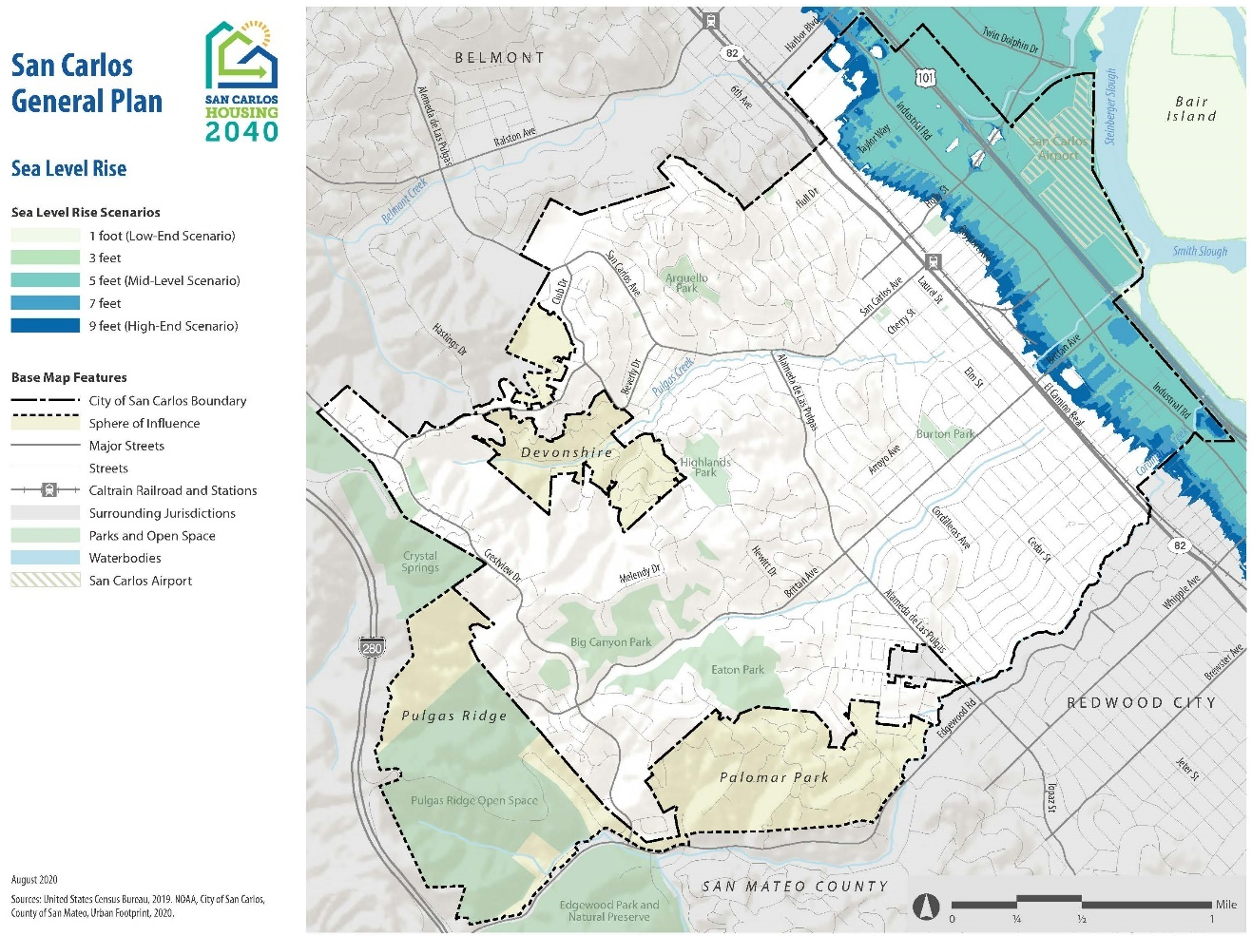
Figure 2: Sea Level Rise Impact Zones

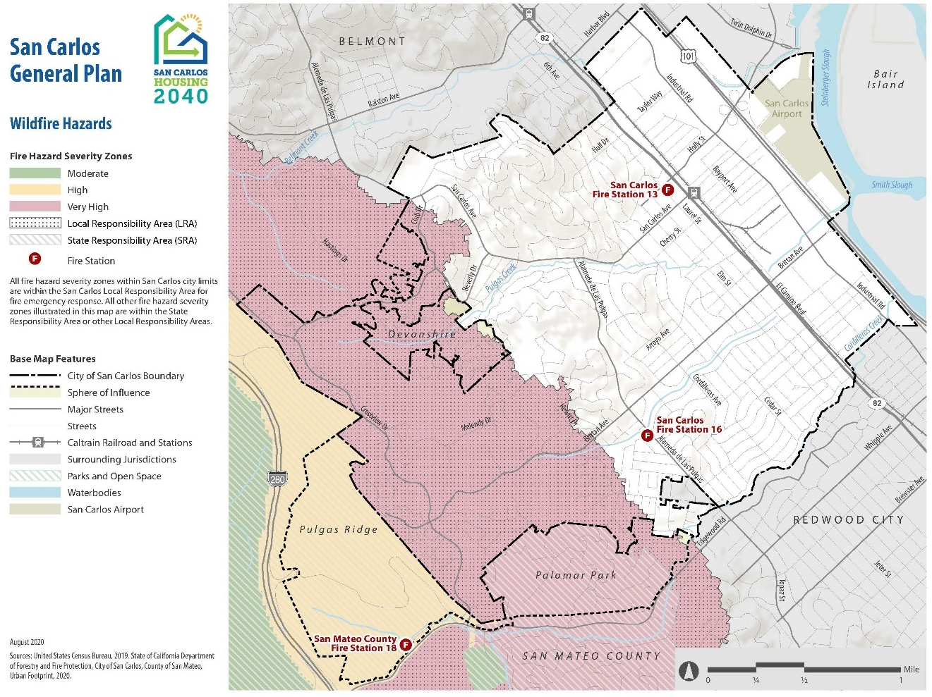
Figure 3. Wildfire Hazards

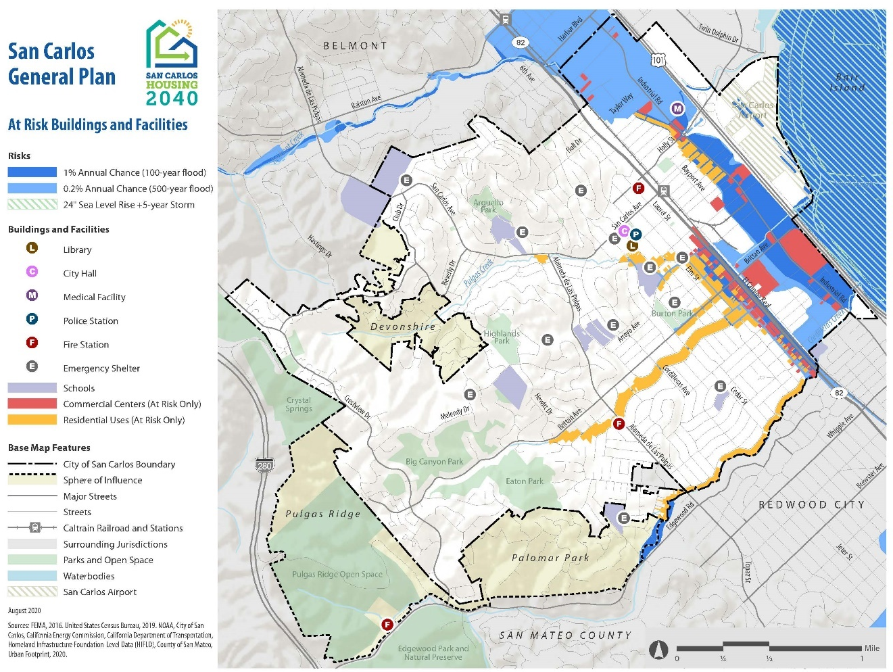
Figure 4: Flooding – At-Risk Buildings and Facilities

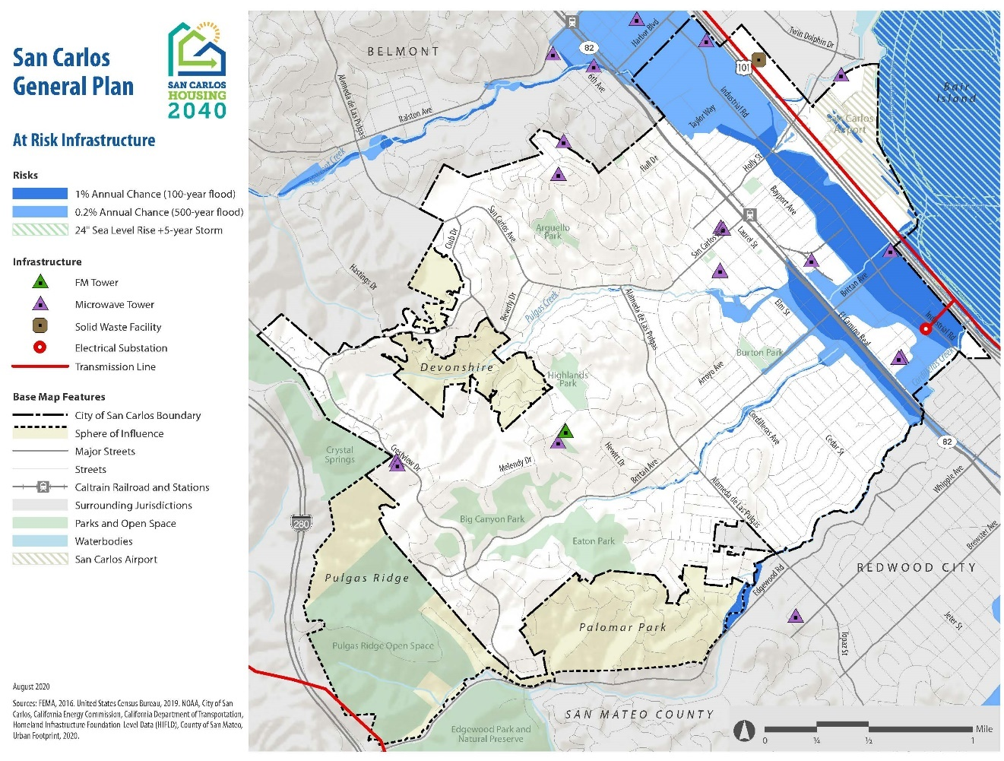
Figure 5: Flooding – At-Risk Infrastructure

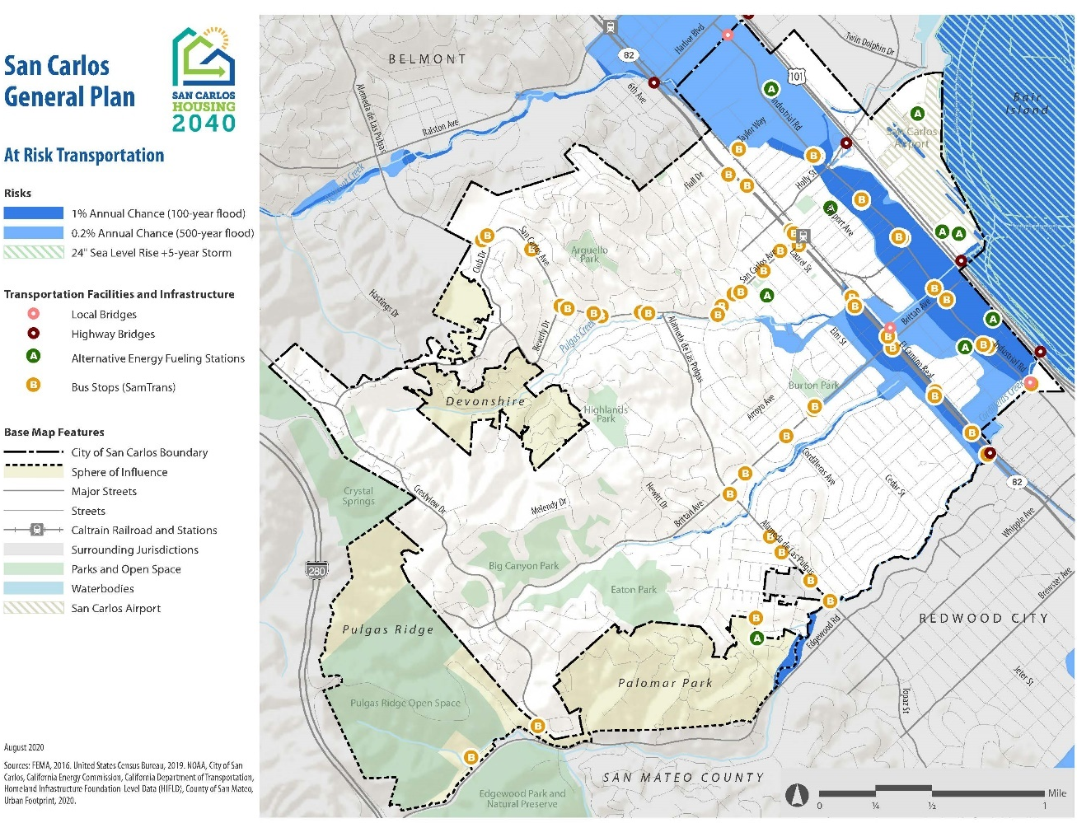
Figure 6: Flooding – At-Risk Transportation Infrastructure

Sources

California Adaptation Planning Guide. (2020, June). Retrieved from https://www.caloes.ca.gov/HazardMitigationSite/Documents/CA-Adaptation-Planning-Guide-FINAL-June-2020-Accessible.pdf

Cal-Adapt. Data: Long Drought Scenarios, LOCA Downscaled CMIP5 Projections, LOCA VIC Runs (Scripps Institution of Oceanography), Gridded Observed Meteorological Data (University of Colorado, Boulder).

Cal-Adapt. Data: LOCA Downscaled Climate Projections (Scripps Institution of Oceanography), Gridded Historical Observed Meteorological Data (University of Colorado, Boulder).

County of San Mateo. Sea Lea Level Rise Vulnerability Assessment. (2018, March). Retrieved from https://seachangesmc.org/wp-content/uploads/2018/03/2018-03-05-mp-SLR_VA_Report_2.2018_v4_WEB.pdf

San Carlos Draft Climate Mitigation and Adaptation Plan (CMAP) Vulnerability Assessment (PlaceWorks)

San Carlos Climate Action Plan. (2009, October). Retrieved from https://www.cityofsancarlos.org/home/showdocument?id=378

San Mateo County Hazard Mitigation Plan. (2016, July). Retrieved from https://planning.smcgov.org/sites/planning.smcgov.org/files/documents/files/San%20Mateo%20HMP%20-%20Volume%20I%20-%20Final%20APA.pdf

The Daily Journal Staff Report. (2016, March 12). San Carlos tackles flooding. Retrieved from https://www.smdailyjournal.com/news/local/san-carlos-tackles-flooding/article_33b22dc1-c2a7-5408-818e-85f3206c9f5b.html

Westerling, Anthony Leroy. (University of California, Merced). 2018. Wildfire Simulations for California’s Fourth Climate Change Assessment: Projecting Changes in Extreme Wildfire Events with a Warming Climate. California’s Fourth Climate Change Assessment, California Energy Commission. Publication Number: CCCA4-CEC-2018-014. https://www.energy.ca.gov/sites/default/files/2019-07/Projections_CCCA4-CEC-2018-014.pdf

