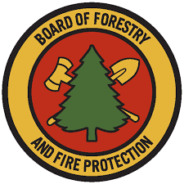

Range Management Advisory Committee
State Lands Grazing License and Land Management subcommittee
APPENDIX A:
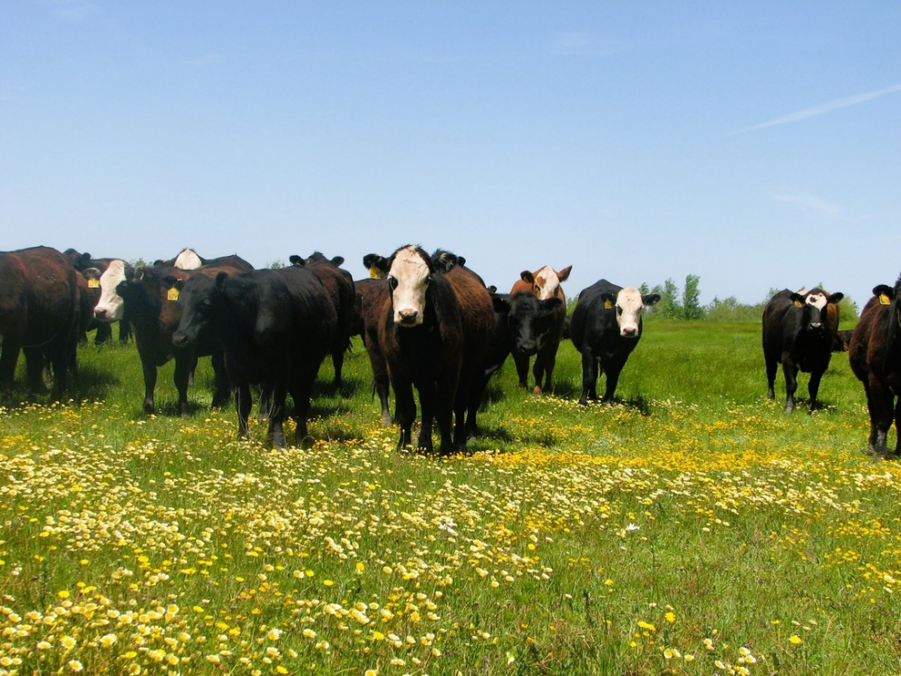
Grazing Agreement
California State Board of Forestry and Fire Protection (‘Board’)
Range Management Advisory Committee (RMAC)
State Lands Grazing License and Land Management Sub-Committee (‘RMAC Subcommittee’)
Approved: MONTH DAY 2025
Cover photos details and credits: Heifers grazing vernal pools in Lincoln, California (Credit: Bart Cremers).
Contents
FOREWORD v
Grazing Agreement Team Members v
I. INTRODUCTION 1
II. GRAZING AGREEMENT TEMPLATE 1
1. Identification of the Parties 1
a. Legal Description of “Landlord/Lessor/Licensor” and “Tenant/Lessee/Licensee” 1
b. Contracting Parties 1
2. Property Description 1
a. Legal Description such as county assessor’s parcel numbers, Public Land Survey System description, or legal description from the Title Report 1
b. Grazing Unit(s) or parcel(s) should be identified in the Agreement 1
c. Maps or aerial photo of property if feasible 1
d. Infrastructure 1
e. Address or nearest roads and county 1
3. Duration, Termination, and Extension Options 1
a. Effective and Termination Dates of the Agreement 1
b. Occupancy Rights 1
c. Grazing Season and Pressure 1
d. Early Termination 1
e. Extension/Renewal Terms and Conditions 1
4. Rent or Payment, and Fee Credits for Improvements 1
a. Rent or Payments 1
b. Fee Credits 1
5. Taxes 1
a. Personal Property Taxes on site improvements and infrastructure should be considered 1
b. Real Property Taxes are typically paid by landlord 1
c. Possessory Interest Taxes 2
6. Property Uses 2
a. Agreement Type 2
b. Allowable Uses 2
c. Living Quarters Policies should be defined for temporary living quarters for handlers, if any. 2
7. Entry 2
a. Allowable Parties 2
b. Landlord’s Access details as they relate to the property. 2
c. Public Access details as they relate to the property, if applicable. 2
d. Access Gate Location(s) 2
8. Maintenance, Repairs, and Improvements 2
a. Maintenance and Repairs 2
b. Permanent Improvements 2
c. Liens are not typically allowed against the property or owner 2
9. Stewardship Guidelines 2
10. Additional Constraints 2
a. Soil Altering Practices that are allowed or not allowed should be described, if applicable. 2
b. Hazardous Substances and Dead Animal Disposal 2
c. Temporary Structures 2
d. Invasive Species Measures 2
e. Animal Welfare 2
f. Other Restrictions 2
11. Subcontracting 2
a. Landlord Consent 2
b. Grazing Operator Responsibilities 2
12. Insurance and Liability 2
a. Liability Insurance 2
b. Workers Compensation Insurance should be obtained if tenant has employees working on the property. 3
13. Indemnification 3
a. Landlord Indemnification 3
b. Accessible Public Lands 3
14. Damage or Destruction 3
15. Condemnation 3
16. Removal of Personal Property 3
17. Dispute Resolution 3
18. Notices and Communications 3
REFERENCES 4

FOREWORD
A subcommittee of the Range Management Advisory Committee (RMAC) developed a Grazing Agreement template (Appendix A, this document, ‘Agreement’ template) and a Management Action Plan (MAP) template (Appendix B, ‘MAP’ template) (RMAC 2024a) to guide and support California government agencies, land managers, and graziers in the use of managed livestock grazing as a tool to enhance ecological and sustainability values and to reduce fire fuels and risk on public lands. A Guidebook (RMAC 2024b) was developed to accompany the Agreement and MAP templates to provide more in-depth information related to the development of specific items and to provide a directory of related resources. Collectively, the three documents developed by the State Lands Grazing License and Land Management (SLGLLM) sub-committee—the Agreement template, MAP template, and Guidebook—are referred to as the ‘State Lands Grazing Packet’. A list of acronyms and definitions is provided in the associated Guidebook. Please refer to the Guidebook for additional guidance in the use of this Agreement template, and information on its relationship to the MAP template.

Grazing Agreement Team Members
- Richard M. Ross – RMAC member; legal counsel
- Kevin Conway – Department of Forestry & Fire Protection (CAL FIRE), Jackson State Demonstration Forest
- Bart Cremers* – RMAC member; WILDLANDS; rancher
With additional edits** by:
- Marc Horney, PhD* – RMAC Chair; Professor, California Polytechnic State University, San Luis Obispo
- Kristina Wolf, PhD* – RMAC staff support, California State Board of Forestry & Fire Protection
* Certified Rangeland Manager (CRM), licensed by the Professional Forester’s Licensing Committee under a specialty certificate within the California’s Forest Practice Rules under the California Board of Forestry and Fire Protection
** Additional editing and contributions were incorporated from stakeholders across various public agencies and during the two public comment periods, which were opened during the development of the State Lands Grazing Packet: a 30-day review period beginning July 22, 2022 and a 21-day review period beginning November 01, 2024. Suggested edits were also provided by various state agencies, including the California Department of Fish and Wildlife, California Natural Resources Agency (CNRA), the Natural and Working Lands Science Team (affiliated with CNRA), and Department of General Services.

Disclaimer: The State is not liable for the practices of any individual or organization in the use and application of these documents. Any revisions to the language or adaptations in the use of these documents is at the sole discretion and liability of the individual and/or organization utilizing these documents.

INTRODUCTION
The Grazing Agreement Team of the Board of Forestry’s Range Management Advisory Committee (RMAC) and State Lands Grazing License and Land Management (SLGLLM) sub-committee recommends the template below for the development of Grazing Agreements (‘Agreement’ template), including sections specifically devoted to grazing management on state lands. Any stipulations described in the Agreement should correspond to those in the MAP.

GRAZING AGREEMENT TEMPLATE

1. Identification of the Parties

a. Legal Description of “Landlord/Lessor/Licensor” and “Tenant/Lessee/Licensee”

b. Contracting Parties

2. Property Description

a. Legal Description such as county assessor’s parcel numbers, Public Land Survey System description, or legal description from the Title Report

b. Grazing Unit(s) or parcel(s) should be identified in the Agreement

c. Maps or aerial photo of property if feasible

d. Infrastructure

e. Address or nearest roads and county

3. Duration, Termination, and Extension Options

a. Effective and Termination Dates of the Agreement

b. Occupancy Rights

c. Grazing Season and Pressure

d. Early Termination for Any Reason

e. Extension/Renewal Terms and Conditions

4. Rent or Payment, and Fee Credits for Improvements

a. Rent or Payments

b. Fee Credits

5. Taxes

a. Personal Property Taxes on site improvements and infrastructure should be considered

b. Real Property Taxes are typically paid by landlord

c. Possessory Interest Taxes

6. Property Uses

a. Agreement Type

b. Allowable Uses

c. Living Quarters Policies should be defined for temporary living quarters for handlers, if any.

7. Entry

a. Allowable Parties

b. Landlord’s Access details as they relate to the property.

c. Public Access details as they relate to the property, if applicable.

d. Access Gate Location(s)

8. Maintenance, Repairs, and Improvements

a. Maintenance and Repairs

b. Permanent Improvements

c. Liens are not typically allowed against the property or owner

9. Stewardship Guidelines

10. Additional Constraints

a. Soil Altering Practices that are allowed or not allowed should be described, if applicable.

b. Hazardous Substances and Dead Animal Disposal

c. Temporary Structures

d. Invasive Species Measures

e. Animal Welfare

f. Other Restrictions

11. Subcontracting

a. Landlord Consent

b. Grazing Operator Responsibilities

12. Insurance and Liability

a. Liability Insurance

b. Workers Compensation Insurance should be obtained if tenant has employees working on the property.

13. Indemnification

a. Landlord Indemnification

b. Accessible Public Lands

14. Damage or Destruction

15. Condemnation

16. Removal of Personal Property

17. Dispute Resolution

18. Notices and Communications

REFERENCES
RMAC. 2024a. Appendix B: Management Action Plan template. State Lands Grazing License and Land Management subcommittee, Range Management Advisory Committee, Board of Forestry and Fire Protection, California Natural Resources Agency. Sacramento, CA. Available online: Verified To be updated once finalized and online.
RMAC. 2024b. Guidebook. State Lands Grazing License and Land Management subcommittee, Range Management Advisory Committee, Board of Forestry and Fire Protection, California Natural Resources Agency. Sacramento, CA. Available online: Verified To be updated once finalized and online.

