2019 EFFECTIVENESS MONITORING COMMITTEE ANNUAL REPORT AND WORKPLAN

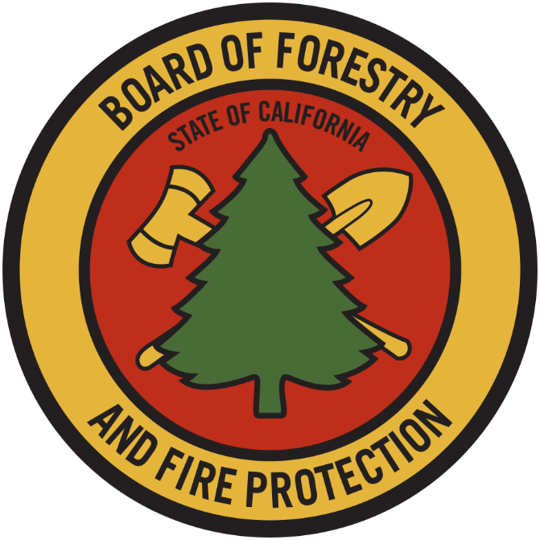

STATE BOARD OF FORESTRY AND FIRE PROTECTION

December 5, 2019

EXECUTIVE SUMMARY
The Effectiveness Monitoring Committee (EMC) Annual Report and Workplan is a living document which is updated and approved by the Board of Forestry and Fire Protection annually and is intended to catalogue the yearly accomplishments and status of ongoing EMC efforts. The Annual Report and Workplan summarizes EMC accomplishments, details EMC funding actions for the year, and provides an update of current EMC membership and staffing. Funding details include information on all projects submitted to the EMC, regardless of whether they are selected for funding. For fiscal year 2018/2019, the EMC selected two proposed effectiveness monitoring projects to fund and support. Five additional projects were received for consideration in fiscal year 2019/2020.

EMC PROCESS SUMMARY
Project Submission Timeline (approximate)

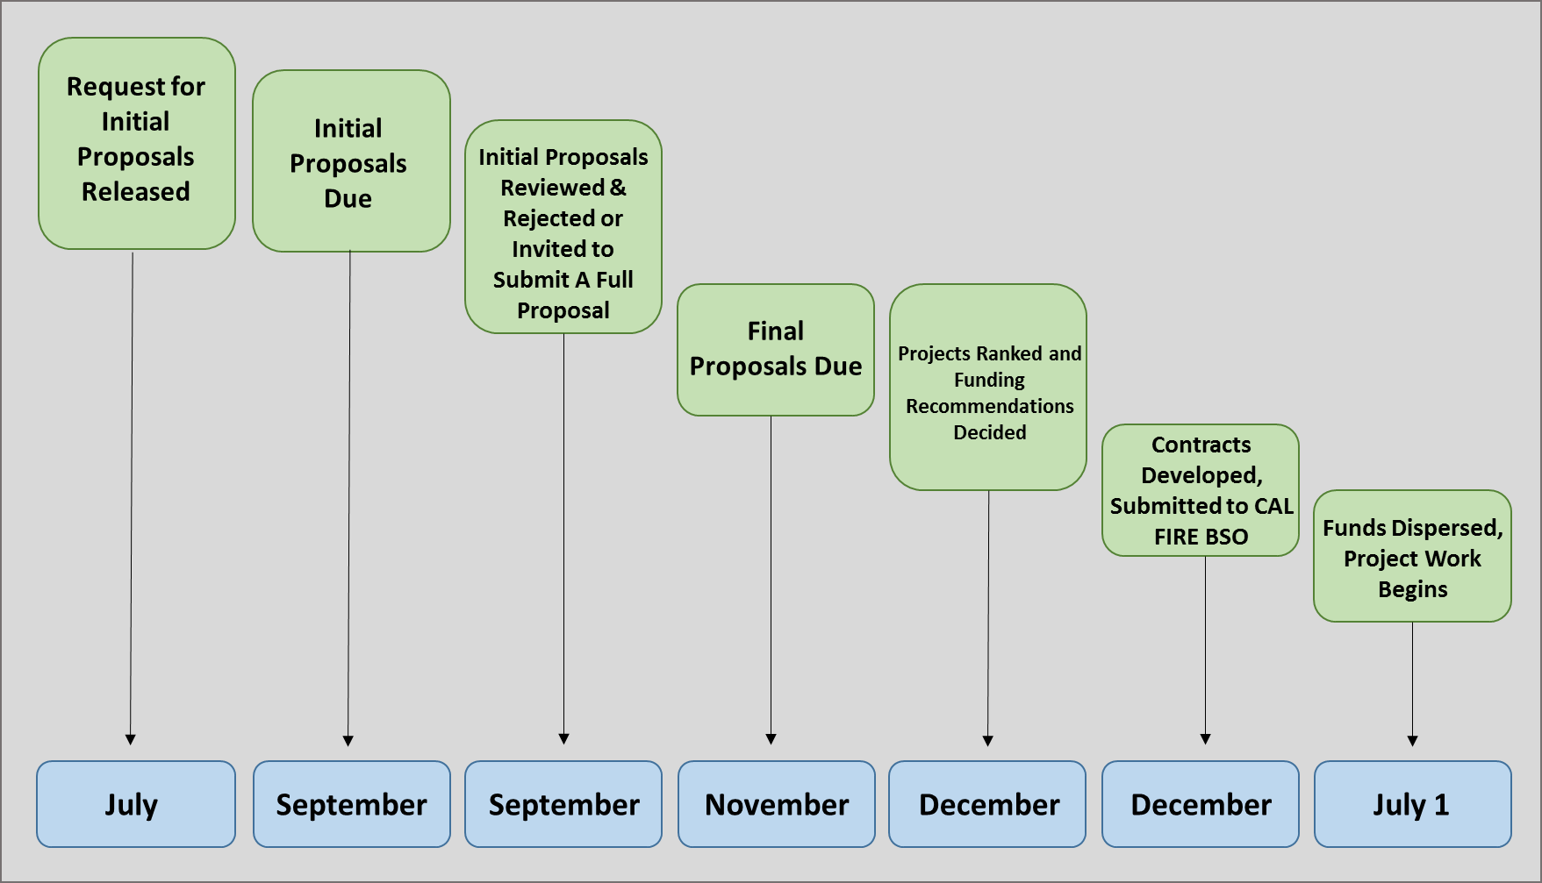

The EMC Strategic Plan will be updated approximately every three years and the EMC Annual Report and Work Plan will be updated every calendar year. This linked approach, including a longer more static document and a shorter more fluid document, was developed in response to Board member suggestions.
EMC projects are solicited through an annual Request for Proposals (RFP) which is released following the start of the new fiscal year (July 1st). Initial Concept Proposals are received in September and the EMC conducts a preliminary technical review of all Initial Concept Proposals that are received by the deadline (established annually in the RFP). This review considers the completeness of the proposals and whether they are within the scope of the Themes and Critical Monitoring Questions elaborated in the Strategic Plan. The EMC also works with Board staff to screen proposals for any conflicts of interest and may request that the Principal Investigator provide additional information within a reasonable period.

When the EMC determines that an Initial Concept is complete and within scope, the Principal Investigator is invited to submit a Full Project Proposal by the deadline specified in the RFP. The EMC then conducts a thorough technical review of all Full Project Proposals that are received and a formal ranking according to the procedures outlined in the EMC’s Strategic Plan is conducted. EMC members individually rank each project and the average ranking score is calculated for each project. No specific minimum average ranking score is required for support; rather, individual project scores will be considered relative to other project scores. Once all Full Project Proposals have been ranked, EMC members vote to make recommendations for allocation of available EMC funds, taking into consideration the project ranking score, how well the project tests the effectiveness of the FPRs, and the reasonableness of the requested budget. Utilizing the EMC’s funding recommendations, Board staff, as delegated by the Board, will make the final funding decisions. It is the intent of the EMC to keep the ranking process transparent, with the ranking done in an easily trackable manner. The EMC receives periodic updates on the projects that have received funding and presentations on findings from completed projects.

EMC FUNDING
For fiscal year 2019/2020, the EMC has been allocated ongoing funding of $425,000 per year from the Timber Regulation and Forest Restoration Fund (TRFRF), established by AB 1492 (2012). This funding is being used to support EMC projects and is granted through the Board/CAL FIRE contracting process.

EMC ACCOMPLISHMENTS
During 2019 the EMC accomplished the following:

- Received an ongoing allocation of $425,000 from the Timber Regulation and Forest Restoration Fund.
- Reappointed Board Member Susan Husari as EMC Co-Chair.
- Appointed Loretta Moreno, CNRA, as EMC Co-Chair.
- Reappointed Dr. Matt O’Connor to the EMC as a Public member.
- Recruited 3 Academic Members to the EMC: Dr. Sarah Bisbing, Dr. Leander Anderegg, and Dr. Peter Freer-Smith.
- Regularly met in open, webcast public meetings to conduct its work.
- Utilized the project ranking procedure included in the EMC Strategic Plan to select two (2) proposed effectiveness monitoring projects to fund and support (Table 1).
- Made determinations on total project funding for each submitted project, and developed contracts for the twofunded projects.
- Revised the EMC Request for Proposals with the support of a two-person sub-committee.
- Developed new standard initial concept proposal and full concept proposal forms for potential principal investigators to use when submitting their projects to the Committee for review. These forms can be found on the EMC’s webpage (https://bof.fire.ca.gov/board-committees/effectiveness-monitoring-committee/).
- Developed and released a Request for Proposals (RFP) soliciting monitoring project initial concept proposals. Proposals were due to the EMC by September 7, 2019.

Table 1. EMC Projects Ranked and Funded (2019)

Project # | Project Title | Primary Investigator & Project Collaborators | Ranking Score | EMC Funding Allocation
EMC-2018-003 | Alternative Meadow Restoration | Dr. Christopher Surfleet with collaboration from Blodgett Demonstration State Forest and The Plumas Corporation | 17.9 | $101,802.00
EMC-2018-006 | Class II Watercourse and Lake Protection Zone | Dr. Kevin Bladon, Dr. Catalina Segura, Dr. Matthew House, and Drew Coe with collaboration from Green Diamond Resource Company and CAL FIRE | 16.2 | $694,371.00
Table 2. EMC Projects not Ranked and/or Funded (2018)

Project | Project Title | Primary Investigator | Ranking Score | Reason
EMC-2018-001 | 14 CCR Section 1038(j) Exemption Monitoring | Joe Barren, RPF | N/A | Revised project proposal requested
EMC-2018-002 | Spotted Owl Use of Post-Fire Landscapes | J. David Wiens | 10.64 | Revised project proposal requested
EMC-2018-004 | Tracked Feller Bunchers in the WLPZ | Dr. Kevin Lyons | 9.27 | Revised project proposal requested
EMC-2018-05 | Characterizing Amphibian Distribution | Lynn Webb | N/A | Project Outside Scope of EMC
EMC-2018-07 | Effects of Experimental Site Exclusion on Pacific Martens | Dr. Katie Moriarty, Dr. Jake Vershuyl, and Matthew Delheimer | 12.7 | Revised project proposal requested

EMC SUPPORTED MONITORING PROJECTS – 2015 to 2018
The comprehensive list of EMC supported monitoring projects can be found on the Board’s EMC webpage (https://bof.fire.ca.gov/board-committees/effectiveness-monitoring-committee/)

EMC PRIORITIES
EMC priorities are developed by the Committee, but as an advisory body to the Board, the Board can also request prioritization of items by the EMC. The current EMC Priorities are as follows:
- Consider the project proposals received during the 2019 EMC RFP cycle using the EMC review and ranking process.

- Support projects related to the EMC themes and critical questions, through funding or other appropriate means.
- Monitor progress on previously funded or -supported EMC monitoring projects.

- Meet in the field at least once per year to observe active or proposed monitoring projects.

SUMMARY OF SUBMITTED PROJECTS FOR CONSIDERATION BY JANUARY 2020
The following summary table is a catalog of monitoring projects under consideration by the Effectiveness Monitoring Committee. For individual Project Summary(s) and concept proposals that provide more detailed project information, see the EMC website (https://bof.fire.ca.gov/board-committees/effectiveness-monitoring-committee/).
Table 3. Summary of Projects Under Consideration for Ranking and/or Funding by February 2020.
Project Number | Project Title |  | Current  Status |  | Principal Investigator(s)
EMC-2019-001 |  | Assessing the Connectivity of Black-backed Woodpecker Populations in Green and Burned Forest within a Fire-prone Landscape |  | Awaiting Committee Review |  | Dr. James Rivers, Dr. Jake Vershuyl
EMC-2019-002 |  | Evaluating Treatment Longevity and Maintenance Needs for Fuel Reduction Projects Implemented in the WUI of Plumas County, CA |  | Awaiting Committee Review |  | Jason Moghaddas, RPF, Gary Roller, RPF, and Hannah Hepner
EMC-2019-003 |  | Fuel Treatments and Hydrologic Implications in the Sierra Nevada |  | Awaiting Committee Review |  | Dr. Terri Hogue and Dr. Alicia Kinoshita
EMC-2019-004 |  | Drafting Bypass Flows and their Effects on Native Fish: Linking Forest Practice Rules to Fish and Game Code |  | Awaiting Committee Review |  | Dr. Robert Lusardi, Dr. Andrew Rypel, Dr. Nann Fangue
EMC-2019-005 |  | Sediment Monitoring and Fish Habitat – San Vicente Accelerated Wood Recruitment |  | Awaiting Committee Review |  | Cheryl Hayhurst, CGS

CURRENT EMC APPOINTED MEMBERS AND STAFF
For FY 2019/2020, the Committee has two Co-Chair positions, eight agency representatives, seven EMC Members, and five support staff.
Table 4. Current EMC Membership and Support Staff.

Name | Specialty | Affiliation | Term  Expiration
Co-Chairs
Loretta Moreno | Co-Chair, Forest Ecology | California Natural Resources Agency | 7/5/2023
Susan Husari | Co-Chair, Forestry/Fire Management | Board of Forestry and Fire Protection | 11/6/2023
Agency Representatives
Stacy Drury, Ph.D. | Fire Ecology | USDA Forest Service Pacific Southwest Research Station | n/a
Elliot Chasin | Wildlife | California Department of Fish and Wildlife | n/a
Drew Coe | Hydrology/Forestry, RPF 2981 | CAL FIRE | n/a
Cliff Harvey | Water Quality/Hydrology | State Water Resources Control Board | n/a
Justin LaNier | Geology/Hydrology/Water Quality | Central Valley Regional Water Quality Control Board | n/a
Clarence Hostler | Fisheries | NOAA National Marine Fisheries Service | n/a
Bill Short | Engineering Geology/ Hydrogeology | California Geological Survey | n/a
Jim Burke | Geology/Water Quality | North Coast Regional Water Quality Control Board | n/a
Monitoring Community
Greg Giusti | Forestry, RPF 2709 | University of California Cooperative Extension Advisor Emeritus-Lake and Mendocino counties | 7/1/2021
Matt House | Hydrology/Fisheries | Green Diamond Resource Company | 8/31/2020
Sal Chinnici | Wildlife | Humboldt Redwood Company | 7/1/2020
Matt O’Connor, Ph.D. | Geology/Geomorphology | Public | 11/6/2023
Sarah Bisbing, Ph.D. | Forest Ecology/Forestry | Academic, University of Nevada, Reno | 7/5/2023
Leander Anderegg, Ph.D. | Forest Ecology/Forestry | Academic, University of California, Berkeley | 7/5/2023
Peter Freer-Smith, Ph.D. | Plant Ecology and Environmental Policy | Academic, University of California, Davis | 7/5/2023
Support Staff
Matt Dias | Forestry, RPF 2773 | Board of Forestry and Fire Protection Executive Officer | n/a
Pete Cafferata | Hydrology/Forestry, RPF 2184 | CAL FIRE | n/a
Stacy Stanish | Biology/Fisheries, RPF 3000 | CAL FIRE | n/a
Dave Fowler | Geology/Water Quality | North Coast Regional Water Quality Control Board | n/a
David Ludwig | Forestry | Board of Forestry and Fire Protection | n/a
Brandi Goss | Biology/Environmental Science | Board of Forestry and Fire Protection | n/a
Brandi Goss | Biology/Environmental Science | Board of Forestry and Fire Protection | n/a

EMC PROJECT UPDATES
- EMC-2015-001: Class II-Large Monitoring (ongoing): Oregon State University Master of Science (MS) student Adam Pate selected three main areas to implement the regional scale component of the Class II Large watercourse study, which is assessing the effectiveness of rule criteria for identifying Class II watercourses susceptible to thermal loading. Field work took place during the summer of 2018 in three Jackson Demonstration State Forest watersheds, two upper Klamath River basins, and the Cow Creek watershed (South Cow Creek on LaTour Demonstration State Forest). A total of at least 100 sites are being studied. Data analysis is being conducted this fall, including the use of LiDAR and NetMap data. Adam Pate defended his thesis in the Summer of 2019. Drs. Catalina Segura and Kevin Bladon will be turning Adam’s thesis into a manuscript to be submitted to a peer reviewed journal in 2020. PhD student Austin Wissler will be analyzing the thermistor data from Caspar Creek and Latour Demonstration State Forest as the first part of his dissertation research.

- EMC-2015-002: Forest Practice Rules Implementation and Effectiveness Monitoring (FORPRIEM) ver. 2.0.: A final statistical consultation report for EMC-2015-002 was written by Dr. Ashley Steel and Pat Cunningham, USFS Pacific Northwest Research Station (PNW)and submitted to the EMC. No further work has progressed to date.

- EMC-2015-004: Effectiveness of Road Rules in Reducing Hydrologic Connectivity and Significant Sediment Discharge (completed): A final statistical consultation report for EMC-2015-004 was written by Dr. Ashley Steel and Pat Cunningham, USFS Pacific Northwest Research Station (PNW)and submitted to the EMC. No further work has progressed to date.

- EMC-2016-002: Post-fire effectiveness of the Forest Practice Rules in protecting water quality on Boggs Mountain Demonstration State Forest (ongoing):. Data collection will continue for a 5th post-fire season. A BMP demonstration project was implemented to test different erosion control measures on skid trails. Testing was done using a runoff simulator and a flow rate calibrated from previous runoff simulations performed on skid trails at BMDSF. Six replicates of five different treatments were tested including: 1) control; 2) increasing waterbreak frequency; 3) slash packed; 4) slash packed and walked-in with equipment; and 5) slash packed waterbreak outlets. The first of the two rainfall simulation experiments (i.e., lab-based rainfall simulations) was published in the Journal of Hydrology.

- EMC-2016-003: Road Rules Effectiveness at Reducing Mass Wasting (Repeat LiDAR Surveys to Detect Landslides) (ongoing): The CAL FIRE/CGS contract has been augmented to purchase LiDAR. The LiDAR acquisition, using the USGS as a subcontractor, is scheduled to be completed during the month of November. Once completed, the LiDAR data will be publicly available from the USGS. The Pilot project data is expected to be available for review in mid-January, 2020 with the complete project area available for review at the end of March, 2020 and final data available at the end of July, 2020.

- EMC-2017-001: Caspar Creek Nutrient Study (ongoing): UC Davis MS student Seanna McLaughlin and Drs. Helen Dahlke and Randy Dahlgren prepared a final report for pre-harvest biogeochemical analysis of four Caspar Creek sub-watersheds for the Save the Redwoods League, one of the project funders. A bromide/nitrate stream injection took place during September of 2018, allowing the characterization of in-stream nitrogen dynamics (data analysis ongoing). Sub-watershed logging was completed during November 2018, and the first winter post-logging water samples have been analyzed. Seanna McLaughlin has nearly completed her thesis work and is expected to graduate by March 2020. UC Davis will conduct post-logging nutrient sampling and sample analysis through the 2019/2020 winter period, but it is unclear whether this data will be included in the final report to CAL FIRE and the Board of Forestry and Fire Protection.

- EMC-2017-002: Boggs Mountain Demonstration State Forest (BMDSF) Post-Fire Automated Bird Recorders Study (ongoing): The second year of bird recordings were made in the late spring of 2018 and the bird call expert is currently interpreting the recordings. Stacy Stanish prepared a poster for the Western Section of the Wildlife Society Meeting held in February 2018. She will be presenting the study and preliminary results to the CARCD Annual Conference "Celebrating Resilient Landscapes and Adaptive Communities" in San Diego in November.

- EMC-2017-004: Monitoring Class III Watercourses (ongoing): Equipment for this project has been purchased by BOF and CAL FIRE staff, including 120 Onset temperature loggers. No further work has progressed to date.

- EMC-2017-006: Tradeoffs Between Riparian Buffers, Fire, and Regeneration (ongoing): Dr. Rob York, UC Berkeley, has implemented this project on Blodgett Forest Research Station. Feller bunchers and skidders have been used in Class I and II WLPZs; logging slash has been hand piled for burning. Parameters being measured include soil strength (index of soil compaction), species composition/structure, fuel loading, canopy cover/light availability, water temperature, and stream sediment. In 2019, eight additional riparian zones were treated. This included all three of the treatment alternatives (status quo- directional felling; thin from below with equipment; thin from below plus gap creation with equipment). Pre-treatment measurements and plot installation occurred in the summer of 2019. Post-harvest treatment of activity fuels is occurring in the fall of 2019 and the spring of 2020. Post-treatment measurements will occur in the summer of 2020. This will conclude the measurements needed for "phase 1" of the study. A report and publication is planned for the winter/spring of 2021.

- EMC-2017-007: The Life Cycle of Dead Trees and Implications for Management (ongoing): Dr. John Battles, UC Berkeley, has implemented this project on Blodgett Forest Research Station. The 2018 snag inventory in compartment 160 was updated using a 40-m grid to map snags with GPS. An additional component of the project, a long-term study of downed wood decay rates, has been implemented using eight log decay sites (e.g., “log cemeteries”) in compartment 160 and four functional groups of trees (fir, pine, oak and cedar). Log density and volume will be measured over the next 20 years.

- EMC-2017-008: FPRs to Minimize Fir Mortality from Root Diseases (ongoing): The root disease control experimental site was identified and analysis of an existing long-term root disease and bark beetle monitoring plot dataset has been completed. Pre-treatment tree measurements have occurred in addition to identification of local strains of Phlebiopsis gigantea and growth of P. gigantean and Heterobasidion occidentale isolates. Establishment of the standing-tree wounding experiment and the stump treatment experiment has occurred as well as a resurvey of the long-term root disease and bark beetle monitoring plot network. A replicate field experiment using wood blocks in the laboratory will commence in 2020.

- EMC-2017-012: Bat Study on Demonstration State Forests (ongoing): Eight acoustic detectors were deployed at forested upland sites on Jackson Demonstration State Forest (JDSF) in May of 2019. Four sites were sampled within the James Creek (Road 100) area and 4 sites were sampled within the Chamberlain Creek (Road 200) area, both north of Highway 20, near the eastern extent of JDSF. Insect trapping, targeting moths (by using “ultraviolet light traps”), was conducted at each of the 8 study sites for one night each month in May, June, and July but sampling was reduced to trapping at 4 sites each month (divided systematically among site classifications) in August, September, and October to reduce the number of samples collected and processed. An annual project progress report will be produced in early 2020 to provide summary information regarding preliminary data analyses. This project is scheduled to continue at other Demonstration State Forests in each of the 2020, 2021, and 2022 summer seasons.

- EMC-2018-003: Alternative Meadow Restoration (ongoing): Instrument installation is expected to have occurred in July, 2019 and monitoring has begun. Meadow restoration implementation will occur in spring and summer 2020 and will continue through spring 2022.
- EMC-2018-006: Class II Watercourse and Lake Protection Zone (ongoing): Drs. Kevin Bladon and Catalina Segura launched this four year project, in collaboration with Green Diamond Resource Company, during summer 2019. Launching of this project involved several critical steps that will ensure long-term success of the project. First, spatial analysis was completed to narrow down the potential study watersheds from >60 to ~30. All sites were then visited multiple times to confirm and collect site description data on drainage area, aspect, active channel width, gradient, dominant canopy cover, and site access. This data was used to facilitate selection of 18 watersheds to include in the study—6 reference watersheds and 4 of each of the three riparian treatments. Watersheds will be harvested in 2020 with one of the three treatments: (a) Coastal Anadromy Salmonid Protection Zone Class II-L Prescription (30 ft core zone, 70 ft inner zone with 80% overstory canopy cover), (b) Green Diamond Resource Company Habitat Conservation Plan Prescription (30 ft inner zone with 85% overstory canopy, 70 ft outer zone with 70% overstory canopy cover), or (c) an alternative prescription resembling pre-ASP (100 ft zone with 50 % overstory canopy). In summer 2019, we established six circular fixed area plots in the riparian area of each watershed to quantify tree condition, species, diameter at breast height, basal area, and canopy closure (from hemispherical photographs). At the outlet of each of the 18 streams we installed a pressure transducer to measure stream elevation to calculate discharge, a dissolved oxygen sensor, and a photosynthetically active radiation sensor. Longitudinally, along each of the 18 streams we installed four air temperature sensors, and 12 stream temperature sensors (288 total sensors). All automated sensors have been set up to collect data at 15 minute intervals. We also successfully recruited a PhD student, Austin Wissler, who started working on the project in August 2019. Austin has already begun preliminary QA/QC of the first summer of data and will soon begin preliminary analyses to assess the comparability of the sites in the pre-harvest period. Along with Drs. Bladon and Segura, he will continue to oversee collection and maintenance of this critical pre-harvest and post-harvest data.

EMC PROJECT RESULTS AND PRODUCTS
EMC-2015-002 Forest Practice Rules Implementation and Effectiveness Monitoring (FORPRIEM) ver. 2.0.: A final statistical consultation report for EMC-2015-002 and EMC-2015-004 was written by Dr. Ashley Steel and Pat Cunningham, USFS Pacific Northwest Research Station (PNW)and submitted to the EMC.

EMC-2015-004 Effectiveness of Road Rules in Reducing Hydrologic Connectivity and Significant Sediment Discharge: A final statistical consultation report for EMC-2015-002 and EMC-2015-004 was written by Dr. Ashley Steel and Pat Cunningham, USFS Pacific Northwest Research Station (PNW)and submitted to the EMC.

EMC-2016-002: Post-fire effectiveness of the Forest Practice Rules in protecting water quality on Boggs Mountain Demonstration State Forest: A manuscript titled “Hydrologic and erosive responses of compaction versus cover in post-fire logged areas Part I: Isolating the key factors” was submitted to the Journal of Hydrology by Drs. Sergio Prats and collaborators. The study used soil collected from BMDSF and replicated post-fire salvage logging conditions and practices in a laboratory setting.
Two reports have been produced for this project:
- Will Olsen’s 2016 Master of Science Thesis, Michigan Tech, is titled: “Effects of Wildfire and Post-Fire Salvage Logging on Rill Networks and Sediment Delivery in California Forests”.
- Drew Coe’s presentation abstract for the 2016 Geological Society of America Cordilleran Section 112th Annual Meeting titled “Post-Fire Erosion and Sediment Delivery Rates to Headwater Streams in the California Coast Ranges”.

EMC-2017-001 Caspar Creek Nutrient Study: UC Davis MS student Seanna McLaughlin and Drs. Helen Dahlke and Randy Dahlgren prepared a final report for pre-harvest biogeochemical analysis of four Caspar Creek sub-watersheds for the Save the Redwoods League, one of the project funders.

EMC-2017-002 Boggs Mountain Demonstration State Forest (BMDSF) Post-Fire Automated Bird Recorders Study: A poster and poster abstract were prepared for the Western Section of the Wildlife Society Meeting held in February 2018.

POTENTIAL EMC PROJECT IMPACTS TO REGULATIONS
The EMC provides valuable insight to the Board on testing the effectiveness of their rules and regulations by way of science-based research projects. EMC funded studies may have the ability to show that regulatory modifications, either minor or major, need to occur to ensure the effectiveness of the Forest Practice Rules (14 CCR § 895 et seq.). At this time, EMC funded projects have not identified any rulemaking possibilities.

Fiscal year denotes from the July 1st of one year to July 1st of the next. The State of California uses this time frame for tax and accounting purposes.
http://leginfo.legislature.ca.gov/faces/billNavClient.xhtml?bill_id=201120120AB1492.

