Please adjust your screen reader settings to recognize underline and strikethrough text.

Recreation
This section describes existing recreation resources within the treatable landscape. The analysis includes a description of the existing environmental conditions including applicable regulatory requirements, the methods used for assessment, and the potential direct and indirect impacts of program implementation related to recreation.
Comments on the Notice of Preparation (NOP) related to recreation generally addressed impacts (including cumulative impacts) to recreational facilities throughout the state as well as impacts to users of recreation facilities and consideration of aesthetic impacts in the context of recreation (see Appendix A). These are addressed in Section 3.14.3, “Impact Analysis and Mitigation Measures.”

Environmental Setting
Recreational opportunities throughout the treatable landscape are available within lands owned by State agencies, local governments, special districts and non-profit organizations, and privately-owned land.

State Recreational Facilities

California State Parks
The California State Parks (CSP) manages diverse natural and cultural heritage landholdings in California. These lands encompass an array of the state’s landscape provinces, environmentally sensitive habitat areas, habitat for endangered and threatened species, ancient Native American sites, and historic facilities. CSP manages almost twenty-five percent of California’s coastline, including coastal wetlands, estuaries, and dune systems. Collectively, CSP manages 280 state park units, including 340 miles of coastline, 970 miles of lake and river frontage, 15,000 campsites, and 4,500 miles of trails. Each year, more than 67 million people visit facilities within the state park system, including beaches, ghost towns, monuments, parks, recreation areas, visitor centers, lakes, and reservoirs. Recreational activities include boating, fishing, camping, trails, biking, hiking, sightseeing, interpretative exhibits, picnic tables, museums, horseback riding, and nature viewing (CSP 2019). State park facilities located within the treatable landscape are shown on Figure 3.14-1.

California Department of Fish and Wildlife
The California Department of Fish and Wildlife (CDFW) manages fish, wildlife, and plant resources, and habitats on which species depend, for their ecological values and for public enjoyment. Collectively, CDFW manages over 1,100,000 acres of fish and wildlife habitat through 79 properties throughout the state. CDFW lands provide habitat for a rich diversity of fish, wildlife, and plant species and comprise habitats from every major ecosystem in the state. In addition, several private lands conservation programs assist landowners with the management of wetlands, riparian habitats, native grasslands and wildlife-friendly farmlands. CDFW prepares Land Management Plans (LMP) for managed areas to guide the management of natural resources and to protect and enhance native wildlife for their ecological value and enjoyment by the public. LMPs also serve as a guide for appropriate public uses for that property. CDFW facilities located within the treatable landscape are shown on Figure 3.14-1.

Public Trails
There are a variety of public hiking and multi-use trails throughout California; they vary in length and use type depending on the location. For example, some wilderness trails are strictly for hikers while others are designated for equestrian and mountain biking as well. Two of the most well-known are the Pacific Coast Trail (PCT) and John Muir Trail. The PCT spans 2,650 miles from Mexico through California, Oregon, and Washington. Due to its length, the PCT traverses through multiple jurisdictions and is managed by the U.S. Forest Service, in partnership with the National Park Service, Bureau of Land Management, CSP, and the Pacific Crest Trail Association. Similarly, the John Muir Trail spans 211 miles from Yosemite Valley to Mt. Whitney though the Sierra Nevada and uses the PCT trail for most of its length. The treatable landscape encompasses hiking trails throughout the state, including sections of the PCT trail and John Muir trail.
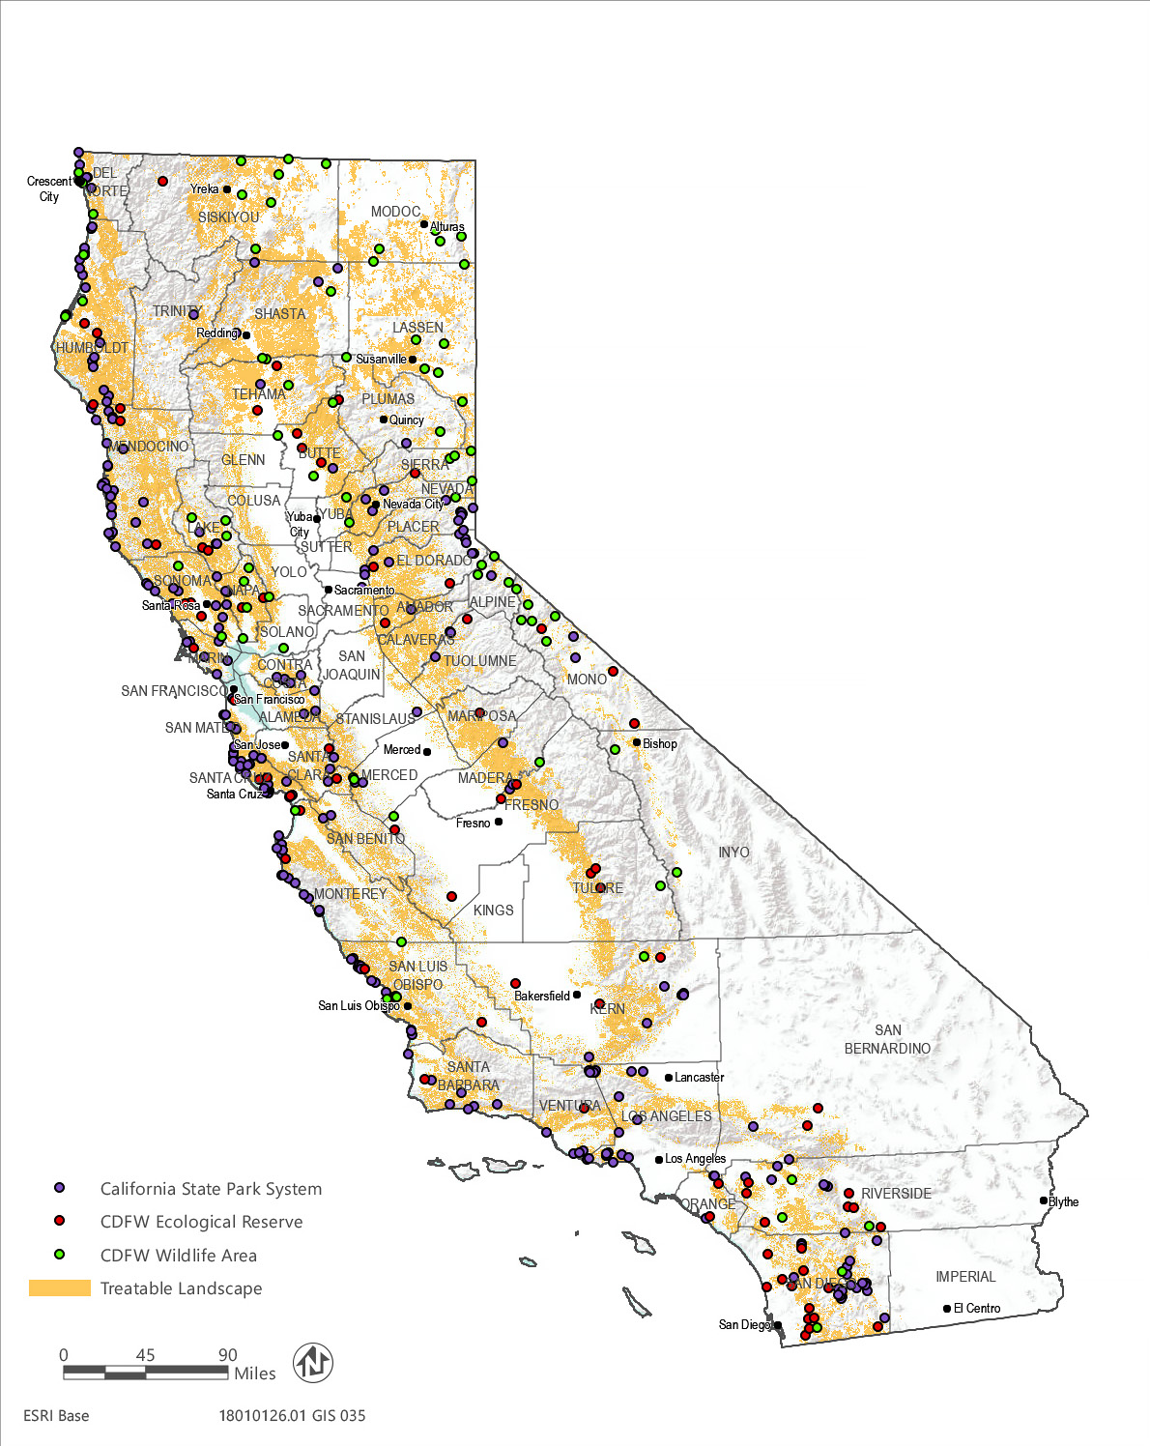
Source: Data downloaded from CDFW and CSP in 2019
Figure 3.14-1 State Recreational Facilities within the Treatable Landscape

Local Recreational Facilities

County Recreational Facilities
There is a total of 58 counties within California, and each county is responsible for providing municipal services to residents, including roads, parks, law enforcement, emergency response services, and libraries. Each county is also charged with providing and maintaining recreational services within the unincorporated areas. For example, the Santa Clara County Parks and Recreation Department manages 28 regional parks encompassing over 52,000 acres of land within the County. Recreational opportunities include biking, hiking, boating, fishing, camping, picnic tables, dog parks, cultural venues, playgrounds, and sports facilities. Similarly, the San Mateo County Parks Department manages 22 parks, encompassing over 16,000 acres, and 190 miles of local trails.

City Operated Recreational Facilities
There is a total of 482 cities in California, and each city is responsible for providing municipal services and maintaining infrastructure, including roads, parks, law enforcement, emergency response services, and libraries. Cities are also charged with providing recreational resources to residents within their respective city limits. For example, the City of Santa Rosa Recreation and Parks Department maintains approximately 525 acres of city parks, sports facilities, and historic structures. The City of Redding Parks and Recreation Department owns 41 parks and nine school-park sites, including playgrounds, and facilities for picnicking, walking, boating, fishing, basketball, softball, baseball, volleyball, soccer skateboarding, aquatics, and off-leash dog play. Incorporated cities are excluded from the SRA and thus the treatable landscape; however, city-owned lands occur outside of incorporated city limits and may be within the treatable landscape.

Special Districts and Nonprofit Organizations
Special districts are a form of local government created to deliver specific public services within a defined boundary. They are governed by an independent board of directors elected by the districts’ voters or appointed to a fixed term of office by either the city council or board of supervisors. In California, there are nearly 3,400 special districts that provide a variety of services including water, sewer, fire protection, and parks. Examples of recreation and parks districts in the treatable landscape include the Santa Clara Valley Open Space Authority, East Bay Regional Park District, and Midpeninsula Regional Open Space District. Recreational opportunities can vary depending on the location and type of special districts; however, common recreational opportunities include hiking, sightseeing, mountain biking, horseback riding, and educational activities.
In addition to special districts, there are a variety of nonprofit organizations in California that preserve undeveloped land as open space for historical, educational, ecological, recreational, and scenic purposes. Typically, nonprofits receive private donations and raise funds from the community to purchase undeveloped properties as opportunities arise. Examples of nonprofit organizations that manage public open space in the treatable landscape include the Nature Conservancy, Big Sur Land Trust, and Wildlands Conservancy. Recreation opportunities can vary depending on the location and habitat sensitivity; however, common recreational opportunities include hiking, outdoor education, camping, picnicking, birding, fishing, and wildlife viewing.

Privately-Owned FacilIties
Private recreation consists of privately-owned facilities which generally required some form of membership or residence. Types of privately-owned facilities include yacht clubs, marinas, boat-docks, sports leagues, camps, amusement parks, commercial recreation development, and recreational vehicle (RV) parks. These types of facilities are located throughout the State, and recreational opportunities can vary depending on the location. Common recreational opportunities include camping, hiking, horseback riding, sailing, and sporting activities.

Effects of Wildfire on Recreation
As discussed in Section 3.17, “Wildfire,” many of California’s ecosystems are fire-adapted. However, in recent decades, increasing drought frequency and warming temperatures have led to an increase in wildfire activity (Westerling et al. 2006, Schoennagel et al. 2017). California has seen increases in wildfire activity in terms of area burned, frequency of large fires, and fire season length (Westerling et al. 2006, Abatzoglou and Williams 2016). During wildfire incidents all areas near or adjacent to managed recreational areas are closed to ensure visitor safety. In 2018, CSP closed numerous state parks as a result of the Butte County Camp fire, Los Angeles County Woolsey fire, and the Ventura County Hill fire (CSP 2018).

Past and Current Vegetation Treatments
Vegetation treatments are currently implemented within the treatable landscape by CAL FIRE and sometimes have temporary effects on recreation, such as limiting access in public parks and trails for public safety reasons. In addition, there are a variety of organizations that currently implement vegetation treatments in the treatable landscape including Bridgeville Community Center, Western Shasta Resource Conservation District, Sonoma County Regional Parks, East Bay Regional Parks District, and Fall River Resource Conservation District. As described in Chapter 1, “Introduction,” and Section 2.3.1, “Past and Current Treatments,” vegetation treatment currently occurs around the state under several other wildfire risk reduction programs implemented by various federal, state, and local agencies. In 2017–2018, CAL FIRE treated approximately 33,000 acres in California using the same treatment activities as proposed under the CalVTP.

Regulatory Setting

Federal
No federal laws or regulations related to recreation are applicable to the program.

State

California Department of Fish and Wildlife
CDFW manages fish, wildlife, and plant resources, and habitats on which species depend, for their ecological values and for public enjoyment. CDFW is divided into seven regions throughout the state. Each region is responsible for the conservation, protection, and management of wildlife, native plants, and habitat necessary to maintain biologically sustainable populations. Per Section 1019 of the Fish and Game Code, CDFW must draft LMP for any property wholly under its jurisdiction that was purchased after January 1, 2002. Generally, each LMP includes an Element that serves as a guide for appropriate public uses for that property, including recreation. In addition, visitor use of all CDFW properties is subject to 14 CCR, which includes regulations that outline designated public uses, allowed activities, and restrictions for all CDFW properties.

California Department of Parks and Recreation
CSP is charged with preparing and adopting a general plan for each of its facilities. The general plan directs the long-range development and management of a park by providing broad policy and program guidance. For the purposes of lands managed by California State Parks, the State is divided into 19 districts. Each district provides oversight for facilities within its service area.

California State Parks Department Operation Manual
The Department Operation Manual (DOM), prepared by CSP, includes a policy framework to guide recreation, interpretive opportunities, and maintenance of the park system. Relevant DOM recreation-related management policies, processes, and procedures are briefly described below (CSP 2004:65):
- Visitor Recreational Uses (0317.1): Interim management plans and General Plans should assess natural resource values and visitor needs and opportunities on a regional basis. These plans can contribute to higher quality recreation, reduced capital outlay costs, reduced staff demands, and habitat conservation.
- Visitor Recreational Uses Policy (0317.1.1): It is the policy of CSP that careful analysis of long-term impacts to natural processes and resources are carried out when planning recreational uses, including interim public use, for State Parks, State Reserves, State Natural Preserves and State Wildernesses. Districts should complete long-term planning for removal or relocation of impacting visitor uses within prime resource areas.
- Closure of Fire of Damaged Areas (0313.2.1.3): All or a portion of a park unit may be closed when an unwanted wildland fire is threatening or burns on CSP lands. Areas of a park unit which have burned will remain closed until appropriate CSP staff have inspected the area and rectified any public safety, property or resource protection issues.

Local
When state agencies, including CAL FIRE, are conducting governmental activities under the authority of state law or the State Constitution, in this case, treatments implemented under the proposed CalVTP they are exempt from local government plans, policies, and ordinances (unless a constitutional provision or stature directs otherwise). Nonetheless, CAL FIRE voluntarily seeks to operate consistently with local governance to the extent feasible. Given its statewide extent and the possible number of local and regional responsible agencies, this PEIR does not identify potentially applicable local government plans, policies, and ordinances. Types of local regulations relevant to recreation may include general plans, zoning ordinances, and adopted policies to avoid conflicts with recreational uses. This PEIR assumes that any vegetation treatments proposed by local or regional agencies under the CalVTP would be consistent with local plans, policies, and ordinances, as required by SPR AD-3.

Impact Analysis and Mitigation Measures

Analysis Methodology
The analysis of environmental impacts on recreation facilities focuses on the potential for substantial physical deterioration of existing facilities, construction or expansion of recreation facilities, and disruption of recreational activities within a designated recreation area. Significance determinations account for the influence of relevant SPRs, which are incorporated into treatment design and listed below.
- SPR AD-3 Consistency with Local Plans, Policies, and Ordinances: The project proponent will design and implement the treatment in a manner that is consistent with applicable local plans (e.g., general plans, Community Wildfire Protection Plans, CAL FIRE Unit Fire Plans), policies, and ordinances to the extent the project is subject to them. This SPR applies to all treatment activities and treatment types, including treatment maintenance.
- SPR REC-1 Notify Recreational Users of Temporary Closures. If a treatment activity would require temporary closure of a public recreation area or facility, the project proponent to will coordinate with the owner/manager of that recreation area or facility. If temporary closure of a recreation area or facility is required, the project proponent will work with the owner/manager to post notifications of the closure approximately at least 2 weeks prior to the commencement of the treatment activities. Additionally, notification of the treatment activity will be provided to the Administrative Officer (or equivalent official responsible for distribution of public information) of the county(ies) in which the affected recreation area or facility is located. This SPR applies to all treatment activities and treatment types, including treatment maintenance.

Thresholds of Significance
Thresholds of significance are based on Appendix G of the State CEQA Guidelines and comments received on the NOP. A treatment implemented under the proposed CalVTP would result in a significant impact on parks and recreational facilities if it would:
- increase the use of existing neighborhood parks or recreational facilities such that substantial physical deterioration of the facility would occur or be accelerated;
- include recreational facilities or require the construction or expansion of recreational facilities which might have an adverse physical effect on the environment; or
- directly or indirectly disrupt recreational activities within designated recreation areas.

Issues Not Evaluated Further
Implementation of the CalVTP would consist of vegetation treatment activities that would modify portions of the treatable landscape to reduce wildfire risk. Treatment activities would not increase the use of recreational facilities to the extent that substantial deterioration would occur. Typically, this impact occurs when a project induces population growth, such as a new housing development or a business that would necessitate a large number of new employees. As discussed in Section 3.12, “Land Use and Planning, Population and Housing,” implementation of the proposed VTP would not induce substantial population growth. New employment would vary and would be dispersed over a large geographic area rather than concentrated in the same location. This would not substantially increase use of existing recreational facilities by employees associated with vegetation treatments. Therefore, implementation of the CalVTP is not expected to generate employees such that substantial physical deterioration of recreational facilities would occur through increased use, and this issue is not evaluated further.
Implementation of the CalVTP would not involve the development of residential communities or other similar types of development or induce substantial population growth in an area that would require the construction of or expansion of recreational facilities. As discussed previously, employees required to implement the proposed CalVTP would be dispersed over a large geographic area rather than concentrated in the same location. This would minimize any localized demand for recreational facilities from employees associated with vegetation treatments such that the construction or expansion of recreational facilities would not be needed. This issue is not evaluated further.

Impact Analysis

Impact REC-1: Directly or Indirectly Disrupt Recreational Activities within Designated Recreation Areas
Implementation of treatment activities within the treatable landscape could result in potential conflicts with recreationists and recreation areas. Conflicts include access restrictions or nuisance impacts during treatment activities including degradation of views, dust emissions, and increased traffic that disrupt the recreational experience. Implementation of SPRs would avoid and minimize disruptions to recreation. This impact would be less than significant.
Implementation of the CalVTP would result in disruption of recreational activities if the proposed treatment directly impedes use of an existing recreational resource or indirectly degrade the experience of recreationists.
Depending on the location and other site-specific considerations of the treatment, proposed treatment activities may temporarily restrict public access to surrounding areas for safety reasons, which would disrupt the recreation experience. Potential nuisance impacts that could also disrupt recreation may include:
- degradation of scenic resources (e.g., short-term presence of equipment or long-term changes to the landscape) within the viewshed of designated recreation areas;
- decreased air quality (e.g., smoke, dust) due to prescribed burning, pile burning, and the use of motorized equipment along unpaved roadways; or
- traffic as a result of ingress/egress of heavy equipment, which may limit, restrict, or delay access to recreation areas.
Each of these potential disruptions and associated mitigation are discussed in PEIR Sections, 3.2, “Aesthetics,” 3.4, “Air Quality,” and 3.15, “Transportation,” respectively. Regulatory compliance, SPRs, and mitigation measures, that would minimize these impacts would also reduce disruption of recreation by requiring workers to store equipment outside of the viewshed, minimize smoke dispersion, suspend ground disturbing treatment activities when there is visible dust, and minimize the ingress/egress of heavy equipment along public roadways. In addition, SPR REC-1 requires the project proponent to coordinate with the owner/manager of any public recreation area or facility that would require temporary closure as a result of treatment activities and post notifications of the closure at least approximately 2 weeks prior to the commencement of the treatment activities. Implementation of this SPR would avoid and minimize disruptions to recreational users be affording recreationists the opportunity to use alternate recreation areas. This impact would be less than significant.

Mitigation Measures
No mitigation is required for this impact.

This page intentionally left blank.

