Please adjust your screen reader settings to recognize underline and strikethrough text.

Program DESCRIPTION

Overview of the CalVTP
The California Vegetation Treatment Program (CalVTP) is proposed by the California Board of Forestry and Fire Protection (Board) to treat vegetation that could become fire fuel. The purpose of the CalVTP is to serve as one component of the state’s range of actions to reduce wildfire risk and diminish or avoid the harmful effects of wildfire on people, property, and natural resources within the California Department of Forestry and Fire Protection’s (CAL FIRE’s) State Responsibility Area (SRA). The SRA is an area of more than 31 million acres of private and public land (see Figure 1-1 in Chapter 1, “Introduction”). The treatable landscape, which is the portion of the SRA where vegetation conditions are suitable for treatment, consists of approximately 20.3 million acres. As part of the CalVTP, CAL FIRE and other project proponents would implement vegetation treatment activities on up to approximately 250,000 acres annually within the treatable landscape. The 250,000-acre annual target is necessary to help meet the Governor’s goals in response to California’s wildfire crisis.
The proposed CalVTP consists of three treatment types: wildland-urban interface (WUI) fuel reduction, fuel breaks, and ecological restoration. The vegetation treatment activities proposed to implement each of these treatment types are prescribed burning, manual treatment, mechanical treatment, prescribed herbivory, and targeted ground application of herbicides. The following sections provide a description of the proposed CalVTP.

Objectives of the CalVTP
California Environmental Quality Act (CEQA) Guidelines call for the identification of objectives sought by a proposed project (CEQA Guidelines Section 15124[b]). A statement of objectives helps convey the reasons for considering approval of the proposed CalVTP, including its intended benefits, and guides the development of a reasonable range of alternatives to evaluate in the PEIR.
The statement of objectives below describes the underlying purposes of the CalVTP and expresses the role of vegetation treatment in implementing state policies and plans for wildfire risk reduction, greenhouse gas (GHG) reduction, and management of natural and working lands. The objectives of the CalVTP are to:
1. serve as the vegetation management component of the state’s range of actions underway to reduce risks to life, property, and natural resources by managing the amount and continuity of hazardous vegetative fuels that promote wildland fire consistent with California’s 2018 Strategic Fire Plan (Board and CAL FIRE 2018);
2. substantially increase the pace and scale of vegetation treatments to contribute to achieving a statewide total of at least 500,000 acres per year on non-federal lands, consistent with the Governor’s Executive Order B-52-18, which results in a target up to 250,000 acres per year after considering other types and areas of vegetation treatments;
3. increase the use of prescribed burning as a vegetation treatment tool, consistent with the provisions of Senate Bill 1260, Statutes of 2018, and Public Resources Code (PRC) Section 4483(a);
4. contribute to meeting California’s GHG emission goals by managing forests and other natural and working lands as a net carbon sink, consistent with the California Forest Carbon Plan (Forest Climate Action Team 2018), California’s 2017 Climate Change Scoping Plan (CARB 2017), Fire on the Mountain: Rethinking Forest Management in the Sierra Nevada (Little Hoover Commission 2018), and California 2030 Natural and Working Lands Climate Change Implementation Plan (CalEPA et al. 2019); and
5. improve ecosystem health in fire-adapted habitats by safely mimicking the effects of a natural fire regime, considering historic fire return intervals, climate change, and land use constraints.

Description of the Proposed CalVTP

Past and Current Treatments
Over the last century, fire suppression practices have resulted in the unnatural buildup of fire fuel in many locations throughout the state. CAL FIRE has been conducting vegetation treatments for more than 20 years to reduce fire fuel accumulation within the SRA through the 21 operational units that cover the state (CAL FIRE Units) and within county jurisdictions where CAL FIRE or county contracts have been executed (Contract Counties). Vegetation treatments are currently primarily implemented under CAL FIRE’s Vegetation Management Program (VMP), which is limited to prescribed burning and manual and mechanical treatments. The VMP does not include the use of herbicides or mechanical mastication or treatments on forested lands (tree fuel type). Annual records of treated acreage by CAL FIRE Units and Contract Counties from 2004 to 2018 under the VMP indicate an average of approximately 7,000 acres of lands treated per year. The annual treated acreage statewide ranged from a high of 10,443 acres in 2018 to low of 701 acres in 2014; however, some of the tabulated data for this period is incomplete, so the 7,000-acre average during this period may be an underestimate. Years with more complete reporting (i.e., 1996-2004) indicate an annual average of approximately 23,000 treated acres under the VMP. CAL FIRE treats additional acreage outside of the VMP under other approved programs and on project-specific bases. Since 2010, the total acreage of fuel reduction treatments by CAL FIRE under the VMP and other vegetation treatment programs has nearly doubled and the number of acres treated by prescribed burning has tripled (Table 2-1).
Table 2-1 Annual Acres of Vegetation Treatments by CAL FIRE
Fiscal Year | Fuels Reduction | Prescribed Fire | Total
2018/2019 (through January 2019) | 5,490 | 10,352 | 15,842 (to date)
2017/2018 | 13,344 | 19,413 | 32,757
2016/2017 | 15,755 | 13,941 | 29,696
2015/2016 | 11,481 | 16,896 | 28,377
2014/2015 | 14,728 | 3,331 | 18,059
Source: CAL FIRE 2019
Entities other than CAL FIRE also implement vegetation treatments within the treatable landscape including private landowners, state, regional, and local agencies. Treatment activities currently being undertaken by these other entities include all of the treatment types proposed under the CalVTP and described below.

Proposed CalVTP Implementation
The Board is mandated to regulate forestry activities within the SRA and develop policies and regulations that contribute to fire prevention and recovery efforts (PRC Section 740). The Board’s proposed discretionary action needing CEQA compliance is approval of the CalVTP. After approval, implementation of the CalVTP would consist of vegetation treatment activities carried out by CAL FIRE on private or public land, by public agencies and organizations funded by CAL FIRE grants from CAL FIRE or other state agencies, or potentially by public agencies that own land within the treatable landscape.
This CalVTP PEIR addresses the following:
- Expansion of CAL FIRE’s vegetation treatment activities to reach a total treatment acreage target of approximately 250,000 acres per year to contribute to the achievement of the 500,000 annual non-federal acres expressed in EO B-52-18, signed by Governor Jerry Brown in May 2018. The expanded target would be a substantial increase compared both to current activity and to the level proposed in the 2017 VTP Draft PEIR (i.e., 60,000 acres per year).
- A project-specific implementation approach for streamlining CEQA review of later site-specific, vegetation treatment activities consistent with the CalVTP and the PEIR, in accordance with procedures described in CEQA Guidelines Section 15168. The streamlined CEQA review approach would document how a project’s environmental effects are covered and which feasible mitigation measures from the CalVTP PEIR are incorporated. This would include evaluation of whether later activities and impacts of site-specific vegetation treatment projects are within the scope of the CalVTP and the PEIR. A “within the scope” finding for later activities would facilitate an increase in the pace and scale of project approvals in a manner that includes environmental protections in compliance with CEQA. Where later vegetation treatment projects do not qualify for a “within the scope” finding, site-specific mitigated negative declarations (MNDs) or EIRs would be prepared.
Proposed vegetation treatment activities would be designed to reduce hazardous vegetative fuels, improve protection from wildfires that are not primarily driven by high winds through strategically located fuel breaks, and/or mimic a natural fire regime using prescribed burning. In addition, ecosystem restoration activities would be designed to approximate natural habitat conditions, processes, and values to those occurring prior to the period of fire suppression. While targeting approximately 250,000 acres a year, the actual acres treated annually would fluctuate based on several factors, such as the number of willing landowners who would participate, funding availability, and access constraints. Also, it would take several years to “ramp up” from the current treatment acreage to the proposed treatment acreage. It is estimated that treatment acreages in the first year of CalVTP implementation would be consistent with current CAL FIRE acreage goals of 25,000 acres of prescribed burning and 20,000 acres of other treatment activities statewide, for a total of 45,000 acres. It is assumed that the acres treated annually would increase each year, reaching approximately 250,000 acres per year in 2024. The proposed increase in the pace and scale of vegetation treatment is in response to the Natural Resources Agency’s directive from the former Governor Brown to work with relevant federal, State, and local agencies to increase the acres treated each year statewide on nonfederal lands to 500,000 acres. The 250,000 acres per year proposed for treatment as part of the CalVTP would account for CAL FIRE’s s portion of the 500,000-acre statewide goal, recognizing vegetation treatment projects implemented by other departments under the Natural Resources Agency.
With implementation of the CalVTP, several factors would facilitate achieving this increase in the pace and scale of vegetation treatments. First, upon certification, this CalVTP PEIR would support and supplement CAL FIRE’s existing VMP, so the acres treated through the existing VMP are encompassed in the projected treated acres of the CalVTP. Second, this CalVTP PEIR is intended to replace the existing process of preparing a stand-alone CEQA document for qualifying treatment projects proposed in forested fuel types. This streamlined CEQA review process would reduce the need for staff effort and time for approval of individual treatment projects, while incorporating consistent standards of environmental protection, thereby allowing CAL FIRE and other state, regional, and local landowners to treat more acres each year than are currently. Third, mechanical mastication and the use of herbicides are not activities authorized in the existing VMP; they are included in the CalVTP to broaden the array of treatment tools available. The inclusion of these new treatment activities adds flexibility and improves efficiency, which also increases the ability to treat more acres compared to current practices.
To support implementation of the CalVTP, new funding sources have been made available that would allow CAL FIRE to increase treated acres. A variety of grant programs have been developed in recent years that specifically fund vegetation management which would also increase the acres treated by other public agencies receiving CAL FIRE grants for vegetation treatment. Additionally, increased funding has been allocated to CAL FIRE by State Budget Acts, which allows CAL FIRE to hire more staff to implement vegetation treatment, including staff dedicated to vegetation treatment. Currently, most staff conducting vegetation treatment activities can be diverted to firefighting efforts when there is a wildfire. The substantial increase in available funding statewide combined with the increase in CAL FIRE staffing provides additional resources to treat the acreage projected as part of the CalVTP.

Geographic Scope of the CalVTP – Treatable landscape
Appropriate areas within which to implement vegetation treatments as part of the CalVTP were identified by first dividing the SRA into vegetation types from the California Wildlife Habitat Relationship (CWHR) system. The CWHR system, managed by California Department of Fish and Wildlife (CDFW), was developed to categorize major vegetative complexes at a scale sufficient to predict wildlife-habitat relationships. Certain CWHR vegetation types were then excluded because the wildfire risks within these types are negligible (e.g., wet meadow, estuarine). Agricultural CWHR vegetation types were also excluded because agricultural land is generally outside the SRA.
Using this method, 20.3 million acres within the 31 million-acre SRA were identified that may be appropriate for vegetation treatments as part of the CalVTP (Figure 2-1). Throughout this PEIR, this area is called the “treatable landscape.” The proposed target of 250,000 annual acres of treatment would occur within the 20.3 million acres of treatable landscape, as described in Section 2.3.2, “Proposed CalVTP Implementation.”

Fuel Types
The treatable landscape is divided into three broad categories of hazardous vegetative fuels (referred to in this PEIR as “fuel types”) that exhibit similar fire behavior characteristics: grass, shrub, and tree (see Appendix PD-1 for more information on data assumptions and methods for categorizing the treatable landscape by fuel type).
In the grass fuel type, fire spread is governed by fine, very porous, and continuous herbaceous fuels that have dried or are nearly dry. Fires are typically surface fires that move very rapidly through the dry grass and associated material. Generally, less than one-third of the area is composed of shrub or timber. Where shrub or tree fuel types exist, fire intensity generally increases along with an increase in the production of embers that spread fire. The grass fuel type in a specific location has historically burned in wildfires at frequencies ranging from every year up to every 35 years. The interval within which fire returns to an area is called “fire frequency” or “fire return interval.”
Fire in the shrub fuel type is generally carried in the surface fuels composed of litter cast by the shrubs, as well as the grasses or forbs (i.e., flowering, non-grass plants) in the understory. Fire intensity is variable in this group; however, fuel and weather conditions can produce intense fast-spreading fires, because of the available live and dead fine woody material in the crowns of a nearly continuous secondary overstory. Besides flammable foliage, dead woody material in the stands substantially contributes to the fire intensity as well as a deep litter layer. Wildfire in the shrub fuel type can completely burn a large stand of vegetation, called stand replacement, and occur with a frequency ranging from every 35 to 200 years.
Wildfire in the tree fuel type in forested landscapes has mixed levels of severity. Tree fuel types may experience surface fires with low flame lengths, although the fire may encounter an occasional heavy fuel concentration that can flare up and carry a ground fire into the canopy, called a crown fire. High temperatures, low humidity, and high winds can pose severe fire hazards if surface fires transition into crown fires. Closed canopy stands of short-needle conifers or hardwoods that have leafed out support fire in the compact litter layer. Dead/down fuels include greater quantities of 3-inch or larger Iimbs resulting from over maturity or natural events. These conditions result in more fires reaching the crowns of trees or shrubs, fire producing embers that are carried by the wind and start new fires, and the ignition and flare-up of trees, leading to potential difficulty controlling fires. Wildfire frequency in the tree fuel type is highly variable depending on forest type and location. However, typical wildfire frequency for tree fuel types ranges from every year up to every 35 years.
Within these primary fuel types, the tree fuel type encompasses approximately 40 percent of the treatable landscape and is the largest of the three groups. The grass and shrub fuel types encompass approximately 38 percent and 22 percent of the total acreage, respectively. Fuel types are shown in Figure 2-2 and discussed in more detail in Appendix PD-1.
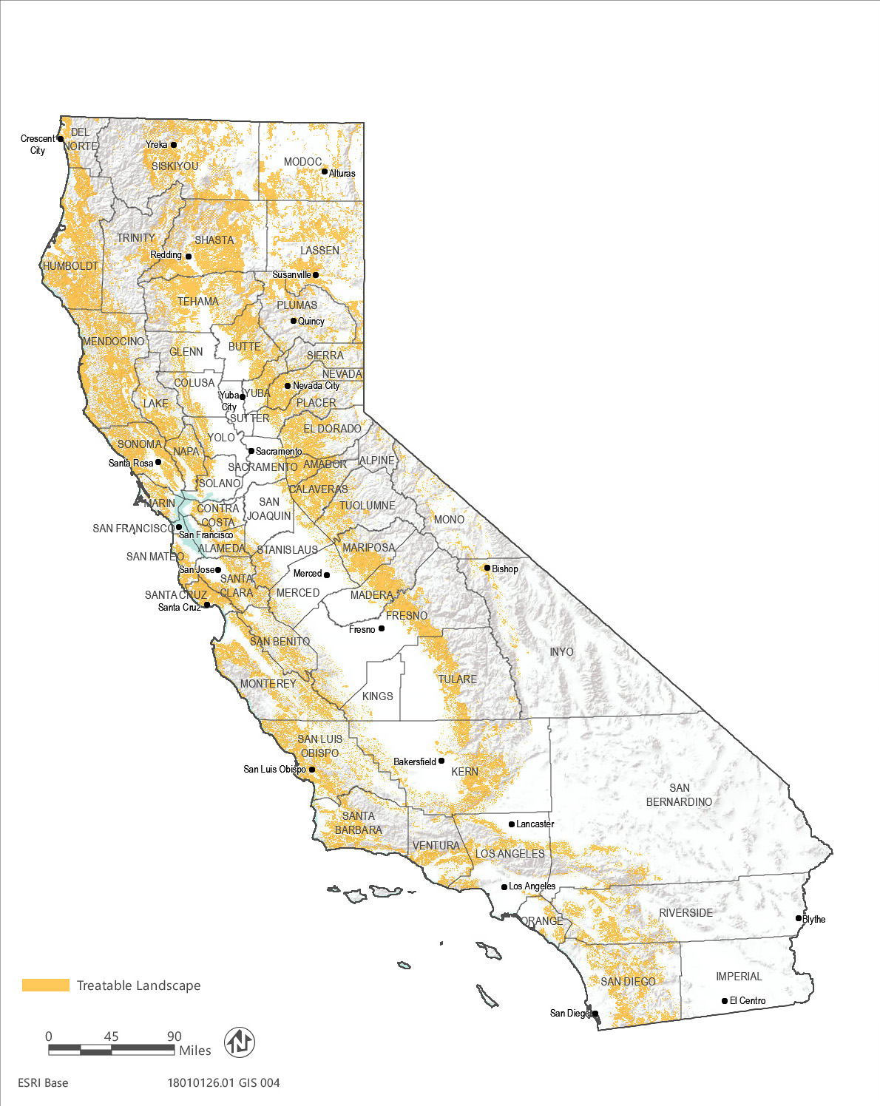
Source: Data received from the Department of Forestry and Fire Protection in 2019
Figure 2-1 Treatable Landscape
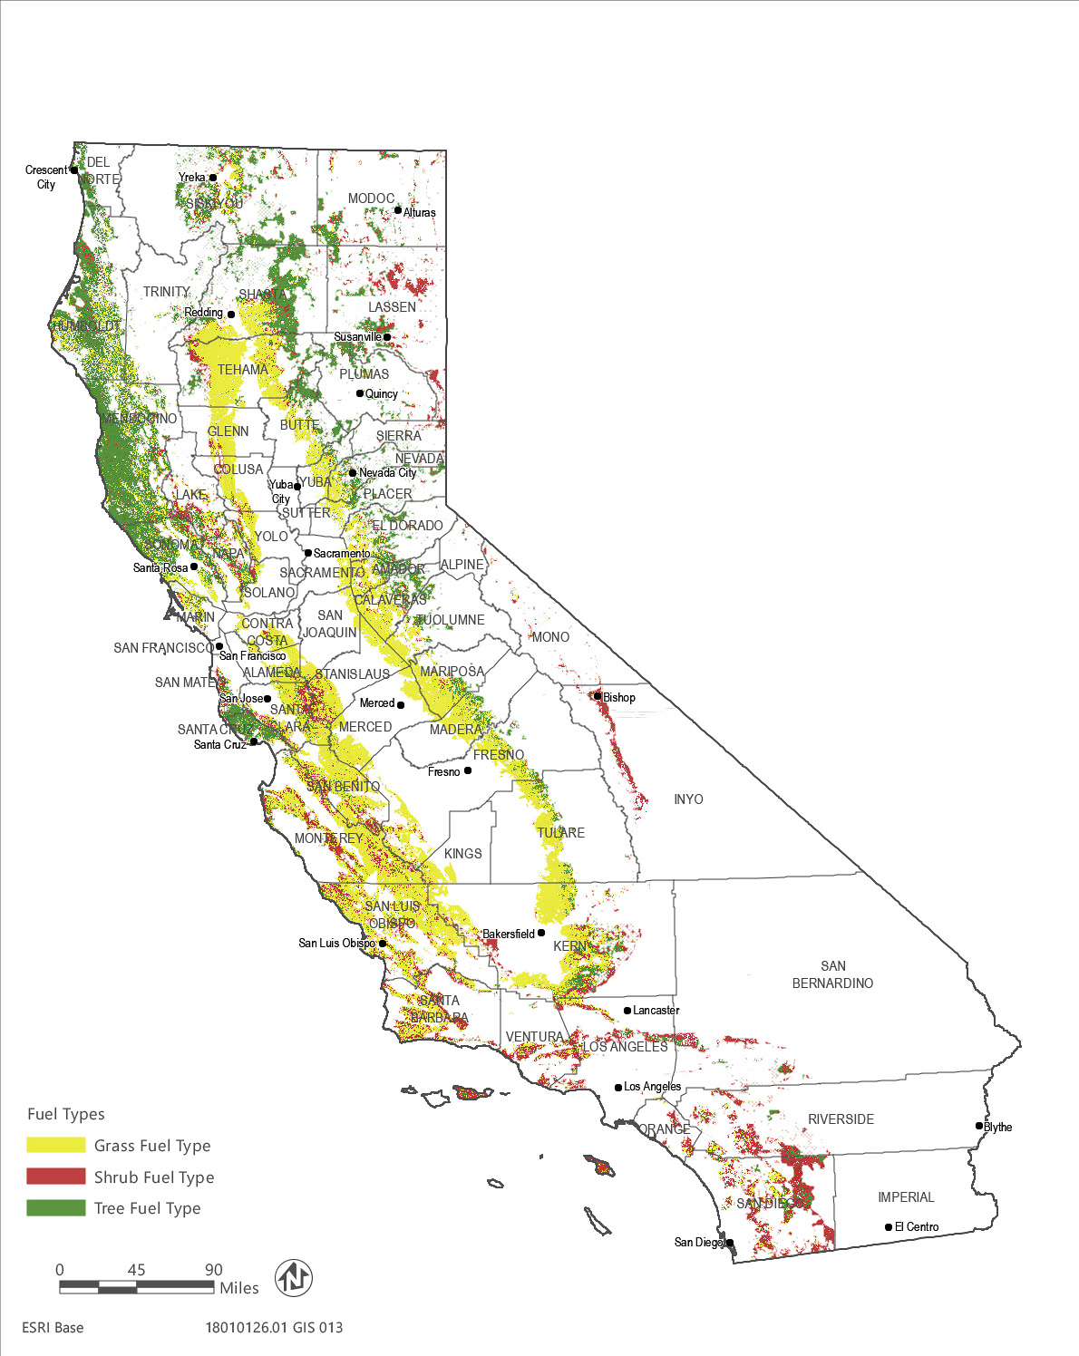
Source: Data received from the Department of Forestry and Fire Protection in 2019
Figure 2-2 Fuel Types in the Treatable Landscape

Program Description

Description of Treatment Types
Vegetation treatment at the landscape scale is focused on reducing the likelihood of a ground fire increasing in intensity and helping suppression forces more easily contain a fire. This is accomplished by modifying fire behavior through strategic removal or modification of vegetation (Finney and Cohen 2003, Graham et al. 2004). Certain wind and weather conditions lead to ultrahigh-intensity, fast-moving, wind-driven wildfires. Although the most individually destructive, these extreme fires represent a small number of the total fires that occur each year. While vegetation treatments under the CalVTP may not be able to slow or halt such extreme fires; most fires that occur within the state are not highly wind driven and the proposed vegetation treatments can help slow and suppress them. Vegetation treatments can also play a valuable role in containing the more extreme fires, when weather conditions shift, wind subsides, and fire intensity decreases. By implementing the proposed treatment types, the CalVTP would strategically modify portions of the landscape to reduce losses from and improve resiliency to wildfire. The proposed treatment types are:
- Wildland-Urban Interface Fuel Reduction: Located in WUI-designated areas, fuel reduction would generally consist of strategic removal of vegetation to prevent or slow the spread of non-wind driven wildfire between structures and wildlands, and vice versa.
- Fuel Breaks: In strategic locations, fuel breaks create zones of vegetation removal and ongoing maintenance, often in a linear layout, that support fire suppression by providing responders with a staging area or access to a remote landscape for fire control actions. While fuel breaks can passively interrupt the path of a fire or halt or slow its progress, this is not the primary goal of constructing fuel breaks.
- Ecological Restoration: Generally, outside of the WUI in areas that have departed from the natural fire regime as a result of fire exclusion, ecological restoration would focus on restoring ecosystem processes, conditions, and resiliency by moderating uncharacteristic wildland fuel conditions to reflect historic vegetative composition, structure, and habitat values.
These treatment types may occur on different landscapes depending on the local assets at risk, ecological conditions, or other priorities. CAL FIRE’s Fire and Resource Assessment Program (FRAP) modeled the areas where each of the three proposed treatment types could be implemented within the treatable landscape. Condition class designations within the treatable landscape were considered in identifying areas within which fuel break and ecological restoration treatments could be implemented. FRAP analyzed expected fires in comparison to historic fire regimes with respect to fire frequency, size, patchiness, and effects on key ecosystem elements and processes (CAL FIRE 2003). Using this information, condition classes were assigned to areas based on current vegetation type and structure, an understanding of pre-settlement fire regime, and current conditions regarding expected fire frequency and potential fire behavior (Table 2-2).
Condition class is a function of the degree of departure from historical fire regimes (Hardy et al. 2001). Condition Classes 2 and 3 identify areas that have the greatest departure from historic conditions, where fire behavior is uncharacteristic and vegetation composition is altered from the loss of the key components of an ecosystem. Approximately 15.5 million acres within the SRA are ecologically at risk from fire (Moderate and High condition classes), with almost 6 million acres in Condition Class 3 (High). Condition class provides a parameter for prioritizing projects proposed for fuel break and ecological restoration treatments. Condition class, however, does not distinguish between a negative and positive deviation from the fire return interval; an evaluation of the existing conditions of the specific activity area needs to be conducted to establish the most appropriate action for moving forward on a site-specific basis. Additional information about the process of modeling appropriate treatment areas within which to implement proposed CalVTP treatments is presented in Appendix PD-1.
Table 2-2 Condition Class Definitions
Condition Class | Departure from Natural Regime | Vegetation Composition, Structure, Fuels | Fire Behavior, Severity, Pattern | Disturbance Agents, Native Species, Hydrologic Functions | Increased Smoke Production
Low  (Condition Class 1) | None, minimal | Similar to natural | Similar to natural | Within natural range of variation | Low
Moderate (Condition Class 2) | Moderate | Moderately altered | Uncharacteristic | Outside historic range | Moderate
High  (Condition Class 3) | High | Substantially Different than natural | Highly uncharacteristic | Substantially outside historic range | High
The following summarizes the primary considerations for identifying the areas within which each of the three proposed treatment types could be implemented. Multiple treatment types can be implemented where modeled treatment areas for treatment types overlap.
- Modeling of areas appropriate for the WUI fuel reduction treatment type combined three main factors: ranking fuel hazard, human asset exposure, and proximity of those human assets to the fire threats. WUI fuel reduction treatments could be implemented where these factors intersect.
- Fuel breaks were modeled by identifying ridgelines and roadways within fuel types that have deviated from the historic fire regime (i.e., Condition Class 2 or 3 described below) and assuming a 300-foot wide fuel break.
- Areas suitable for ecological restoration were identified by excluding the modeled WUI, then determining areas that have deviated from the historic fire regime (i.e., Condition Class 2 and 3).
Each of the proposed treatment types is described in more detail in the sections below.

Wildland-Urban Interface Fuel Reduction
The WUI is the geographic overlap of two diverse systems, wildland and structures (Figure 2-3). At this interface, buildings and vegetation are sufficiently close that a wildland fire could spread to a structure or a structure fire could ignite wildland vegetation. Once homes are built within or adjacent to natural areas, they increase the complexity of fighting wildland fires because the priority of extinguishing the wildland fire is often superseded by the necessity to first protect human life and private property. The focus of WUI fuel reduction treatments is to strategically reduce vegetation density and remove fuel to directly protect communities and assets at risk from potential damage from non-wind driven wildfires originating in the adjacent wildlands, as well as to protect the wildlands from fires starting in or near development. WUI fuel reduction treatments also serve as emergency access points and staging areas for firefighters and equipment and reduce flammable vegetation along emergency evacuation routes for the community. Also, where existing habitat within the WUI is degraded, such as by the infestation of non-native plant species, as well as needing fuel reduction, WUI treatments would also help enhance habitat quality. (Ecological Restoration treatments are discussed below; while they are focused in the landscape outside the WUI, ecological enhancements would be included in WUI treatments, as existing vegetation conditions warrant.)
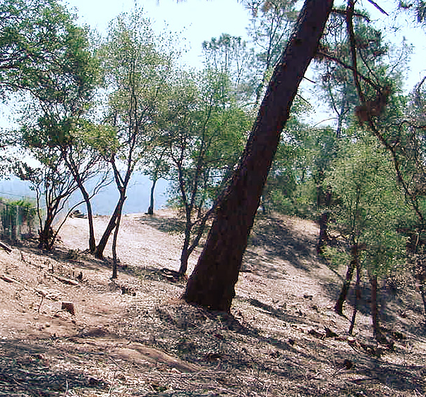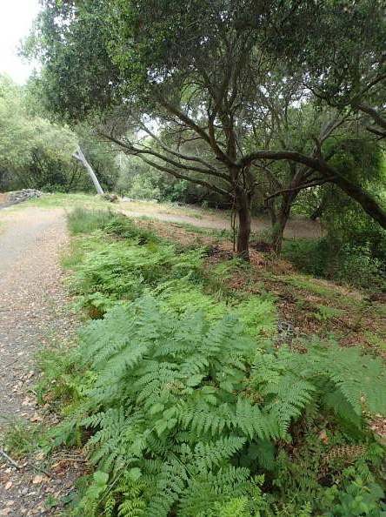
Source: CAL FIRE 2017 Source: CNGA 2019
Figure 2-3 Examples of WUI Fuel Reduction Treatments
The areas suitable for WUI fuel reduction treatments are defined through a complex modeling process undertaken by FRAP and the California Fire Alliance (Figure 2-4). Modeling of areas appropriate for the WUI fuel reduction treatment type contain three main factors: ranked fuel hazard, human asset exposure, and proximity of human assets to the fire threats (CAL FIRE 2003, 2017). The WUI exists where these three characteristics exist together on the landscape. Maps were developed that identify areas suitable for WUI fuel reduction treatments. Additional information on the spatial modeling of the WUI fuel reduction treatment area is presented in Appendix PD-1.
Activities implemented within the WUI fuel reduction treatment type would occur outside of the 100-foot defensible space requirements described in PRC 4291 and within the modeled WUI. As described in Chapter 1, “Introduction,” WUI fuel reduction treatments would serve as one component of the larger wildfire risk reduction effort occurring in the WUI. WUI building codes (California Building Code Chapter 7A) and other structure hardening and fire safe development requirements would continue to be implemented in addition to and separately from this proposed program. Once it is determined that a WUI fuel reduction treatment would be implemented, specific locations for such a treatment would be prioritized based on an evaluation of the topography, fuel loading, and proximity to communities.
The modeled WUI fuel reduction treatment areas within the treatable landscape are shown in Figure 2-4 and encompass approximately 10.1 million acres, which is approximately half of the treatable landscape for the CalVTP. The modeled WUI fuel reduction treatment area overlaps in some areas the modeled treatment areas for the fuel break and ecological restoration treatment types.
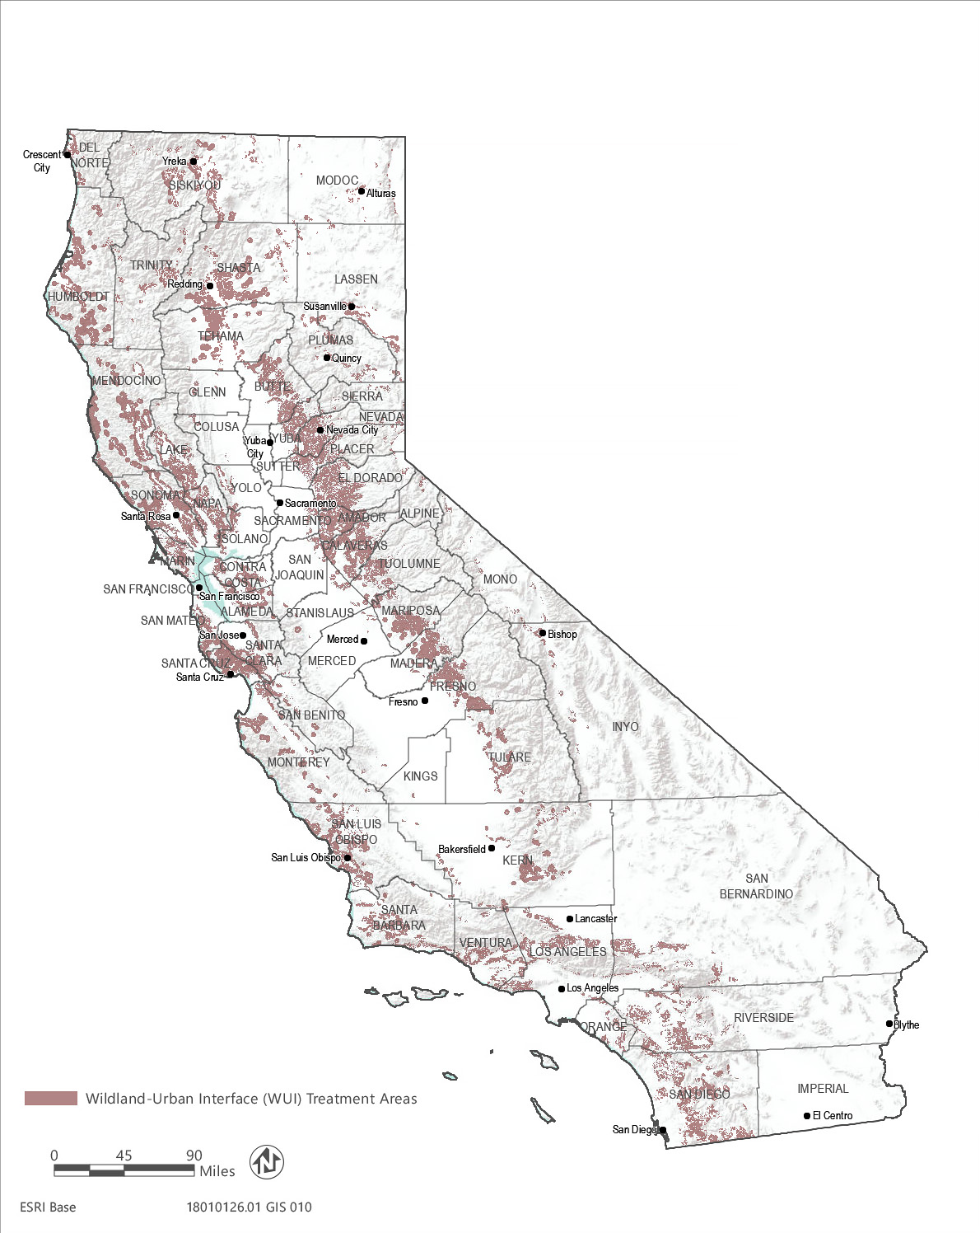
Source: Data received from the Department of Forestry and Fire Protection in 2019
Figure 2-4 Modeled Wildland-Urban Interface (WUI) Fuel Reduction Treatment Areas

Fuel Breaks
Fuel breaks would be established in strategic areas where flammable vegetation can be modified to reduce fire spread to structures and/or natural resources, while providing a safer location for firefighters to fight fires. This treatment type could be used in combination with other treatment types to increase its effectiveness in achieving applicable objectives of the CalVTP. Fuel breaks created as part of the CalVTP would assist active suppression efforts and are not designed to passively prevent or control wildfires, including when extreme wind and weather conditions drive a wildfire’s spread. Two types of fuel break treatments would be implemented: non-shaded and shaded.
Non-shaded fuel breaks are typically created where there is a natural change in vegetation type, such as from forest or shrubland to grassland, and all vegetation is removed from the fuel break (Figure 2-5). Heavy equipment would be used to create these types of fuel breaks, except on slopes steeper than 65 percent or 50 percent in areas susceptible to erosion, where manual or prescribed burning treatments would be employed.
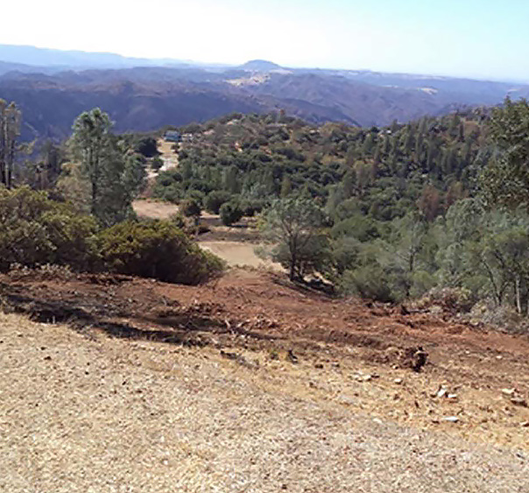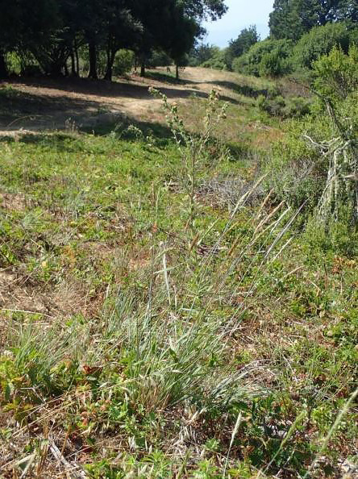
Source: CAL FIRE 2019 Source: CNGA 2019
Figure 2-5 Examples of Non-Shaded Fuel Break Treatments
Shaded fuel breaks are used in forest settings (Figure 2-6). Typically, the tree canopy is thinned to reduce the potential for a crown fire to move through the canopy; however, larger trees would remain. The shade of the retained canopy also helps reduce the potential for rapid re-growth of shrubs and sprouting hardwoods and can reduce rill and gully erosion.
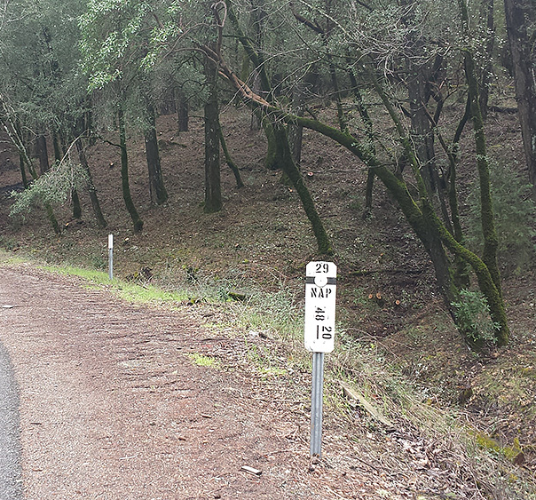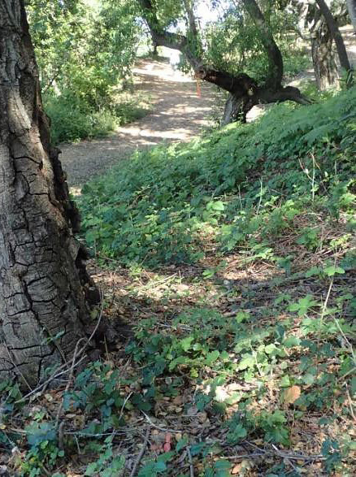
Source: CAL FIRE 2019 Source: CNGA 2019
Figure 2-6 Examples of Shaded Fuel Break Treatments
Fuel breaks are a fundamental tool in allowing firefighters access to control wildfires and are useful in slowing non-wind driven fires before they grow beyond initial attack capabilities. Fuel breaks are primarily used to allow responders to reach the leading edges of a fire and increase protection of isolated communities. In non-wind driven fires, fuel breaks can also help to stop or reduce the lateral spread of fires. Studies of past fires have assessed the effectiveness of fuel breaks in reducing wildfire risk. Within seven counties in southern California from 1990 through 2009, ridgeline fuel breaks accounted for 8 percent of the fire perimeters in Santa Ana wind-driven fires and up to 13 percent within non-Santa Ana wind-driven fires. Roads accounted for up to 72 percent of the fire perimeter in non-Santa Ana wind-driven fires and 56 percent in Santa Ana wind-driven fires (Jin et al. 2015). Syphard et al. (2011) conducted a spatial analysis of the Los Padres National Forest in southern California and concluded that fires stopped at fire-crew accessed fuel breaks 46 percent of the time. Preexisting fuel breaks allowed fire suppression activity to take advantage of the lighter fuels along the ridgelines to cut control lines. This was useful in both wildland areas and areas outside the wildland areas where heavy equipment could aid in suppression efforts (Syphard et al. 2011).
Colleen Mooney summarizes the advantage of fuel breaks in a 2010 study addressing Canada’s boreal forest:
There is consensus in the literature that modification of forest fuels will alter wildland fire behavior (Agee et al. 2000, Alexander and Lanoville 2004, Fites and Henson 2004, Hirsch et al. 2001, Martinson and Omi 2003, Martinson and Omi 2006, Omi et al. 2007, Graham et al. 2004 and others). The literature suggests that the primary purpose for fuel breaks is to change fire behavior as it enters the fuel-altered zone (Stratton 2004) resulting in limited, or slowed, fire spread (Davis 1951, Duguy 2007, Dennis 2005, Green and Schimke 1971, van Wagtendonk 1996); reduced flame lengths (van Wagtendonk 1996); and reduced probability of torching and independent crown fire (Agee et al. 2000). A fuel break can provide other numerous advantages as well: it can be used as an anchor point for indirect attack (Salazar and Caban 1987, Murphy et al. 1967); it can facilitate the rapid construction of a fire line/firebreak by suppression forces (Bevers et al. 2004, Murphy et al. 1967); it can provide safe access for ground suppression crews (Salazar and Caban 1987, Murphy et al. 1967); and can allow greater penetration to surface fuels of fire retardants dropped from the air (Agee et al. 2000, Murphy et al. 1967) (Mooney 2010).
Mooney indicates that fuel breaks need to be tailored to topography, fuel characteristics, fire regimes, and expected weather conditions to improve their effectiveness in reducing wildfire risk. Given the diversity of California fuel types, topography, and weather conditions, standardized fuel break width or volume of fuels to remove as part of the CalVTP treatments would not be feasible. Historically, fuel break design is variable depending on location (Agee et al. 2000).
The areas suitable for fuel breaks were identified by modeling the dominant ridgelines and identifying roads within the defined WUI that are Condition Class 2 or 3. A 150-foot buffer was placed on the identified roads and ridgelines, which created a 300-foot-wide modeled fuel break treatment area. The 300-foot-wide fuel break was used as a typical or average width for fuel breaks; however, the width of each fuel break would vary depending on the location, vegetation, and topography. In some cases, when a fuel break is adjacent to a roadway that extends into the Local Responsibility Area (LRA), the fuel break could also be constructed partially into the LRA.
In most cases fuel breaks would occur along strategic topographic locations and adjacent to public roads but could also occur next to areas naturally low in fuel (rocky outcrops) or high moisture vegetation (drainages). These areas are typically referred to as anchor points and help improve the effectiveness of a fuel break.
Fuel break treatments may have multiple objectives or goals shaping their design and purpose, including, but not limited to, the following:
- creating strategic control points to allow firefighters to safely engage a wildfire, improving opportunities to control wildfire in the initial attack phase and prior to it reaching communities;
- maintaining shaded fuel breaks as part of a community fuel break system that is designed to protect the community and the watershed values of the area from wildfire; and
- improving the safety of ingress and egress routes by reducing flammable vegetation along roadways and driveways.
Shaded fuel breaks are used instead of non-shaded fuel breaks in areas where habitat needs to be retained for sensitive species, where there is the potential for erosion or visual impacts, or the fuel type will support this kind of treatment.
Fuel break treatments are not designed to passively halt or slow the progress of wind-driven wildfires. Although experience with past fires has confirmed that fuel breaks can contribute to establishing control perimeters when fires are wind-driven, fuel breaks are generally not effective in extreme wind and weather conditions that cause embers to be carried over fuel breaks. For these extreme conditions, fuel breaks provide value for staging fire attacks and contributing to establishment of control perimeters, but they are not designed to halt the advancement of this type of fire. Fuel breaks are most effective for non-wind driven wildfires where they can provide access for firefighters and equipment, establish a perimeter around a fire, or slow or halt the fire.
The modeled fuel break treatment area is approximately 3.1 million acres or 15 percent of the treatable landscape for the CalVTP. Figure 2-7 illustrates the modeled fuel break treatment area within the treatable landscape.
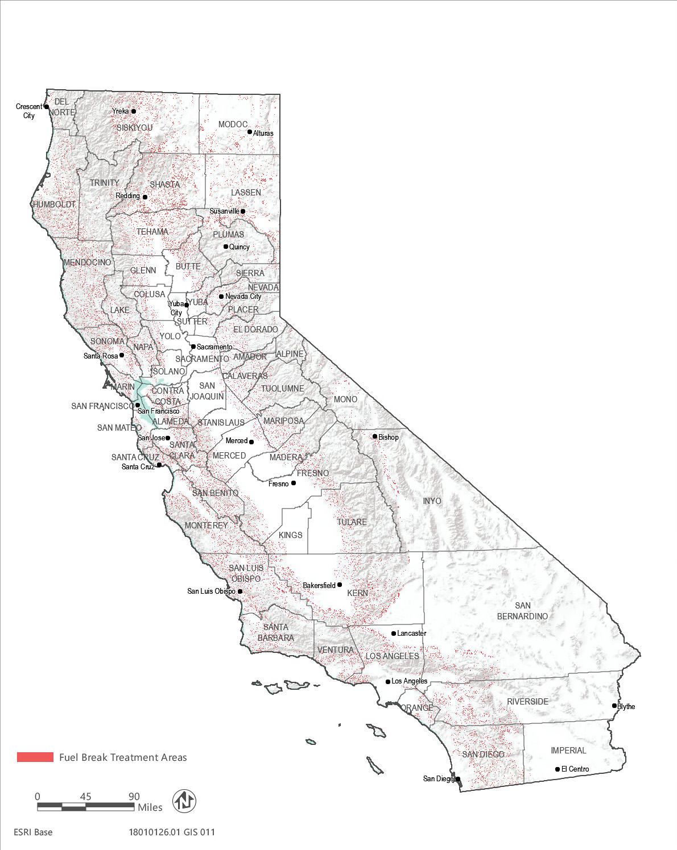
Source: Data received from the Department of Forestry and Fire Protection in 2019
Figure 2-7 Modeled Fuel Break Treatment Areas

Ecological Restoration
For the purposes of the CalVTP, ecological restoration is the process of re-establishing the composition, structure, pattern, integrity, and ecological processes necessary to facilitate terrestrial and aquatic ecosystem sustainability, resilience, and health currently and in the future. This would involve vegetation treatments that seek to return the landscape closer to native conditions where natural fire processes can be reestablished and habitat quality is improved, including habitat remediation where non-native, invasive plants have spread, and excess fire fuel buildup has occurred (Figure 2-8). It is also the process of assisting the recovery of an ecosystem that has been degraded, damaged, or destroyed by destructively intense wildfire.
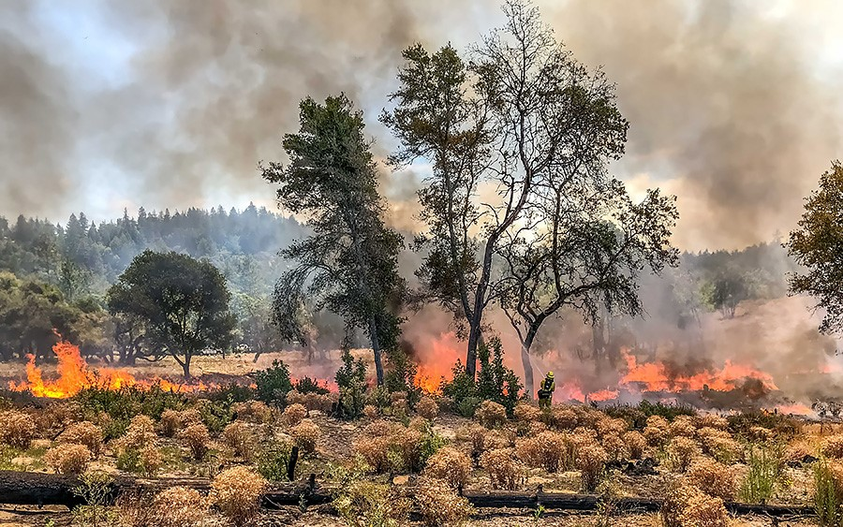
Source: CAL FIRE 2019
Figure 2-8 Example EcosystemEcological Restoration Treatment
Fire is a natural process in many ecosystems and has played an important role in shaping the ecology and evolution of species. Periodic wildfire helps to maintain ecosystem processes and functions, particularly those in which species have developed strategic adaptations to fire (Pausas et al. 2004). Despite the important ecosystem role played by fire, human activities have altered natural fire regimes relative to the historic range of variability (Syphard et al. 2007). In California, the two primary mechanisms altering fire regimes are fire suppression, resulting in fire exclusion, and increased human ignition sources, resulting in abnormally high fire frequencies. Climate change, land use conversions, and other indirect factors may also play a role in altering fire regimes (Lenihan et al. 2003).
While these patterns are widely applicable to many forested landscapes in the western United States, California chaparral shrublands have experienced such substantial human population growth and urban expansion that the increase in ignitions in these areas (Schroeder et al. 1964) have offset the effects of suppression to the point that fire frequency exceeds the historic range of variability (Keeley et al. 1999). Because anthropogenic ignitions tend to be concentrated near development, more fires now occur at the urban fringe than in the backcountry (Keeley et al. 2004). Profound impacts on land cover condition and ecological community dynamics are possible if a disturbance regime exceeds its natural range of variability, and these altered fire regimes can lead to cascading ecological effects (Dale et al. 2000).
Implementation of the ecological restoration treatment type is proposed to improve fire resiliency in target fire-adapted plant communities by restoring degraded, damaged, or destroyed ecosystems and habitats to conditions associated with a natural fire regime. Conceptually, ecological restoration for fire-adapted ecosystems seeks to restore fire regimes that support natural ecological structure. The disruption of fire regimes leads to changes in plant composition and structure, hydrologic processes, resistance to pests, and alters fire behavior and smoke impacts. A primary component of ecological restoration treatments is removal of invasive or non-native species to promote native, fire-adapted plant communities. Ecological restoration would also improve range and forage on private property, thereby increasing land management options for private landowners.
Ecological restoration treatments may have multiple objectives or goals shaping their design and purpose, including, but not limited to, the following:
- restoring fire adapted ecosystems that resist high intensity fire and associated property and watershed damage;
- improving ecological health by returning appropriate fire frequencies to the landscape;
- restoring watershed ecosystems and creating forest conditions more closely associated with pre-settlement conditions;
- providing locations to conduct research and monitoring on prescribed burning to educate the public and plan burning more effectively in the future.
Areas suitable for ecological restoration treatment were identified by excluding the WUI fuel reduction treatable area and intersecting the remaining treatable acreage with land identified as Condition Class 2 or 3. This mapping method places the ecological restoration treatments in more remote locations. However, ecological restoration goals related to improving ecological health and restoring watershed conditions would also be integrated into WUI fuel reduction treatments to the extent that existing vegetation conditions warrant (e.g., non-native, invasive plant infestations). These goals would not be limited to areas modeled for the ecological restoration treatment type.
The ecological restoration treatment area is approximately 9.2 million acres or 45 percent of the area identified as “treatable” for the CalVTP. Figure 2-9 illustrates the modeled ecological restoration treatment areas within the treatable landscape.
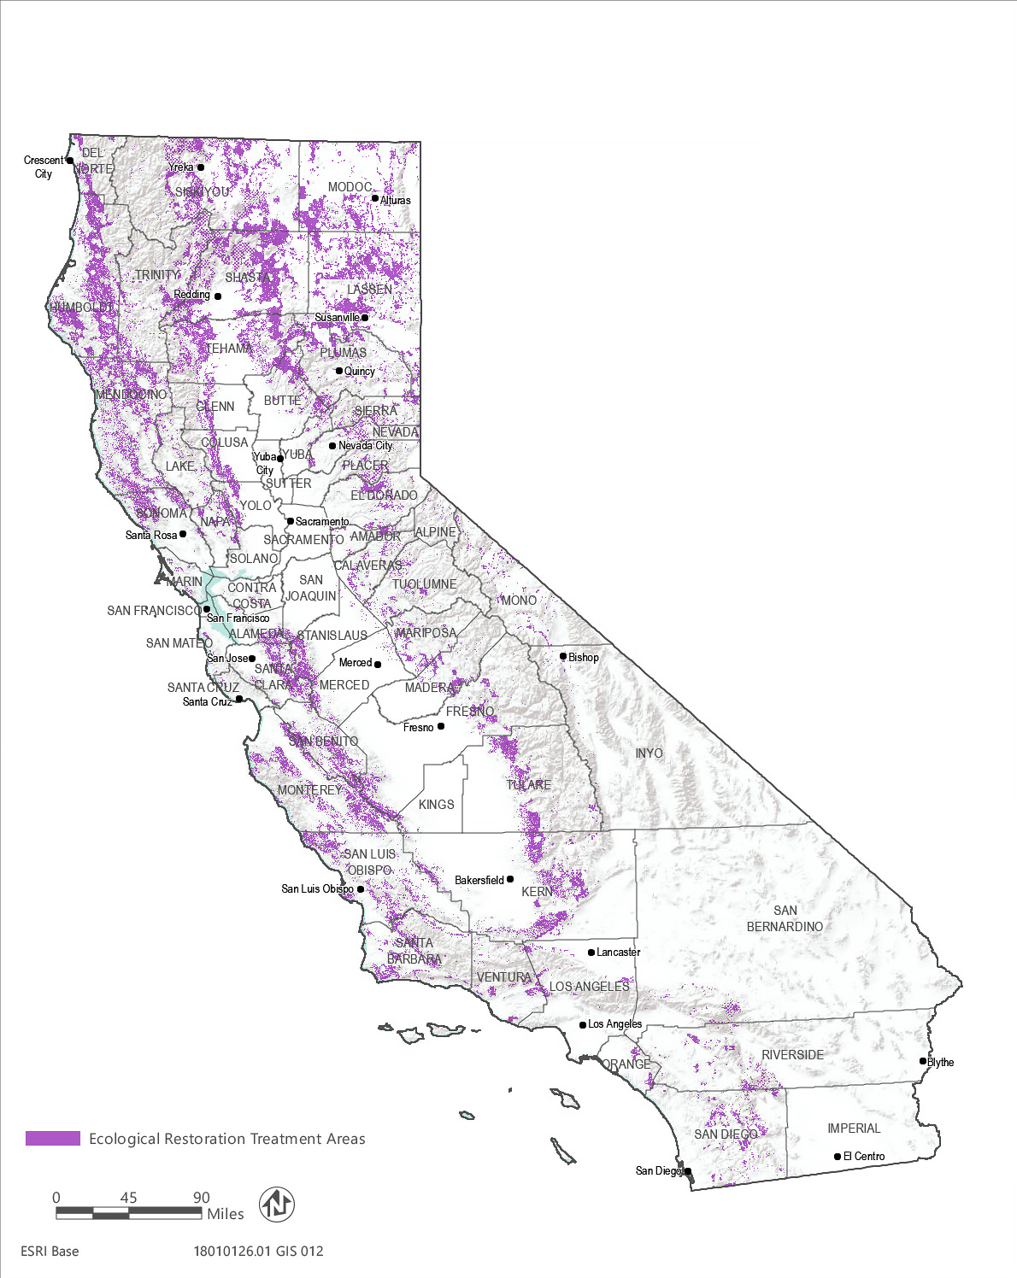
Source: Data received from the Department of Forestry and Fire Protection in 2019
Figure 2-9 Modeled Ecological Restoration Treatment Areas

Description of Treatment Activities
The WUI fuel reduction, fuel break, and ecological restoration treatment types would be implemented using various treatment “activities” that may be applied singularly or in combination. The treatment activity or activities selected would be those that are most likely to achieve the desired treatment objectives for the specific site, protect natural resource values, and meet the overall program objectives. During the planning phase for a CalVTP activity, the appropriate treatment activity or activities would be selected that best match the operational needs and treatment constraints on the landscape. The treatment activities proposed as part of the CalVTP are identified in Table 2-3.
Table 2-3 Treatment Activities
Treatment Activities | Description | Method of Application
Prescribed Burning | Pile burning: Prescribed burning of piles of vegetative material to reduce fuel and/or remove biomass following treatment  Broadcast burning: Prescribed burning to reduce fuels over a larger area or restore fire resiliency in target fire-adapted plant communities; would be conducted under specific conditions related to fuels, weather, and other variables | Pile burning: Place removed fuels in piles on site and burn fuel  Broadcast burning: Burn understory within timber or oak woodlands, or broadcast treatment using fire with a control line along the perimeter
Mechanical Treatment | Use of motorized equipment to cut, uproot, crush/compact, or chop existing vegetation | Mastication, chipping, brush raking, tilling, mowing, roller chopping, chaining, skidding and removal, piling; often combined with pile burning
Manual Treatment | Use of hand tools and hand-operated power tools to cut, clear, or prune herbaceous or woody species | Hand pull and grub, thin, prune, hand pile, lop and scatter, hand plant; often combined with pile burning
Prescribed Herbivory | Use of domestic livestock to reduce a target plant population thereby reducing fire fuels or competition of desired plant species | Grazing or browsing by cows, goats, or sheep
Herbicides | Chemical application designed to inhibit growth of target plant species | Ground-level application only, such as paint-on stems, backpack hand-applicator, hypo-hatchet tree injection, or hand placement of pellets. No aerial spray is allowed.
The treatment activity or activities would be selected by the applicable CAL FIRE Unit or project proponent (i.e., a project proponent is a public agency providing funding for vegetation treatment or with land ownership, land management, or other regulatory responsibility in the treatable landscape and seeking to implement vegetation treatments consistent with this PEIR for CEQA compliance a public agency or organization funded by CAL FIRE grants or with land ownership/management responsibilities in the treatable landscape and seeking to implement vegetation treatments consistent with this PEIR for CEQA compliance), based on several parameters including the following (refer to Section 2.6.1, “Implementation Process,” for additional information on planning treatments):
- characteristics of the site such as size; distribution, density, life cycle, and life stage during which plants are most affected by treatment; soil characteristics; weather conditions; and proximity to sensitive areas;
- ability and willingness of landowner to maintain treated area;
- effectiveness of the treatment in achieving desired fuel conditions and other applicable CalVTP objectives and cost of the treatment methods and follow-up maintenance requirements;
- cost of the treatment methods;
- potential for adverse environmental effects;
- objectives for the site;
- historic and current conditions;
- opportunities to preserve desirable vegetation and wildlife habitat;
- available funding;
- success of past treatments, or treatments conducted under similar conditions;
- recommendations by local experts and input from local community;
- primary land use (e.g., WUI, forestry, range, open space);
- accessibility of the site; and
- topography, slope, and aspect of the site.
Treatment activities would typically be implemented in combination. For example, a prescribed burn of 260 acres would require up to 2.5 miles of fuel break, which can result in as many as 11 of the 260 acres being cleared by heavy equipment for use as control lines. Manual treatments that do not involve the use of a chipper are often accompanied by pile burning the winter after treatment.
Table 2-4 shows which treatment activity would most likely be used given the treatment type (i.e., WUI fuel reduction, fuel breaks, and ecological restoration) and fuel type (i.e., tree, shrub, and grass). In general, mechanical treatments would have a high likelihood of being used within all treatment types in the tree fuel type, and WUI fuel reduction treatments within the shrub fuel type. Mechanical treatments would have a moderate likelihood to be used for ecological restoration treatments in shrub fuel types, and for WUI fuel reduction and fuel break treatments in grass fuel type. On the other hand, prescribed burning would have a high likelihood of being used for ecological restoration treatments in the grass fuel type, moderate potential for ecological restoration treatments in tree fuel types, and a moderate likelihood of being used for fuel breaks in tree and shrub fuel types.
Table 2-4 Relative Likelihood of Implementing Treatment Activities by Fuel Type for each Treatment Type
Treatment Activity | Tree |  |  | Shrub |  |  | Grass
 | WUI | Fuel Break | Ecosystem Restoration | WUI | Fuel Break | Ecosystem Restoration | WUI | Fuel Break | Ecosystem Restoration
Prescribed Burning | L | M | M | L | M | L | M | M | H
Manual Treatments | H | M | M | M | M | M | L | L | L
Mechanical Treatments | H | H | H | H | L | M | M | M | L
Herbicides | M | M | L | L | M | L | L | L | L
Prescribed Herbivory | L | L | L | L | M | L | L | M | M
Notes: H: high; M: medium; L: low

Prescribed Burning
Prescribed burning is the intentional application of fire to vegetation under specified conditions of fuels, weather, and other variables (Figure 2-10). The intent is for the fire to stay within a predetermined area to achieve site-specific resource management objectives. Prescribed low intensity surface fires may be used to control vegetation by enhancing the growth, reproduction, or vigor of certain species, in addition to managing fuel loads and/or maintaining a targeted vegetation community.
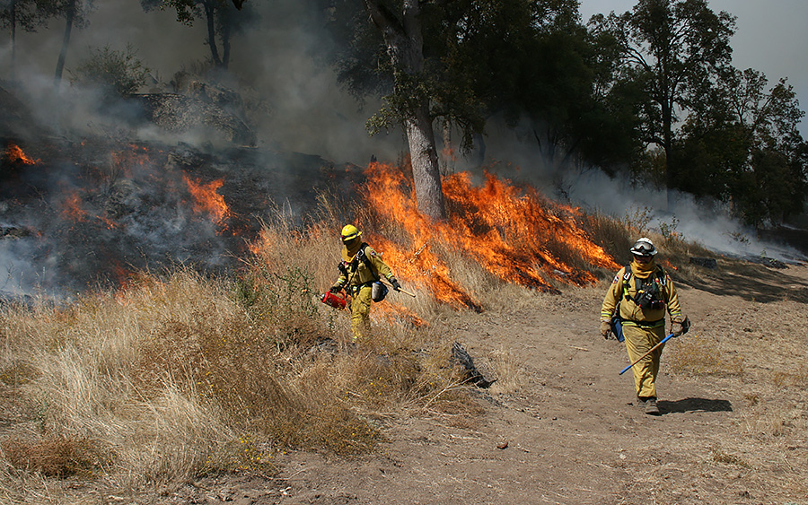
Source: CAL FIRE 2019
Figure 2-10 Example Prescribed Burn Treatment
Prescribed burning can be used to restore the ecological function in areas that have departed from their natural fire regime. Fire suppression has changed fire activity in the 20th century, and prescribed burning is a tool that can restore and maintain appropriate fire regimes (Keeley and Syphard 2016).
Typically, prescribed burning would require the construction of control lines (fuel breaks) using manual or mechanical treatments. In some cases, extensive or mature shrubs may be trimmed or removed manually by hand crews or by mechanical equipment in advance of burning, or vegetation may be pretreated with herbicides to kill the aboveground portions and cause them to dry before burning. Prescribed burning may be used where other activities are not feasible because of rocky soils, steep slopes (i.e., greater than 65 percent or 50 percent in high erosion areas), or irregular terrain; although, prescribed burning is limited to situations where sufficient fuel is available and arranged properly to carry the fire.
Factors that are considered when designing and implementing a prescribed burn include risk to structures and property, land use, environmental impacts, weather conditions, soil stability, slope and aspect, soil type, vegetation types and density, fuel moisture content, time of year, fire return interval, and the efficacy of alternative activity methods. Another consideration is how often prescribed burning may need to be applied to achieve a particular outcome. A comprehensive summary of historic fire frequency estimates for California ecosystems indicates that there is considerable variability in the fire return intervals of the ecosystems evaluated. Generally, median historic fire return intervals were lowest for drier forests such as yellow pine, dry and moist mixed conifer, and oak woodland (7 years, 9 years, 12 years, respectively). Median historic fire return intervals were highest for less productive woodlands such as pinyon-juniper (94 years), high elevation habitats such as subalpine forest (132 years), very dry habitats such as desert mixed shrub (610 years), and productive moist forests such as spruce-hemlock (275 years) (Van de Water and Safford 2011). Cost is also a consideration, as prescribed burning is less expensive than other treatment activities and can generally be achieved for less than $150 per acre (Nadar et al. 2007).
Burning may occur throughout the year, but it is usually conducted during late spring when the ground is still wet, or during the fall or winter when precipitation is imminent, and plants have completed their yearly growth cycle and their moisture content has declined. Considerations when timing a prescribed burn include public safety, animal and plant reproduction cycles, the natural fire return interval for the ecosystem, and the timing of annual grasses drying out in May. In brush or chaparral communities, fall burning may not be desirable because of the possibility of high fire intensities. Some chaparral species may benefit from spring burns to help germinate seed, while other chaparral species may benefit from fall sprouting (Beyers and Wakeman 2000).
There are multiple studies that identify the beneficial aspects of maintaining a matrix of burn severities from large unburned areas to areas with high severity burns. These studies identify benefits from the heterogeneity of these landscapes (Roberts et al. 2015). However, developing a prescribed high severity burn event requires substantial resources, low fuel moistures, and low relative humidity. These three requirements often coalesce during the summer and early fall, which is peak fire season in California. The resource drawdown that is typically occurring at these times to fight fires in California and elsewhere, and the higher fire risk throughout the state, typically does not leave resources available to perform these high severity prescribed burns.
Depending on a specific activity’s objectives, fuel modeling, and environmental conditions, a broadcast burn can be used to treat various fuel sizes. “Understory burn” prescriptions, using patterned lighting techniques and timing the fires during periods of high humidity and high fuel moisture content, typically result in partial removal of understory or groundcover vegetation. The goal of understory burns is to conduct a low intensity burn that only burns the targeted fuel types (i.e., ground and litter fuels). The existing groundcover vegetation would be partially retained in a mosaic pattern in forest and shrub communities. While the amount of vegetation remaining following a prescribed burn varies, up to 70 percent of the vegetation typically remains. Fire behavior and burn severity would also depend on the properties of various fuel layers and the horizontal and vertical continuity of those layers (Graham et al. 2010).
Prescribed burns typically last 1 day and may occur for up to 1 week. The average number of workers on-site for a prescribed burn is 45. Equipment used for a prescribed burn include between 2 and 10 engines, two to four crews, up to two bulldozers and bulldozer transports, masticators or track chippers (to create fuel break perimeter), and onsite water truck for fire suppression, and hand torches. There are several types of equipment and associated fuels or other materials that may be used in specific circumstances to ignite prescribed burns. Drip torches and fusees are the primary ignition and firing tools that CAL FIRE and other agencies use, which are typically applied along the perimeter of prescribed burn unit to ignite a fire. Drip torches use a gasoline/diesel fuel mixture that is dispensed by hand from a cylindrically shaped aluminum container. Fusees are similar to railroad flares and are often put on a stick, ignited, and used as a hand ignition device. Other devices such as the Terra torch and projected aerial devices (i.e., Very Pistol, FireQuick flare launcher, and Polystyrene spheres) may be used. A helicopter with a helitorch may be used when a large area needs to be burned or an area has terrain with limited accessibility. Terra torches and helitorches use gasoline mixed with a gelling agent, such as alumagel (aluminum carboxylates) or Flash 21, which solidifies the gasoline into a jelly-like form. The gelled gasoline helps the operator carefully target ignition locations. It is ignited by a propane lighter and typically applied along the perimeter of a burn unit using a Terra torch or in discrete, planned strips through a burn unit using a helitorch. The fuel and other associated compounds (e.g., gelling agents) that form the basis for the targeted ignition process in each of these methods are collectively referred to as accelerants. As described above, Fuels accelerants may be used to assist with ignition; however, no fire retardants or suppression chemicals would be used under the program. Crews inspect prescribed burn sites prior to ignition to see if any hazardous materials are present.
Any prescribed burn under the CalVTP would require a burn plan (see Appendix PD-2) that includes a smoke management plan. The smoke management plan identifies the affected air district(s), sensitive receptors, wind direction, venting elevation, and visibility factors related to smoke dispersal. Smoke management plans are designed to minimize public exposure to air pollutants generated by prescribed burns. See Section 2.7, “Standard Project Requirements,” below for additional details.

Mechanical Vegetation Treatment
Mechanical treatment involves the use of motorized equipment (rather than hand or manual equipment), such as wheeled tractors, crawler-type tractors, or specially designed vehicles with attached implements designed to cut, uproot, crush/compact, or chop target vegetation (Figure 2-11). The selection of a mechanical treatment and associated equipment is based upon several factors such as the characteristics of the vegetation, seedbed preparation and re-vegetation needs, topography and terrain, soil characteristics, climatic conditions, and a comparison of the improvement cost to the expected increase in productivity or public and/or private benefit. In some cases, mechanical treatment can be used to create a desired stand structure and composition without having to use prescribed burning, or in areas where there are risks and uncertainties with prescribed burning. Mechanical treatment methods that may be used include tilling, drill seeding, mowing, masticating (Figure 2-12), grubbing, and chipping, among others. For projects located in forested landscapes, the use of mechanical equipment can create and maintain a desired forest floor condition in various settings, although if used improperly, mechanical equipment can displace mineral soil and reduce organic content (Graham et al. 2010).
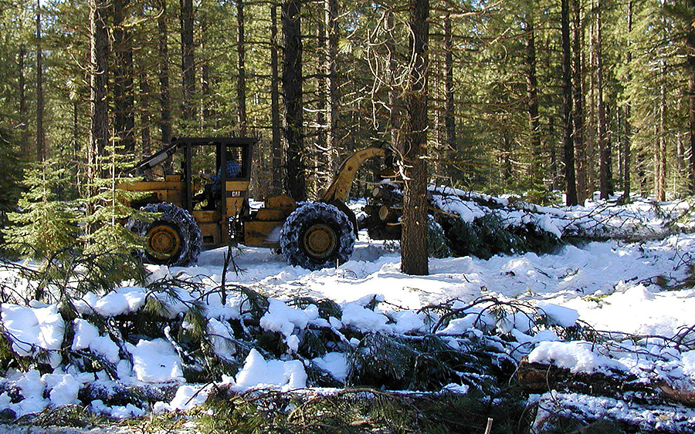
Source: CAL FIRE 2019
Figure 2-11 Example Mechanical Treatment
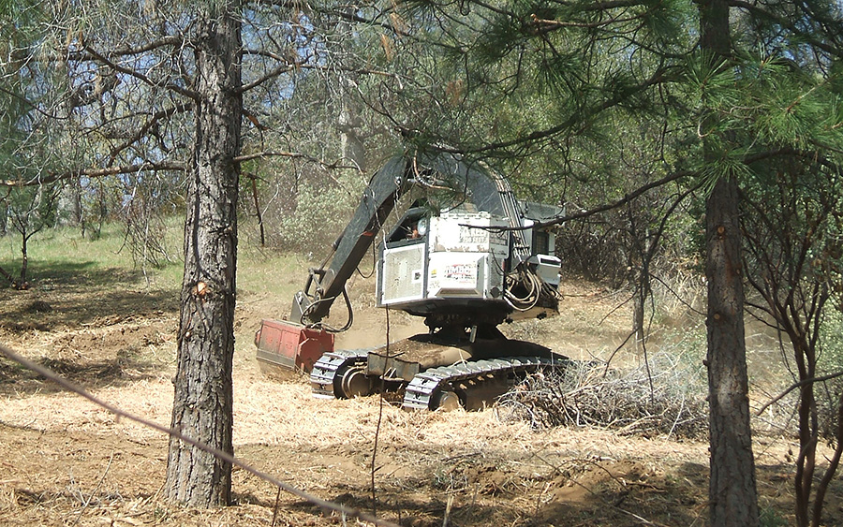
Source: CAL FIRE 2019
Figure 2-12 Example Mechanical Treatment with Masticator
Mechanical treatment is effective for removing dense stands of vegetation and is typically used in shrub and tree fuel types. Some mechanical equipment can masticate (mulch) or lop and scatter vegetative debris concurrently with vegetation removal. Mastication involves the use of a large mechanized device for chopping and is used in areas with shrubs and trees to break up the fuel pattern and decrease combustibility by placing fuels on the ground. Mechanical treatments may be the best tool to restore forest overstory health and has also proven to reduce fire hazards while maintaining the healthy overstory over time (Collins et al. 2014). Mechanical treatments are appropriate where a high level of control over vegetation removal is needed, such as near residential area, communities, or in sensitive habitats and are often used instead of prescribed burning or herbicide application. Unless followed with targeted application of herbicides, mechanical treatment has limited use for noxious weed control, as the machinery tends to spread seeds and may not kill root systems.
A study looking at 11 National Forests in California over an 8-year period found that surface fuels returned to 67-79 percent of pretreatment densities after mechanical treatment. However, mechanical treatments were more successful in reducing canopy bulk density and canopy base height (Vaillant et al. 2015). This is consistent with another study that identified that mechanical treatments can lower future susceptibility to fires but may lack specific vegetation structural elements that prescribed burning can provide (Collins et al. 2014).
Currently, vegetation removed during mechanical treatments (i.e., biomass) is disposed as follows:
- approximately 70 percent – disposed of on-site including:
- lopping to a specified maximum length and scattering within treatment boundary to a specified depth to reduce flame lengths in the event of a wildfire;
- piling and leaving piles unburned for wildlife habitat;
- chipping, with the chips blown onto the ground as mulch or into piles for later removal;
- cutting large woody material into lengths for firewood gatherers; or
- removing large woody material by hand.
- approximately 25 percent - piling by hand and subsequent pile burning during wet periods of the year. Pile burning is only used in combination with manual and mechanical activities to remove biomass and differs from prescribed (broadcast) burning described below; and
- approximately 5 percent – hauled to a biomass facility.
Vegetation removed with mechanical treatments under the CalVTP is expected to be disposed of similar to current methods. However, the percentage of vegetation hauled to biomass facilities for energy generation is expected to increase over time as the number of biomass treatment facilities increase in response to recent legislation including Senate Bill (SB) 859 (2016), which requires utilities to purchase a portion of their electricity from existing bioenergy facilities that use fuel from High Hazard Zones in California, and SB 1078, SB 107, SB X1-2, and SB 350 that require electricity retailers in the state to procure a portion of retail sales from renewable energy sources, including biomass energy (Forest Climate Action Team 2018).
Typically, one hand crew (i.e., 20 workers), skid steers, excavators, dozers and dozer transport; tow chippers, track chippers, masticators, and at least one fire engine are used for mechanical treatments. Mechanical treatments vary depending on the size of the treatment area and the type of vegetation being treated (i.e., dense shrub and tree fuel types take longer) and can take from several days up to several months. Mechanical treatment costs range from $800 to more than $2,000 per acre for equipment, fuel, and labor. Repeated mechanical treatments are often necessary, as residual weed or shrub seed in the soil or re-sprouting of shrubs may re-vegetate treated areas with undesired plants. Mechanical treatments tend to cost 3.5 times more than prescribed burns because of the removal requirements of non-commercial biomass (North et al. 2012). In general, most mechanical treatments occur in late spring, summer, or fall (May to November).

Manual Vegetation Treatment
Manual treatment would involve the use of hand tools and hand-operated power tools to cut, clear, or prune herbaceous and woody species (Figure 2-13). Activities could include the following:
- thinning trees with chainsaws, loppers, or pruners;
- cutting undesired competing brush species above ground level to favor desirable species and spacing;
- pulling, grubbing, or digging out root systems of undesired plants to prevent sprouting and regrowth; and
- placing mulch around desired vegetation to limit competitive growth.
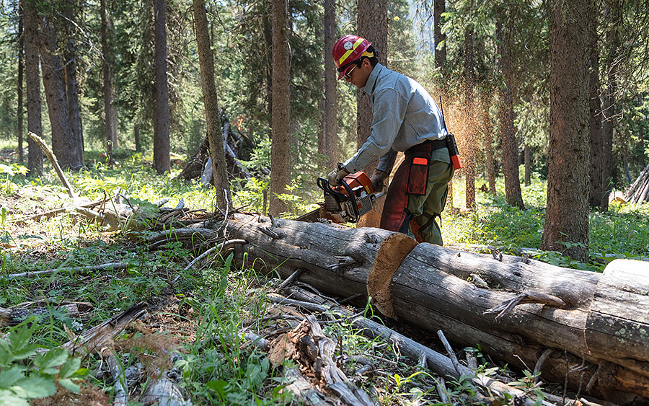
Source: CAL FIRE 2019
Figure 2-13 Example Manual Treatment
Accumulations of vegetation created by manual treatments would be disposed of as described above for mechanical vegetation treatments.
Ground disturbance from manual treatments is typically less than mechanical treatment within an equivalent area. Manual treatments are effectively used in sensitive habitats, such as riparian areas and wet areas, areas where prescribed burning or herbicide application would not be appropriate, around structures, to install control lines for prescribed burns where mechanical equipment cannot be used, and in areas that are inaccessible to vehicles.
Typically, one or two hand crews (i.e., 20-40 crew members) and four to eight chainsaws are used for manual treatments. Masticators and chippers are used occasionally to assist with manual treatments, and a drip torch or Terra Torch may be used if pile burning is used to dispose of biomass. Manual treatments can take between 3 and 6 months depending on the treatment size and type of vegetation. Crews can typically clear 0.3 acre or more per day. Manual treatments are expensive and labor intensive compared to other vegetation management methods. Costs range from $800 to $2,300 per acre, depending on the amount and type of vegetation (Nadar et al. 2007). While manual treatments may not be efficient or cost effective over large acreages, they may be useful for targeting specific species or minimizing impacts to desirable species and may also be cost effective for small-scale projects where heavy equipment mobilization costs are prohibitive.

Prescribed Herbivory
Prescribed herbivory (also known as “targeted grazing” [ASI 2006, Macon 2019]) is the use of domestic livestock to accomplish specific and measurable vegetation management objectives. Those would include things like removing biomass (fine fuel loads), reducing populations of specific plant species, slowing the re-establishment of shrubs on burned or mechanically thinned sites, and improving plant community structure for wildlife habitat values (Figure 2-14).
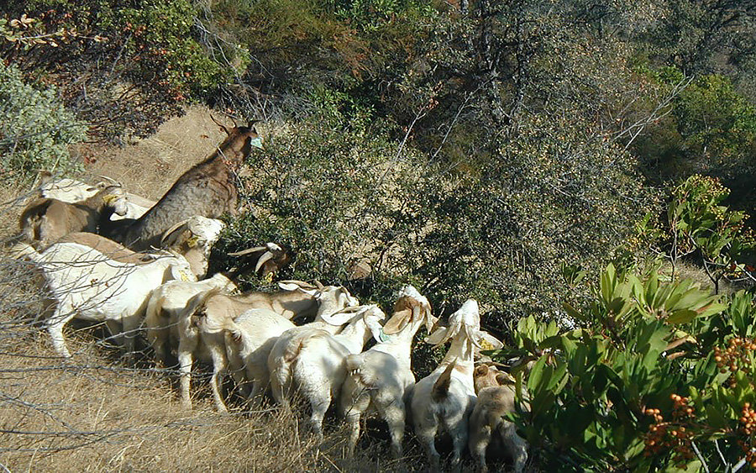
Source: CAL FIRE 2017
Figure 2-14 Example Prescribed Herbivory Treatment
Cattle, sheep, and goats are the animals most commonly used for this purpose because they are relatively common and easy to manage. Grazing/browsing by these animals is best used for green herbaceous plants that produce fine fuels and smaller diameter woody species that produce highly flammable fire fuels (Nader et al. 2007). Animals are best selected according to the types of vegetation that need to be managed. Goats are typically best suited to shrubs, and cattle are better suited to herbaceous plants, especially grasses. Sheep tend to prefer herbaceous plants, but they can be used in a variety of environments. Sheep graze selectively but may consume both herbaceous and woody vegetation. Dietary preference among species is not absolute as diet is also driven by the availability of vegetation, nutritional needs, experiences and inherited and learned behaviors.
Successful herbivory treatments can enhance habitat for wildlife. Prescribed grazing can enhance habitat for wildlife in addition to controlling fire fuel loads. For example, cattle and sheep feeding in the spring and early summer can thin understory forbs and grasses, reducing competition for light, nutrients, and water for desirable shrub species. The shrub species will then increase their vegetative output for winter browsing by deer and other wildlife.
For this treatment activity to be effective at reducing wildfire risk or in achieving other applicable objectives of the CalVTP, the right combination of animals, stocking rates, timing, and rest must be used. Prescribed herbivory by domestic livestock should occur when the target plant species is (are) palatable and when feeding on the plants can damage them or reduce viable seeds. Additionally, prescribed herbivory should be restricted during critical growth stages of desirable competing plant species. When desirable species are present, the area needs a period without herbivory to allow the desirable species to recover. The frequency of moving the livestock would be based on numerous site-specific factors, including slope, density and type of vegetation, stocking rate, type of livestock, and precipitation/moisture content of vegetation. Herds may be moved as often as every 1 to 3 days and one to two workers would be required on average to implement this treatment activity.
Short-term and long-term treatments can be used to reduce flammable vegetation, while longer term treatments can be used to change vegetation composition by depleting root carbohydrates in perennials and reducing the soil seed bank for annual plants (Nader et al. 2007). Use of a high density of livestock within small areas is typically the most successful in fuels management.
Whenever prescribed herbivory is considered, the needs of the livestock as well as the other multiple use objectives for the area must be considered. A herder, fencing, mineral block, and/or a watering site may be required to keep the animals within the desired area. Portable electric fencing is typically used for prescribed herbivory. Many weed species are less palatable than desired vegetation, so the livestock may overgraze desired vegetation rather than the weeds. Additionally, some weeds may be toxic to certain livestock and not to others, which would influence the treatment activity selected. Proper management of the livestock is extremely important for this method of activity to be successful. Consulting with a Certified Rangeland Manager (CRM) is advised when prescribed grazing is being considered as a treatment. Effectiveness of these treatments depend on a number of things that CRMs have familiarity with, including the palatability of plant species on the site to the animals available for use; how terrain, water availability, and environmental conditions during the grazing period are likely to influence animal behavior; and other potentially complicating factors like predators (including domestic dogs); public access; and setting up adequate facilities up for gathering and loading animals arriving at or being removed from the site.
Weed seeds may still be viable after passing through the digestive tract of animals, so the livestock should not be moved to weed-free areas until ample time has passed for all seeds to pass through their systems. Seeds can also travel on the wool or hair of domestic stock. Some sites may need to be monitored for impacts on soil surfaces, on special-status plant and/or wildlife species, or water quality. These should be considered as components of a complete prescribed herbivory plan. Typical prescribed herbivory costs range from $500 to $1,200 per acre. However, the cost of prescribed herbivory services can vary widely depending upon many different factors including the complexity of the area to be treated, project requirements, season, and access to water.

Herbicide Application
Herbicides are chemicals that damage or kill plants and can be classified by their mode of action. They include growth regulators, amino acid inhibitors, grass meristem destroyers, cell membrane destroyers, root and shoot inhibitors, and amino acid derivatives, all of which interfere with plant metabolism in different ways.
Herbicides can also be categorized as selective or non-selective. Selective herbicides kill only a specific type of plant, such as broad-leaved plants, which allows the herbicide to be used to control weeds while maintaining grass species. Other herbicides, such as glyphosate (Roundup®), are non-selective and kill any type of plant. These must be used carefully to avoid damaging non-target plants. Herbicides that may be applied under the CalVTP are:
- Borax (tetraborate decahydrate);
- Clopyralid (monoethanolamine salt);
- Glyphosate (isopropylamine salt, potassium salt, dimethylamine salt & diammonium salt);
- Hexazinone;
- Imazapyr (isopropylamine salt);
- Sulfometuron Methyl;
- Triclopyr (butoxyethyl ester & triethylamine salt);
- Nonylphenol 9 Ethoxylates (NP9E);
- Cleantraxx (penoxsulam & oxyfluorfen);
- Velpar (hexazinone); and
- Indaziflam.
Herbicide application under the CalVTP must comply with the U.S. Environmental Protection Agency (EPA) label directions, as well as California Environmental Protection Agency and Department of Pesticide Regulation (DPR) label standards. Only ground-level application would occur; no aerial applications would be allowed under the CalVTP. Several herbicide application methods are available for use by on-the-ground personnel, including as paint-on stems, backpack hand-applicator, hypo-hatchet tree injection, boom sprayers from ATVs (sprayers would be pointing down and only used in when the target species occurs throughout the treated area), or hand placement of pellets. The application method chosen would depend on the written recommendations of an independent Pest Control Advisor (PCA) licensed by DPR for the targeted weed species and characteristics of the site to which the treatment is proposed.
Herbicides may be applied to targeted species in various ways. Under the CalVTP, herbicides would only be applied on the ground from equipment on vehicles (including all-terrain vehicles and tractors) or by manual application devices. At the direction of the licensed PCA, herbicides may be applied to green leaves with a backpack hand-applicator or spray bottle, wick (painted or wiped on), hand wand (sprayed on), or hand applied as pellets to the ground surface. Herbicides may also be applied to trees around the circumference of the trunk on the intact bark (basal bark), to cuts in the trunk or stem (frill, or “hack and squirt”), to cut stems and stumps (paint on cut stumps), or injected into the inner bark with a hypo-hatchet.
Restricted use herbicides must be applied per written recommendations from a licensed PCA per the label and by an herbicide applicator certified by DPR. Typically, two to four workers would implement this treatment activity. CAL FIREA project proponent would obtain a permit from the applicable County Agricultural Commissioner (CAC) prior to applying restricted herbicides. Permits are site and time specific. Site specificity is achieved by having a clear description of the site when the permit is issued. Because permits are issued for a 12- or 24-month period, time-specificity is achieved by having the permittee file a “notice of intent” to apply the herbicide at least 24 hours before the scheduled application. The notice must describe the site to be treated and the herbicides to be applied. It must also contain information on any changes in the environmental setting (e.g., construction of residences or schools or changes in vegetation cover types that may have occurred since the permit was issued). This notice allows the CAC an additional opportunity to review the planned application and apply additional restrictions if needed.
Before a pesticide can be registered (licensed) in California, it must be registered with EPA. After receiving an application for registration, DPR evaluates the product thoroughly under guidelines of the Food and Agricultural Code to confirm that it is effective and would not harm human health or the environment when used per label directions.
DPR scientists review the pesticide product label and scientific data and must find it acceptable before the product can be registered. The product must be labeled properly for its intended use. Pesticides that pass this scientific, legal, and administrative process are granted registration that allows their distribution, sale, and use in California (DPR 2017). DPR and EPA generally, but not always, reach the same conclusions about product registration, but DPR gives more focused consideration to product use under California’s specific climatic and cultural conditions. DPR can also add California-specific label restrictions to a product during the registration process.
Limitations in the use of herbicides are addressed by requirements for application methodology, regulatory requirements (e.g., requirement to have a licensed PCA involved in the project), label restrictions, and project-specific guidelines. The limitations intended to be addressed by these requirements include the potential to damage or kill non-target plants; development of a resistance to a particular herbicide over time; or toxicity in humans, animals, birds, amphibians, reptiles, insects, and fish. Typical herbicide treatment of targeted species costs range from $25 to $250 per acre.

Treatment Maintenance
Most treatments require maintenance; however, the maintenance interval varies widely. For example, treatment in tree-dominated vegetation types might initially involve a mechanical or manual treatment to reduce surface and ladder fuels. Following that initial activity, prescribed burning could be used at 10- to 15-year intervals to maintain the lower fuel hazard in consideration of the natural fire return interval of the vegetation community and other environmental factors as well as treatment objectives. Maintenance intervals may vary greatly and are generally related to the vegetation life form, landscape location (e.g. climate and soil types influence plant regrowth), and activity type.
Vegetation communities are dynamic, and treatment activities should change over time and space to reflect that. Often the maintenance treatment is different than the original treatment, such as a prescribed burn followed by herbicide application(s) to control shrub regrowth, or manual treatment using chainsaws to create shaded fuel breaks along public roads followed by periodic prescribed burning to keep sprouting and fuel loads low.
Research by Finney indicates that not all acres need to be retreated to achieve changes in wildland fire behavior (Finney 2001, Finney et al. 2005). In addition, because the CalVTP is based on willing landowner participation, not every acre initially treated would be maintained in the future; the landowner may change their management objectives, their land use type, or the land may change owners or management stewards.
A proposed treatment project under the CalVTP would identify the time frame to complete the initial treatment and any anticipated maintenance. The treatment may be considered complete Oonce either the time frame for accomplishing the treatment has concluded, the treatment objectives have been met, or the contractual agreements in place between the project proponent and landowner/land manager expire. The project component proponent will consider whether additional treatment is warranted.

Distribution of Treatment Activities
The spatial distribution and size of the treatment activities implemented under the proposed CalVTP would be within the treatable area identified for each treatment type in Figure 2-1 “Treatable Landscape” and would be designed based on the factors described in Section 2.5.2, above. It is not feasible to precisely describe specific treatments in this programmatic evaluation. Nonetheless, for purposes of a good faith analysis of potential environmental impacts, reasonably foreseeable expectations for the percentage of each treatment type and size of treatment areas are appropriate to describe. The proportions of the types of treatment and average size of treatments have been defined based on historic trends. The relative distribution of treatment activities is reasonably expected to be distributed as follows:
- 50 percent prescribed burning,
- 10 percent manual treatments,
- 20 percent mechanical treatments,
- 10 percent herbicide treatments, and
- 10 percent prescribed herbivory.
Under the CalVTP, the average size of a treatment project would be approximately 260 acres.

Treatment Activities Excluded from the CalVTP
This PEIR is programmatic in nature, addressing the treatment types and activities described above. If vegetation treatment activities are proposed beyond those activities identified above, CAL FIRE would independently assess potential impacts of those activities and prepare appropriate environmental documents.
The following lists actions that are not included under the proposed CalVTP:
- activities within the Federal Responsibility Area;
- activities within the LRA (except limited extension of fuel breaks that cross into local jurisdiction, as discussed above), including implementation of defensible space programs and building code creation/enforcement;
- aerial spraying of herbicides; and
- removal of trees for commercial purposes (timber harvesting).

Implementation Framework
The initial discretionary action to implement the CalVTP would be certification of the PEIR by the Board. For later treatment activities consistent with the CalVTP, CAL FIRE would serve as the primary project proponent for treatments on private land and would also oversee the implementation of vegetation treatment activities by the Contract Counties. Currently, Contract Counties include: Kern, Los Angeles, Marin, Orange, Santa Barbara and Ventura counties. Other state, regional, and local agencies with land management authority could also act as the project proponent for implementation of later treatment activities on their lands. Examples of other agency lands include state parks, state wildlife areas, state conservancy lands, regional open space and park lands, and parks and natural lands managed by local jurisdictions (see Section 1.5.2, “Responsible and Trustee Agencies”). For later activities that would be funded and/or implemented by private landowners, Fire Safe Councils, or non-governmental organizations, the implementing entity would enter into a contract or agreement with CAL FIRE to implement the CalVTP activity.
When CAL FIRE is the project proponent, the CAL FIRE Unit or Contract County staff would evaluate a proposed treatment project by completing the CalVTP Project-Specific Analysis (PSA) (Appendix PD-3). Review and analysis of later activities for CAL FIRE-led projects would, in large part, be conducted by a Registered Professional Forester (RPF). An RPF is a person knowledgeable in a wide range of studies such as biology, ecology, entomology, geology, hydrology, dendrology, silviculture, engineering, business administration, forest economics, and other natural resource subjects. RPFs use their education and extensive experience to maintain the sustainability of forest resources like timber, forage, wildlife, water, and outdoor recreation to meet the needs of the people while protecting the biological integrity and quality of the forest environment. If the activity is proposed by another state, regional, or local public agency, the implementing agency would complete the PSA. The purpose of the PSA is to evaluate the proposed site and the later activity to determine whether the environmental effects of the activity are addressed within the scope of this PEIR, consistent with Section 15168 of the CEQA Guidelines for later activities consistent with a program and its PEIR. The PSA also requires the project proponent to determine that all applicable SPRs and mitigation measures identified in the CalVTP PEIR have been incorporated into the project, and whether additional mitigation would be necessary. If the project is being implemented by contract through a private landowner or by other public or non-profit entities, the contract terms or treatment activity description would include implementation of the applicable SPRs and mitigation measures identified after completing the PSA. The PSA would document whether any specific permits from responsible and trustee agencies would be required. The CalVTP PSA is presented in Appendix PD-3.
Once completed, the PSA for CAL FIRE-led, funded, or contracted projects would be submitted for three levels of review: CAL FIRE Unit or Contract County review, Regional review, and Sacramento CEQA Coordinator review. When a treatment activity would be implemented by a public agency other than CAL FIRE, the PSA would be reviewed by the appropriate agency environmental personnel carrying out the agency’s own CEQA process.
The CAL FIRE Unit or Contract County review would focus on:
- activity objectives,
- activity scope,
- proper use of the CalVTP PSA, and
- feasibility of the activities proposed.
The CAL FIRE Region representative would:
- review the PSA,
- confirm the later activity is within the scope of the PEIR, and
- determine if there are any areas where shared use of resources between Units could be coordinated.

Finally, the Sacramento CEQA Coordinator review would:
- provide the final determination of whether the later activity is considered within the scope of the PEIR,
- determine whether supplemental environmental review in compliance with CEQA is required, and
- determine if the activity does not qualify under the CalVTP PEIR and separate environmental documentation would be needed.
If it is determined that the proposed treatment is within the scope of this PEIR, then no additional CEQA documentation would be required (i.e., additional EIR, negative declaration, or MND). The PSA would provide the substantial evidence to support a determination that the proposed treatment is within the scope. If it is determined that the proposed treatment includes activities that may result in one or more new significant effect(s) not addressed in the PEIR or a substantial increase in the severity of significant impacts addressed in the PEIR, the following actions may be taken:
- The treatment may be changed to avoid the potential significant effect or substantial increase in severity.
- The treatment may be cancelled.
- Additional CEQA analysis in the form of an MND or supplemental or subsequent EIR focused on the new or substantially more severe significant environmental effect may be conducted to address the effect and identify any feasible mitigation measures.
At the conclusion of the treatment, the treated site would be inspected by CAL FIRE staff or the appropriate state, regional, or local agency environmental personnel responsible for carrying out the later activity. The inspection would evaluate if the treatment was completed in accordance with the authorized PSA including verifying that data is recorded for each treatment activity and reported to the Board upon its completion including the location, acreage, and treatment type (see Appendix PD-3). This data could be entered into a database and used for tracking and adaptive management as described below.

Adaptive Management – Framework Development and Monitoring
Effectiveness or validation m Monitoring after application of a treatment may be performed to the extent feasible, recognizing fiscal constraints, the need for ongoing access to property, and staff availability; objectives of post-treatment monitoring are described below. As part of the CalVTP, the Board has developed an Adaptive Management Framework. The value of monitoring and adaptive management is the gathering of empirical information from treatment sites (before, during, and after treatment) that can help refine the approaches to vegetation treatment that better meet site-specific project objectives, provide effective wildfire risk reduction, and protect the environment. The proposed CalVTP requires includes elements that would aid in program implementation, help assess program effectiveness, and provide feedback for adaptive decision-making. Required Such elements under the CalVTP include but are not limited to:
- introducinge independent science into the CalVTP activities,
- geospatially tracking later vegetation treatment projects activities through a geodatabase that is managed by CAL FIRE,
- monitoring implementation of SPRs and mitigation measures to document compliance, and
- monitoring the effectiveness of treatments in achieving desired fuel conditions and other CalVTP objectives applicable to a treatment project activities to the extent feasible to communicate “lessons learned” through photo-documentation.

The efforts to geospatially track later activities is currently ongoing within CAL FIRE by FRAP. The CalVTP directs implementation of vegetation treatment activities that would alter landscape fuels to reduce the size, number, and frequency of wildfire, and reduce losses to life, property and natural resources. Geospatially mapping these activities, through data collected for later treatment activities, would support the tracking and monitoring of site conditions before, during, and after treatment to determine if the objectives are being met and if program methods need to be revised. It should also be noted that the geospatial tracking efforts within CAL FIRE are constantly progressing and should be considered as an evolutionary process that would continue to improve over time.

Standard Project Requirements
The SPRs listed below will be incorporated into all proposed vegetation treatments under the CalVTP as a standard part of treatment design and implementation. SPRs are intended to avoid and minimize environmental impacts and comply with applicable laws and regulations. For the purposes of this PEIR, SPRs are intended to be implemented and enforced in the same way as mitigation measures consistent with Section 15126.4 of the State CEQA Guidelines. In the absence of the implementation of any SPR, there would be a greater potential for significant impacts. Additionally, there may be residual impacts after implementation of SPRs. Refer to the impact analysis in Sections 3.2 through 3.17 for more detail.
In the description of SPRs, the “project proponent” refers to a public agency providing funding for vegetation treatment or with land ownership, land management, or other regulatory responsibility in the treatable landscape and seeking to implement vegetation treatments consistent with this PEIR for CEQA compliance CAL FIRE or public agencies and organizations funded by CAL FIRE grants, or public agencies with land ownership/stewardship responsibilities seeking to implement vegetation treatment with CAL FIRE funding or to use this PEIR for CEQA compliance.

Administrative Standard Project Requirements
- SPR AD-1 Project Proponent Coordination: For treatments coordinated with CAL FIRE, CAL FIRE will meet with the project proponent to discuss all natural and environmental resources that must be protected using SPRs and any applicable mitigation measures; identify any sensitive resources onsite; and discuss resource protection measures. For any prescribed burn treatments, CAL FIRE will also discuss the and details of the burn plan in the incident action plan (IAP) for any prescribed burn treatments. This SPR applies to all treatment activities and treatment types, including treatment maintenance.
- SPR AD-2 Delineate Protected Resources: The project proponent will clearly define the boundaries of the treatment area and protected resources on maps for the treatment area and with highly-visible flagging or clear, existing landscape demarcations (e.g., edge of a roadway) prior to beginning any treatment to avoid disturbing the resource. “Protected Resources” refers to environmentally sensitive places within or adjacent to the treatment areas that would be avoided or protected to the extent feasible during planned treatment activities to sustain their natural qualities and processes. This work will be performed by a qualified person, as defined for the specific resource (e.g., qualified Registered Professional Forester or biologist). This SPR applies to all treatment activities and treatment types, including treatment maintenance.
- SPR AD-3 Consistency with Local Plans, Policies, and Ordinances: The project proponent will design and implement the treatment in a manner that is consistent with applicable local plans (e.g., general plans, Community Wildfire Protection Plans, CAL FIRE Unit Fire Plans), policies, and ordinances to the extent the project is subject to them. This SPR applies to all treatment activities and treatment types, including treatment maintenance.
- SPR AD-4 Public Notifications for Prescribed Burning: At least One to three days prior to the commencement of prescribed burning operations, the project proponent will: 1) post signs along the closest public roadway to the treatment area describing the activity and timing, and requesting persons in the area to contact a designated representative of the project proponent (contact information will be provided with the notice) if they have questions or smoke concerns; 2) publish a public interest notification in a local newspapers or other widely distributed media source describing the activity, timing, and contact information; 3) send the local county supervisor and county administrative officer (or equivalent official responsible for distribution of public information) a notification letter describing the activity, its necessity, timing, and measures being taken to protect the environment and prevent prescribed burn escape. This SPR applies only to prescribed burn treatment activities and all treatment types, including treatment maintenance.
- SPR AD-5 Maintain Site Cleanliness: If trash receptacles are used on-site, the project proponent will use fully covered trash receptacles with secure lids (wildlife proof) to contain all food, food scraps, food wrappers, beverages, and other worker generated miscellaneous trash. Remove all temporary non-biodegradable flagging, trash, debris, and barriers from the project site upon completion of project activities. This SPR applies to all treatment activities and all treatment types, including treatment maintenance.
- SPR AD-6 Public Notifications for Treatment Projects. One to three days prior to the commencement of a treatment activity, the project proponent will post signs in a conspicuous location near the treatment area describing the activity and timing, and requesting persons in the area to contact a designated representative of the project proponent (contact information will be provided with the notice) if they have questions or concerns. This SPR applies to all treatment activities and all treatment types, including treatment maintenance. Prescribed burning is subject to the additional notification requirements of SPR AD-4.
- SPR AD-7 Provide Information on Proposed, Approved, and Completed Treatment Projects. For any vegetation treatment project using the CalVTP PEIR for CEQA compliance, the project proponent will provide the information listed below to the Board or CAL FIRE during the proposed, approved, and completed stages of the project. The Board or CAL FIRE will make this information available to the public via an online database or other mechanism.
Information on proposed projects (PSA in progress):
- GIS data that include project location (as a point);
- project size (typically acres);
- treatment types and activities; and
- contact information for a representative of the project proponent.
Information on approved projects (PSA complete):
- A completed PSA Environmental Checklist;
- A completed Mitigation Monitoring and Reporting Program (using Attachment A to the Environmental Checklist);
- GIS data that include a polygon(s) of the project area, showing the extent of each treatment type included in the project (ecological restoration, fuel break, WUI fuel reduction)
Information on completed projects:
- GIS data that include a polygon(s) of the treated area, showing the extent of each treatment type implemented (ecological restoration, fuel break, WUI fuel reduction)
- A post-project implementation report (referred to by CAL FIRE as a Completion Report) that includes
- Size of treated area (typically acres);
- Treatment types and activities;
- Dates of work;
- A list of the SPRs and mitigation measures that were implemented
- Any explanations regarding implementation if required by SPRs and mitigation measures (e.g., explanation for feasibility determination required by SPR BIO-12; explanation for reduction of a no-disturbance buffer below the general minimum size described in Mitigation Measures BIO-1a and BIO-2b).
This SPR applies to all treatment activities and all treatment types, including treatment maintenance.
- SPR AD-8 Request Access for Post-Treatment Assessment. For CAL FIRE projects, during contract development, CAL FIRE will include access to the treated area over a prescribed period (usually up to three years) to assess treatment effectiveness in achieving desired fuel conditions and other CalVTP objectives as well as any necessary maintenance, as a contract term for consideration by the landowner. For public landowners, access to the treated area over a prescribed period will be a requirement of the executed contract. This SPR applies to all treatment activities and all treatment types, including treatment maintenance.
- SPR AD-9: Obtain a Coastal Development Permit for Proposed Treatment Within the Coastal Zone Where Required. When planning a treatment project within the Coastal Zone, the project proponent will contact the local Coastal Commission district office, or applicable local government to determine if the project area is within the jurisdiction of the Coastal Commission, a local government with a certified Local Coastal Program (LCP), or both. All treatment projects in the Coastal Zone will be reviewed by the local Coastal Commission district office or local government with a certified LCP (in consultation with the local Coastal Commission district office regarding whether a Coastal Development Permit (CDP) is required). If a CDP is required, the treatment project will be designed to meet the following conditions:
i. The treatment project will be designed in compliance with applicable provisions of the Coastal Act that provide substantive performance standards for the protection of potentially affected coastal resources, if the treatment activity will occur within the original jurisdiction of the Commission or an area of a local coastal government without a certified LCP; and
ii. The treatment project will be designed in compliance with the applicable provisions of the certified LCP, specifically the substantive performance standards for the protection of potentially affected coastal resources, if the treatment activity will occur within the jurisdiction of a local coastal government with a certified LCP.
This SPR applies to all treatment activities and all treatment types, including treatment maintenance.

Aesthetic and Visual Resource Standard Project Requirements
- SPR AES-1 Vegetation Thinning and Edge Feathering: The project proponent will thin and feather adjacent vegetation to break up or screen linear edges of the clearing and mimic forms of natural clearings as reasonable or appropriate for vegetation conditions. In general, thinning and feathering in irregular patches of varying densities, as well as a gradation of tall to short vegetation at the clearing edge, will achieve a natural transitional appearance. The contrast of a distinct clearing edge will be faded into this transitional band. This SPR only applies to mechanical and manual treatment activities and all treatment types, including treatment maintenance.
- SPR AES-2 Avoid Staging within Viewsheds: The project proponent will store all treatment-related materials, including vehicles, vegetation treatment debris, and equipment, outside of the viewshed of public trails, parks, recreation areas, and roadways to the extent feasible. The project proponent will also locate materials staging and storage areas outside of the viewshed of public trails, parks, recreation areas, and roadways to the extent feasible where they will minimize or avoid visual impacts. This SPR applies to all treatment activities and treatment types, including treatment maintenance.
- SPR AES-3 Provide Vegetation Screening: The project proponent will preserve sufficient vegetation within, at the edge of, or adjacent to treatment areas to screen views from public trails, parks, recreation areas, and roadways as reasonable or appropriate for vegetation conditions. This SPR applies to all treatment activities and all treatment types, including treatment maintenance.

Air Quality Standard Project Requirements
- SPR AQ-1 Comply with Air Quality Regulations: The project proponent will comply with the applicable air quality requirements of air districts within whose jurisdiction the project is located. This SPR applies to all treatment activities and all treatment types, including treatment maintenance.
- SPR AQ-2 Submit Smoke Management Plan: The project proponent will submit a smoke management plan for all prescribed burns greater than 10 acres or estimated to produce more than 1 ton of particulate matter to the applicable air district, in accordance with 17 CCR Section 80160. Pursuant to this regulation a smoke management plan will not be required for burns less than 10 acres that also will not be conducted near smoke sensitive areas, unless otherwise directed by the air district. Burning will only be conducted in compliance with the burn authorization program of the applicable air district(s) having jurisdiction over the treatment area. Example of a smoke management plan is in Appendix PD-2. This SPR applies only to prescribed burning treatment activities and all treatment types, including treatment maintenance.
- SPR AQ-3 Create Burn Plan: The project proponent will create a burn plan using the CAL FIRE burn plan template for all prescribed burns. The burn plan will include a fire behavior model output of First Order Fire Effects Model and BEHAVE or other fire behavior modeling simulation and that is performed by a qualified fire behavior technical specialist that predicts fire behavior, calculates consumption of fuels, tree mortality, predicted emissions, greenhouse gas emissions, and soil heating. The project proponent will minimize soil burn severity from broadcast burning to reduce the potential for runoff and soil erosion. The burn plan will be created with input from a qualified technician or certified State burn boss. This SPR applies only to prescribed burning treatment activities and all treatment types, including treatment maintenance.
- SPR AQ-4 Minimize Dust: To minimize dust during treatment activities, the project proponent will implement the following measures:
- Limit the speed of vehicles and equipment traveling on unpaved areas to 15 miles per hour to reduce fugitive dust emissions, in accordance with the California Air Resources Board (CARB) Fugitive Dust protocol.
- If road use creates excessive dust, the project proponent will wet appurtenant, unpaved, dirt roads using water trucks or treat roads with a non-toxic chemical dust suppressant (e.g., emulsion polymers, organic material) during dry, dusty conditions. Any dust suppressant product used will be environmentally benign (i.e., non-toxic to plants and will not negatively impact water quality) and its use will not be prohibited by ARB, EPA, or the State Water Resources Control Board (SWRCB). The project proponent will not over-water exposed areas such that the water results in runoff. The type of dust suppression method will be selected by the project proponent based on soil, traffic, site-specific conditions, and air quality regulations.
- Remove visible dust, silt, or mud tracked-out on to public paved roadways where sufficient water supplies and access to water is available. The project proponent will remove dust, silt, and mud from vehicles at the conclusion of each workday, or at a minimum of every 24 hours for continuous treatment activities, in accordance with Vehicle Code Section 23113.
- Suspend ground-disturbing treatment activities, including land clearing and bulldozer lines, when there is visible dust transport (particulate pollution) outside the treatment boundary, if the particulate emissions may “cause injury, detriment, nuisance, or annoyance to any considerable number of persons or to the public, or that endanger the comfort, repose, health, or safety of any of those persons or the public, or that cause, or have a natural tendency to cause, injury or damage to business or property,” per Health and Safety Code Section 41700.
This SPR applies to all treatment activities and treatment types, including treatment maintenance.
- SPR AQ-5 Avoid Naturally Occurring Asbestos: The project proponent will avoid ground-disturbing treatment activities in areas identified as likely to contain naturally occurring asbestos (NOA) per maps and guidance published by the California Geological Survey, unless an Asbestos Dust Control Plan (17 CCR Section 93105) is prepared and approved by the air district(s) with jurisdiction over the treatment area. Any NOA-related guidance provided by the applicable air district will be followed. This SPR applies to all treatment activities and treatment types, including treatment maintenance.
- SPR AQ-6: Prescribed Burn Safety Procedures. Prescribed burns planned and managed by non-CAL FIRE crews will follow all safety procedures required of CAL FIRE crew, including the implementation of an approved Incident Action Plan (IAP). The IAP will include the burn dates; burn hours; weather limitations; the specific burn prescription; a communications plan; a medical plan; a traffic plan; and special instructions such as minimizing smoke impacts to specific local roadways. The IAP will also assign responsibilities for coordination with the appropriate air district, such as conducting onsite briefings, posting notifications, weather monitoring during burning, and other burn related preparations. This SPR applies only to prescribed burning treatment activities and all treatment types, including treatment maintenance.

Archaeological, Historical, and Tribal Cultural Resources Standard Project Requirements
Cultural resource SPRs and mitigation measures require that qualified individuals implement components of the measures. The requirements listed below will be met to be considered qualified and may be performed by individuals of various titles (including supervised designees) as long as they are qualified.
Qualified Archaeologist: To be qualified, an archaeologist would hold a Prehistoric Archeology, Historic Archeology, Conservation, Cultural Anthropology, or Curation degree from an accredited university and meet the Secretary of Interior’s Qualifications Standards (36 CFR Part 61). The project proponent will review the resume and approve the qualifications of the archaeologists.
Archaeologically Trained Resource Professional: To be qualified, an archaeologically-trained resource professional would hold a valid Archaeological Training Certificate issued by CAL FIRE and the Board or equivalent state or local agency training or certification. Work performed by an archaeologically-trained resource professional must be reviewed and approved by a qualified archaeologist.
- SPR CUL-1 Conduct Record Search: For treatments led by CAL FIRE, a An archaeological and historical resource record search will be conducted per the “Archaeological Review Procedures for CAL FIRE Projects” (CAL FIRE current edition dated 2010). For treatments led by a project proponent other than CAL FIRE, an archaeological and historical resource record search will be conducted per the “Archaeological Review Procedures for CAL FIRE Projects” or equivalent applicable state or local agency procedures. Instead of conducting a new search, the project proponent may use recent record searches containing the treatment area requested by a landowner or other public agency in accordance with the Archaeological Review Procedures for CAL FIRE Projects or equivalent applicable agency guidance. This SPR applies to all treatment activities and treatment types, including treatment maintenance.
- SPR CUL-2 Contact Geographically Affiliated Native American Tribes: The project proponent will obtain the latest Native American Heritage Commission (NAHC) provided Native Americans Contact List, which may be obtained from the CAL FIRE website, as appropriate. Using the appropriate Native Americans Contact List, the project proponent will notify the California Native American Tribes in the counties where the treatment activity is located. The notification will contain the following:
- A written description of the treatment location and boundaries.
- Brief narrative of the treatment objectives.
- A description of the activities used (e.g., prescribed burning, mastication) and associated acreages.
- A map of the treatment area at a sufficient scale to indicate the spatial extent of activities.
- A request for information regarding potential impacts to cultural resources from the proposed treatment.
- A detailed description of the depth of excavation, if ground disturbance is expected.
In addition, the project proponent will contact the NAHC for a review of their Sacred Lands File. This SPR applies to all treatment activities and treatment types, including treatment maintenance.
- SPR CUL-3 Pre-field Research: The project proponent will conduct research prior to implementing treatments as part of the cultural resource investigation. The purpose of this research is to properly inform survey design, based on the types of resources likely to be encountered within the treatment area, and to be prepared to interpret, record, and evaluate these findings within the context of local history and prehistory. The qualified archaeologist and/or archaeologically-trained resource professional will review records, study maps, read pertinent ethnographic, archaeological, and historical literature specific to the area being studied, and conduct other tasks to maximize the effectiveness of the survey. This SPR applies to all treatment activities and treatment types, including treatment maintenance.
- SPR CUL-4 Archaeological Surveys: The project proponent will coordinate with an archaeologically-trained resource professional and/or qualified archaeologist to conduct a site-specific survey of the treatment area. The survey methodology (e.g., pedestrian survey, subsurface investigation) depends on whether the area has a low, moderate, or high sensitivity for resources, which is based on whether the records search, pre-field research, and/or Native American consultation identifies archaeological or historical, or tribal cultural resources near or within the treatment area. A survey report will be completed for every cultural resource survey completed. The specific requirements will comply with the current edition of “Archaeological Review Procedures for CAL FIRE Projects” or equivalent applicable state or local agency procedures, as applicable. This SPR applies to all treatment activities and treatment types, including treatment maintenance.
- SPR CUL-5 Treatment of Archaeological Resources: If cultural resources are identified within a treatment area, including tribal cultural resources, and cannot be avoided, a qualified archaeologist will notify the culturally affiliated tribe(s) based on information provided by NAHC and assess, whether an archaeological find qualifies as a unique archaeological resource, an historical resource, or in coordination with said tribe(s), as a tribal cultural resource. The project proponent, in consultation with culturally affiliated tribe(s), will develop effective protection measures for important tribal cultural resources located within treatment areas. These measures may include adjusting the treatment location or design to entirely avoid cultural resource locations or changing treatment activities so that damaging effects to cultural resources will not occur. These protection measures will be written in clear, enforceable language, and will be included in the survey report in accordance with the “Archaeological Review Procedures for CAL FIRE Projects” or equivalent applicable state or local agency procedures. If the resource is a tribal cultural resource, the project proponent will provide the tribe(s) the opportunity to submit comments and participate in consultation to resolve issues of concern. This SPR applies to all treatment activities and treatment types, including treatment maintenance.
- SPR CUL-6 Treatment of Tribal Cultural Resources: The project proponent, in consultation with the culturally affiliated tribe(s), will develop effective protection measures for important tribal cultural resources located within treatment areas. These measures may include adjusting the treatment location or design to entirely avoid cultural resource locations or changing treatment activities so that damaging effects to cultural resources will not occur. The project proponent will provide the tribe(s) the opportunity to submit comments and participate in consultation to resolve issues of concern. The project proponent will defer implementing the treatment until the tribe approves protection measures, or if agreement cannot be reached after a good-faith effort, the proponent determines that any or all feasible measures have been implemented, where feasible, and the resource is either avoided or protected. This SPR applies to all treatment activities and treatment types, including treatment maintenance.
- SPR CUL-76 Avoid Built Historical Resources: If the records search identifies built historical resources, as defined in Section 15064.5 of the State CEQA Guidelines, the project proponent will avoid these resources. Within a buffer of 100 feet of the built historical resource, there will be no prescribed burning or mechanical treatment activities Buffers less than 100 feet for built historical resources will only be used after consultation with and receipt of written approval from a qualified archaeologist. If the records search does not identify known historical resources in the treatment area, but structures (i.e., buildings, bridges, roadways) over 50 years old that have not been evaluated for historic significance are present in the treatment area, they will similarly be avoided. This SPR applies to all treatment activities and treatment types, including treatment maintenance.
- SPR CUL-87 Cultural Resource Training: The project proponent will train all crew members and contractors implementing treatment activities on the protection of sensitive archaeological, historical, or tribal cultural resources. Workers will be trained to halt work if archaeological resources are encountered on a treatment site and the treatment method consists of physical disturbance of land surfaces (e.g., soil disturbance). This SPR applies to all treatment activities and treatment types, including treatment maintenance.

Biological Resources Standard Project Requirements
Biological resource SPRs and mitigation measures require that qualified individuals implement components of the measures. The requirements listed below will be met to be considered qualified and may be performed by individuals of various titles (including biologist, botanist, ecologist, Registered Professional Forester, biological technician, or supervised designees working at the direction of a qualified professional) as long as they are qualified for the task at hand.
Qualified Registered Professional Forester (RPF) or Biologist: To be qualified, an RPF or biologist would hold a wildlife biology, botany, ecology, forestry, or other relevant degree from an accredited university and: 1) be knowledgeable in relevant species life histories and ecology, 2) be able to correctly identify relevant species and habitats, 3) have experience conducting field surveys of relevant species or resources, 4) be knowledgeable about survey protocols, 5) be knowledgeable about state and federal laws regarding the protection of special-status species, and 6) have experience with CDFW’s California Natural Diversity Database (CNDDB) and Biogeographic Information and Observation System (BIOS). The project proponent will review the resume and approve the qualifications of RPFs or biologists. If species-specific protocol surveys are performed, surveys would be conducted by qualified RPFs or biologists with the minimum qualifications required by the appropriate protocols, including having CDFW or USFWS approval to conduct such surveys, if required by certain protocols.
Qualified RPF or Botanist: To be qualified, an RPF or botanist would 1) be knowledgeable about plant taxonomy, 2) be familiar with plants of the region, including special-status plants and sensitive natural communities, 3) have experience conducting floristic botanical field surveys as described in CDFW “Protocols for Surveying and Evaluating Impacts to Special Status Native Plant Populations and Sensitive Natural Communities” (current version dated March 20, 2018), or experience conducting such botanical field surveys under the direction of an experienced botanical field surveyor, 4) be familiar with the California Manual of Vegetation (Sawyer et al. 2009 or current version, including updated natural communities data at http://vegetation.cnps.org/), and 5) be familiar with federal, state, and local statutes and regulations related to plants and plant collecting. The project proponent will review the resume and approve the qualifications of RPFs or botanists.
Qualified RPF or Biological Technician: To be qualified, an RPF or biological technician would 1) be knowledgeable in relevant species life histories and ecology, 2) be able to correctly identify relevant species and habitats, 3) have experience conducting biological monitoring of relevant species or resources, and 4) be knowledgeable about state and federal laws regarding the protection of special-status species. The project proponent will review the resume and approve the qualifications of RPFs or biological technicians.
- SPR BIO-1: Review and Survey Project-Specific Biological Resources. The project proponent will require a qualified RPF or biologist to conduct a data review and reconnaissance-level survey prior to treatment, no more than one year prior to the submittal of the PSA for each treatment project, and no more than one year between completion of the PSA and implementation of the treatment project. The data reviewed will include the biological resources setting, species and sensitive natural communities tables, and habitat information in this PEIR for the ecoregion(s) where the treatment will occur. It will also include review of the best available, current data for the area, including vegetation mapping data, species distribution/range information, CNDDB, California Native Plant Society (CNPS) Inventory of Rare and Endangered Plants of California, relevant BIOS queries, and relevant general and regional plans. Reconnaissance-level biological surveys will be general surveys that include visual and auditory inspection for biological resources to help determine the environmental setting of a project site. The qualified surveyor will 1.) identify and document sensitive resources, such as riparian or other sensitive habitats, sensitive natural community, wetlands, or wildlife nursery site or habitat (including bird nests), and 2.) assess the suitability of habitat for special-status plant and animal species. The surveyor will also record any incidental wildlife observations. For each treatment project, Hhabitat assessments will be completed at a time of year that is appropriate for identifying habitat and no more than one year prior to the submittal of the PSAroject Specific Analysis (Appendix PD-3) for each treatment project, unless it can be demonstrated in the Biological Resources Discussion in the PSA that habitat assessments older than one year remain valid (e.g., site conditions are unchanged and no treatment activity has occurred since the assessment). If more than one year passes between completion of the PSA and initiation of the treatment project, the project proponent will verify the continued accuracy of the PSA prior to beginning the treatment project by reviewing for any data updates and/or visiting the site to verify conditions. Based on the results of the data review and reconnaissance-level survey, the project proponent, in consultation with a qualified RPF or biologist, will determine which one of the following best characterizes the treatment:
- Suitable Habitat Is Present but Adverse Effects Can Be Clearly Avoided. If, based on the data review and reconnaissance-level survey, the qualified RPF or biologist determines that suitable habitat for sensitive biological resources is present but adverse effects on the suitable habitat can clearly be avoided through one of the following methods, the avoidance mechanism will be implemented prior to initiating treatment and will remain in effect throughout the treatment:
  - by physically avoiding the suitable habitat, or
  - by conducting treatment outside of the season when a sensitive resource could be present within the suitable habitat or outside the season of sensitivity (e.g., outside of special-status bird nesting season, during dormant season of sensitive annual or geophytic plant species, or outside of maternity and rearing season at wildlife nursery sites).
Physical avoidance will include flagging, fencing, stakes, or clear, existing landscape demarcations (e.g., edge of a roadway) to delineate the boundary of the avoidance area around the suitable habitat. For physical avoidance, a buffer may be implemented as determined necessary by the qualified RPF or biologist.
- Suitable Habitat is Present and Adverse Effects Cannot Be Clearly Avoided. Further review and surveys will be conducted to determine presence/absence of sensitive biological resources that may be affected, as described in the SPRs below. Further review may include contacting USFWS, NOAA Fisheries, CDFW, CNPS, or local resource agencies as necessary to determine the potential for special-status species or other sensitive biological resources to be affected by the treatment activity. Focused or protocol-level surveys will be conducted as necessary to determine presence/absence. If protocol surveys are conducted, survey procedures will adhere to methodologies approved by resource agencies and the scientific community, such as those that are available on the CDFW webpage at: https://www.wildlife.ca.gov/Conservation/Survey-Protocols. Specific survey requirements are addressed for each resource type in relevant SPRs (e.g., additional survey requirements are presented for special-status plants in SPR BIO-7).
This SPR applies to all treatment activities and treatment types, including treatment maintenance.
- SPR BIO-2: Require Biological Resource Training for Workers. The project proponent will require crew members and contractors to receive training from a qualified RPF or biologist prior to beginning a treatment project. The training will describe the appropriate work practices necessary to effectively implement the biological SPRs and mitigation measures and to comply with the applicable environmental laws and regulations. The training will include the identification, relevant life history information, and avoidance of pertinent special-status species; identification and avoidance of sensitive natural communities and habitats with the potential to occur in the treatment area; impact minimization procedures; and reporting requirements. The training will instruct workers when it is appropriate to stop work and allow wildlife encountered during treatment activities to leave the area unharmed and when it is necessary to report encounters to a qualified RPF, biologist, or biological technician. The qualified RPF, biologist, or biological technician will immediately contact CDFW or USFWS, as appropriate, if any wildlife protected by the California Endangered Species Act (CESA) or Federal Endangered Species Act (ESA) is encountered and cannot leave the site on its own (without being handled). This SPR applies to all treatment activities and treatment types, including treatment maintenance.

Sensitive Natural Communities and Other Sensitive Habitats
- SPR BIO-3: Survey Sensitive Natural Communities and Other Sensitive Habitats. If SPR BIO-1 determines that sensitive natural communities or sensitive habitats may be present and adverse effects cannot be avoided, the project proponent will:
- require a qualified RPF or biologist to perform a protocol-level survey following the CDFW “Protocols for Surveying and Evaluating Impacts to Special Status Native Plant Populations and Sensitive Natural Communities” (current version dated March 20, 2018) of the treatment area prior to the start of treatment activities for sensitive natural communities and sensitive habitats. Sensitive natural communities will be identified using the best means possible, including keying them out using the most current edition of A Manual of California Vegetation (including updated natural communities data at http://vegetation.cnps.org/), or referring to relevant reports (e.g., reports found on the VegCAMP website).
- map and digitally record, using a Global Positioning System (GPS), the limits of any potential sensitive habitat and sensitive natural community identified in the treatment area.
This SPR applies to all treatment activities and treatment types, including treatment maintenance.
- SPR BIO-4: Design Treatment to Avoid Loss or Degradation of Riparian Habitat Function. Project proponents, in consultation with a qualified RPF or qualified biologist, will design treatments in riparian habitats to retain or improve habitat functions by implementing the following within riparian habitats:
- Retain at least 75 percent of the overstory and 50 percent of the understory canopy of native riparian vegetation within the limits of riparian habitat identified and mapped during surveys conducted pursuant to SPR BIO-3. Native riparian vegetation will be retained in a well distributed multi-storied stand composed of a diversity of species similar to that found before the start of treatment activities.
- Treatments will be limited to removal of uncharacteristic fuel loads (e.g., removing dead or dying vegetation), trimming/limbing of woody species as necessary to reduce ladder fuels, and select thinning of vegetation to restore densities that are characteristic of healthy stands of the riparian vegetation types characteristic of the region. This includes hand removal (or mechanized removal where topography allows) of dead or dying riparian trees and shrubs, invasive plant removal, selective thinning, and removal of encroaching upland species.
- Removal of large, native riparian hardwood trees (e.g., willow, ash, maple, oak, alder, sycamore, cottonwood) will be minimized to the extent feasible and 75 percent of the pretreatment native riparian hardwood tree canopy will be retained. Because tree size varies depending on vegetation type present and site conditions, the tree size retention parameter will be determined on a site-specific basis depending on vegetation type present and setting; however, live, healthy, native trees that are considered large for that type of tree and large relative to other trees in that location will be retained. A scientifically-based, project-specific explanation substantiating the retention size parameter for native riparian hardwood tree removal will be provided in the Biological Resources Discussion of the PSA. Consideration of factors such as site hydrology, erosion potential, suitability of wildlife habitat, presence of sufficient seed trees, light availability, and changes in stream shading may inform the tree size retention requirements.
- Removed trees will be felled away from adjacent streams or waterbodies and piled outside of the riparian vegetation zone (unless there is an ecological reason to do otherwise that is approved by applicable regulatory agencies, such as adding large woody material to a stream to enhance fish habitat, e.g., see Accelerated Wood Recruitment and Timber Operations: Process Guidance from the California Timber Harvest Review Team Agencies and National Marine Fisheries Service).
- Vegetation removal that could reduce stream shading and increase stream temperatures will be avoided.
- Ground disturbance within riparian habitats will be limited to the minimum necessary to implement effective treatments. This will consist of the minimum disturbance area necessary to reduce hazardous fuels and return the riparian community to a natural fire regime (i.e., Condition Class 1) considering historic fire return intervals, climate change, and land use constraints.
- Only hand application of herbicides approved for use in aquatic environments will be allowed and only during low-flow periods or when seasonal streams are dry.
- The project proponent will notify CDFW pursuant to California Fish and Game Code Section 1602 prior to implementing any treatment activities in riparian habitats. Notification will identify the treatment activities, map the vegetation to be removed, identify the impact avoidance identification methods to be used (e.g., flagging), and appropriate protections for the retention of shaded riverine habitat, including buffers and other applicable measures to prevent erosion into the waterway.
- In consideration of spatial variability of riparian vegetation types and condition and consistent with California Forest Practice Rules Section 916.9(v) (February 2019 version), a different set of vegetation retention standards and protection measures from those specified in the above bullets may be implemented on a site-specific basis if the qualified RPF and the project proponent demonstrate through substantial evidence that alternative design measures provide a more effective means of achieving the treatment goals objectives and would result in effects to the Beneficial Functions of Riparian Zones equal or more favorable than those expected to result from application of the above measures. Deviation from the above design specifications, different protection measures and design standards will only be approved when the treatment plan incorporates an evaluation of beneficial functions of the riparian habitat and with written concurrence from CDFW.
This SPR applies to all treatment activities and treatment types, including treatment maintenance.
- SPR BIO-5: Avoid Environmental Effects of Type Conversion and Maintain Habitat Function in Chaparral and Coastal Sage Scrub. The project proponent will design treatment activities to avoid type conversion where native coastal sage scrub and chaparral are present. An ecological definition of type conversion is used in the CalVTP PEIR for assessment of environmental effects: a change from a vegetation type dominated by native shrub species that are characteristic of chaparral and coastal sage scrub vegetation alliances to a vegetation type characterized predominantly by weedy herbaceous cover or annual grasslands. For the PEIR, type conversion is considered in terms of habitat function, which is defined here as the arrangement and capability of habitat features to provide refuge, food source, and reproduction habitat to plants and animals, and thereby contribute to the conservation of biological and genetic diversity and evolutionary processes (de Groot et al. 2002). Some modification of habitat characteristics may occur provided habitat function is maintained (i.e., the location, essential habitat features, and species supported are not substantially changed).
During the reconnaissance-level survey required in SPR BIO-1, a qualified RPF or biologist will identify chaparral and coastal sage scrub vegetation to the alliance level and determine the condition class and fire return interval departure of the chaparral and/or coastal sage scrub present in each treatment area.
For all treatment types in chaparral and coastal sage scrub, the project proponent, in consultation with a qualified RPF or qualified biologist will:
- Develop a treatment design that avoids environmental effects of type conversion in coastal chaparral and coastal sage scrub vegetation alliances, which will include evaluating and determining the appropriate spatial scale at which the proponent would consider type conversion, and substantiating its appropriateness. The project proponent will demonstrate with substantial evidence that the habitat function of chaparral and coastal sage scrub would be at least maintained within the identified spatial scale at which type conversion is evaluated for the specific treatment project. Consideration of factors such as site hydrology, erosion potential, suitability of wildlife habitat, spatial needs of sensitive species, presence of sufficient seed plants and nurse plants, light availability, and edge effects may inform the determination of an appropriate spatial scale.
- The treatment design will seek to maintain a minimum percent cover of mature native shrubs within the treatment area to maintain habitat function; the appropriate percent cover will be identified by the project proponent in the development of treatment design and be specific to the vegetation alliances that are present in the identified spatial scale used to evaluate type conversion. Mature native shrubs that are retained will be distributed contiguously or in patches within the stand. If the stand consists of multiple age classes, patches representing a range of middle to old age classes will be retained to maintain and improve heterogeneity, to the extent needed to avoid type conversion.
These SPR requirements apply to all treatment activities and all treatment types, including treatment maintenance.
Additional measures will be applied to ecological restoration treatment types:
- For ecological restoration treatment types, complete removal of the mature shrub layer will not occur in native coastal chaparral and coastal sage scrub vegetation types.
- Ecological restoration treatments will not be implemented in vegetation types that are within their natural fire return interval (i.e., time since last burn is less than the average time listed as the fire return interval range in Table 3.6-1) unless the project proponent demonstrates with substantial evidence that the habitat function of chaparral and coastal sage scrub would be improved.
- A minimum of 35 percent relative cover of existing shrubs and associated native vegetation will be retained at existing densities in patches distributed in a mosaic pattern within the treated area or the shrub canopy will be thinned by no more than 20 percent from baseline density (i.e., if baseline shrub canopy density is 60 percent, post treatment shrub canopy density will be no less than 40 percent). A different percent relative cover can be retained if the project proponent demonstrates with substantial evidence that alternative treatment design measures would result in effects on the habitat function of chaparral and coastal sage scrub that are equal or more favorable than those expected to result from application of the above measures. Biological considerations that may inform a deviation from the minimum 35 percent relative cover retention include but are not limited to soil moisture requirements, increased soil temperatures, changes in light/shading, presence of sufficient seed plants and nurse plants, erosion potential, and site hydrology.
- If the stand within the treatment area consists of multiple age classes, patches representing a range of middle to old age classes will be retained to maintain and improve heterogeneity.
These SPR requirements apply to all treatment activities and only the ecosystem restoration treatment type, including treatment maintenance.
A determination of compliance with the SB 1260 prohibition of type conversion in chaparral and coastal sage scrub is a statutory issue separate from CEQA compliance that may involve factors additional to the ecological definition and habitat functions presented in the PEIR, such as geographic context. It is beyond the legal scope of the PEIR to define SB 1260 type conversion and statutory compliance. The project proponent, acting as lead agency for the proposed later treatment project, will be responsible for defining type conversion in the context of the project and making the finding that type conversion would not occur, as required by SB 1260. The project proponent will determine its criteria for defining and avoiding type conversion and, in making its findings, may draw upon information presented in this PEIR.
- SPR BIO-6: Prevent Spread of Plant Pathogens. When working in sensitive natural communities, riparian habitats, or oak woodlands that are at risk from plant pathogens (e.g., Ione chaparral, blue oak woodland), the project proponent will implement the following best management practices to prevent the spread of Phytopthora and other plant pathogens (e.g., pitch canker (Fusarium), goldspotted oak borer, shot hole borer, bark beetle):
- clean and sanitize vehicles, equipment, tools, footwear, and clothes before arriving at a treatment site and when leaving a contaminated site, or a site in a county where contamination is a risk;
- include training on Phytopthora diseases and other plant pathogens in the worker awareness training;
- minimize soil disturbance as much as possible by limiting the number of vehicles, avoiding off-road travel as much as possible, and limiting use of mechanized equipment;
- minimize movement of soil and plant material within the site, especially between areas with high and low risk of contamination;
- clean soil and debris from equipment and sanitize hand tools, buckets, gloves, and footwear when moving from high risk to low risk areas or between widely separated portions of a treatment area; and
- follow the procedures listed in Guidance for plant pathogen prevention when working at contaminated restoration sites or with rare plants and sensitive habitat (Working Group for Phytoptheras in Native Habitats 2016).
This SPR applies to all treatment activities and treatment types, including treatment maintenance.

Special-Status Plants
- SPR BIO-7: Survey for Special-Status Plants. If SPR BIO-1 determines that suitable habitat for special-status plant species is present and cannot be avoided, the project proponent will require a qualified RPF or botanist to conduct protocol-level surveys for special-status plant species with the potential to be affected by a treatment prior to initiation of the treatment. The survey will follow the methods in the current version of CDFW’s “Protocols for Surveying and Evaluating Impacts to Special Status Native Plant Populations and Sensitive Natural Communities.”
Surveys to determine the presence or absence of special-status plant species will be conducted in suitable habitat that could be affected by the treatment and timed to coincide with the blooming or other appropriate phenological period of the target species (as determined by a qualified RPF or botanist), or all species in the same genus as the target species will be assumed to be special-status.
If potentially occurring special-status plants are listed under CESA or ESA, protocol-level surveys to determine presence/absence of the listed species will be conducted in all circumstances, unless determined otherwise by CDFW or USFWS.
For other special-status plants not listed under CESA or ESA, as defined in Section 3.6.1 of this PEIR, surveys will not be required under the following circumstances:
- If protocol-level surveys, consisting of at least two survey visits (e.g., early blooming season and later blooming season) during a normal weather year, have been completed in the last 5 years before implementation of the treatment project and no special-status plants were found, and no treatment activity has occurred following the protocol-level survey, treatment may proceed without additional plant surveys.
- If the target special-status plant species is an herbaceous annual, stump-sprouting, or geophyte species, the treatment may be carried out during the dormant season for that species or when the species has completed its annual lifecycle without conducting presence/absence surveys provided the treatment will not alter habitat or destroy seeds, stumps, or roots, rhizomes, bulbs and other underground parts in a way that would make it unsuitable for the target species to reestablish following treatment.
This SPR applies to all treatment activities and treatment types, including treatment maintenance.

Environmentally Sensitive Habitat Areas
- SPR BIO-8: Identify and Avoid or Minimize Impacts in Coastal Zone ESHAs. When planning a treatment project within the Coastal Zone, the project proponent will, in consultation with the Coastal Commission or a local government with a certified Local Coastal Program (LCP) (as applicable), identify the habitat types and species present to determine if the area qualifies as an Environmentally Sensitive Habitat Area (ESHA). All treatment projects in the coastal zone would require a coastal development permit (CDP) pursuant to the Coastal Act, regardless of whether it qualifies as an ESHA. If the area is an ESHA, the ecological restoration treatment type project may be allowed pursuant to this PEIR, if it meets the following conditions. If a project requires a CDP by the Coastal Commission or a local government with a certified LCP (as applicable), the CDP approval may require modification to; however, a CDP may modify these conditions to further avoid and minimize impacts:
- The treatment will be designed, in compliance with the Coastal Act and or Local Coastal Program (LCP) where applicable, if a site is within a certified plan LCP area, to improve protect the habitat function of the affected ESHA, improve protect habitat values, and prevent loss or type conversion of habitat and vegetation types that define the ESHA, or loss of special-status species that inhabit the ESHA.
- Treatment actions will be limited to eradication or control of invasive plants, removal of uncharacteristic fuel loads (e.g., removing dead, diseased, or dying vegetation), trimming/limbing of woody species as necessary to reduce ladder fuels, and select thinning of vegetation to restore densities that are characteristic of healthy stands of the vegetation types present in the ESHA.
- A qualified biologist or RPF familiar with the ecology of the treatment area will monitor all treatment activities in ESHAs.
- Appropriate no-disturbance buffers will be developed in compliance with the Coastal Act or relevant LCP policies for treatment activities in the vicinity of ESHAs to avoid adverse direct and indirect effects to ESHAs.
This SPR applies to all treatment activities and only the ecosystem restoration all treatment types, including treatment maintenance.

Invasive Plants and Wildlife
- SPR BIO-9: Prevent Spread of Invasive Plants, and Noxious Weeds, and Invasive Wildlife. The project proponent will take the following actions to prevent the spread of invasive plants, and noxious weeds, and invasive wildlife (e.g., New Zealand mudsnail):
- clean clothing, footwear, and equipment used during treatments of soil, seeds, vegetative matter, or other debris or seed-bearing material, or water (e.g., rivers, streams, creeks, lakes) before entering the treatment area or when leaving an area with infestations of invasive plants, and noxious weeds, or invasive wildlife;
- for all heavy equipment and vehicles traveling off road, pressure wash, if feasible, or otherwise appropriately decontaminate equipment at a designated weed-cleaning station prior to entering the treatment area from an area with infestations of invasive plants, and noxious weeds, or invasive wildlife. Anti-fungal wash agents will be specified if the equipment has been exposed to any pathogen that could affect native species;
- inspect all heavy equipment, vehicles, tools, or other treatment-related materials for sand, mud, or other signs that weed seeds or propagules could be present prior to use in the treatment area. If the equipment is not clean, the qualified RPF or biological technician will deny entry to the work areas;
- stage equipment in areas free of invasive plant infestations unless there are no uninfested areas present within a reasonable proximity to the treatment area;
- identify significant infestations of invasive plant species (i.e., those rated as invasive by Cal-IPC or designated as noxious weeds by California Department of Food and Agriculture) during reconnaissance-level surveys and target them for removal during treatment activities. Treatment methods will be selected based on the invasive species present and may include herbicide application, manual or mechanical treatments, prescribed burning, and/or herbivory, and will be designed to maximize success in killing or removing the invasive plants and preventing reestablishment based on the life history characteristics of the invasive plant species present. Treatments will be focused on removing invasive plant species that cause ecological harm to native vegetation types, especially those that can alter fire cycles;
- treat invasive plant biomass onsite to eliminate seeds and propagules and prevent reestablishment or dispose of invasive plant biomass offsite at an appropriate waste collection facility (if not kept on site); transport invasive plant materials in a closed container or bag to prevent the spread of propagules during transport; and
- implement Fire and Fuel Management BMPs outlined in the “Preventing the Spread of Invasive Plants: Best Management Practices for Land Mangers” (Cal-IPC 2012, or current version).
This SPR applies to all treatment activities and treatment types, including treatment maintenance.

Wildlife
- SPR BIO-10: Survey for Special-Status Wildlife and Nursery Sites. If SPR BIO-1 determines that suitable habitat for special-status wildlife species or nurseries of any wildlife species is present and cannot be avoided, the project proponent will require a qualified RPF or biologist to conduct focused or protocol-level surveys for special-status wildlife species or nursery sites (e.g., bat maternity roosts, deer fawning areas, heron or egret rookeries, monarch overwintering sites) with potential to be directly or indirectly affected by a treatment activity. The survey area will be determined by a qualified RPF or biologist based on the species and habitats and any recommended buffer distances in agency protocols.
The qualified RPF or biologist will determine if following an established protocol is required, and the project proponent may consult with CDFW and/or USFWS for technical information regarding appropriate survey protocols. Unless otherwise specified in a protocol, the survey will be conducted no more than 14 days prior to the beginning of treatment activities. Focused or protocol surveys for a special-status species with potential to occur in the treatment area may not be required if presence of the species is assumed.
This SPR applies to all treatment activities and treatment types, including treatment maintenance.
- SPR BIO-11. Install Wildlife-Friendly Fencing (Prescribed Herbivory). If temporary fencing is required for prescribed herbivory treatment, a wildlife-friendly fencing design will be used. The project proponent will require a qualified RPF or biologist to review and approve the design before installation to ensure that minimize the risk of wildlife entanglement is low. The fencing design will meet the following standards:
- Minimize the chance of wildlife entanglement by avoiding barbed wire, loose or broken wires, or any material that could impale or snag a leaping animal; and, if feasible, keeping electric netting-type fencing electrified at all times or laid down while not in use.
- Charge temporary electric fencing with intermittent pulse energizers; continuous output fence chargers will not be permitted.
- Allow wildlife to jump over easily without injury by installing fencing that can flex as animals pass over it and installing the top wire low enough (no more than approximately 40 inches high on flat ground) to allow adult ungulates to jump over it. The determination of appropriate fence height will consider slope, as steep slopes are more difficult for wildlife to pass.
- Be highly visible to birds and mammals by using high-visibility tape or wire, flagging, or other markers.
This SPR applies only to prescribed herbivory and all treatment types, including treatment maintenance.
- SPR BIO-12. Protect Common Nesting Birds, Including Raptors. The project proponent will schedule treatment activities to avoid the active nesting season of common native bird species, including raptors, that could be present within or adjacent to the treatment site, if feasible. Common native birds are species not otherwise treated as special status in the CalVTP PEIR. The active nesting season will be defined by the qualified RPF or biologist.
If active nesting season avoidance is not feasible, a qualified RPF or biologist will conduct a survey for common nesting birds, including raptors. Existing records (e.g., CNDDB, eBird database, State Wildlife Action Plan) should be reviewed in advance of the survey to identity the common nesting birds, including raptors, that are known to occur in the vicinity of the treatment site. The survey area will encompass reasonably accessible areas of the treatment site and the immediately surrounding vicinity viewable from the treatment site. The survey area will be determined by a qualified RPF or biologist, based on the potential species in the area, location of suitable nesting habitat, and type of treatment. For vegetation removal or project activities that would occur during the nesting season, the survey will be conducted at a time that balances the effectiveness of detecting nests and the reasonable consideration of potential avoidance strategies. Typically, this timeframe would be up to 3 weeks before treatment. The survey will occur in a single survey period of sufficient duration to reasonably detect nesting birds, including raptors, typically one day for most treatment projects (depending on the size, configuration, and vegetation density in the treatment site), and conducted during the active time of day for target species, typically close to dawn and/or dusk. The survey may be conducted concurrently with other biological surveys, if they are required by other SPRs. Survey methods will be tailored by the qualified RPF or biologist to site and habitat conditions, typically involving walking throughout the survey area, visually searching for nests and birds exhibiting behavior that is typical of breeding (e.g., delivering food).
If an active nest is observed (i.e., presence of eggs and/or chicks) or determined to likely be present based on nesting bird behavior, the project proponent will implement a feasible strategy to avoid disturbance of active nests, which may include, but is not limited to, one or more of the following measures:
- Establish Buffer. The project proponent will establish a temporary, species-appropriate buffer around the nest sufficient to reasonably expect that breeding would not be disrupted. Treatment activities will be implemented outside of the buffer. The buffer location will be determined by a qualified RPF or biologist. Factors to be considered for determining buffer location will include: presence of natural buffers provided by vegetation or topography, nest height above ground, baseline levels of noise and human activity, species sensitivity, and expected treatment activities. Nests of common birds within the buffer need not be monitored during treatment. However, buffers will be maintained until young fledge or the nest becomes inactive, as determined by the qualified RPF, biologist, or biological technician.
- Modify Treatment. The project proponent will modify the treatment in the vicinity of an active nest to avoid disturbance of active nests (e.g., by implementing manual treatment methods, rather than mechanical treatment methods). Treatment modifications will be determined by the project proponent in coordination with the qualified RPF or biologist.
- Defer Treatment. The project proponent will defer the timing of treatment in the portion(s) of the treatment site that could disturb the active nest. If this avoidance strategy is implemented, treatment activity will not commence until young fledge or the nest becomes inactive, as determined by the qualified RPF, biologist, or biological technician.
Feasible actions will be taken by the project proponent to avoid loss of common native bird nests. The feasibility of implementing the avoidance strategies will be determined by the project proponent based on whether implementation of this SPR will preclude completing the treatment project within the reasonable period of time necessary to meet CalVTP program objectives, including, but not limited to, protection of vulnerable communities. Considerations may include limitations on the presence of environmental and atmospheric conditions necessary to execute treatment prescriptions (e.g., the limited seasonal windows during which prescribed burning can occur when vegetation moisture, weather, wind, and other physical conditions are suitable). If it is infeasible to avoid loss of common bird nests (not including raptor nests), the project proponent will document the reasons implementation of the avoidance strategies is infeasible in the PSA. After completion of the PSA and prior to or during treatment implementation, if there is any change in the feasibility of avoidance strategies from those explained in the PSA, this will be documented in the post-project implementation report (referred to by CAL FIRE as a Completion Report).
The following avoidance strategies may also be considered together with or in lieu of other actions for implementation by a project proponent to avoid disturbance to raptor nests:
- Monitor Active Raptor Nest During Treatment. A qualified RPF, biologist, or biological technician will monitor an active raptor nest during treatment activities to identify signs of agitation, nest defense, or other behaviors that signal disturbance of the active nest is likely (e.g., standing up from a brooding position, flying off the nest). If breeding raptors are showing signs of nest disturbance, one of the other avoidance strategies (establish buffer, modify treatment or defer treatment) will be implemented or a pause in the treatment activity will occur until the disturbance behavior ceases.
- Retention of Raptor Nest Trees. Trees with visible raptor nests, whether occupied or not, will be retained.
This SPR applies to all treatment activities and treatment types, including treatment maintenance.

Geology, Soils, and Mineral Resource Standard Project Requirements
- SPR GEO-1 Suspend Disturbance during Heavy Precipitation: The project proponent will suspend mechanical, prescribed herbivory, and herbicide treatments if the National Weather Service forecast is a “chance” (30 percent or more) of rain within the next 24 hours. Activities that cause mechanical soil disturbance may resume when precipitation stops and soils are no longer saturated (i.e., when soil and/or surface material pore spaces are filled with water to such an extent that runoff is likely to occur). Indicators of saturated soil conditions may include, but are not limited to: (1) areas of ponded water, (2) pumping of fines from the soil or road surfacing, (3) loss of bearing strength resulting in the deflection of soil or road surfaces under a load, such as the creation of wheel ruts, (4) spinning or churning of wheels or tracks that produces a wet slurry, or (5) inadequate traction without blading wet soil or surfacing materials. This SPR applies only to mechanical, prescribed herbivory, and herbicide treatment activities and all treatment types, including treatment maintenance.
- SPR GEO-2 Limit High Ground Pressure Vehicles: The project proponent will limit heavy equipment that could cause soil disturbance or compaction to be driven through treatment areas when soils are wet and saturated to avoid compaction and/or damage to soil structure. Saturated soil means that soil and/or surface material pore spaces are filled with water to such an extent that runoff is likely to occur. If use of heavy equipment is required in saturated areas, other measures such as operating on organic debris, using low ground pressure vehicles, or operating on frozen soils/snow covered soils will be implemented to minimize soil compaction. Existing compacted road surfaces are exempted as they are already compacted from use. This SPR applies only to mechanical treatment activities and all treatment types, including treatment maintenance.
- SPR GEO-3 Stabilize Disturbed Soil Areas: The project proponent will stabilize soil disturbed during mechanical, and prescribed herbivory treatments, and prescribed burns that result in exposure of bare soil over 50 percent or more of the treatment area with mulch or equivalent immediately after treatment activities, to the maximum extent practicable, to minimize the potential for substantial sediment discharge. If mechanical, or prescribed herbivory, or prescribed burn treatment activities could result in substantial sediment discharge from soil disturbed by machinery, or animal hooves, or being bare, organic material from mastication or mulch will be incorporated onto at least 75 percent of the disturbed soil surface where the soil erosion hazard is moderate or high, and 50 percent of the disturbed soil surface where soil erosion hazard is low to help prevent erosion. Where slash mulch is used, it will be packed into the ground surface with heavy equipment so that it is sufficiently in contact with the soil surface. This SPR only applies to mechanical, and prescribed herbivory, and prescribed burns that result in exposure of bare soil over 50 percent of the project area treatment activities and all treatment types, including treatment maintenance.
- SPR GEO-4 Erosion Monitoring: The project proponent will inspect treatment areas for the proper implementation of erosion control SPRs and mitigations prior to the rainy season. If erosion control measures are not properly implemented, they will be remediated prior to the first rainfall event per SPR GEO-3 and GEO-8. Additionally, the project proponent will inspect for evidence of erosion after the first large storm or rainfall event (i.e., ≥ 1.5 inches in 24 hours) as soon as is feasible after the event. Any area of erosion that will result in substantial sediment discharge will be remediated within 48 hours per the methods stated in SPRs GEO-3 and GEO-8. This SPR applies only to mechanical, prescribed herbivory, and prescribed burning treatment activities and all treatment types, including treatment maintenance.
- SPR GEO-5 Drain Stormwater via Water Breaks: The project proponent will drain compacted and/or bare linear treatment areas capable of generating storm runoff via water breaks using the spacing and erosion control guidelines contained in Sections 914.6, 934.6, and 954.6(c) of the California Forest Practice Rules (February 2019 version). Where waterbreaks cannot effectively disperse surface runoff, including where waterbreaks cause surface run-off to be concentrated on downslopes, other erosion controls will be installed as needed to maintain site productivity by minimizing soil loss. comply with 14 CCR 914 [934, 954]. This SPR applies only to mechanical, manual, and prescribed burn treatment activities and all treatment types, including treatment maintenance.
- SPR GEO-6 Minimize Burn Pile Size: The project proponent will not create burn piles that exceed 20 feet in length, width, or diameter, except when on landings, road surfaces, or on contour to minimize the spatial extent of soil damage. In addition, burn piles will not occupy more than 15 percent of the total treatment area (Busse et al. 2014). The project proponent will not locate burn piles in a Watercourse and Lake Protection Zone as defined in 14 CCR Section 916.5 of the California Forest Practice RulesSPR HYD-4. This SPR applies to mechanical, manual, and prescribed burning treatment activities and all treatment types, including treatment maintenance.
- SPR GEO-7 Minimize Erosion: To minimize erosion, the project proponent will:
- Prohibit use of heavy equipment where any of the following conditions are present:
(i) Slopes steeper than 65 percent.
(ii) Slopes steeper than 50 percent where the erosion hazard rating is high or extreme.
(iii) Slopes steeper than 50 percent that lead without flattening to sufficiently dissipate water flow and trap sediment before it reaches a watercourse or lake.
- On slopes between 50 percent and 65 percent where the erosion hazard rating is moderate, and all slope percentages are for average slope steepness based on sample areas that are 20 acres, or less, heavy equipment will be limited to:
(i) Existing tractor roads that do not require reconstruction, or
(ii) New tractor roads flagged by the project proponent prior to the treatment activity.
- Prescribed herbivory treatments will not be used in areas with over 50 percent slope.
This SPR applies to all treatment activities and all treatment types, including treatment maintenance.
- SPR GEO-8 Steep Slopes: The project proponent will require a Registered Professional Forester (RPF) or licensed geologist to evaluate treatment areas with slopes greater than 50 percent for unstable areas (areas with potential for landslide) and unstable soils (soil with moderate to high erosion hazard). If unstable areas or soils are identified within the treatment area, are unavoidable, and will be potentially directly or indirectly affected by the treatment, a licensed geologist (P.G. or C.E.G.) will determine the potential for landslide, erosion, of other issue related to unstable soils and identity measures (e.g., those in SPR GEO-7) that will be implemented by the project proponent such that substantial erosion or loss of topsoil would not occur. This SPR applies only to mechanical treatment activities and WUI fuel reduction, non-shaded fuel breaks, and ecological restoration treatment types, including treatment maintenance.

Greenhouse Gas Emissions Standard Project Requirements
- SPR GHG-1 Contribute to the AB 1504 Carbon Inventory Process: The project proponent of treatment projects subject to the AB 1504 process will provide all necessary data about the treatment that is needed by the U.S. Forest Service and FRAP to fulfill requirements of the AB 1504 carbon inventory, and to aid in the ongoing research about the long-term net change in carbon sequestration resulting from treatment activity. This SPR applies to all treatment activities and all treatment types, including treatment maintenance.

Hazardous Material and Public Health and Safety Standard Project Requirements
- SPR HAZ-1 Maintain All Equipment: The project proponent will maintain all diesel- and gasoline-powered equipment per manufacturer’s specifications, and in compliance with all state and federal emissions requirements. Maintenance records will be available for verification. Prior to the start of treatment activities, the project proponent will inspect all equipment for leaks and inspect everyday thereafter until equipment is removed from the site. Any equipment found leaking will be promptly removed. This SPR applies to all treatment activities and treatment types, including treatment maintenance.
- SPR HAZ-2 Require Spark Arrestors: The project proponent will require mechanized hand tools to have federal- or state-approved spark arrestors. This SPR applies only to manual treatment activities and all treatment types, including treatment maintenance.
- SPR HAZ-3 Require Fire Extinguishers: The project proponent will require tree cutting crews to carry one fire extinguisher per chainsaw. Each vehicle would be equipped with one long-handled shovel and one axe or Pulaski consistent with PRC Section 4428. This SPR applies only to manual treatment activities and all treatment types, including treatment maintenance.
- SPR HAZ-4 Prohibit Smoking in Vegetated Areas: The project proponent will require that smoking is only permitted in designated smoking areas barren or cleared to mineral soil at least 3 feet in diameter (PRC Section 4423.4). This SPR applies to all treatment activities and treatment types, including treatment maintenance.
- SPR HAZ-5 Spill Prevention and Response Plan: The project proponent or licensed Pest Control Advisor (PCA) will prepare a Spill Prevention and Response Plan (SPRP) prior to beginning any herbicide treatment activities to provide protection to onsite workers, the public, and the environment from accidental leaks or spills of herbicides, adjuvants, or other potential contaminants. The SPRP will include (but not be limited to):
- a map that delineates staging areas, and storage, loading, and mixing areas for herbicides;
- a list of items required in an onsite spill kit that will be maintained throughout the life of the activity;
- procedures for the proper storage, use, and disposal of any herbicides, adjuvants, or other chemicals used in vegetation treatment.
This SPR applies only to herbicide treatment activities and all treatment types, including treatment maintenance.
- SPR HAZ-6 Comply with Herbicide Application Regulations: The project proponent will coordinate pesticide use with the applicable County Agricultural Commissioner(s), and all required licenses and permits will be obtained prior to herbicide application. The project proponent will prepare all herbicide applications to do the following:
- Be implemented consistent with recommendations prepared annually by a licensed PCA.
- Comply with all appropriate laws and regulations pertaining to the use of pesticides and safety standards for employees and the public, as governed by the EPA, DPR, and applicable local jurisdictions.
- Adhere to label directions for application rates and methods, storage, transportation, mixing, container disposal, and weather limitations to application such as wind speed, humidity, temperature, and precipitation.
- Be applied by an applicator appropriately licensed by the State.
This SPR applies only to herbicide treatment activities and all treatment types, including treatment maintenance.
- SPR HAZ-7 Triple Rinse Herbicide Containers: The project proponent will triple rinse all herbicide and adjuvant containers with clean water at an approved site, and dispose of rinsate by placing it in the batch tank for application per 3 CCR Section 6684. The project proponent will puncture used containers on the top and bottom to render them unusable, unless said containers are part of a manufacturer’s container recycling program, in which case the manufacturer’s instructions will be followed. Disposal of non-recyclable containers will be at legal dumpsites. Equipment will not be cleaned, and personnel will not be washed in a manner that would allow contaminated water to directly enter any body of water within the treatment area or adjacent watersheds. Disposal of all herbicides will follow label requirements and waste disposal regulations.
This SPR applies only to herbicide treatment activities and all treatment types, including treatment maintenance.
- SPR HAZ-8 Minimize Herbicide Drift to Public Areas: The project proponent will employ the following herbicide application parameters during herbicide application to minimize drift into public areas:
- application will cease when weather parameters exceed label specifications or when sustained winds at the site of application exceeds 7 miles per hour (whichever is more conservative);
- spray nozzles will be configured to produce the largest appropriate droplet size to minimize drift;
- low nozzle pressures (30-70 pounds per square inch) will be utilized to minimize drift; and
- spray nozzles will be kept within 24 inches of vegetation during spraying.
This SPR applies only to herbicide treatment activities and all treatment types, including treatment maintenance.
- SPR HAZ-9 Notification of Herbicide Use in the Vicinity of Public Areas: For herbicide applications occurring within or adjacent to public recreation areas, residential areas, schools, or any other public areas within 500 feet, the project proponent will post signs at each end of herbicide treatment areas and any intersecting trails notifying the public of the use of herbicides. The signs will include the signal word (i.e., Danger, Warning or Caution), product name, and manufacturer; active ingredient; EPA registration number; target pest; treatment location; date and time of application; restricted entry interval, if applicable per the label requirements; date which notification sign may be removed; and a contact person with a telephone number. Signs will be posted prior to the start of treatment and notification will remain in place for at least 72 hours after treatment ceases. This SPR applies only to herbicide treatment activities and all treatment types, including treatment maintenance.

Hydrology and Water Quality Standard Project Requirements
- SPR HYD-1 Comply with Water Quality Regulations: Project proponents must also conduct proposed vegetation treatments in conformance with appropriate RWQCB timber, vegetation and land disturbance related Waste Discharge Requirements (WDRs) and/or related Conditional Waivers of Waste Discharge Requirements (Waivers), and appropriate Basin Plan Prohibitions. Where these regulatory requirements differ, the most restrictive will apply The project proponent will comply with all applicable water quality requirements adopted by the appropriate Regional Water Quality Control Board and approved by the SWRCB (i.e., Basin Plan). If applicable, this includes compliance with the conditions of general waste discharge requirements (GWDR) and waste discharge requirement waivers for timber or silviculture activities where these waivers are designed to apply to non-commercial fuel reduction and forest health projects. In general, GWDR and Waivers waivers of waste discharge requirements for fuel reduction and forest health activities require that wastes, including but not limited to petroleum products, soil, silt, sand, clay, rock, felled trees, slash, sawdust, bark, ash, and pesticides must not be discharged to surface waters or placed where it may be carried into surface waters; and that Water Board staff must be allowed reasonable access to the property in order to determine compliance with the waiver conditions. The specifications for each GWDR and Waiver vary by region. Regions 2 (San Francisco Bay), 4 (Los Angeles), 8 (Santa Ana), and 7 (Colorado River) are highly urban or minimally forested and do not offer GWDRs or Waivers for fuel reduction or vegetation management activities. The current applicable GWDRs and Waivers for timber and vegetation management activities are included in Appendix HYD-1. This SPR applies to all treatment activities and treatment types, including treatment maintenance.
- SPR HYD-2 Avoid Construction of New Roads: The project proponent will not construct or reconstruct (i.e., cutting or filling involving less than 50 cubic yards/0.25 linear road miles) any new roads (including temporary roads). This SPR applies to all treatment activities and treatment types, including treatment maintenance.
- SPR HYD-3 Water Quality Protections for Prescribed Herbivory: The project proponent will include the following water quality protections for all prescribed herbivory treatments:
- Environmentally sensitive areas such as waterbodies, wetlands, or riparian areas will be identified in the treatment prescription and excluded from prescribed herbivory project areas using temporary fencing or active herding. A buffer of approximately 50 feet will be maintained between sensitive and actively grazed areas.
- Water will be provided for grazing animals in the form of an on-site stock pond or a portable water source located outside of environmentally sensitive areas.
- Treatment prescriptions will be designed to protect soil stability. Grazing animals will be herded out of an area if accelerated soil erosion is observed.
This SPR applies to prescribed herbivory treatment activities and all treatment types, including treatment maintenance.
- SPR HYD-4 Identify and Protect Watercourse and Lake Protection Zones: The project proponent will establish Watercourse and Lake Protection Zones (WLPZs) on either side of watercourses as defined in the table below, which is based onin 14 CCR Section 916 .5 of the California Forest Practice Rules (February 2019 version)on either side of watercourses. WLPZ’s are classified based on the uses of the stream and the presence of aquatic life. Wider WLPZs are required for steep slopes.
Procedures for Determining Watercourse and Lake Protection Zone (WLPZ) widths
Water Class | Class I | Class II | Class III | Class IV
Water Class Characteristics or Key Indicator Beneficial Use | 1) Domestic supplies, including springs, on site and/or within 100 feet downstream of the operations area and/or  2) Fish always or seasonally present onsite, includes habitat to sustain fish migration and spawning. | 1) Fish always or seasonally present offsite within 1000 feet downstream and/or  2) Aquatic habitat for nonfish aquatic species.  3) Excludes Class III waters that are tributary to Class I waters. | No aquatic life present, watercourse showing evidence of being capable of sediment transport to Class I and II waters under normal high-water flow conditions after completion of timber operations. | Man-made watercourses, usually downstream, established domestic, agricultural, hydroelectric supply or other beneficial use.
WLPZ Width (ft) – Distance from top of bank to the edge of the protection zone
< 30 % Slope | 75 | 50 | Sufficient to prevent the degradation of downstream beneficial uses of water. Determined on a site-specific basis.
30-50 % Slope | 100 | 75
>50 % Slope | 150 | 100
Source: 14 CCR Section 916.5 [936.5, 956.5] (February 2019 version)
The following WLPZ protections will be applied for all treatments:
- Treatment activities with WLPZs will meet the overstory and understory vegetation retention guidelines and ground disturbance limitations described in 14 CCR Section 916.4 [936.4, 956.4] Subsection (b) and Section 916.5, including retention of at least 75 percent surface cover and undisturbed area. retain at least 75 percent surface cover and undisturbed area to act as a filter strip for raindrop energy dissipation and for wildlife habitat. If this percentage is reduced, a qualified RPF will provide the project proponent with a site- and/or treatment activity-specific explanation for the percent surface cover reduction, which will be included in the PSA. After completion of the PSA and prior to or during treatment implementation, if there is any deviation (e.g., further reduction) from the reduced percent as explained in the PSA, this will be documented in the post-project implementation report (referred to by CAL FIRE as a Completion Report). This requirement is based on 14 CCR Section 916.4 [936.4, 956.4] Subsection (b)(6) (February 2019 version) and 14 CCR Section 916.5 (February 2019 version).
- Equipment, including tractors and vehicles, must not be driven in wet areas or WLPZs, except over existing roads or watercourse crossings where vehicle tires or tracks remain dry.
- Equipment used in vegetation removal operations will not be serviced in WLPZs, within wet meadows or other wet areas, or in locations that would allow grease, oil, or fuel to pass into lakes, watercourses, or wet areas.
- WLPZs will be kept free of slash, debris, and other material that harm the beneficial uses of water. Accidental deposits will be removed immediately.
- Burn piles will be located outside of WLPZs.
- No fire ignition (nor use of associated accelerants) will occur within WLPZs however low intensity backing fires may be allowed to enter or spread into WLPZs.
- Large areas of bare soil within WLPZs that are exposed by treatment activities will be stabilized with mulching, rip-rap, grass seeding, or soil stabilizers prior to the beginning of the rainy season, as described in 14 CCR 916.7. Within Class I and Class II WLPZs, locations where project operations expose a continuous area of mineral soil 800 square feet or larger shall be treated for reduction of soil loss. Treatment shall occur prior to October 15th and disturbances that are created after October 15th shall be treated within 10 days. Stabilization measures shall be selected that will prevent significant movement of soil into water bodies and may include but are not limited to mulching, rip-rap, grass seeding, or chemical soil stabilizers.
Where mineral soil has been exposed by project operations on approaches to watercourse crossings of Class I, II, or III within a WLPZ, the disturbed area shall be stabilized to the extent necessary to prevent the discharge of soil into watercourses or lakes in amounts that would adversely affect the quality and beneficial uses of the watercourse.
Where necessary to protect beneficial uses of water from project operations, protection measures such as seeding, mulching, or replanting shall be used to retain and improve the natural ability of the ground cover within the WLPZ to filter sediment, minimize soil erosion, and stabilize banks of watercourses and lakes.
- Equipment limitation zones (ELZs) will be designated adjacent to Class III and Class IV watercourses with minimum widths of 25 feet where side-slope is less than 30 percent and 50 feet where side-slope is 30 percent or greater. An RPF will describe the limitations of heavy equipment within the ELZ and, where appropriate, will include additional measures to protect the beneficial uses of water.
This SPR applies to all treatment activities and treatment types, including treatment maintenance.
- SPR HYD-5 Protect Non-Target Vegetation and Special-status Species from Herbicides: The project proponent will implement the following measures when applying herbicides:
- Locate herbicide mixing sites in areas devoid of vegetation and where there is no potential of a spill reaching non-target vegetation or a waterway.
- Use only herbicides labeled for use in aquatic environments when working in riparian habitats or other areas where there is a possibility the herbicide could come into direct contact with water. Only hand application of herbicides will be allowed in riparian habitats and only during low-flow periods or when seasonal streams are dry.
- No terrestrial or aquatic herbicides will be applied within WLPZs of Class I and II watercourses, if feasible. If this is not feasible, hand application of herbicides labeled for use in aquatic environments may be used within the WLPZ provided that the project proponent notifies the applicable regional water quality control board no fewer than 15 days prior to herbicide application. The feasibility of avoiding herbicide application within WLPZ of Class I and II watercourses will be determined by the project proponent and may be based on whether doing so will preclude achieving CalVTP program objectives, including, but not limited to, protection of vulnerable communities. The reasons for infeasibility will be documented in the PSA.
- No herbicides will be applied within a 50-foot buffer of ESA or CESA listed plant species or within 50 feet of dry vernal pools.
- For spray applications in and adjacent to habitats suitable for special-status species, use herbicides containing dye (registered for aquatic use by DPR, if warranted) to prevent overspray.
- Application will cease when weather parameters exceed label specifications or when sustained winds at the site of application exceeds 7 miles per hour (whichever is more conservative);Spray application of herbicides will not be carried out when wind speeds are 7 miles per hour or greater.
- No herbicide will be applied during precipitation events or if precipitation is forecast 24 hours before or after project activities.
This SPR applies to herbicide treatment activities and all treatment types, including treatment maintenance.
- SPR HYD-6 Protect Existing Drainage Systems: If a treatment activity is adjacent to a roadway with stormwater drainage infrastructure, the existing stormwater drainage infrastructure will be marked prior to ground disturbing activities. If a drainage structure or infiltration system is inadvertently disturbed or modified during project activities, the project proponent will coordinate with owner of the system or feature to repair any damage and ensure that restore pre-project drainage conditions are restored. This SPR applies to all treatment activities and treatment types, including treatment maintenance.

Noise Standard Project Requirements
- SPR NOI-1 Limit Heavy Equipment Use to Daytime Hours: The project proponent will require that operation of heavy equipment associated with treatment activities (heavy off-road equipment, tools, and delivery of equipment and materials) will occur during daytime hours if such noise would be audible to receptors (e.g., residential land uses, schools, hospitals, places of worship). Cities and counties in the treatable landscape typically restrict construction-noise (which would apply to vegetation treatment noise) to particular daytime hours. If the project proponent is subject to local noise ordinance, it will adhere to those to the extent the project is subject to them. If the applicable jurisdiction does not have a noise ordinance or policy restricting the time-of-day when noise-generating activity can occur noise-generating vegetation treatment activity will be limited to the hours of 7:00 a.m. to 6:00 p.m., Monday through Saturday, and between 9:00 a.m. and 6:00 p.m. on Sunday and federal holidays. If the project proponent is not subject to local ordinances (e.g., CAL FIRE), it will adhere to the restrictions stated above or may elect to adhere to the restrictions identified by the local ordinance encompassing the treatment area. This SPR applies to all treatment activities and treatment types, including treatment maintenance.
- SPR NOI-2 Equipment Maintenance: The project proponent will require that all powered treatment equipment and power tools will be used and maintained according to manufacturer specifications. All diesel- and gasoline-powered treatment equipment will be properly maintained and equipped with noise-reduction intake and exhaust mufflers and engine shrouds, in accordance with manufacturers’ recommendations. This SPR applies to all activities and all treatment types, including treatment maintenance.
- SPR NOI-3 Engine Shroud Closure: The project proponent will require that engine shrouds be closed during equipment operation. This SPR applies only to mechanical treatment activities and all treatment types, including treatment maintenance.
- SPR NOI-4 Locate Staging Areas Away from Noise-Sensitive Land Uses: The project proponent will locate treatment activities, equipment, and equipment staging areas away from nearby noise-sensitive land uses (e.g., residential land uses, schools, hospitals, places of worship), to the extent feasible, to minimize noise exposure. This SPR applies to all treatment activities and treatment types, including treatment maintenance.
- SPR NOI-5 Restrict Equipment Idle Time: The project proponent will require that all motorized equipment be shut down when not in use. Idling of equipment and haul trucks will be limited to 5 minutes. This SPR applies to all treatment activities and all treatment types, including treatment maintenance.
- SPR NOI-6 Notify Nearby Off-Site Noise-Sensitive Receptors: For treatment activities utilizing heavy equipment, the project proponent will notify noise-sensitive receptors (e.g., residential land uses, schools, hospitals, places of worship) located within 1,500 feet of the treatment activity. Notification will include anticipated dates and hours during which treatment activities are anticipated to occur and contact information, including a daytime telephone number, of the project representative. Recommendations to assist noise-sensitive land uses in reducing interior noise levels (e.g., closing windows and doors) will also be included in the notification. This SPR applies only to mechanical treatment activities and all treatment types, including treatment maintenance.

Recreation Standard Project Requirements
- SPR REC-1 Notify Recreational Users of Temporary Closures. If a treatment activity would require temporary closure of a public recreation area or facility, the project proponent to will coordinate with the owner/manager of that recreation area or facility. If temporary closure of a recreation area or facility is required, the project proponent will work with the owner/manager to post notifications of the closure approximately at least 2 weeks prior to the commencement of the treatment activities. Additionally, notification of the treatment activity will be provided to the Administrative Officer (or equivalent official responsible for distribution of public information) of the county(ies) in which the affected recreation area or facility is located. This SPR applies to all treatment activities and treatment types, including treatment maintenance.

Transportation Standard Project Requirements
- SPR TRAN-1 Implement Traffic Control during Treatments: Prior to initiating vegetation treatment activities the project proponent will work with the agency(ies) with jurisdiction over affected roadways to determine if a Traffic Management Plan (TMP) is needed. A TMP will be needed if traffic generated by the project would result in obstructions, hazards, or delays exceeding applicable jurisdictional standards along access routes for individual vegetation treatments. If needed, a TMP will be prepared to provide measures to reduce potential traffic obstructions, hazards, and service level degradation along affected roadway facilities. The scope of the TMP will depend on the type, intensity, and duration of the specific treatment activities under the CalVTP. Measures included in the TMP could include (but are not be limited to) construction signage to provide motorists with notification and information when approaching or traveling along the affected roadway facilities, flaggers for lane closures to provide temporary traffic control along affected roadway facilities, treatment schedule restrictions to avoid seasons or time periods of peak vehicle traffic, haul-trip, delivery, and/or commute time restrictions that would be implemented to avoid peak traffic days and times along affected roadway facilities. If the TMP identifies impacts on transportation facilities outside of the jurisdiction of the project proponent, the TMP will be submitted to the agency with jurisdiction over the affected roadways prior to commencement of vegetation treatment projects. This SPR applies to all treatment activities and treatment types, including treatment maintenance.
Smoke generated during prescribed burn operations could potentially affect driver visibility and traffic operations along nearby roadways. Direct smoke impacts to roadway visibility and indirect impacts related to driver distraction will be considered during the planning phase of burning operations. Smoke impacts and smoke management practices specific to traffic operations during prescribed fire operations will be identified and addressed within the TMP. The TMP will include measures to monitor smoke dispersion onto public roadways, and traffic control operations will be initiated in the event burning operations could affect traffic safety along any roadways. This SPR applies only to prescribed burn treatment activities and all treatment types, including treatment maintenance.

Public Services and Utilities Standard Project Requirements
- SPR UTIL-1: Solid Organic Waste Disposition Plan. For projects requiring the disposal of material outside of the treatment area, the project proponent will prepare an Organic Waste Disposition Plan prior to initiating treatment activities. The Solid Organic Waste Disposition Plan will include the amount (e.g., tons) of solid organic waste to be managed onsite (i.e., scattering of wood materials, generating unburned piles, and pile burning) and transported offsite for processing (i.e., biomass power plant, wood product processing facility, composting). If the project proponent intends to transport solid organic waste offsite, the Solid Organic Waste Disposition Plan will clearly identify the location and capacity of the intended processing facility, consistent with local and state regulations to demonstrate that adequate capacity exists to accept the treated materials. This SPR applies only to mechanical and manual treatment activities and all treatment types, including treatment maintenance.

Potential Permits and Approvals Required
As individual treatments are proposed, site- and condition-specific permits and/or approvals may be needed depending on the circumstances. As discussed in Chapter 1, “Introduction,” State and local agencies that own or manage land within the SRA could act as responsible agencies under the CalVTP. In addition, the following agencies may be required to issue permits or approve certain aspects of a particular treatment activity:

Federal
- U.S. Army Corps of Engineers: Compliance with Section 404 of the Clean Water Act for discharge of fill to Waters of the U.S.
- U.S. Fish and Wildlife Service: Compliance with Section 10 of the federal Endangered Species Act, or potentially Section 7 of the act, if federal approval of the project is necessary (such as a Section 404 permit).

State
- California Department of Fish and Wildlife: Compliance with the California Endangered Species Act, incidental take authorization permits under Section 2081 of the Fish and Game Code if take of listed species is likely to occur, and Section 1602 streambed alteration notification for activities that occur within the bed or bank of adjacent waterways.
- Regional Water Quality Control Boards: National Pollutant Discharge Elimination System construction stormwater permit (Notice of Intent to proceed under General Construction Permit) for disturbance of more than 1 acre, discharge permit for stormwater, and Clean Water Act Section 401 water quality certification or waste discharge requirements.
- California Department of Transportation: Encroachment permits to provide temporary access for treatment activities within Caltrans rights-of-way.
- California Coastal Commission: Coastal development permits for treatments within the coastal zone in compliance with the California Coastal Act.

Local
- County Agricultural Commissioners: Restricted materials use permit for application of pesticides.
- Air Districts: Burn permits and review of smoke management plans for prescribed burns.
- Special Districts: Encroachment permits for work occurring within the jurisdiction of a Special District (e.g., utility districts, water/watershed districts, sewer districts).
Other local agency approvals and permits may be required for activities depending on the jurisdictional authority of the project proponent, scope of the activities, and local agency ordinance requirements.

This page intentionally left blank.

