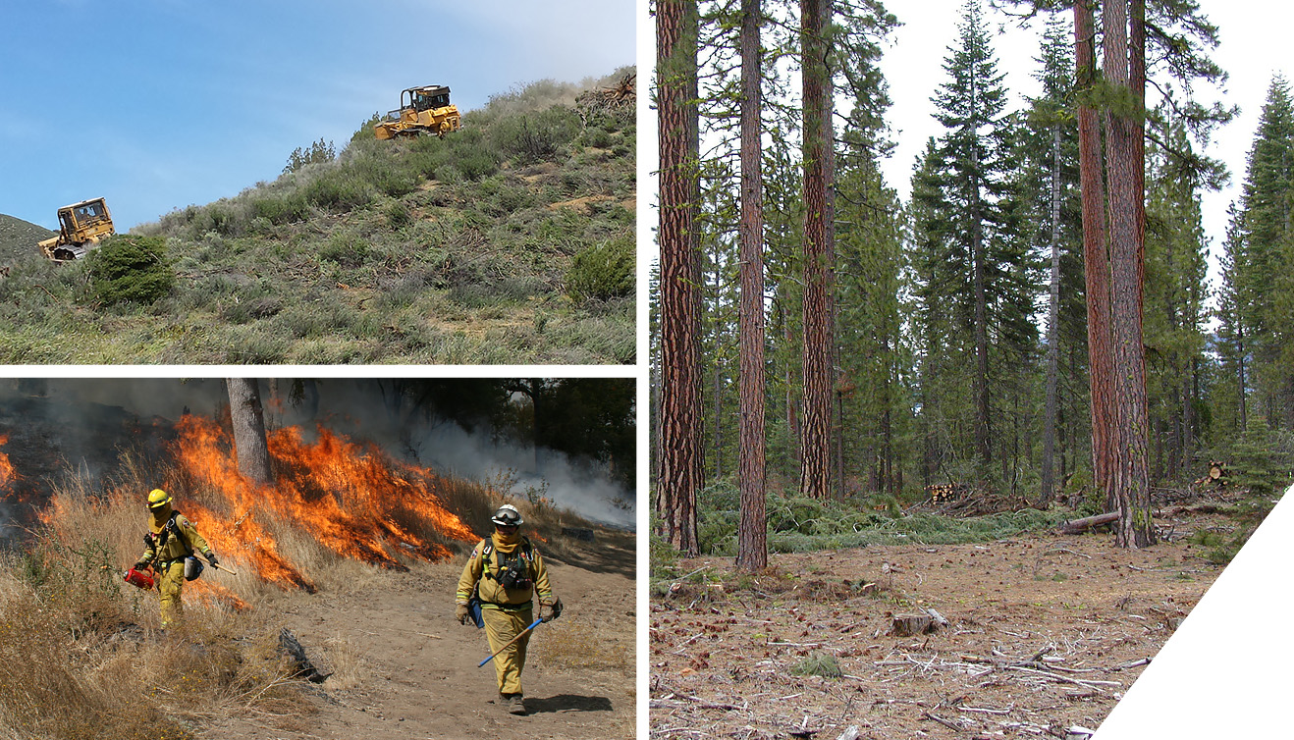
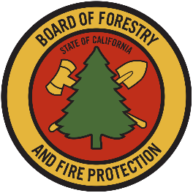
Volume I: Responses to Comments
247 190 38

California Vegetation Treatment Program
Final Program Environmental Impact Report
State Clearinghouse # 2019012052
Prepared for:
California Board of Forestry and Fire Protection
Prepared by:
Ascent Environmental
November 2019

Volume I: Responses to Comments
California Vegetation Treatment Program
Final Program Environmental Impact Report
State Clearinghouse # 2019012052
Prepared for:
California Board of Forestry and Fire Protection
1416 9th Street, Room 1506-14
Sacramento, CA 95814
Contact:
Matt Dias
Executive Officer
Prepared by:
Ascent Environmental
455 Capitol Mall, Suite 300
Sacramento, CA 95814
Contact:
Heather Blair
Senior Project Manager
November 2019
18010126.02

TABLE OF CONTENTS
Section Page
list of Abbreviations ii
1 INTRODUCTION 1-1
1.1 Summary of the CalVTP 1-1
1.2 Purpose of Responses to Comments 1-1
1.3 Environmental Review Process 1-2
1.4 Summary of Revisions to the Draft Program EIR 1-2
1.5 Organizational Structure of the Response to Comments Document 1-3
2 Responses to Comments 2-1
2.1 List of Commenters on the Draft PEIR 2-1
2.2 Master Responses 2-6
2.3 Comments and Responses 2-23
3 References 3-1

Appendices
Appendix A Comment Letters Received on the Draft Program EIR
Appendix B Mitigation Monitoring and Reporting Program

Tables
Table 2-1 List of Commenters 2-1

LIST OF ABBREVIATIONS
°C | degrees Celsius
°F | degrees Fahrenheit
2017 Scoping Plan | California’s 2017 Climate Change Scoping Plan
AB | Assembly Bill
AB 939 | California Waste Management Act of 1989
ACE | CDFW Areas of Conservation Emphasis
Act | 1974 Warren-Alquist Act
AD | anaerobic digestion
APCD | Air Pollution Control District
AQMD | Air Quality Management District
CAA | federal Clean Air Act
CAAQS | California Ambient Air Quality Standards
CAC | County Agricultural Commissioner
CAFE | corporate average fuel economy
CAL FIRE | California Department of Forestry and Fire Protection
Cal/OSHA | California, Division of Occupational Safety and Health Administration
CALAND | California Natural and Working Lands Carbon and Greenhouse Gas Model
CalEPA | California Environmental Protection Agency
California MUTCD | California Manual on Uniform Traffic Control Devices
Cal-IPC | California Invasive Plant Council
Caltrans | California Department of Transportation
CALVEG | Classification and Assessment with Landsat of Visible Ecological Groupings
CalVTP | California Vegetation Treatment Program
CAP | climate action plan
CARB | California Air Resources Board
CARPA | California Air Response Planning Agency
CCA | California Coastal Act
CCAA | California Clean Air Act
CCC | California Coastal Commission
CCC | California Conservation Corps
CCR | California Code of Regulations
CDFA | California Department of Food and Agriculture
CDFW | California Department of Fish and Wildlife
CDP | coastal development permit
CEC | California Energy Commission
CEQA | California Environmental Quality Act
CERCLA | Comprehensive Environmental Response, Compensation, and Liability Act of 1980
CESA | California Endangered Species Act
CFIP | California Forest Improvement Program
CFR | Code of Federal Regulations
CGS | California Geological Society
CHP | California Highway Patrol
CMP | Chaparral Management Program
CMP | congestion management plan
CNDDB | California Natural Diversity Database
CNEL | Community Noise Equivalent Level
CNPS | California Native Plant Society
CNRA | California Natural Resources Agency
CO | carbon monoxide
CO₂ | carbon dioxide
COG | Council of Government
CPAD | California Protected Areas Database
CPAW | Community Planning Assistance for Wildfire
CPUC | California Public Utilities Commission
CSLC | California State Lands Commission
CSP | California State Parks
CUPA | Certified Unified Program Agency
CWA | Clean Water Act
CWHR | California Wildlife Habitat Relationships
CWPP | Community Wildfire Protection Plan
dB | decibels
diesel PM | diesel engines
DOC | California Department of Conservation
DOM | Department Operation Manual
DOT | U.S. Department of Transportation
DPR | California Department of Pesticide Regulation
DTSC | California Department of Toxic Substances Control
DWR | California Department of Water Resources
EBRPD | East Bay Regional Park District
ELZ | equipment limitation zone
EO | Executive Order
EOP | emergency operations plan
EPA | U. S. Environmental Protection Agency
EPAct | Energy Policy Act of 1992
EPCRA | Emergency Planning and Community Right-to-Know Act
ESA | Federal Endangered Species Act
ESHA | Environmentally Sensitive Habitat Area
FACA | Federal Advisory Committee Act
FGC | California Fish and Game Code
FHSZ | Fire Hazard Severity Zone
FHWA | Federal Highway Administration
FICAN | Federal Interagency Committee on Aviation Noise
FIFRA | Federal Insecticide, Fungicide, and Rodenticide Act
FMMP | Farmland Mapping and Monitoring Program
FMTF | Forest Management Task Force
Forest Practice Act | Z’berg -Nejedly Forest Practice Act
FR | Federal Register
FRAP | Fire and Resource Assessment Program
GHG | greenhouse gas
HAP | hazardous air pollutant
HCD | California Department of Housing and Community Development
HCP | Habitat conservation plan
HSC | Health and Safety Code
HWCA | California Hazardous Waste Control Act
Hz | hertz
IAP | Incident Action Plan
IEPR | Integrated Energy Policy Report
INRMP | El Dorado County Integrated Natural Resources Management Plan
IPCC | Intergovernmental Panel on Climate Change
kHz | kilohertz
LADWP | City of Los Angeles Department of Water and Power
LCFS | Low Carbon Fuel Standard
LCP | Local Coastal Program
L_{eq} | Equivalent Continuous Sound Level
L_{max} | Maximum Sound Level
LMP | Land Management Plan
LOS | level of service
LRA | Local Responsibility Area
MBTA | Migratory Bird Treaty Act
MCL | maximum contaminant level
MCV | Manual of California Vegetation
MLD | Most Likely Descendant
MMPA | Marine Mammal Protection Act
MMTCO₂e | million metric tons of carbon dioxide equivalent
mPa | micro-Pascals
mpg | miles per gallon
NAAQS | national ambient air quality standards
NCCP | natural community conservation plan
NCCPA | California Natural Communities Conservation Planning Act
NHPA | National Historic Preservation Act
NHTSA | National Highway Traffic and Safety Administration
NO₂ | nitrogen dioxide
NOA | naturally-occurring asbestos
NOAA | National Oceanic and Atmospheric Administration
NOP | Notice of Preparation
NO_{X} | oxides of nitrogen
NPDES | National Pollutant Discharge Elimination System
NPPA | Native Plant Protection Act
NRCS | Natural Resources Conservation Service
NRHP | National Register of Historic Places
NVC | National Vegetation Classification
NWI | USFWS National Wetland Inventory
OEL | occupational exposure limit
OPR | Governor’s Office of Planning and Research
OSHA | U.S. Occupational Safety and Health Administration
PAH | polycyclic aromatic hydrocarbon
Park Rangers | State Park Peace Officers
PCA | Pesticide Control Advisor
PCT | Pacific Coast Trail
PEIR | Program Environmental Impact Report
PEL | Permissible Exposure Limits
PFIRS | Prescribed Fire Incident Reporting System
PG&E | Pacific Gas and Electric
PM₁₀ | respirable particulate matter with aerodynamic diameter of 10 micrometers or less
PM_{2.5} | fine particulate matter with aerodynamic diameter of 2.5 micrometers or less
Porter-Cologne Act | Porter-Cologne Water Quality Control Act
PPE | personal protective equipment
PRC | Public Resources Code
Proposition 65 | Safe Drinking Water and Toxic Enforcement Act
PRPA | Paleontological Resources Preservation Act
PSA | Project-Specific Analysis
RCD | Resource Conservation District
RCRA | Resource Conservation and Recovery Act
ROG | reactive organic gases
RPS | Renewable Portfolio Standard
RUP | restricted use pesticide
RWQCB | regional water quality control board
SAF Plan | State Alternative Fuels Plan
SARA | Superfund Amendments and Reauthorization Act
SB | Senate Bill
SB 1383 | Short-Lived Climate Pollutant Strategy/Diversion of Organic Waste from Landfills
SEMS | Standard Emergency Management System
SENL | Single Event [Impulsive] Noise Level
SFPUC | San Francisco Public Utilities Commission
SGC | California Strategic Growth Council
SGMA | Sustainable Groundwater Management Act
SLCP | Short-lived climate pollutant
SMP | smoke management plan
SO₂ | sulfur dioxide
SPL | sound pressure level
SPR | Standard Project Requirements
SRA | State Responsibility Area
SWAP | Statewide Wildlife Action Plan
SWRCB | State Water Resources Control Board
TAC | toxic air contaminant
TCR | Tribal Cultural Resources
TMDL | total maximum daily load
TMP | Transportation Management Plan
TPQ | Threshold Planning Quantity
TPZ | Timberland Production Zone
TTC | Temporary traffic control
UC | University of California
UFP | ultrafine particulate matter
USACE | U.S. Army Corps of Engineers
USC | U.S. Code
USDA | U.S. Department of Agriculture
USFS | U.S. Forest Service
USFWS | U.S. Fish and Wildlife Service
VegCAMP | CDFW Vegetation Classification and Mapping Program
VHFHSZ | very high fire hazard severity zone
VMP | Vegetation Management Program
VMT | vehicle miles traveled
VOC | volatile organic compound
WHR | California Wildlife Habitat Relation
Williamson Act | California Land Conservation Act
WLPZ | Watercourse and Lake Protection Zone
WPS | Worker Protection Standard
WUI | wildland-urban interface

This page intentionally left blank.

