June 28, 2024
Project No: 19-07111
Rachel Dimond
Community Development Director
City of Ventura
501 Poli Street
Ventura, California 93001
Subject: City of Ventura Emergency Evacuation Analysis
Dear Ms. Dimond:
This supplemental evacuation analysis was prepared in support of the City of Ventura General Plan Update. This study is intended to provide the City with a broad planning level assessment of the capacity of the transportation system during a citywide evacuation event and serves to build upon the City’s recently completed Emergency Evacuation Plan. It identifies residential developments with a single entrance and exit road, and evaluates the potential consequences of large evacuation events on the roadway system under various hazard scenarios in keeping with the following two statutes:
Senate Bill 99 (SB 99) requires that the Safety Element of the General Plan identify any residential developments in any hazard area that does not have at least two evacuation routes. This is a requirement for all safety element updates included upon the revision of the housing element on or after January 1, 2020.
Assembly Bill 747 (AB 747) requires that the Safety Element be reviewed and updated to identify evacuation routes and their capacity, safety, and viability under a range of emergency scenarios. This will be a requirement for all safety elements or updates to a hazard mitigation plan completed after January of 2022.
These scenarios are intended to model a potential range of different evacuation scenarios, but not all possible scenarios. Emergency evacuations can occur due to any number of events and at any location, beyond those specifically identified in this report. In addition, emergency movement is unpredictable, and the specific conditions of an emergency evacuation could result in evacuation behavior that diverges from the assumptions used in this analysis. This analysis serves only to represent informed estimates of likely potential evacuation scenario footprints and capacity constraints based on available data and does not guarantee that evacuations will follow modeling that is used for analysis purposes. Emergency evacuation assessment is an emerging field, and the legislative requirement does not specify a standard methodology to follow. The methodology used in this evaluation is based upon best practices and the professional experience and knowledge of Rincon staff. Rincon is not responsible for any damage to life or property that might occur based on the results of the evacuation analyses herein, and any accompanying recommendations.

SB 99 Analysis – Single Entrance/Exit Neighborhoods
Per SB 99, the Safety Element of the General Plan is required to identify residential neighborhoods in any hazard area that does not have at least two evacuation routes. For this analysis, a single entrance/exit neighborhood is defined as 30 or more dwelling units located in a residential general plan land use designation that only have a single route to access a collector or arterial road based on California Fire Code Appendix D107.1. As shown in Figure 1, there are 12 CAL FIRE subdivisions and 44 other neighborhoods that have a single entry or exit point. These neighborhoods are distributed throughout the city, especially along State Route (SR) 33, within the eastern neighborhoods along SR 126 and Telephone Road, and adjacent to the beach along Pierpont Boulevard. In the case of an evacuation event, these single entry/exit neighborhoods would likely use US 101, SR 33, or SR 126 to evacuate depending on the location of the evacuation area. Some neighborhoods could also use alternative evacuation routes, such as Telephone Road or North Ventura Avenue, depending on the severity of traffic congestion or the location of the evacuation area.

Figure 1 Single Entry/Exit Neighborhoods
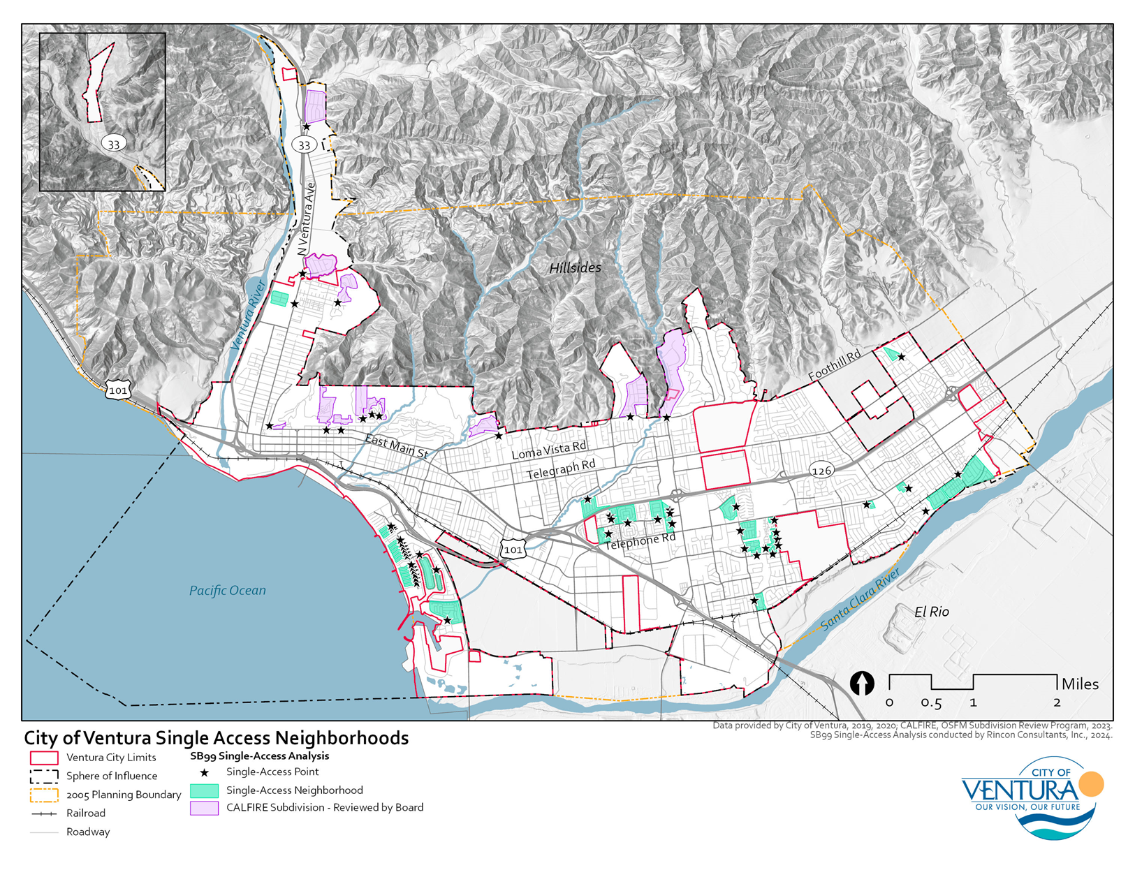

AB 747 Analysis – Evacuation Scenarios
In accordance with AB 747, the following analysis and results outline the potential outcomes of a variety of hazard events requiring emergency evacuation.

Evacuation Scenarios
In accordance with AB 747, a range of potential hazard scenarios are presented in this evacuation analysis. Hazard scenarios were selected in consultation with City staff and are based on a review of past hazard assessments, and by considering the potential likelihood, magnitude, and spatial extent of various hazards.
Scenario 1: Wildfire in City’s Northern Hillsides
A wildfire originates in the city’s northern hillsides and moves westward and southward which triggers immediate evacuation of all neighborhoods along SR 33, and in the foothills within the Very High Fire Hazard Severity Zones.
Roadway closures: SR 33, Foothill Road, North Ventura Avenue, Neighborhood Roads within VHFHSZs north of Foothill Road, including Lake Canyon, East Santa Clara Street, and Crooked Palm Road.
Timing: Peak Weekday Afternoon Traffic Hours.
Evacuation Points: East of city limits along SR 126 and south of city limits along US 101.
Scenario 2: Coastal Flooding due to Tsunami/Storm Wave Impacts
Storm wave impact projections for 2100, resulting in erosion of beaches and flooding within the city’s coastal areas.
Road closures: N/A
Timing: Peak Weekday Afternoon Traffic Hours in December
Evacuation of the city would be gradual, beginning along the coastal neighborhoods and extending beyond US 101 at the intersection of SR 33. Evacuations would mirror how the water enters the city, beginning in the western neighborhoods and moving eastward.
Evacuation Points: Ventura High School.
Scenario 3: Riverine Flooding along Santa Clara River and Ventura River
Extreme rain event that causes localized flooding along the Santa Clara and Ventura Rivers, extending into the Barrancas throughout the city, causing immediate evacuation of low-lying areas within the city.
Roadway closures: Telegraph Road, Main Street, SR 33, US 101 and areas along the Harmon and Arundell Barrancas off US 101.
Timing: Peak Weekday Traffic in January.
Evacuation Points: Ventura High School and Buena High School.

Methodology
This section describes the methods, tools, and data sources utilized to establish the transportation network, the approach to distributing the Ventura population within the city, average roadway capacity, and evacuation modeling.

Transportation Network
The transportation network was created by enhancing the city’s roadway layer with ESRI’s StreetMap Premium, which includes detailed basemap data and a network dataset for routing, both of which were used in the evacuation analyses. StreetMap Premium is a comprehensive dataset that provides enriched network data based on commercial street reference data from leading global and local street data suppliers: HERE and GeoTechnologies, Inc. This dataset is well-suited for emergency evacuation analysis because it includes a comprehensive network of roads, baseline traffic data, and is regularly updated to ensure that it remains accurate and current. In addition, the network data models the movements of automobiles by obeying one-way roads, speed limits, avoiding illegal turns, and other rules specific to automobiles, and finds solutions that optimize travel time.

Population Modeling
The population of Ventura was modeled using ESRI’s Enrich Layer Tool. The Enrich Layer Tool appends demographic and landscape variables to any input polygon feature class for further analysis, modeling, and reporting. The input polygon layer used for Ventura were US census tracts within the city. The Enrich Layer Tool is then used to add daytime population data to the city census tracts. Daytime population data was from ESRI’s daytime population data estimates, which are generated using a mix of inputs from ESRI's U.S. Updated Demographics, the decennial census, the American Community Survey (ACS), and business data from Data Axle, a full-service data provider. ESRI’s daytime population is an estimate of the population that includes residents and workers in the city on weekdays during standard workday hours, between 9:00 a.m. and 5:00 p.m. Daytime population was used to best represent the number of individuals in the city at the time of an evacuation scenario.
After the values of daytime population were assigned to the census tracts, the city’s building footprints were used to concentrate the daytime population into places where the population would typically be present, such as residential areas, shopping centers, schools, and corporate offices and buildings. This was done by randomly distributing total daytime population values to be within building footprints within each census tract. The daytime population points that intersect the evacuation area represent the individuals that are evacuating, and where they start their evacuation from. These points serve as evacuation origin points.

Evacuation Modeling
Evacuation routes and traffic volumes during an emergency evacuation event were modeled using ArcGIS’s Closest Facility tool included in the Network Analyst extension. The Closest Facility tool enables finding the closest facility (e.g., hospital, fire station, or gas station) to a given location or set of locations. The Closest Facility tool can also be customized to include other factors that affect travel time, such as speed limits and road closures. For this evacuation analysis, the “facilities” analyzed will be points of safety and designated evacuation locations both inside and outside of Ventura City boundaries depending on the scenario. The facilities were identified in the section above titled Evacuation Scenarios. The location of facilities outside of city limits were assumed to be located on roads along evacuation routes, including SR 33, SR 126, US 101, North Ventura Avenue, and Telegraph Road. After distributing the daytime population throughout the city, the evacuation model was run to simulate the level of traffic volumes on roads and major highways during each hazard scenario assuming simultaneous departure of all populations from the evacuation area to the nearest designated evacuation locations within the transportation network.
To depict the level of traffic volumes associated with each evacuation scenario, average daily traffic (ADT) was assigned to highways, arterial streets, and local roads within the city. ADT values for the highways, arterial streets, and some local roads were provided by the City and include ADT counts and locations from November 2022 performed by Iteris. ADT data for highways in Ventura were calculated using Caltrans 2022 ramp ADT data. For local roads where ADT was not provided, an ADT value was assigned based on the average ADT value of all local roads provided by City staff. For this analysis, road capacity was estimated using road classifications and the number of lanes traveling in the direction of the evacuation. Grade separated highways (SR 33) were assumed to have a traffic flow of 2,200 vehicles per lane per hour, arterial roads were assumed to have an ideal traffic flow of 1,900 vehicles per lane per hour, and collector and local roads were assumed to have an ideal traffic flow of 950 vehicles per lane per hour. On average, peak hour traffic ranges between 6-10 percent of ADT, according to the US Department of Transportation (DOT) Federal Highway Administration. For this analysis, a median-range value of about 8 percent of ADT was used to get the baseline volume of traffic on the roads, based on the suburban nature of the city. For the baseline scenario, baseline traffic volume is compared to the road capacity to get the baseline volume to capacity (V/C) ratio. For the evacuation scenarios, the number of evacuation routes that traveled along a particular road—moving from the evacuation origin to the nearest evacuation point outside the city limits—will be added to the baseline volume of traffic already assumed to be traveling on the roads and compared to the road capacity to get the evacuation V/C ratios. V/C ratios less than 0.9 depict uncongested traffic, V/C ratios between 0.9 and 1 depict moderately congested traffic, and V/C ratios greater than 1 depict heavily congested traffic, or over-capacity traffic.

Assumptions and Limitations
The results of this analysis are intended to show roads that could experience increased traffic volumes during an emergency evacuation event. The model assumes that the daytime population within the evacuation area is going to exit the hazard area at the nearest evacuation point during typical traffic conditions. It is assumed that the locations of the exit points for each scenario change depending on the original direction of the hazard.

Evacuation Assessment Results

Baseline (Weekday evening traffic hours)
The baseline scenario evaluates typical traffic volumes in the city during peak, weekday traffic hours (e.g., Thursday at 5 P.M.), assuming around 8 percent of ADT. After being compared to the road capacity, the resulting V/C ratio is used as the basis of comparison against each modeled evacuation scenario. As listed in Table 1 and shown in Figure 2, there is a variety of road congestion within the city, ranging from no congestion to roads with a V/C ratio over 1. All expected evacuation routes/locations along SR-33, SR-126, US-101, North Ventura Avenue, and Telegraph Road are available to individuals for evacuation but may experience varying levels of congestion. Notable congestion within the city includes along the southern portion of North Ventura Avenue, the western portion of SR-126 at the intersection of US-101, and eastern Telegraph Road.
Table 1 Baseline Scenario
Roadway | Location/Segment | Congested | Over Capacity
North Ventura Avenue | From Main Street to Dakota Drive | 1.3 miles | 0.7 miles
Loma Vista Road | From East Main Street to North Mills Road | 0.7 miles
East Harbor Boulevard | From Arundell Barranca to South Seaward Avenue | 1.0 miles
SR 126 | From US 101 to South Victoria Avenue | 1.4 miles
South Victoria Avenue | From Telephone Road to Telegraph Road |  | 0.9 miles
Johnson Drive | From Telephone Road to Bristol Road | 0.9 miles
South Victoria Avenue | From Valentine Road to Olivas Park Road | 0.5 miles
Olivas Park Road | From Bunsen Avenue to Golf Course Drive | - miles
Telegraph Road | From North Petit Avenue to North Wells Road | 1.0 miles | 0.5 miles
South Wells Road | From Citrus Drive to West Telegraph Road | 0.3 miles
SR 118 | From SR 126 to Telephone Road |  | 0.5 miles

Figure 2 Baseline Traffic Conditions
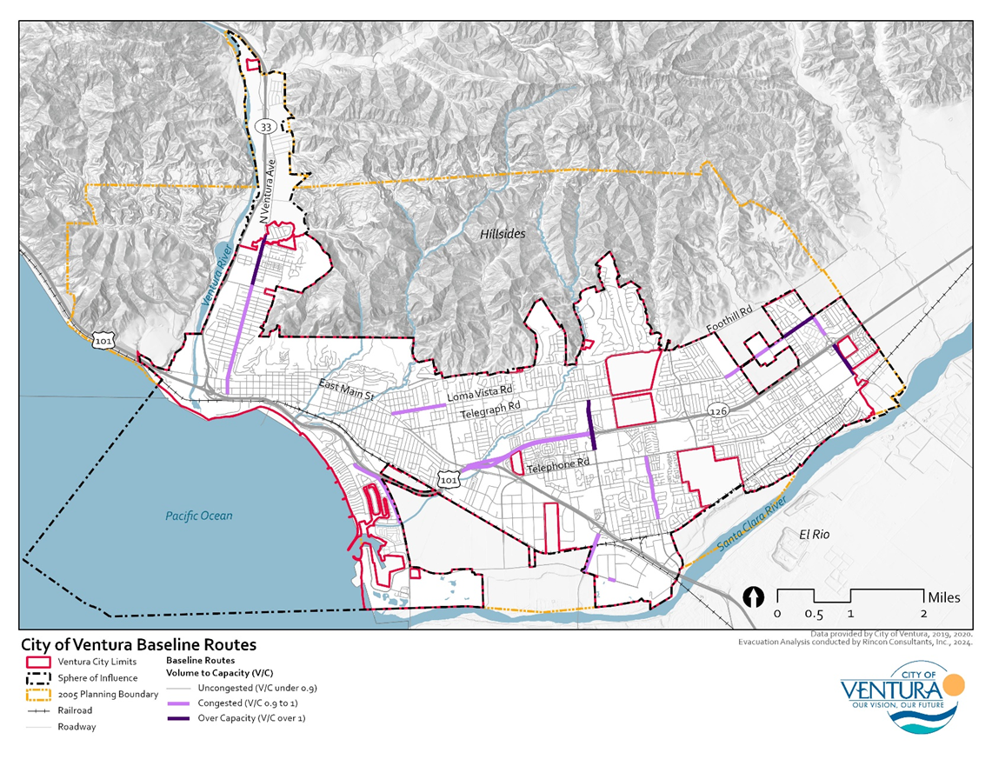

Scenario 1: Wildfire in City’s Northern Hillsides
This scenario assumes a wildfire originating in the city’s northern hillsides within High and Very High Fire Hazard Severity Zones north of Foothill Road and along SR 33 and North Ventura Avenue. Due to the extent of the evacuation zone, many of the city’s evacuation routes will be over capacity. Table 2 lists the expected traffic volumes and congestion resulting from emergency evacuation due to wildfire. Figure 3 shows the extent of the proposed wildfire evacuation area and expected increased traffic volumes resulting from simultaneous departure throughout various points from the evacuation area. It is assumed that all evacuees will be travelling towards the designated evacuation destinations east of SR 126 outside city limits and south of the Santa Clara River along US 101. Due to the northern fires, most evacuation routes near the Fire Hazard Severity Zones are significantly impacted and exhibit V/C scores greater than 1, denoting that these routes are over capacity. These evacuations include the southern portion of North Ventura Avenue, extending from the upper city limit to the entirety of US 101 and the entirety of East Main Street, the southern and northern sections of Loma Vista Road, the southern portions of SR 33, the northern portions of SR 126, and central portions of Foothill Road. Other evacuation routes that will be moderately congested, with a V/C between 0.9 and 1, include central portions of SR 126, Loma Vista Road, and Telegraph Road.
Due to this, evacuation responders could consider activating evacuation traffic management along these roadways and contra-flow lane reversal on eastbound SR 126 and southbound US 101 and East Main Street to allow both lanes to be used for evacuation, if necessary. In addition to these two roads, other areas to consider monitoring in this scenario include vicinities directly alongside the evacuation zone, along North Ventura Avenue, SR 33, Foothill Road, and Loma Vista Road, as immediate, heavy traffic congestion are expected in these areas as individuals vacate southbound and eastbound toward the designated evacuation destinations.
Table 2 Wildfire Scenario
Roadway | Location/Segment | Congested | Over Capacity | Baseline Congested or Over Capacity?
North Ventura Avenue | From Dakota Drive to East Main Street |  | 2.0 miles | Over Capacity
SR 33 | From West Stanley Avenue to US 101 |  | 2.0 miles | Over Capacity
West Stanley Avenue | From SR 33 to North Ventura Avenue |  | 0.4 miles | Over Capacity
North Olive Street | From West Vince Street to West Stanley Avenue | 0.4 miles |  | Congested (not baseline)
North Olive Street to South Garden Street | From West Harrison Avenue to US 101 |  | 0.7 miles | Over Capacity
US 101 | From SR 33 to Johnson Drive |  | 7.5 miles | Over Capacity
East Main Street | From North Kalorama Street to Telephone Road |  | 4.4 miles | Over Capacity
SR 126 | From US 101 to SR 118 | 3.4 miles | 2.0 miles | Over Capacity
East Harbor Boulevard | From Arundell Barranca to South Seaward Avenue | 1.0 miles |  | Baseline Congested
East Harbor Boulevard | From Sanjon Road to San Pedro Street | 0.7 miles |  | Congested (not baseline)
Loma Vista Road | From South Ashwood Avenue to East Main Street | 0.3 miles | 0.9 miles | Over Capacity
Foothill Road | From North Victoria Avenue to Willowick Drive | 0.4 miles | 1.4 miles | Over Capacity
Foothill Road | From Colina Vista to North Kimball Road |  | 0.5 miles | Over Capacity
Loma Vista Road | From Day Road to North Victoria Avenue | 0.4 miles | 0.3 miles | Over Capacity
North Kimball Road | From Foothill Road to SR 126 | 0.4 miles | 0.5 miles | Over Capacity
Telegraph Road | From North Wells Road to North Petit Avenue | 1.0 miles | 0.5 miles | Over Capacity
South Wells Road | From Citrus Drive to West Telegraph Road |  | 0.3 miles | Over Capacity
SR 118 | From Telephone Road to SR 126 |  | 0.5 miles | Over Capacity
Johnson Drive | From Telephone Road to Bristol Road | 0.9 miles |  | Baseline Congested
South Victoria Avenue | From Valentine Road to Olivas Park Road | 0.5 miles |  | Baseline Congested
Olivas Park Road | From Bunsen Avenue to Golf Course Drive | 0.1 miles |  | Baseline Congested
North/South Victoria Avenue | From Santa Lucia Court to Thille Street | 0.1 miles | 1.2 miles | Over Capacity
North/South Mills Road | From Loma Vista Road to East Main Street |  | 0.8 miles | Over Capacity
East Main Street | From North Ventura Avenue to Figuera Street |  | 0.2 miles | Over Capacity
South Oak Street | From Santa Clara Street to US 101 Business |  | 0.1 miles | Over Capacity
South California Street | From Santa Clara Street to US 101 Business |  | 0.1 miles | Over Capacity
South Ash Street | From East Main Street to US 101 Business |  | 0.2 miles | Over Capacity
East Thompson Boulevard/US 101 Business | From South Ash Street to South Chestnut Street On-ramp |  | 0.2 miles | Over Capacity

Figure 3 Northern Hillside Wildfire Evacuation Results
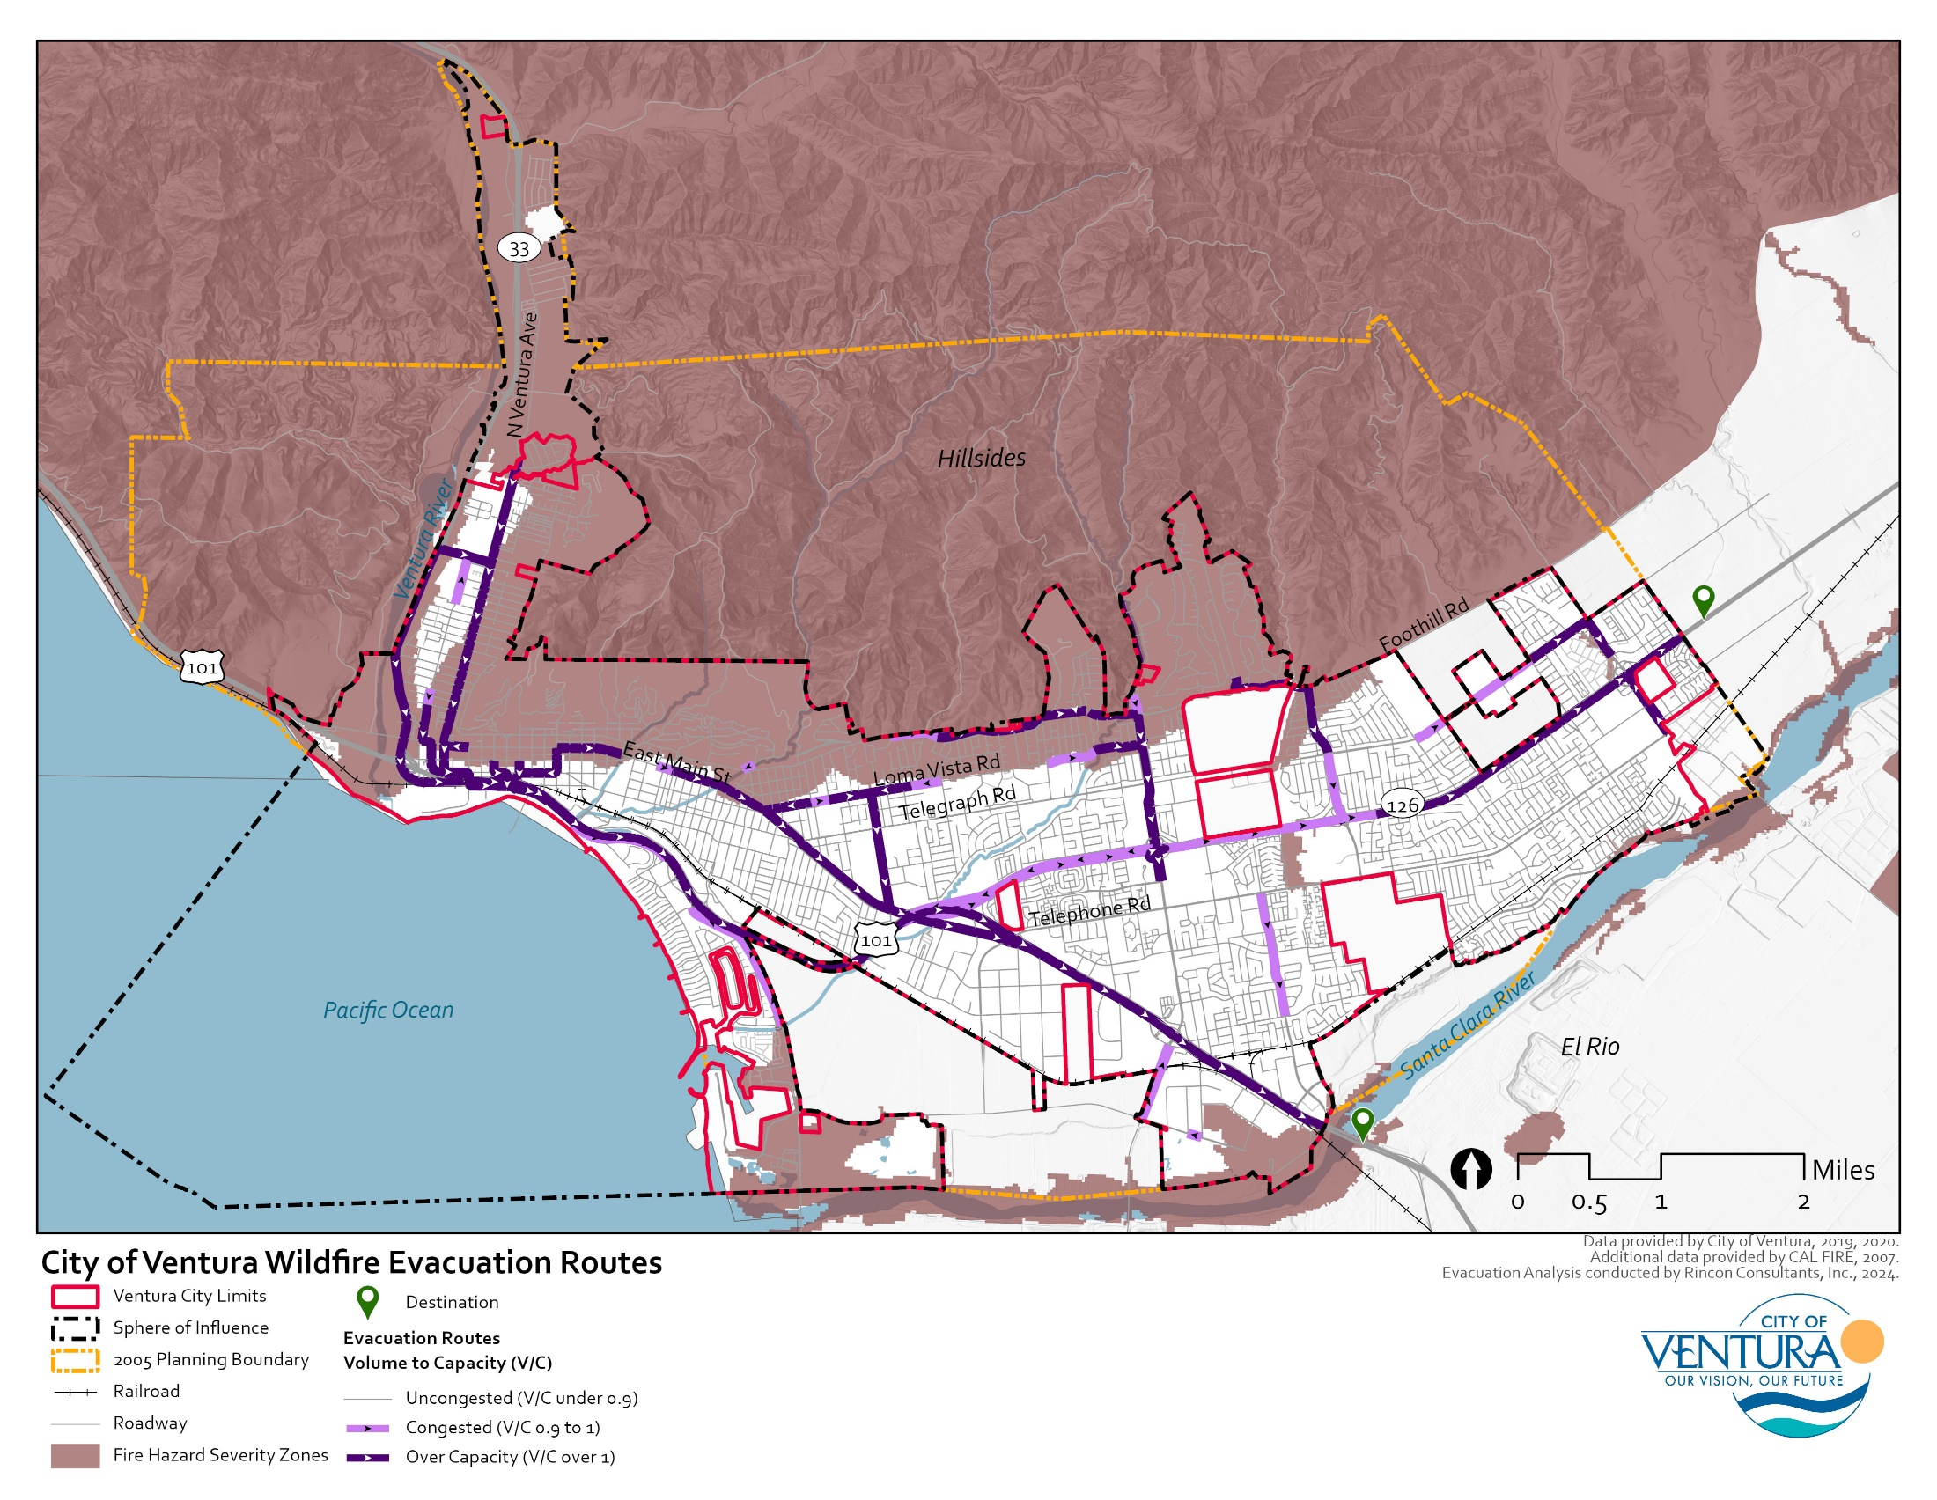

Scenario 2: Coastal Flooding due to Tsunami/Storm Wave Impacts
This scenario assumes a flooding event due to tsunami/storm wave impacts along the western, coastal portions of the city. This scenario assumes that portions of US 101, East Harbor Boulevard, and Pierpont Boulevard are not viable as a result of the modeled flooding trajectory. The homes and buildings located along Pierpont Boulevard and nearby roadways, which will be most impacted by coastal flooding, create a unique baseline evacuation situation within the coastal area. Many of these neighborhoods consist of one-way roads that run perpendicular to the beach, creating dangerous evacuation scenarios for residents on these streets, with one entry/exit. This community largely consists of vacation homes, where people may not be present under an evacuation scenario or flooding event. Table 3 lists the evacuation route congestion and capacity under the coastal flooding scenario, including length of roadways affected. Figure 4 shows the extent of the proposed flooding evacuation area and expected increased traffic congestion resulting from simultaneous departure throughout various points from the evacuation area. The largest traffic volumes, where traffic levels are expected to have a V/C greater than 1, or heavily congested traffic, occur along South Seaward Avenue, Pierpont Boulevard, East Harbor Boulevard, and US 101, as evacuees converge towards the evacuation destination point. Due to the unique baseline evacuation scenario in the coastal areas of the City, evacuation west would be constrained due to the blockage on US 101. However, the ability to get on the US-101 and to South Seaward Avenue towards the evacuation destination would be rapid, as this on-ramp is located only 1.7 miles from the farthest location in the coastal area, located on East Harbor Boulevard and Beachmont Street. Similarly, other collector and arterial roads expected to exhibit moderate to heavily congested traffic volumes include Spinnaker Drive and Sanjon Road, near the harbor, and East Thompson Boulevard, as evacuees move northeastward from the impacted flood zone towards the designated evacuation destination point near Ventura High School and Larabee Stadium.
The critical areas to maintain in this scenario would include all major roadways— South Seaward Avenue, Pierpont Boulevard, East Harbor Boulevard, East Thompson Boulevard, and US 101—used to reach Ventura High School/Larabee Stadium. Other collector and arterial roads, especially those located in the northwestern portion of the city, near Ventura River should also be monitored as flooding in this scenario is expected to move into the Ventura River and could impact the neighborhoods along the river. Similar to the previous scenario, evacuation responders could consider activating evacuation traffic management at these collector and arterial roads, and contra-flow lane reversal on South Seaward Avenue, East Thompson Boulevard, and East Harbor Boulevard to allow both lanes to be used for evacuation if necessary.
Table 3 Coastal Flooding Scenario
Roadway | Location/Segment | Congested | Over Capacity | Baseline Congested or Over Capacity?
East Harbor Boulevard | From Sanjon Road to San Pedro Street |  | 0.7 miles | Over Capacity
Sanjon Road | From East Harbor Boulevard to East Thompson Boulevard | 0.3 miles |  | Congested (not baseline)
East Thompson Boulevard/US 101 Business | From Sanjon Road to South Seaward Avenue |  | 0.9 miles | Over Capacity
South Seaward Avenue | From Pierpont Boulevard to Poli Street |  | 1.2 miles | Over Capacity
East Harbor Boulevard | From Schooner Drive to South Seaward Avenue |  | 1.3 miles | Over Capacity
Anchors Way/Schooner Drive | From Arundell Barranca to East Harbor Boulevard |  | 0.6 miles | Over Capacity
Pierpont Boulevard | From Monmouth Drive to Weymouth Lane | 0.1 miles | 0.5 miles | Over Capacity
Peninsula Street | From Clearview Avenue to East Harbor Boulevard | 0.1 miles | 0.1 miles | Over Capacity

Figure 4 Tsunami/Storm Wave Coastal Flooding Evacuation Results
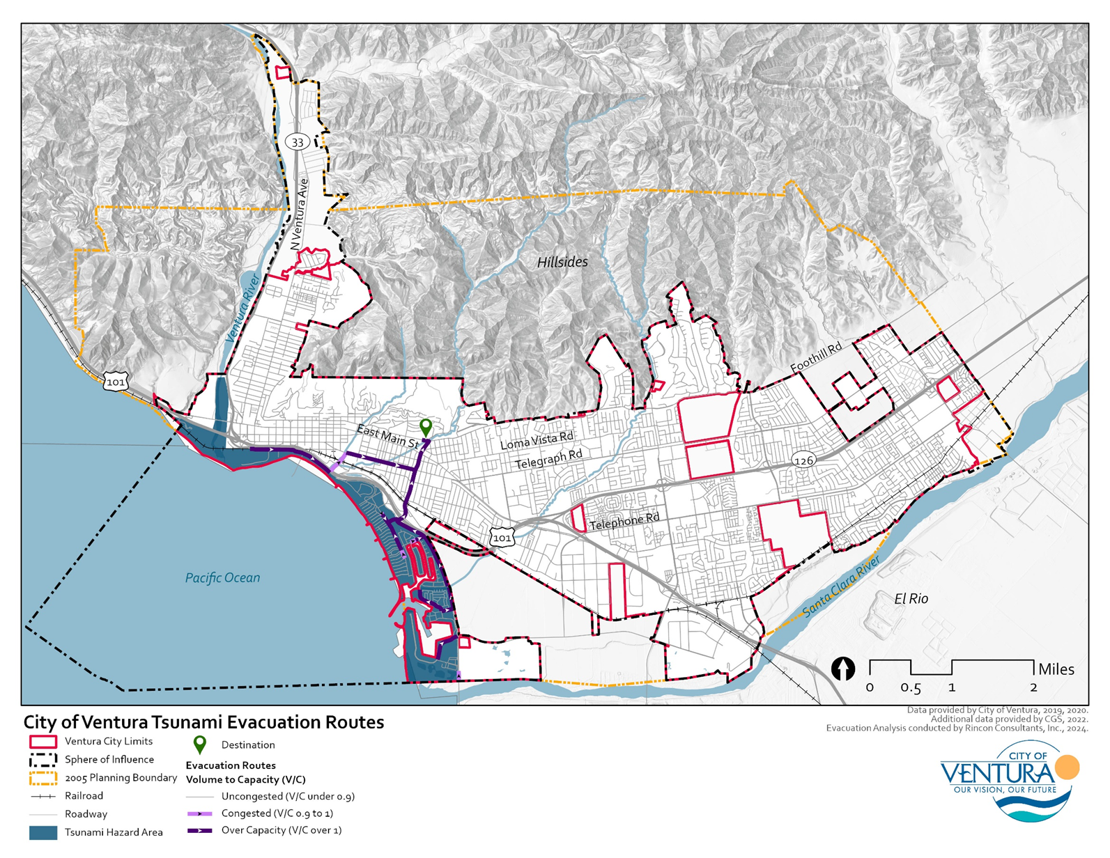

Scenario 3: Riverine Flooding along Santa Clara River and Ventura River
This scenario assumes 100- and 500-year flooding events along the Ventura River and Santa Clara River and the city’s Barranca system. Under the 100-year flood event, flooding is projected to occur along both rivers, especially in the western portion of the Ventura River and near the Buenaventura Golf Course and Olivas Park along the Santa Clara River. Additional flooding will occur along the Arundell Barranca near Arundell Avenue and US 101. Under the 500-year flood event, significant flooding will occur in the same areas, while also inundating larger areas along the Arundell Barranca and Brown Barranca in the eastern portion of the city along SR 126. Table 4 lists the expected traffic conditions during a riverine flooding evacuation scenario and Figure 5 shows the extent of the evacuation area and expected increased traffic congestion resulting from simultaneous departure throughout various points from the evacuation area. The largest traffic volumes, where traffic levels are expected to have a V/C greater than 1, occur along US 101, SR 126, SR 118, South Victoria Avenue, Johnson Drive, and the eastern portion of Telegraph Road. Heavy traffic congestion is projected to occur in the central area of the city along South Victoria Avenue and SR 126 as evacuees travel towards the designated evacuation destinations at Ventura High School and Buena High School. The critical areas to maintain in this scenario would include all possible entry points surrounding the designated evacuation destinations, the immediate evacuation routes within the 100- and 500-year floodplains, and the previously listed roadways with heavily congested traffic. Like the previous scenarios, evacuation responders could consider activating evacuation traffic management on the heavily congested roadways and contra-flow lane reversal on heavily affected arterial roads like South Victoria Avenue, Johnson Drive, and the eastern portion of Telegraph Road, if necessary, to aid in swift movement towards the major evacuation routes.
Table 4 Riverine Flooding Scenario
Roadway | Location/Segment | Congested | Over Capacity | Baseline Congested or Over Capacity?
Poli Street | From North Katherine Drive to Hall Canyon Road |  | 0.1 miles | Over Capacity
East Harbor Boulevard | From Oyster Street to South Seaward Avenue |  | 0.7 miles | Over Capacity
Lemon Grove Avenue | From Preble Avenue to East Main Street | 0.1 miles |  | Congested (not baseline)
Callens Road | From Transport Street to East Main Street | 0.2 miles | 0.3 miles | Over Capacity
Donlon Street | From Bessemer Street to East Main Street |  | 0.2 miles | Over Capacity
SR 126 | From US 101 to South Victoria Avenue | 0.2 miles | 1.5 miles | Over Capacity
South Victoria Avenue | From Buena High School to Telephone Road | 0.1 miles | 1.1 miles | Over Capacity
South Victoria Avenue | From Valentine Road to Olivas Park Road |  | 0.5 miles | Over Capacity
Northbank Drive | From US 101 to Johnson Drive | 0.1 miles |  | Congested (not baseline)
Johnson Drive | From Capri Avenue to Telephone Road | 0.4 miles | 0.8 miles | Over Capacity
South Saticoy Avenue | From Telephone Road to Henderson Road |  | 0.5 miles | Over Capacity
Telegraph Road | From North Saticoy Avenue to North Petit Avenue |  | 1.0 miles | Over Capacity
SR 118 | From Telephone Road to SR 126 |  | 0.5 miles | Over Capacity
Darling Road | From Jonquil Avenue to SR 118 | 0.2 miles |  | Congested (not baseline)
South Wells Road | From Citrus Drive to Carlos Street | 0.1 miles |  | Congested (not baseline)

Figure 5 Riverine Flooding Evacuation Results
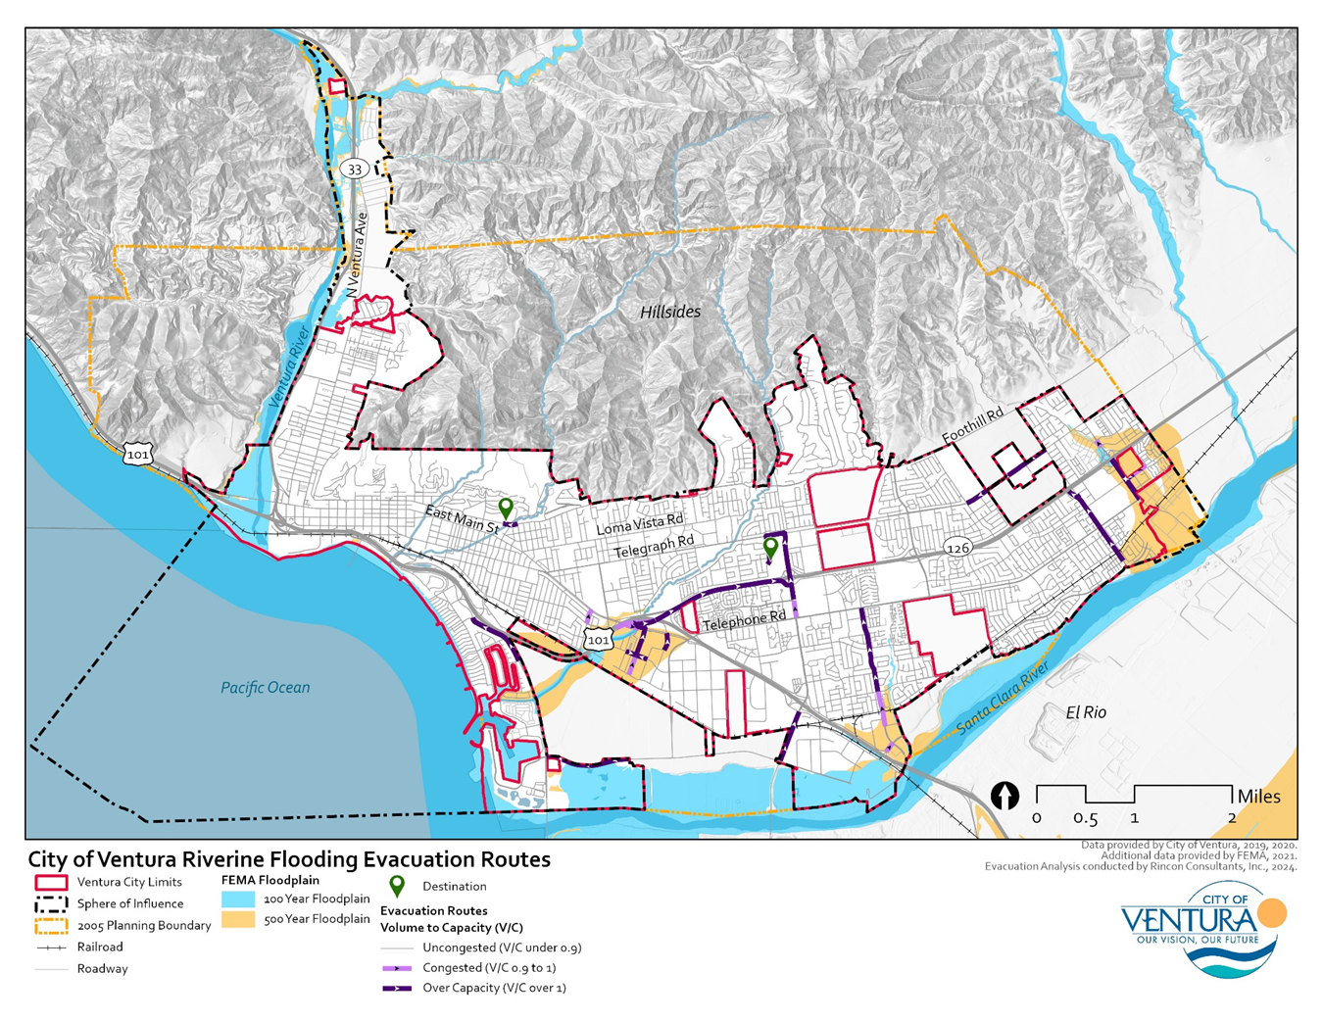

Evacuation Strategies
The following lists evacuation strategies that the City may consider to improve future evacuation events. To build upon these strategies, Ventura County also conducted the Hill & Woolsey Fires Emergency Response After-Action Review in January 2020, which details the County’s recommended solutions to challenges that occurred during those events. The after-action review strategies focus on key functional areas that will serve as a framework for future emergency response efforts and were utilized to build the strategies included in this report.

Single-Access Residential Neighborhoods
Ensure that the Ventura County Fire Department has complete access to all locations in the city and that all roads meet ingress and egress requirements, including gated residential communities and single access neighborhoods.
In coordination with the Ventura County Fire Department and Ventura Police Department, conduct regular evacuation trainings with single-access community homeowner associations and residents.
Proactively engage with residential neighborhoods with single routes of entry and exit to conduct emergency preparedness trainings and appropriate home retrofits.

Traffic Management
Collaborate with Caltrans and California Highway Patrol (CHP) to reverse one or more lanes of SR 12 to accommodate an increased flow of traffic in one direction. Apply the same strategy to City-owned major roadways.
Redirect all lanes of a designated evacuation route to accommodate rapid evacuation from a city or region.
Temporarily close inbound travel lanes on selected unlimited access arterials (such as parkways and boulevards) to allow outbound traffic to utilize these lanes during evacuation.
Collaborate with Caltrans and/or CHP to close inbound lanes on highways used for evacuation routes to prevent drivers on these routes from entering the city while evacuation is underway.
Minimize left-turn movements along evacuation routes and on roads leading to evacuation routes.
Use variable message board equipment, and targeted installation of permanent dynamic message signs on evacuation routes to improve communication and reduce public confusion.
Collaborate with towing services to consider how to stage tow trucks at key bottleneck locations along evacuation routes to help detect and clear minor crashes and maintain traffic flow.
Increase the green time and/or progression band for through movements leading out of an evacuation zone.
Install signal battery backups in case signal operations need to be maintained during a power outage. Consider using channeling devices, static signs, and coning strategies to manage intersection flow during power outage if the signals lack power.
Collaborate with bus system operators to develop transportation solutions such as the use of a bus system for evacuating individuals with special needs (such as those with mobility limitations).
Establish traffic control points (i.e., locations along designated evacuation routes with emergency management personnel) to maintain a greater degree of evacuation management. These locations could enhance the efficiency of an evacuation, reduce public confusion, and allow increased operational flexibility during an evacuation.

Communications
Strengthen and maintain communication among coordinating emergency event agencies. This could be achieved through systems such as the Ventura County Alert Emergency Notification System and Emergency Satellite Communications.
Implement a traffic control center in partnership with the City’s Transportation Department to coordinate all evacuation activities. This center would have up to the minute reports on traffic patterns and can communicate directly with the broadcast media to let drivers know about roadway congestion and conditions and direct them to alternate routes.
Install counters and/or CCTV cameras to assess traffic flow, volume of vehicles evacuating, and monitor incidents.
Develop communication plan to provide information regarding primary and secondary evacuation routes and incidents to the public.

Vulnerable Populations
Understand if there are areas in the city with a greater percentage of senior adults, disabled people, mobility impaired, visually impaired, people with medical conditions, and people without vehicles with of objective of identifying areas that should be prioritized by first responders during an evacuation.
Develop system to ensure hearing impaired receive evacuation warnings.
Provide special assistance to mobility impaired, visually impaired, people with medical conditions, and people without vehicles such as paratransit.
Translated materials should be prepared to support communication to non-English speaking populations including during evacuation.

Conclusion
Ventura’s transportation network allows for evacuation in all directions during a disaster, if necessary. However, due to the City’s location relative to the nearby Santa Ynez Mountains, Topa Topa Mountains, and Pacific Ocean, evacuation is constrained to one main route north and south. Following major climate hazard events such as wildfire and heavy precipitation, roadway closures have historically occurred in the City of Ventura along major transportation routes such as US 101. These impacts are likely to worsen with climate change, prompting emphasis on the importance of a sound emergency evacuation plan for the City. Additionally, due to the City’s population density, an evacuation event could put a burden on the transportation network. In compliance with SB 99, we have identified 12 CAL FIRE subdivisions and 44 other neighborhoods that have a single entry or exit point throughout the city. The AB 747 analysis shows that major roadways and evacuation routes could become affected thus prompting emergency traffic management and the use of alternative evacuation routes during emergency events. While the coastal flooding and riverine flooding scenarios are expected to remain fairly localized, resulting road closures could result in traffic congestion that extends beyond the evacuation zones. The wildfire scenario would result in large scale evacuation of most of the city and is projected to trigger heavy traffic congestion across the entire city. Implementing traffic management strategies will aid in efficient and expeditious flow of evacuation traffic, which is the most critical and challenging element in a successful evacuation. Communication during an evacuation event is found to be an extreme challenge due to the coordination between agencies responsible for communication. Improved training, procedures, platforms, and public education are all strategies that can occur pre-emptively to improve communication among entities involved in the management of response, and communication between the City and the general public. Vulnerability of residents should be considered in determining which areas may need to be prioritized by first responders during an evacuation. Areas within the city with a greater percentage of individuals with high outdoor exposure, individuals facing societal barriers, individuals with chronic health conditions, and under-resourced individuals require a greater amount of support during an evacuation. Other vulnerable groups, such as those identified in the City’s Climate Change Vulnerability Assessment, should be evaluated relative to evacuation route vulnerability.
It is recommended that the results of these analyses be considered to frame supportive policies for the Safety Element Update. These policies can be used to identify potential evacuation capacity and resiliency improvements throughout the city.
Sincerely,
Rincon Consultants, Inc.

Lexi Journey Matt Maddox
Supervising Environmental Planner Principal – Environmental Planning

Ventura, City of. 2024. Emergency Evacuation Plan. https://www.cityofventura.ca.gov/DocumentCenter/View/41058/13 (accessed July 2024)
2019 California Fire Code, Title 24, Part 9 with July 2021 Supplement. Accessed at: https://codes.iccsafe.org/content/CFC2019P4/appendix-d-fire-apparatus-access-roads
ArcGIS StreetMap Premium. Accessed at: https://www.esri.com/en-us/arcgis/products/arcgis-streetmap-premium/overview
The City of Ventura’s building footprint data was sourced from Federal Emergency Management Agency (FEMA) data, which displays footprints for all structures (buildings) greater than 450 square feet in the United States and its territories. Accessed at: https://fema.maps.arcgis.com/home/item.html?id=0ec8512ad21e4bb987d7e848d14e7e24#overview
US DOT Federal Highway Administration. Traffic Data Computation Method Pocket Guide. Accessed at: https://www.fhwa.dot.gov/policyinformation/pubs/pl18027_traffic_data_pocket_guide.pdf
The peak hour volume is generally between 6 percent and 10 percent of the ADT. https://www.precisiontrafficsafety.com/solutions/traffic-studies/
Ventura, County of. 2020. The Hill & Woolsey Fires Emergency Response After-Action Review. January 2020. https://vcportal.ventura.org/BOS/District2/Hill_Woolsey_Fires_Emergency_Response_After_Action_Review_01.21.2020.PDF. (accessed June 2024)

